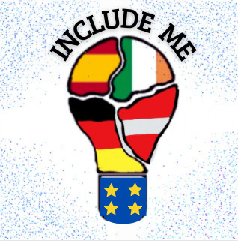
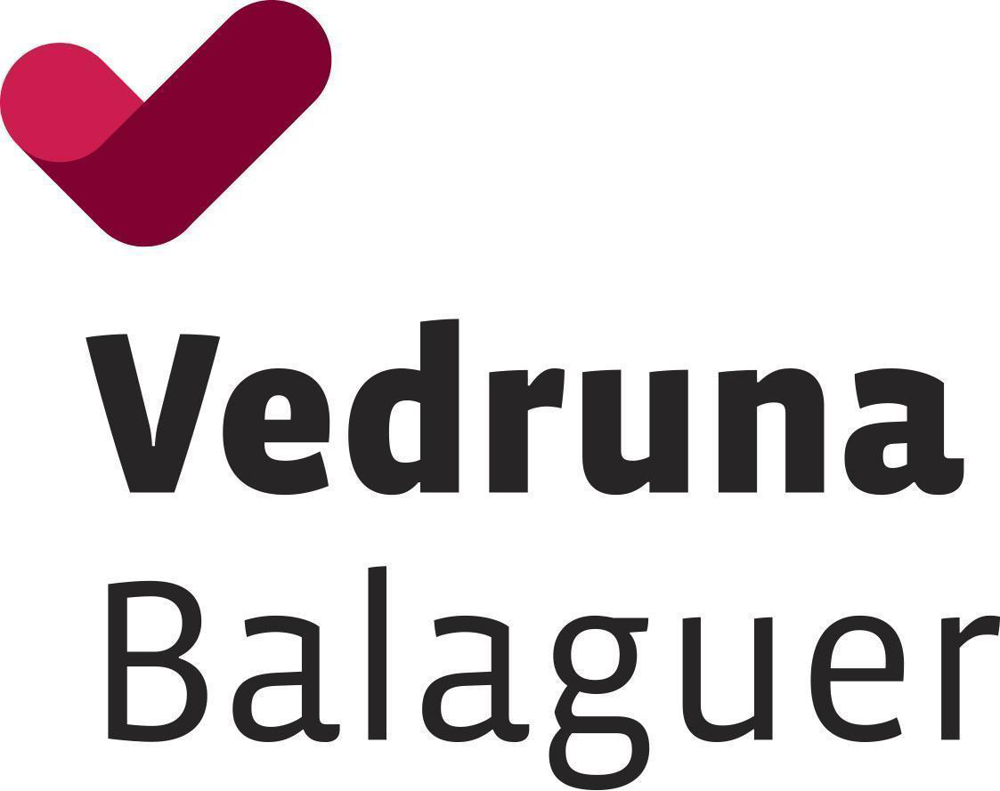
Erasmus Project “Include me “ - Barcelona
Program from 3rd to 7th October 202.

Time | Sunday 2.10 | Monday 3.10 | Tuesdays 04.10 | Wednesday 05.10 | Thursday 06.10 | Friday 07.10
8:30 – 9:30 | School partners  Arrival  To  Barcelona | 9:00 Welcome Ceremony | Visit to Penelles | Modern tales | Improshow | A Day  in Bacerlona
9:30 – 10:30 |  | 10:00 Friendship Bingo | Visit to Penelles | Modern tales
10:30 – 11:00 |  | Break | Break | Break | Break
11:00 – 12:00 |  | 11:30 Town Hall | Writing Stories  Using Graffiti  (Writing labs) | Story dominoes  (Writing labs) | Figure me out  (Writing labs)
12:00 – 13.30 |  | 12:00 Discovering our  School
13:30 – 15:00 |  | Schools & Countries  Presentations | Lunch and free time | Lunch and free time | Lunch and free  time
15:15 - 15:30 |  | Warning up Gathering | Visit to Museo  del L’Or |  | Bachata/Schwimming
15:30 -17:00 |  | Schools & Countries  Presentations | Games by the  river | Visit Lleida | Bachata/Schwimming | Departure
17:00 |  | Break | Break | Break | Break
17:30 – 19:30 |  | Fortune Teller | Board Race |  | Free time
20:00 |  | Dinner at School | Dinner at School |  | 19:30  Closing Cermony  Diplomas/Farewell
22:00 |  |  | Back to Balaguer

