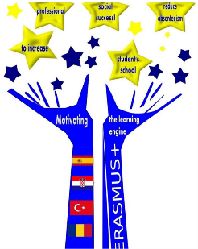
PREPARED BY:
RABİA DEMİREL

THE USE OF MGP METHOD AND THE IMPROVEMENTS
IT HAS BROUGHT.

20 Engaging Ways to Teach With Graffiti Walls
There’s something so satisfying about getting to write on the walls.
Jill Staake on May 14, 2019

Teaching With Graffiti Walls

Graffiti walls are a simple, fun, and interactive way to get kids involved in their learning. All you need is a blank whiteboard or some sheets of butcher paper to get started. Kids can write, draw, and express themselves as they learn and review a variety of subjects. Here are some of our favorite graffiti walls for the classroom.
- Have them tell all about themselves.

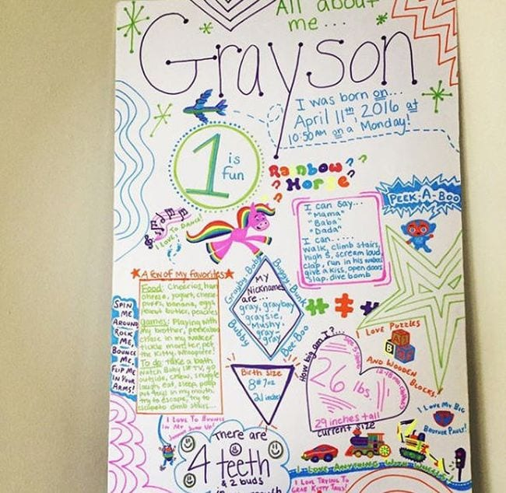

A perfect activity for the first week of class. Have each student make their own”All About Me” graffiti walls to help you and their classmates get to know them.

Source: clnaiva/Instagram

- Take geography to a whole new level.

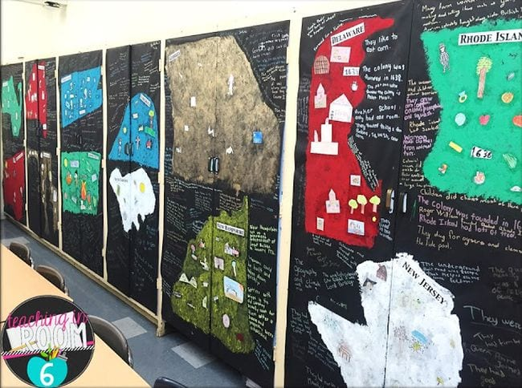

Whether kids are learning about colonies, states, countries, or continents, graffiti walls are a fun way to show off their knowledge. Have them draw or paint the geographic feature, then add fun facts all around.

Source: Teaching in Room 6

- Pose a math teaser.

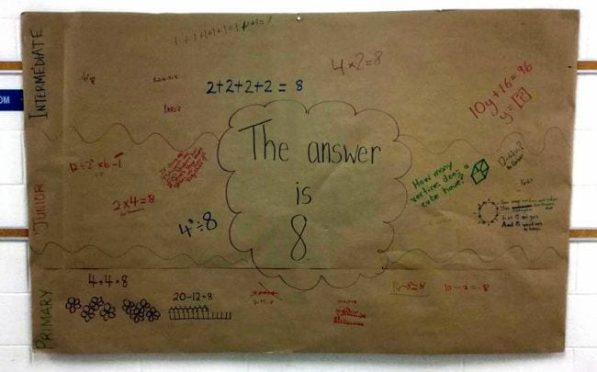

How many different ways can you answer the question? Math teaser graffiti walls have endless possibilities, and kids at all skill levels can get in on the action.

Source: SHOJ Elementary

- Visualize your vocabulary lessons.

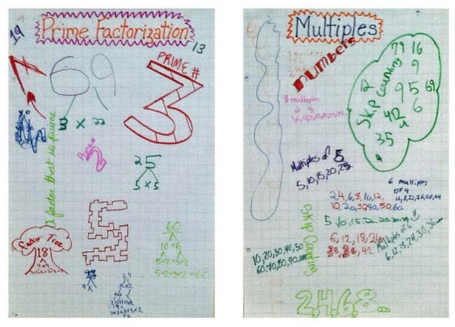

This example is for math, but you could do this for any subject. In English, try boards labelled “Alliterations” or “Irony.” For science, use concepts like “Physical Properties” or “Mammals.” Get the idea?

Source: Runde’s Room

- Review for a test with graffiti walls.

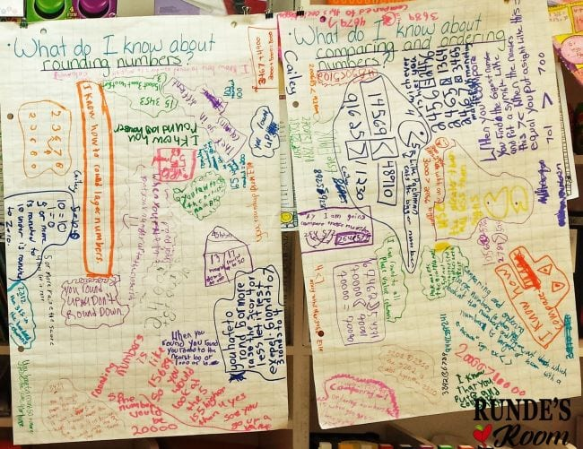

Preparing for a big unit-end test? Review the concepts they’ve learned with graffiti walls. Pose a series of questions around the room, and have kids rotate from one sheet to the next to record their answers. When they’re done, take a “gallery walk” as a class to review all the knowledge (and correct anything that’s wrong).

Source: Runde’s Room

- Capture their favorite reading quotes.

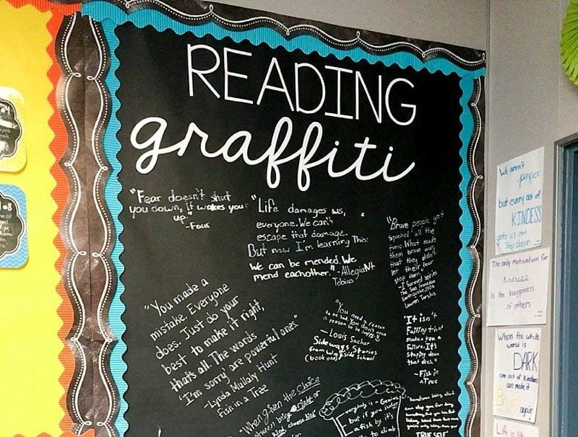

This is one of everyone’s favorite graffiti walls. Have kids post quotes from books they’re reading to inspire others. Use chalk markers on black paper for a striking look.

Source: Lessons With Laughter

- Prepare for a discussion on a serious topic.

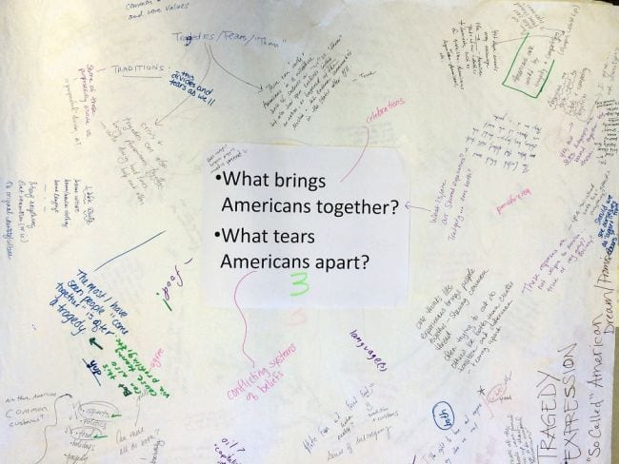

Ready to tackle a tough topic? First, give kids time to gather their thoughts by having them write answers on the wall. (This will especially benefit students who are hesitant to speak up in class.)Then, use their answers as a jumping off point to start the discussion.

Source: Facing History

- Encourage critical thinking skills.

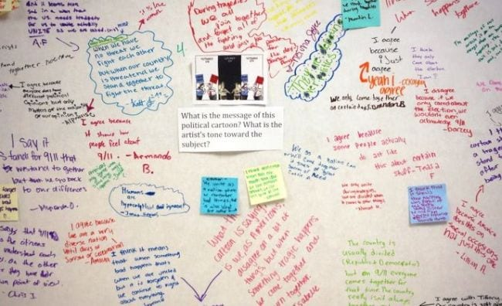

One of the neat things about graffiti walls is getting to see people interact with each other. One comment sparks another, and before you know it, kids are building on each other’s ideas at an amazing pace.

Source: Michelle Nyquist/Pinterest

- Ask for reading recommendations.

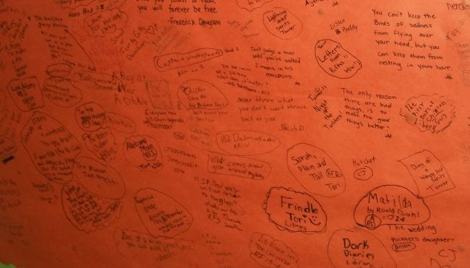

This one would be especially fun in the school library. Ask kids to recommend their favorite books. They can include quotes or brief summaries to pique the interest of other students.

Source: I Run Read Teach

- Make it motivational.

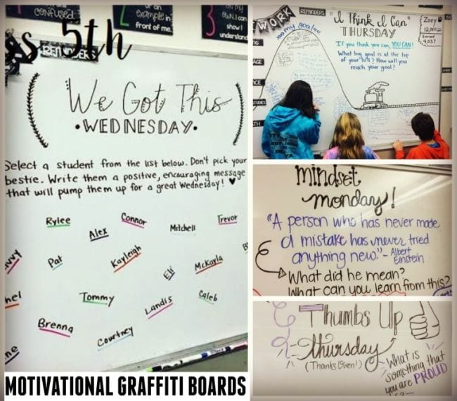

Pump up your students and send them out into the world with motivational messages to and from each other. We really love the idea of each child writing a special note to another student in the class.

Source: Teacher Idea Factory

- Do a daily theme just for fun.

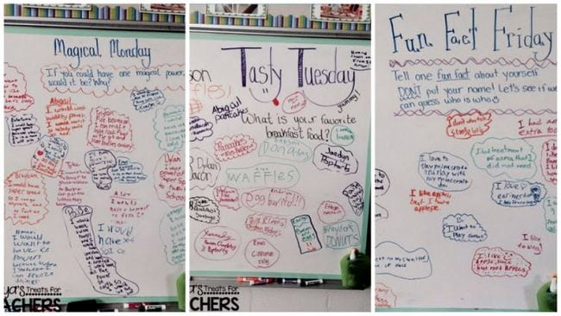

In addition to motivational activities, post themed questions each day (or every so often) that are just plain fun. It’s a wonderful way to fill a few minutes at the end of class, or get them in learning mode before the bell rings.

Source: Tonya’s Treats for Teachers

- Show an image to spark discussion.

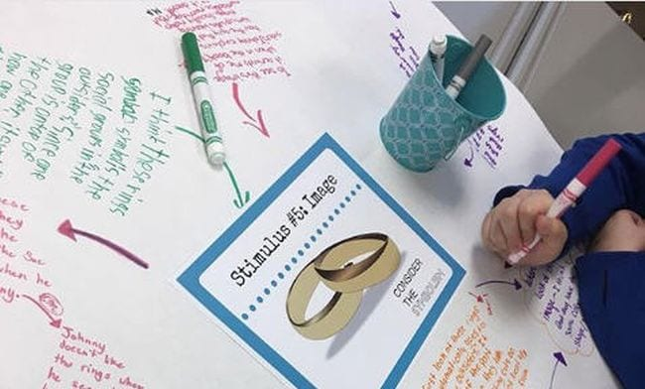

Prompts don’t always need to be questions or even words. Display an image and ask students to jot down their feelings or reactions to it. It’s an interesting way to talk about symbolism.

Source: Jillian Watto/Instagram

- Use graffiti walls to share information during
guided reading.

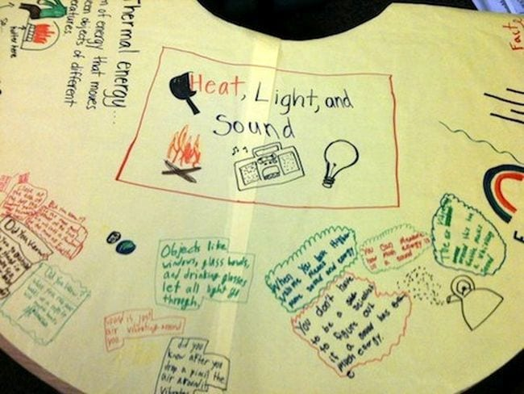

As kids read, have them jot down important points for others to note too. (Graffiti can be done on a table, too, as in this example. You can post them on the wall later if you like.)

Source: Scholastic

- Reflect on the week’s learning.

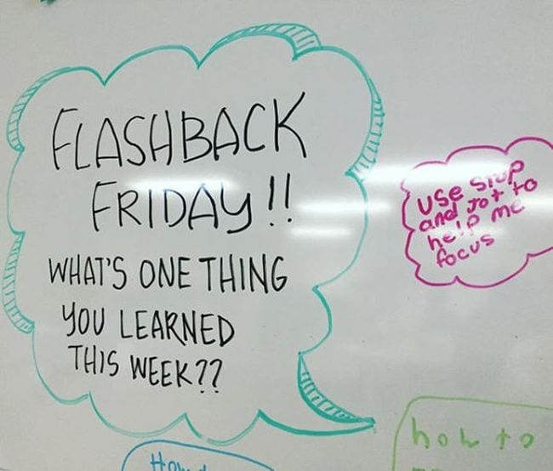

Before students fly out the door on Friday, ask them to jot down one important thing from the week behind them. Leave it up and have kids look it over on Monday to get them ready for the new week ahead.

Source: Melissa R/Instagram

- Hold a drawing contest.

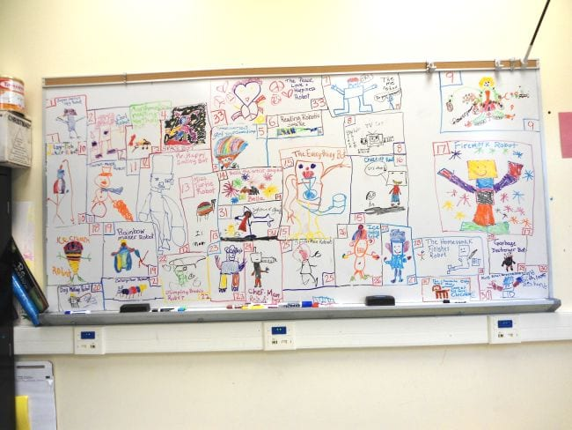

One teacher holds a robot drawing contest every year, and her students love it. Choose any topic your kids will enjoy, then have them mark off their place on the board and go crazy!

Source: Mrs. Iannuzzi

- Find out how they feel about music.

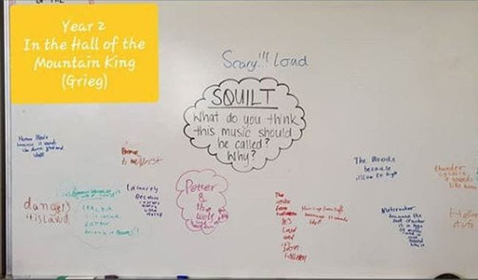

Working on music appreciation? Ask kids to listen to a piece of music, then write down how it makes them feel. They can also draw pictures of what the music brings to mind, or suggest their own song title.

Source: foxeemuso/Instagram

- Introduce new concepts with open-ended
questions.

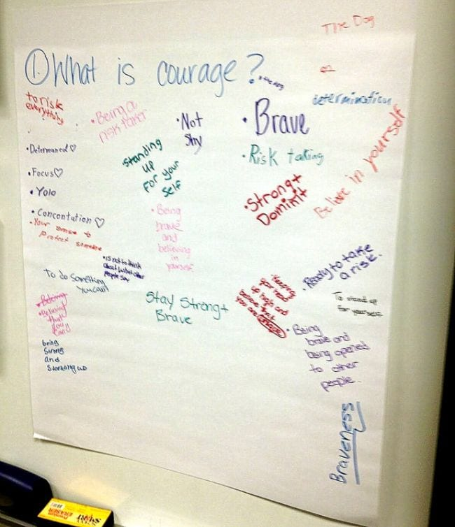

Before starting a new unit or book, get kids to reflect on what they already know about a topic or idea. Ask them “What are clouds?” or “What do you know about the history of our state?” Save the graffiti walls and compare their answers after they’ve completed the unit to see what they’ve learned.
Source: Musings from the Middle School
- Learn about graffiti as an art form.

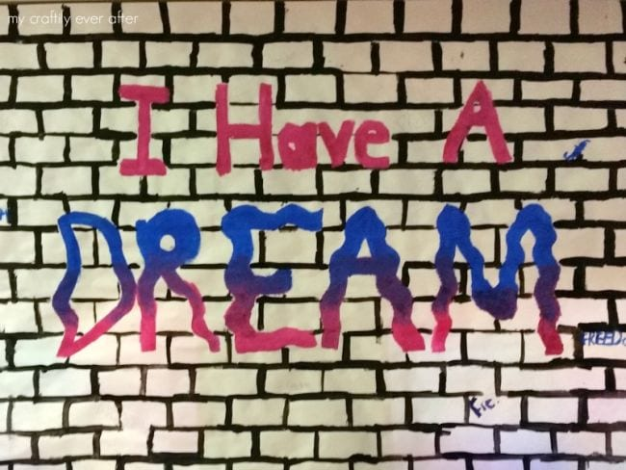

Street artists like Banksy have shown that graffiti is a legitimate art form in many cases. Have a conversation in your class about the difference between graffiti and vandalism. Then have kids draw a brick wall and cover it with their own graffiti art.

Source: My Craftily Ever After

- Build graffiti walls with LEGO bricks.

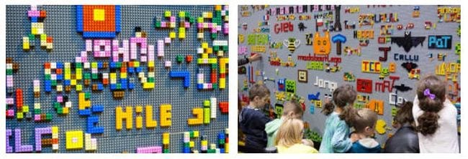

If your classroom has a good collection of LEGO bricks already, this project is easier than you might think. Buy bulk packages of flat base plates and attach them to the wall with double-sided tape. Then let kids build, build, build!

Source: BRICKLIVE

20. Just let them do whatever… really.

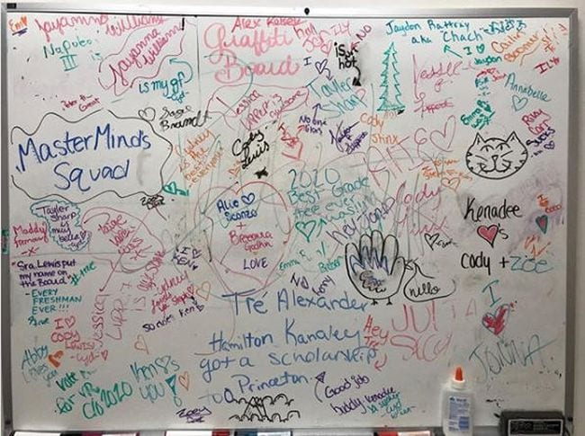

Don’t overthink it! Just throw up a blank piece of paper and allow kids to add to it throughout the semester or year. At the end, they can all snap a picture so they’ll have a record of some of their favorite memories.

Source: stephaniesucree/Instagram

5 Benefits of Graffiti

- Graffiti Can Help Brighten up a Building.

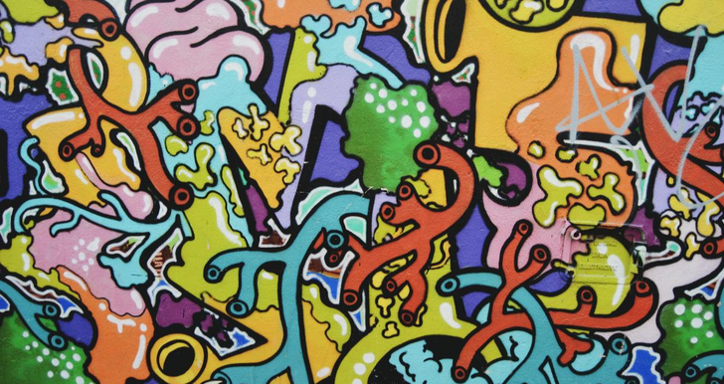

Have you ever gone down a street, especially in the city, and noticed how drab and monotone the buildings are that you are passing? One of the best things about graffiti is that it can help break up the monotony of the city and keep all of the buildings from looking the same.
Graffiti can be used by businesses to draw attention to their services and their products. Depending on where the business is, it may be graffiti in English, Spanish, or another language. Usually, the words aren't just words but they are put together with graphics and drawings to make them stand out.
Although many people associate graffiti with something negative, if it's done right, it can really be a positive way to bring attention to the building and make people sit up and take notice.
- Graffiti Gives You Different Ways to Express Yourself.

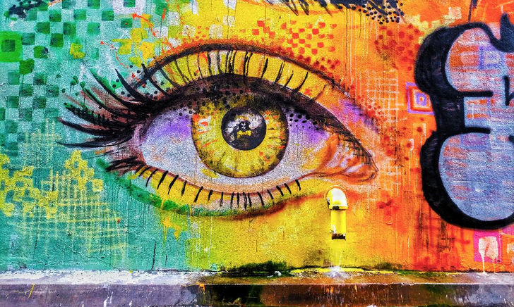

Looking for a new way that you can express yourself? One of the biggest benefits of graffiti is that it provides you with self-expression opportunities. For instance, there was once a boy who was always doodling during class. Guess what happened to him? He's now making money decorating the walls of businesses with his doodles.
Graffiti is something that's associated with people "tagging" signs and buildings with foul language. However, that's not always the case. Graffiti is an art form, just like many other types of art. Those who have true talent and skills, like the young boy mentioned above, can really get far in their life with this type of artwork.
It's just like anything else. You have to find your niche and do it the right way. When someone sees what you are doing and its value, you never know what could happen.

- Graffiti Can Help Bring Awareness.

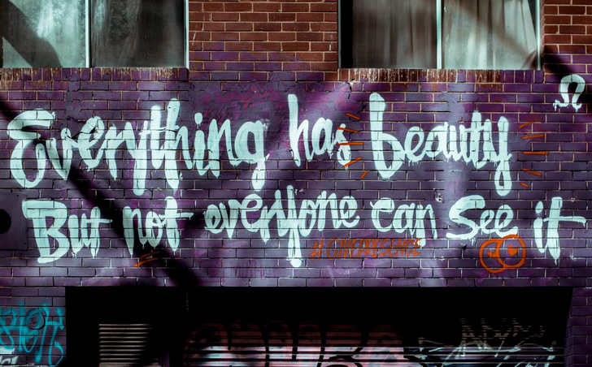

One of the best things about graffiti is that it can be expressed in many positive ways. Something that many people use graffiti for is to bring awareness to the causes that are dear to their heart.
When it's breast cancer month, the graffiti that is done on this subject might be done in pink. For those areas where poverty is a huge problem, poverty might be a topic for graffiti. Then there's the topic of bullying. It's a huge problem, and much graffiti has been used to raise awareness of those who suffer at the hands of a bully.
One of the best things about art is that it can be used to represent so many different things, and graffiti is no exception. If you are interested in making a difference in the world, a good way to do it is through using graffiti as your medium to change the world in a positive way.

- Murals Can Bring a Community Together.

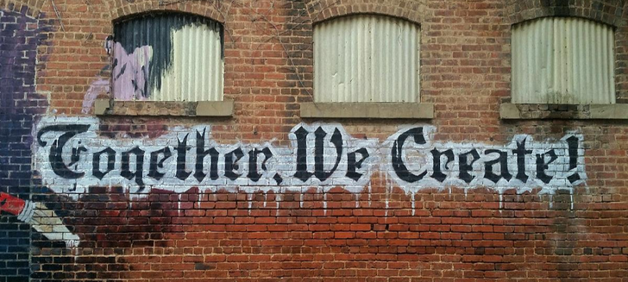

There was a movie that involved a mural that anyone could work on. It was located in an outdoor area and during the movie, different people would come to the mural and add to it. In the end, the mural's scene was revealed.
Murals are popular community art projects that can help with creating something the community can do together. Many times, prominent people in the community will come together and discuss mural ideas and invite others to be a part of the
collaborative effort.
There are many benefits of creating a mural. Not only can it help young and old to take pride in their community, but it also can teach them the importance of creating something that can make their town beautiful. Pride in their hometown can make a huge difference in the way residents act.

- Graffiti Can Brighten Up Sidewalks.

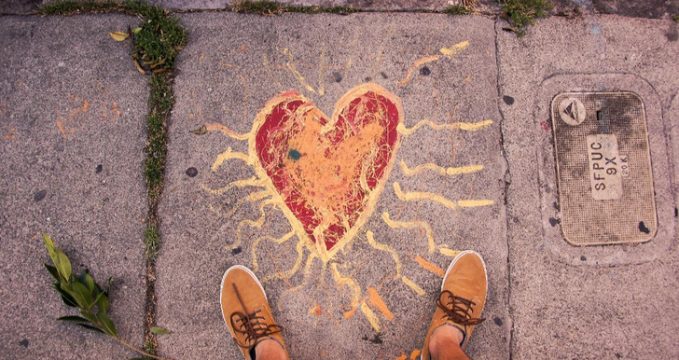

Have you ever watched kids happily drawing outside with sidewalk chalk? Chances are that you wouldn't look at that and think that's graffiti. But the truth is that drawing on the sidewalk is a form of graffiti.
If you open up your browser and search for something like "sidewalk art," you're going to find a lot of amazing pictures. Of course, you might find some beginner pictures drawn by kids who just got their first sidewalk chalk. But then again you might see some 3D type art that will make you think you're either going to fall into a deep hole or that something is leaping out at you. OK, so you won't be able to jump right into the chalk picture just like children did in a well-known Disney movie, but they're amazing nonetheless.
Do you really want to have your mind blown? Go to a sidewalk art festival. Chances are that you are never going to look at sidewalk chalk the same way. The incredible talent of those who showcase their art during these festivals is truly incredible. As you can see, graffiti can do a lot of good in the world. Just like anything else, graffiti can be used for both good and bad. When you use it for good, you may just be able to change the world.

