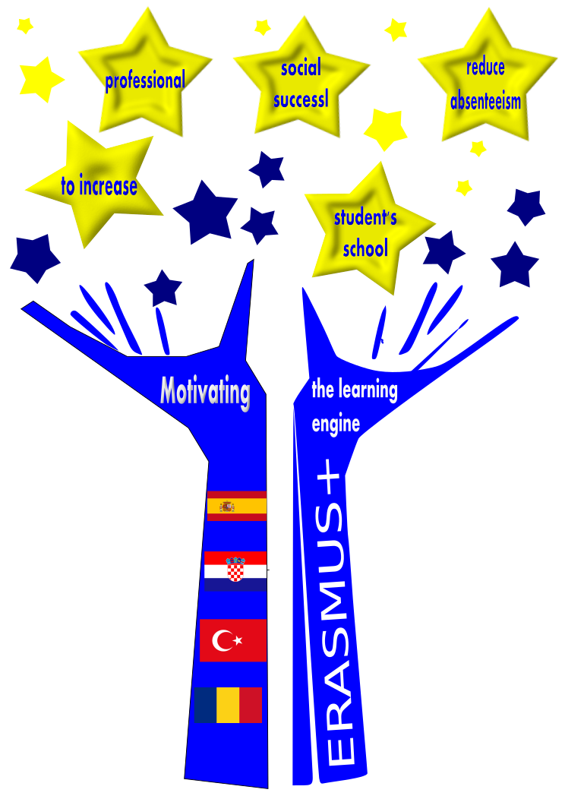

Motivating the learning engine to increase student’s school, profesional and social success and reduce absenteeism

2019-1-RO01-KA229-063851
by Mª Teresa Guerrero / Bianca Mesarus
Project financed by the European Union

All rights reserved. No part of this publication may be reproduced, in any form or any means, without permission in writing from the authors. | “The European Comission is not responsible for any uploaded or submitted content. The content reflects the views only of the European Comission cannot be held responsable for any use which may be made of the information contained therein”

REASONS TO LEARN
- Personal and professional development.
- It can provide us with more and better opportunities (employment, personal life, etc) and improve our quality of life.
- A sense of accomplishment and pride.
- You gain confidence for trying new things.
- Learning something new will make you feel happier.
- You get out of your comfort zone.
- It helps you to acquiring new skills and find innovative solutions in your life.
- It changes your mind and opens your attitude towards different perspectives.
- You build stronger connections with other people that share your same or different interests.
- Learning contributes to higher levels of resilience and self-efficacy in completing a task or tackling a challenge.
- You can discover hidden talents or passions.
- You have an open mind, ready to share new ideas and projects.
- Learning helps you to face new situations.

- Learning provides you experience.
- Learning is beneficial emotionally, financially, physically and socially.
- Learning helps you to understand other cultural contexts.
- Learning helps you to learn from your mistakes.
- It can help you to be more disciplined.
- Learning can be fun!
- You can grow as a person, develop your knowledge base and improve yourself for the better.

