Motivating the learning engine to increase student’s school, professional and social success and reduce absenteeism

2019-1-RO01-KA229-063851
Project financed by the European Union
David Balan/Claudia Agudelo/Nuria Musca/Teo Albert

All rights reserved. No part of this may be reproduced, in any form or any means, without permission in writing from the authors. | “The European Comission is not responsible for any uploaded or submitted content. The content reflects the views only of the European Comission cannot be held responsable for any use which may be made of the information contained there in”

MATHS EXERCISES
1- Calculate the value of each letter so every line, row and diagonal have the same sum.

2- We have 3 cities: N, M and P. A businessman who travels by plane, when he goes from M to N he has to delay his watch 2 hours when he gets to N. And when he goes from M to P he must fast forward his watch when he gets to P. If he goes from P to N at 11 p.m. and the journey has 4 hours, what time will be when he arrives to N?

3- Find the logic
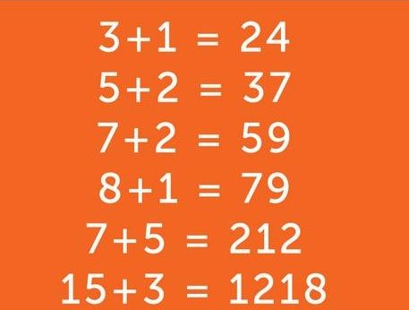

4- Find the secret number

 |  |  |  | 28
 |  |  |  | 30
 |  |  |  | 20
 |  |  |  | 16
? | 19 | 20 | 30

5- It is Flame’s birthday today.
-She is 9 years older than Tyger.
-Altogether, their ages add up to 23 years.
-How old is Flame?

