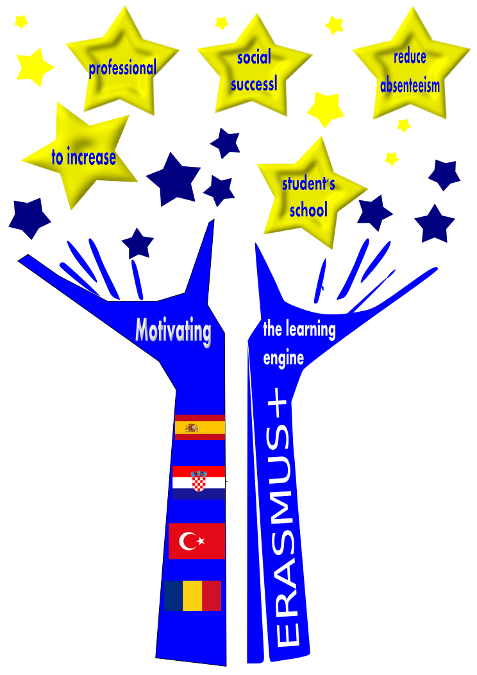

Motivating the learning engine to increase student’s school, profesional and social success and reduce absenteeism

2019-1-RO01-KA229-063851

Project funded by the European Union

C7 WHY SHOULD I LEARN?
10. Presentation and discussion of the “Teaching on nuclear issues”
The Presentation summary: “Teaching UE Key competences in IES Jaume I”
by Isabel Corell /Mª Teresa Olucha

All rights reserved. No part of this publication may be reproduced, in any form or any means, without permission in writing from the authors. | “The European Commission is not responsible for any uploaded or submitted content. The content reflects the views only of the European Commission cannot be held responsable for any use which may be made of the information contained therein”

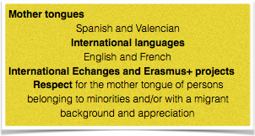
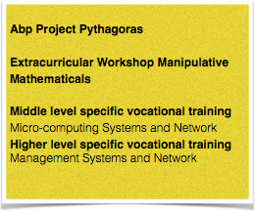
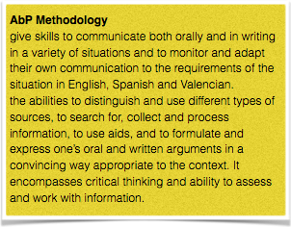
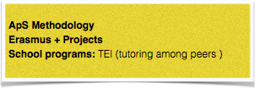
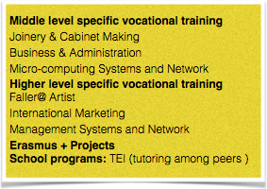
Teaching UE Key competences in
Mathematical, science, technology and engineering
Multilingual
Digital
Personal, social and learning to learn
Citizenship
Entrepreneurship
Cultural awareness and expression
Literacy

