9th Gymnasium of Ilion
PHILOSOPHICAL DIALOGUE WITH STUDENTS OF THE 3RD GRADE
How responsible am I? What can I do to be the change?
On October 19 2017 during an English lesson our teacher Mrs Alexandra Kotsikori said that we would have a philosophical dialogue about how responsible we are concerning the environment and how we can contribute to protect it and as a result to have a better life.
First she asked Nick what he is responsible for and he said that he tries not to throw the rubbish of what he eats on the floor. Moreover he said that he tries to recycle. He also mentioned that some students do throw their rubbish on the floor. When he was asked how he feels about that he said that he doesn’t feel very well. When the teacher asked him what he could do about that he said that he would try and talk to them and persuade them to recycle and be more responsible.
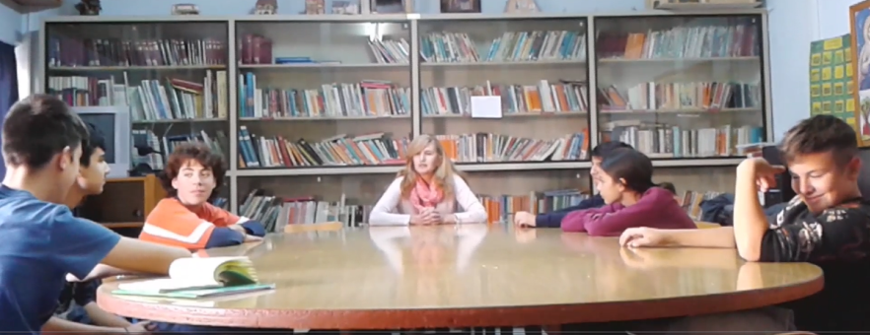
Then Konstantinos said that he also would like to help Nick in his effort to start a campaign and persuade other students to recycle instead of throwing their rubbish and pollute.
When our teacher asked him how he comes to school he said that he comes by car even though he doesn’t live very far. Our teacher said that the exhaust fumes of the cars pollute the environment and we should do our best to use them less. Moreover walking is good way of practicing and keeping fit. We must try and reduce our ecological footprint as much as we can if we want our planet to support us for a longer period of time. At this point Konstantinos said that he would try and come to school on foot and that will be his personal contribution.
Then our teacher asked Nastasia how she and her family consider the importance of recycling. Nastasia said that her family take recycling very seriously and they recycle plastic, glass and paper. She also said that saving energy is something we must take seriously and so she tries to switch off the lights when she exits a room.
Nastasia said that she will also try and persuade other students as well to save energy and recycle more.
Sotiris said that he is very worried about the environment and he feels that not much is done by the people to protect it. He would like to do something but he feels he can’t do much because he is too young. Then our teacher told him that it is not the fact that he is too young the problem. If everybody tries to the point that it is up to his/her abilities then we will see results.
Maria said that she will try to persuade her parents recycle more. She also said that the people in the Government have more power to manage things.
Nastasia added that the Politicians don’t care much because they have other problems to solve and they forget about the environment.
Sotiris added that they may have the power but we the people are more than them and we have to make the difference. We have to be the change.
Then Spyros said that he would like to make recycling bins where we can recycle at school paper and plastic separately. That will be his contribution.
At the end our teacher thanked us for this great discussion we had with her and asked us how we felt.
We said that we feel more determined and confident to try harder for our planet.
The students of class C1 and C3

