Hello! We are Djesi and Aly from Bulgaria and we would like to share our experience about mobility in Greece. We had a great chance to participate in the project '' Be the change ''. We visited Athens, Greece in march, 2018. It was a wonderful place with wonderful people. It was a very good trip and we are very thankful to all teachers, students and, of course, our host families.
When we arrived at the train station we were welcomed by the families. The next day when we arrived at the school we met the students from all countries. All of them looked like very nice and they were friendly with us. Each team presented a presentation, prepared by themselves. When we finished that activity we had a break. In the afternoon we went to Aluminum Recycle Centre. We participated in the recycling process. Next, we went hiking at month Parnitha. There we had a guide and he told us so much information about the species and many different plants. After the long walking way through the mountain we used lift to go back down.
The next day also was very interesting. We were divided in two groups. One group participated in Philosophical dialogue about Responsibility, the another one involved in a workshop about '' The importance of ICT in controlling the climate change ''. These activities were very interesting and meaningful for us because we heard different opinions and we learned many new things. After that we had pic-nick and then we went to the place where in 2004 were held the Olympic games. And then we participated in cleaning beach activities. After all these exciting activities we went homes.
The third day we visited '' Botanical Garden Diomedes ''. There we were split into two groups again. The one group participated in games and the another one was walking around the park by guide. After each group finished we changed the places. When we finished, we went back to school. There we had a pic-nick. After this we learned about the theatre. After our teacher told us the rules, we were ready and started to prepare a play about birds, their trees, humans and the destructive power of the fire. When we were ready to show our job our teachers came to watch our role-play. The day finished successfully.
The fourth day was the best for me. We went to the island of Hydra. First, we travelled by bus and then by a boat. When we arrived we were welcomed by the students from the Gimnasium of Hydra. Then we visited the '' Lazaros Kountouriotis'' - Historical Marsion, the National Historical Museum. After that we had lunch. The Bulgarian students together with Norwegians students and two girls from France were together. When we finished our lunch we went to some shops, we ate ice cream and were talking a lot. Then we ( Bulgarian students ) went to take some pictures. After that we decided to go to the beach. While we were walking we met three boys from Spain and the girls from Norway. The Bulgarian and the Spanish boys went into the water. The weather was very nice and we were happy but it was time to go back.
The last day was full of emotions. First, we went to Acropolis museum, then we visited the Panthenon on the Acropolis sacred rock. After that we had lunch at the restaurant. When we finished we went shopping. When we finished we went back to our homes. We had some free time to prepare for the party. The party was very cool. There were many dancers who were dancing a typical Greek music and other modern ones. We had fun and had a great time. It was the best part of the day. But as you know, although everything was wonderful we had to end and had to say goodbye. And it was the saddest part for us. We were hugging each other and crying... But it was time to say goodbye!
That was the end of our beautiful trip.
We would like to say ''Thank you'' to all the teachers who cared about us and found the right ways to make us feel happily during the whole week. And again thank you for the opportunity to be a part of this project and the chance to improve our key skills.

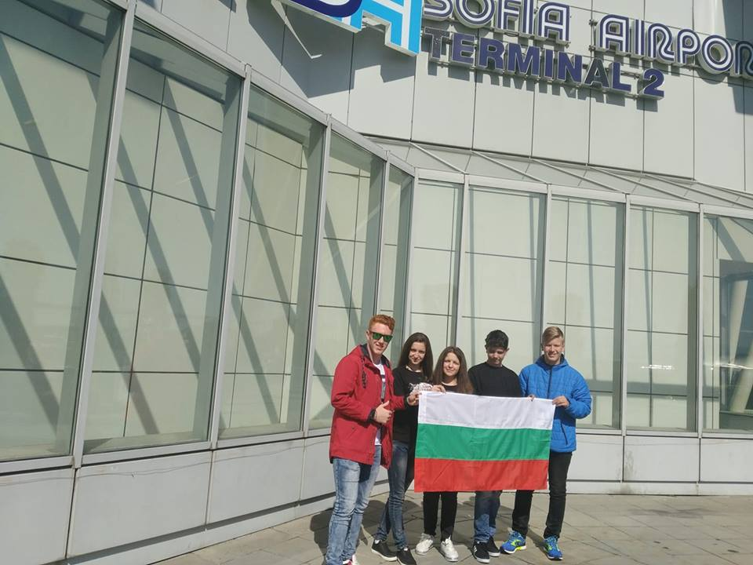

SMOLYAN, BULGARIA
MARCH, 2018

