Thursday 21st March 2019 Philosophical Dialogue
« Relationship between Man and Nature »
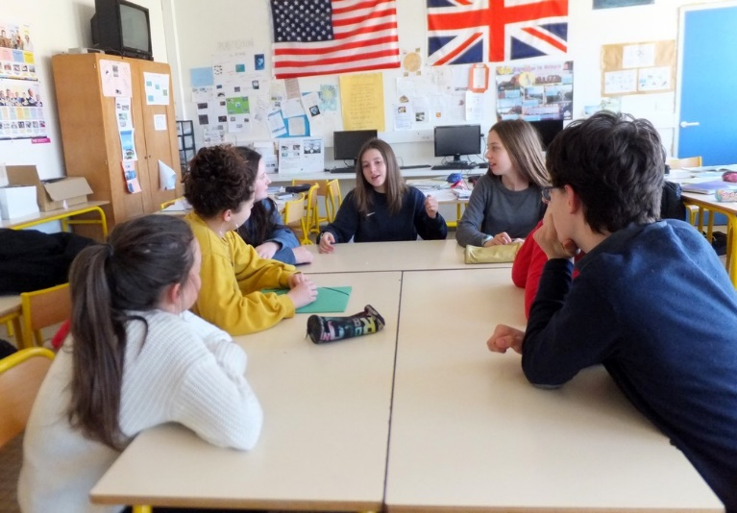
After watching Steve Cutt’s cartoon « Man » and reacting to it, students explored questions such as « Are humans born to rule over nature and exploit it to their advantage or do other species have equal rights to exist ? » « Should humans take care of animals and plants just because we need them to survive ? ».

Here are some their thoughts :
