May Day
May Day, or Labor Day, is a public holiday in many countries worldwide. It usually occurs around May 1, but the date varies across countries. It is associated the start of spring as well as the celebration of workers
Labour Day is an annual holiday to celebrate the achievements of workers. Labour Day has its origins in the labour union movement, which advocated eight hours for work, eight hours for recreation, and eight hours for rest. For many countries, Labour Day is synonymous with, or linked with,International Workers’ Day, which occurs on 1 May. For other countries, Labour Day is celebrated on a different date, often one with special significance for the labour movement in that country. In Canada and the United States, it is celebrated on the first Monday of September and considered the official end of the summer holiday for most of the respective countries, as public school and university students return to school that week or the following week.
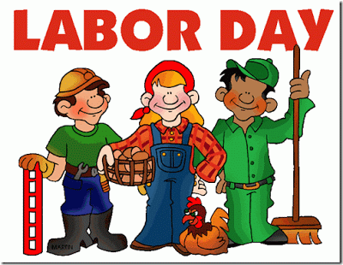
The first Labor Day holiday was celebrated on Tuesday, September 5, 1882, in New York City, in accordance with the plans of the Central Labor Union..
.

