Cafè de l’ òpera ramble 74
have a look at the decoration of this shop. which artistic movement can you identify?
Art nouveau

It is an establishment that opened in 1929 opened as a coffee that differentiates them from the competition is that it is at the forefront of the opera and adamas is an emblematic place and can be considered a heritage of humanity for the people in charge
The majority of customers who are going to visit the establishment are out (70%)
An anecdote happened that at the establishment came a cenaasta to make a movie with a very famous actor who was called Michael Portillo also in the 80s they reached the Rolling stones what matters most the place is the competition but it is not so popular as the es
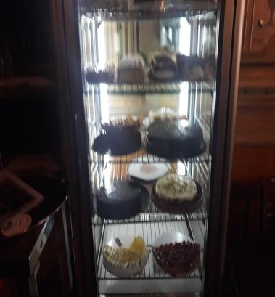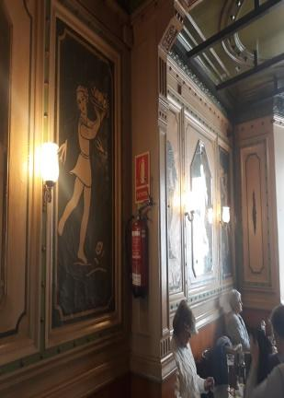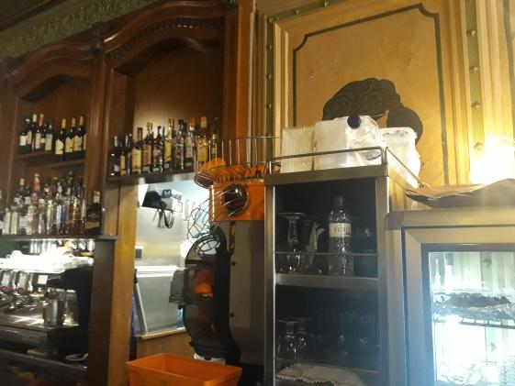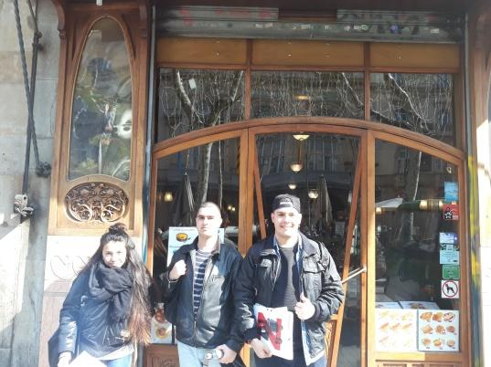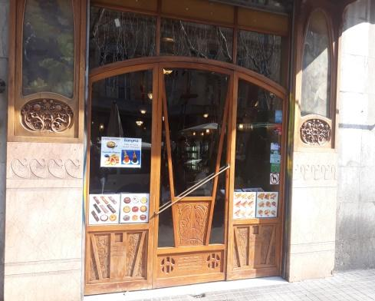

Herboristeria del rei, carrer Vidre 1,

for which reason is well known this shop?

for being the first herb shop of barcelona

It is a herbal shop that lasted 200 years with four generations of the same family until the end was transferred to other people, what makes the store different is that it is old is very well decorated and was the first store to sell herbs. Once Pascual Maragall came to buy herbs.
They come to buy from the shop regular customers but especially tourists, the worst thing about how traders are the agent of the boulevards because they have lost sales.

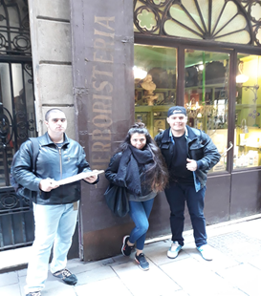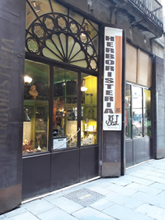
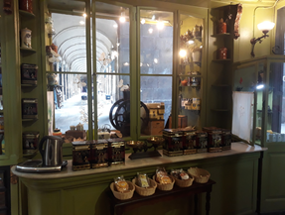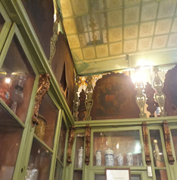

Antiga casa Xanco , les Rambles 78

years ago this used to be a shop where they sell?

swimsuits and shirts

It is a store that faces personalized dresses, the store is from the same family since the 1820s, it is different from the competition because they have materials of very good quality and perform the measurements of the body of the person, an anecdote is that the People who buy their secrets to the dependents, what worries them most is the bankruptcy of the rambles because because of that they lost clients

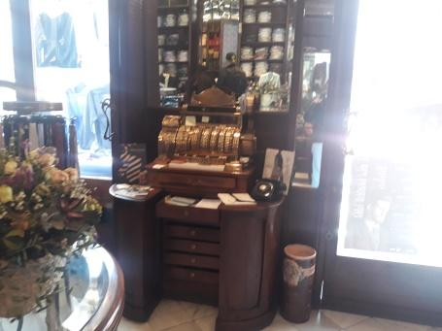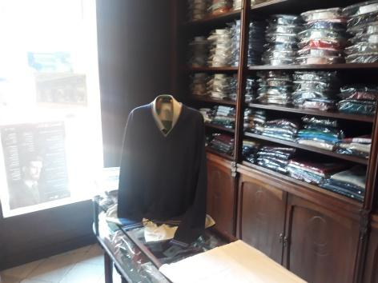
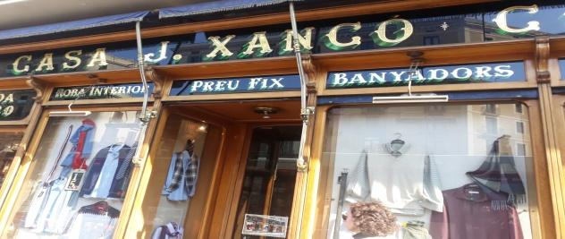

la torre plaça universitat 4

Who is the target of this store?

Classic customer/children

La Torre is one of the most emblematic shops in the neighborhood. In fact, his career dates back to 1900 when Daniel Carreras Jubert opened the doors of the famous number 4 button on Plaça Universitat, starting a business family that has maintained its quality and excellence for two more generations ( with Artemi Carreras Jaumà and updated the work of Artemi Carreras Bartrolí, which takes care of the work done with small details day by day.

At La Torre we can find a whole range of articles: interior t-shirts, shorts, panties, socks, ... in all kinds of colors and shapes, and the most prestigious brands in the market (Avet, ZD, Eminence, ... .). However, the trade offers the security to the clients of a personalized and professional attention, guaranteed by more than a century of experience in the market.
Most are customers who have been faithful to the store for years, tourists also come
This is a brief comment that was given to the store owner

Well ... this place is the most. Only the showcase leaves you insensitive, those thick bands nailed with pins on an old brown background. Those mediums of size 1500, the panties with which you can wrap a gift ... the jewel, the paradise of cotton and macramé.

It is concerned that some shops specializing in men's, women's and children's underwear

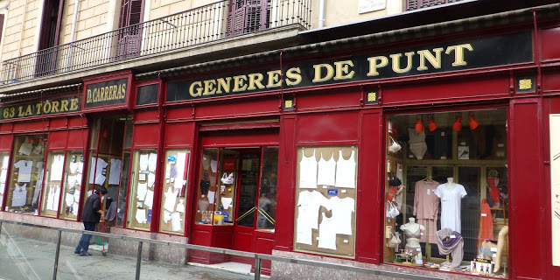

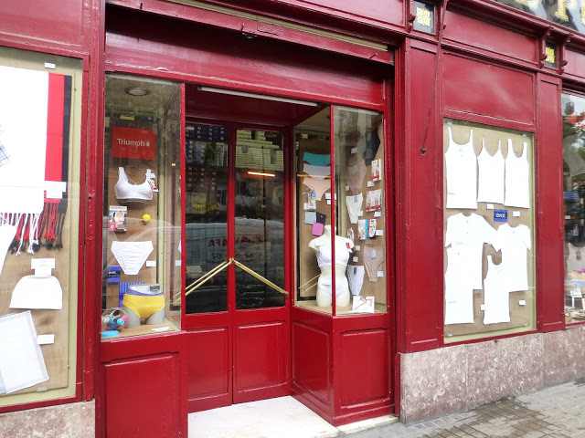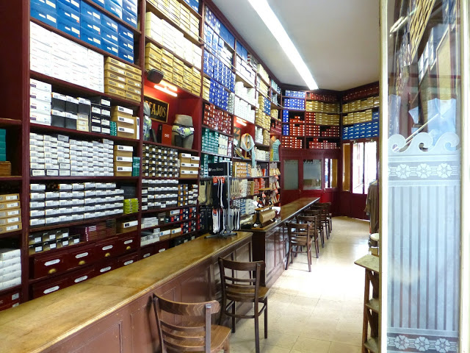

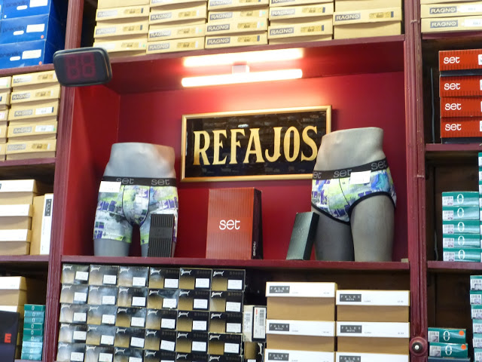

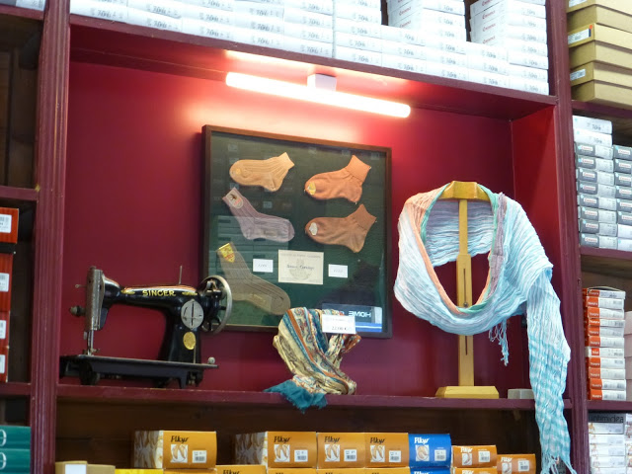
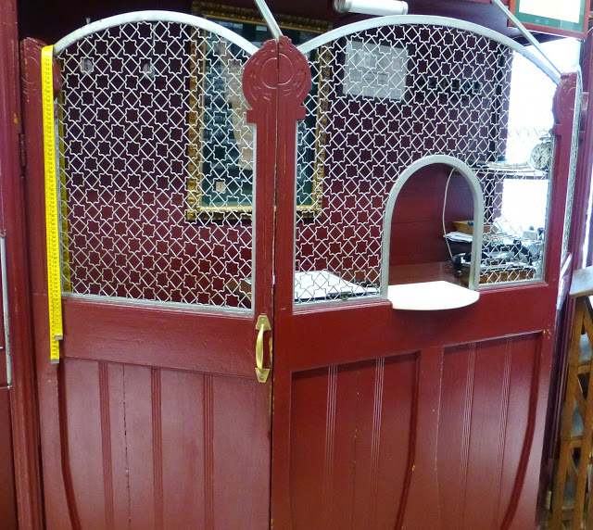

Mesón del cafe
baixada de la llibreteria,16

The inner walls of this store are covered with: Wood

It is a cafeteria that has passed from generation to generation since 1909, which differentiates them from the competition is that they make the best client of Barcelona and that it was very far away, the customers that flocked to the store are distant customers of others countries. They are concerned that there is a lot of competition for this sector, since today there will be many places on coffee and tapes, and this may cause the client to try other things.

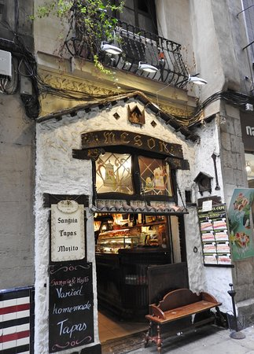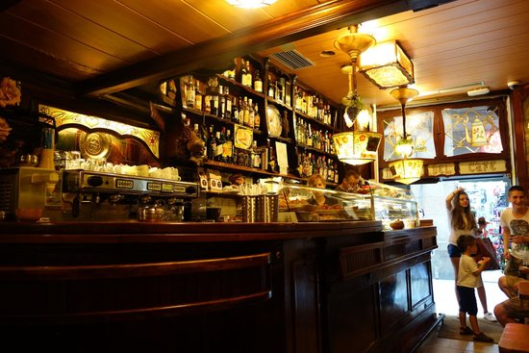
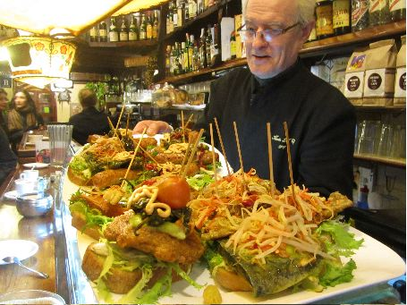

Manantial de la salut
Carrer d´en xuclà,23

Here, you could buy: Herbs

The store has been in business since 1923 and is familiar because it has passed from generation to generation those whose only competence are pharmacies, because they also sell herbs. The type of customer that has been faithful for some time, we also have clients of everything that also includes tourists. an anecdote

In December 2017, the spring health store brought a new Christmas tea that brings an exquisite mixture of roses, star anise, green anise, mauve, herbs and white pennyroyal that will end the abundant Christmas meals, making them much More digestive, and that both liked customers and it was the year it was sold.

What worries them today is that many pharmacies are opened in which they sell almost the same product as us.
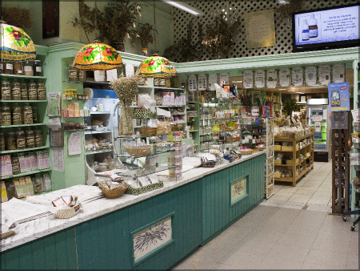
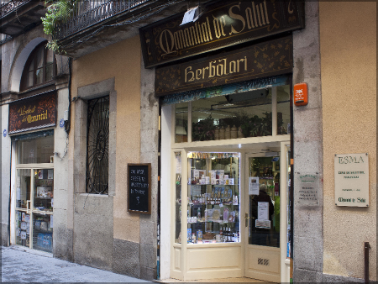

Farmacia, la rambla 121

The façade of this shop is made of? Bricks

The store is from the family and takes from 1920 to the boulevards, the former Masó Arumí Pharmacy, at the moment Pharmacy Nadal, located in an oldest corner building, retains much of the original decoration, this makes it different from the others, also stand out The large half-point arcs of the mezzanine, with sculptures allusive and surrounded by graffiti, the type of customers that come to the store are those that came from the first, moment that the store opened, they also come tourists from outside, the truth that there is no curious anecdote, what worries me as a merchant are the other pharmacies that are also selling the same products as us.

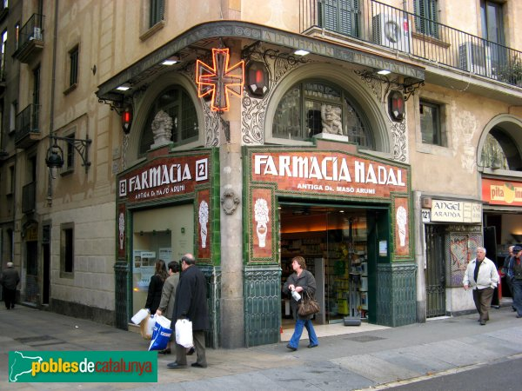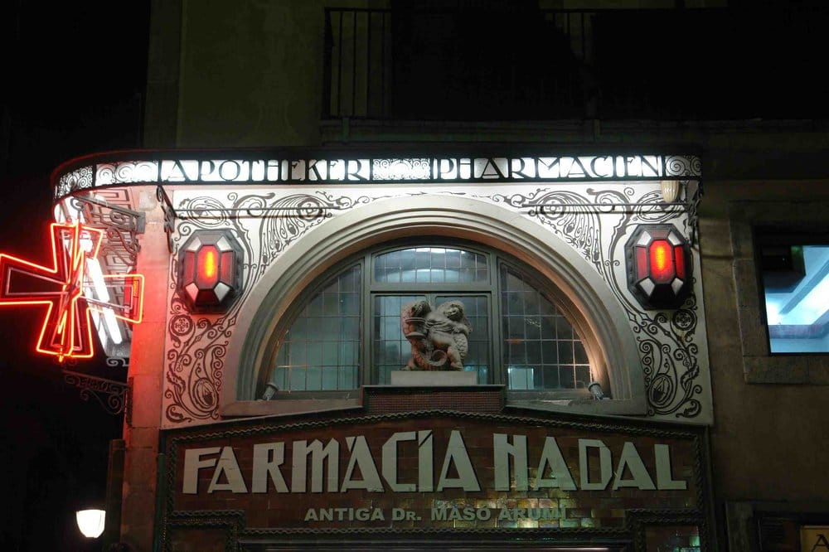
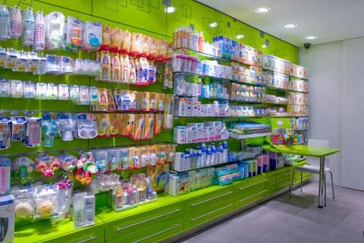

J. Torrente, Carrer del Marquès de barberà 21

What type of products can you buy in this store? Lightning rods

It's a family store since 1860 but it's been a long time since it was a vintage store that was going for lightning, the worst thing about them was its competitors, it does not have much competition since it is no longer a store

