Papirvum
Papirvm was born in the heart of the Gothic district of Barcelona in 1981 from a family business, where you are transported to the paradise of the lovers of writing, from a past time to the present time, in which by that difficult conjugation the forms join old and handmade bookbinding with different materials such as leather, fabric, or paper.
And he is concerned about the increase in store rentals and store transfers.
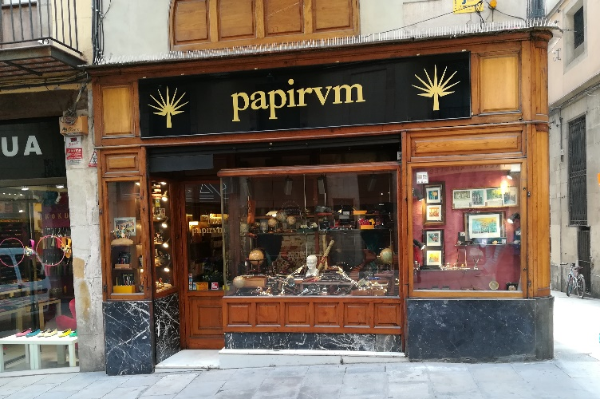

Fargas
Mythical chocolate shop founded in 1827 that offers chocolates by weight, homemade candies and gift boxes. Fargas is a family business, they make chocolate from cocoa beans. The clients are mostly elderly local people and tourist people come. And what most worries the company is the little care of the town hall with the flagship stores.
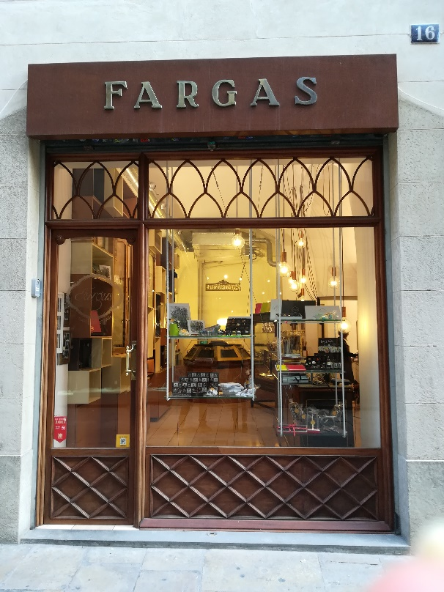
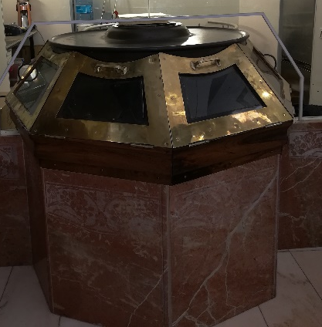

Cereria Abella
Abella cherry or better known as Cerabella began at the end of the nineteenth century when a woman from Pallars left the small town where she lived to venture into the city. From the 60's, begins the story that still defines the essence of Cerabella: the one of a bet for the quality and the investigation to turn the manufacture of the candles, an ancestral lighting method, in a constant creation of forms, perfumes, colours and uses. Their clients are people interested in the craft and quality product.
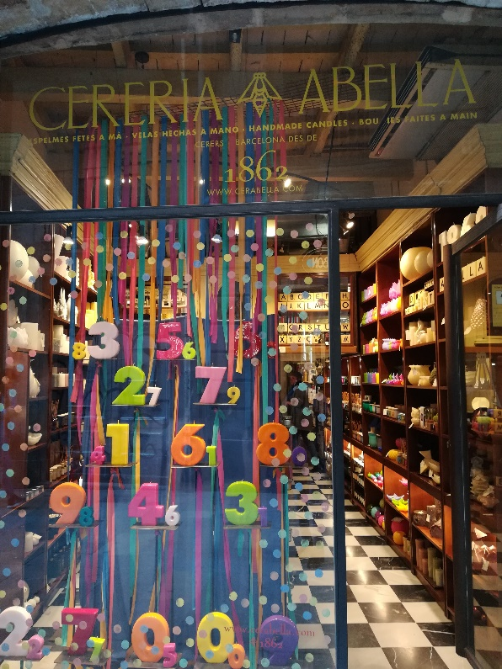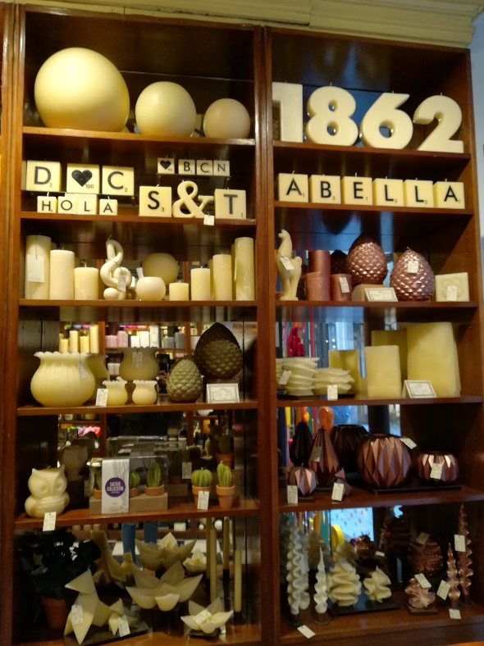

La Casa del Bacalao
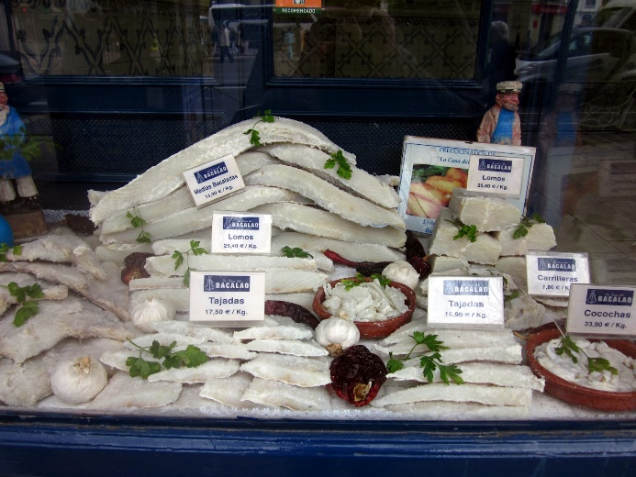
This family business establishment has been preparing cod for more than 50 years with methods of more than 50 years ago. The raw material is of the highest quality and is cooked in each and every one of the multiple varieties, always with a lot of love. All this has contributed to create a fixed clientele that appreciates the quality of this fish. Mostly their clients are local people. His biggest concerns are that his clients are getting older and that young people are not interested.
