Botigues Emblemàtiques

-Mallart:

THE SHOP “MALLART” NOW HAS A NEW OWNER AND NEW BUSINESS BECAUSE THE OLD OWNER IT WAS RETIRED, THIS SHOP WAS ONE SHOP OF TOYS AND NOW ONE SHOP OF SOUVENIRS

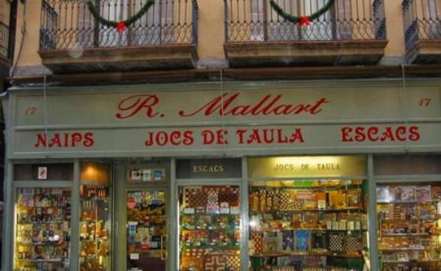

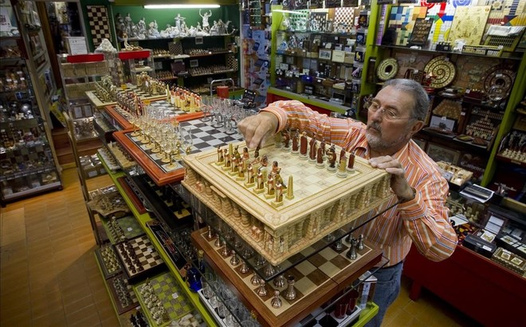
-Casa Teixidó:

Adress: Ronda de Sant Pere, 16, 08010 Barcelona

Casa Teixidó was foundation in the year 1874 , the shop is in hands of family and there is no competition, they have loyal customer , turists customers for the location.
One anecdote: Once time one family tourist come here and buy one glasses for everyone, in total 6 glasses.
What worries they most is the the economic situation in the country

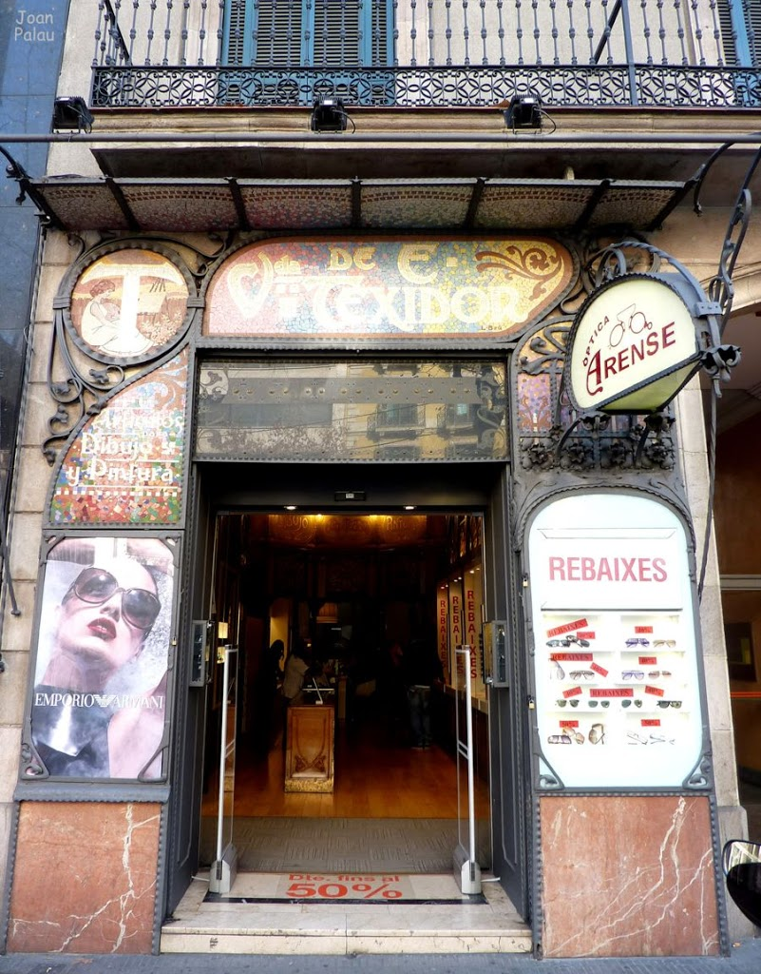

-Coses de casa:

Adress: Plaça de Sant Josep Oriol, 5, 08002 Barcelona

Coses de la casa was foundation in the year 1972, the shop was open for a hands of family and there is no direct competition, being an artisan shop there is no other store that does the same, designs and crafts, they have adults and all types of customers.
One anecdote: Once time a group of tourists entered in the store like 15 persons and the store was overbooking.
What worries they most the lack of help from the city council. They rent, about € 300 a year ago at € 4500 today.

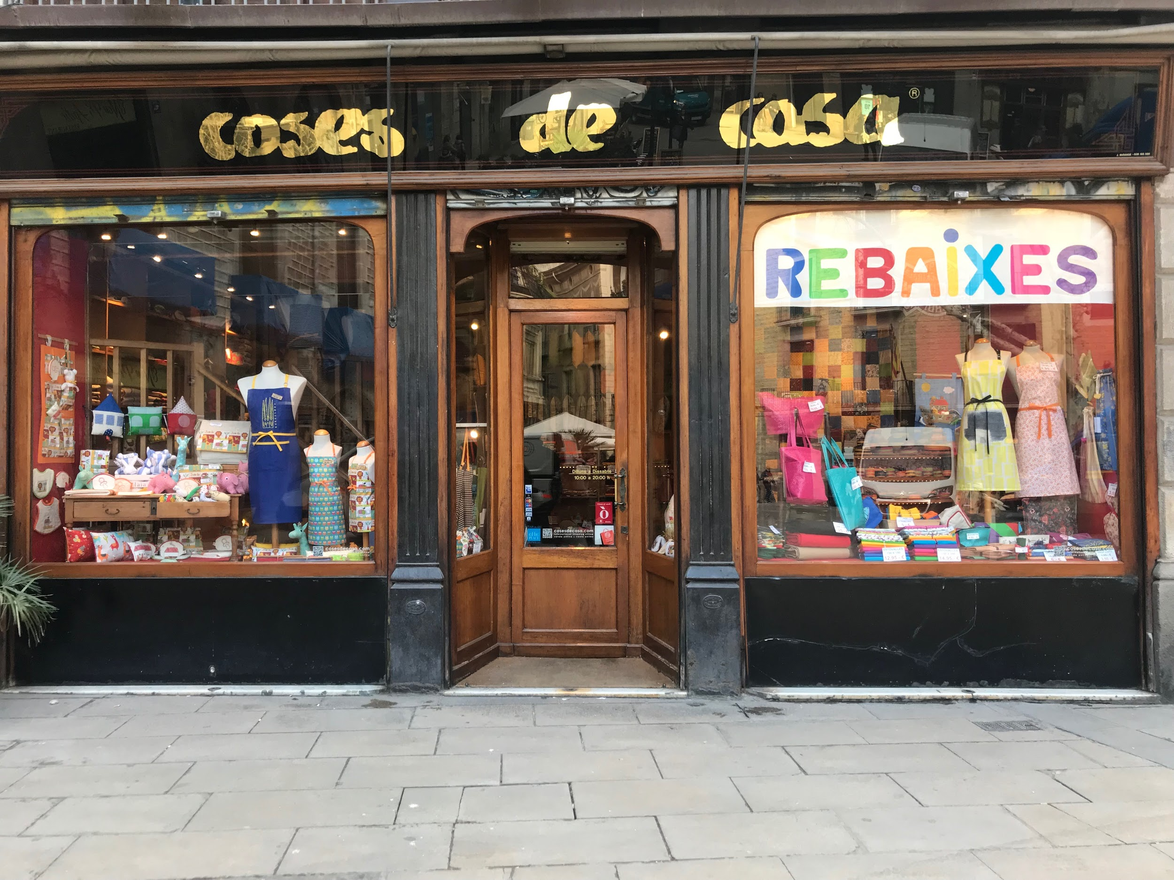

-Roca:

Adress: Plaça del Pi 3, 08002 Barcelona

Roca was foundation in the year 1911, was open by society and the difference with the competition is the quality and price, they have usually turist customers , but also loyal customers.
One anecdote: Once time one customer come in the store 4 times in one day for buy only one knive
What worries they most they most keep on the same line but are afraid of the internet

