Botigues Emblemàtiques

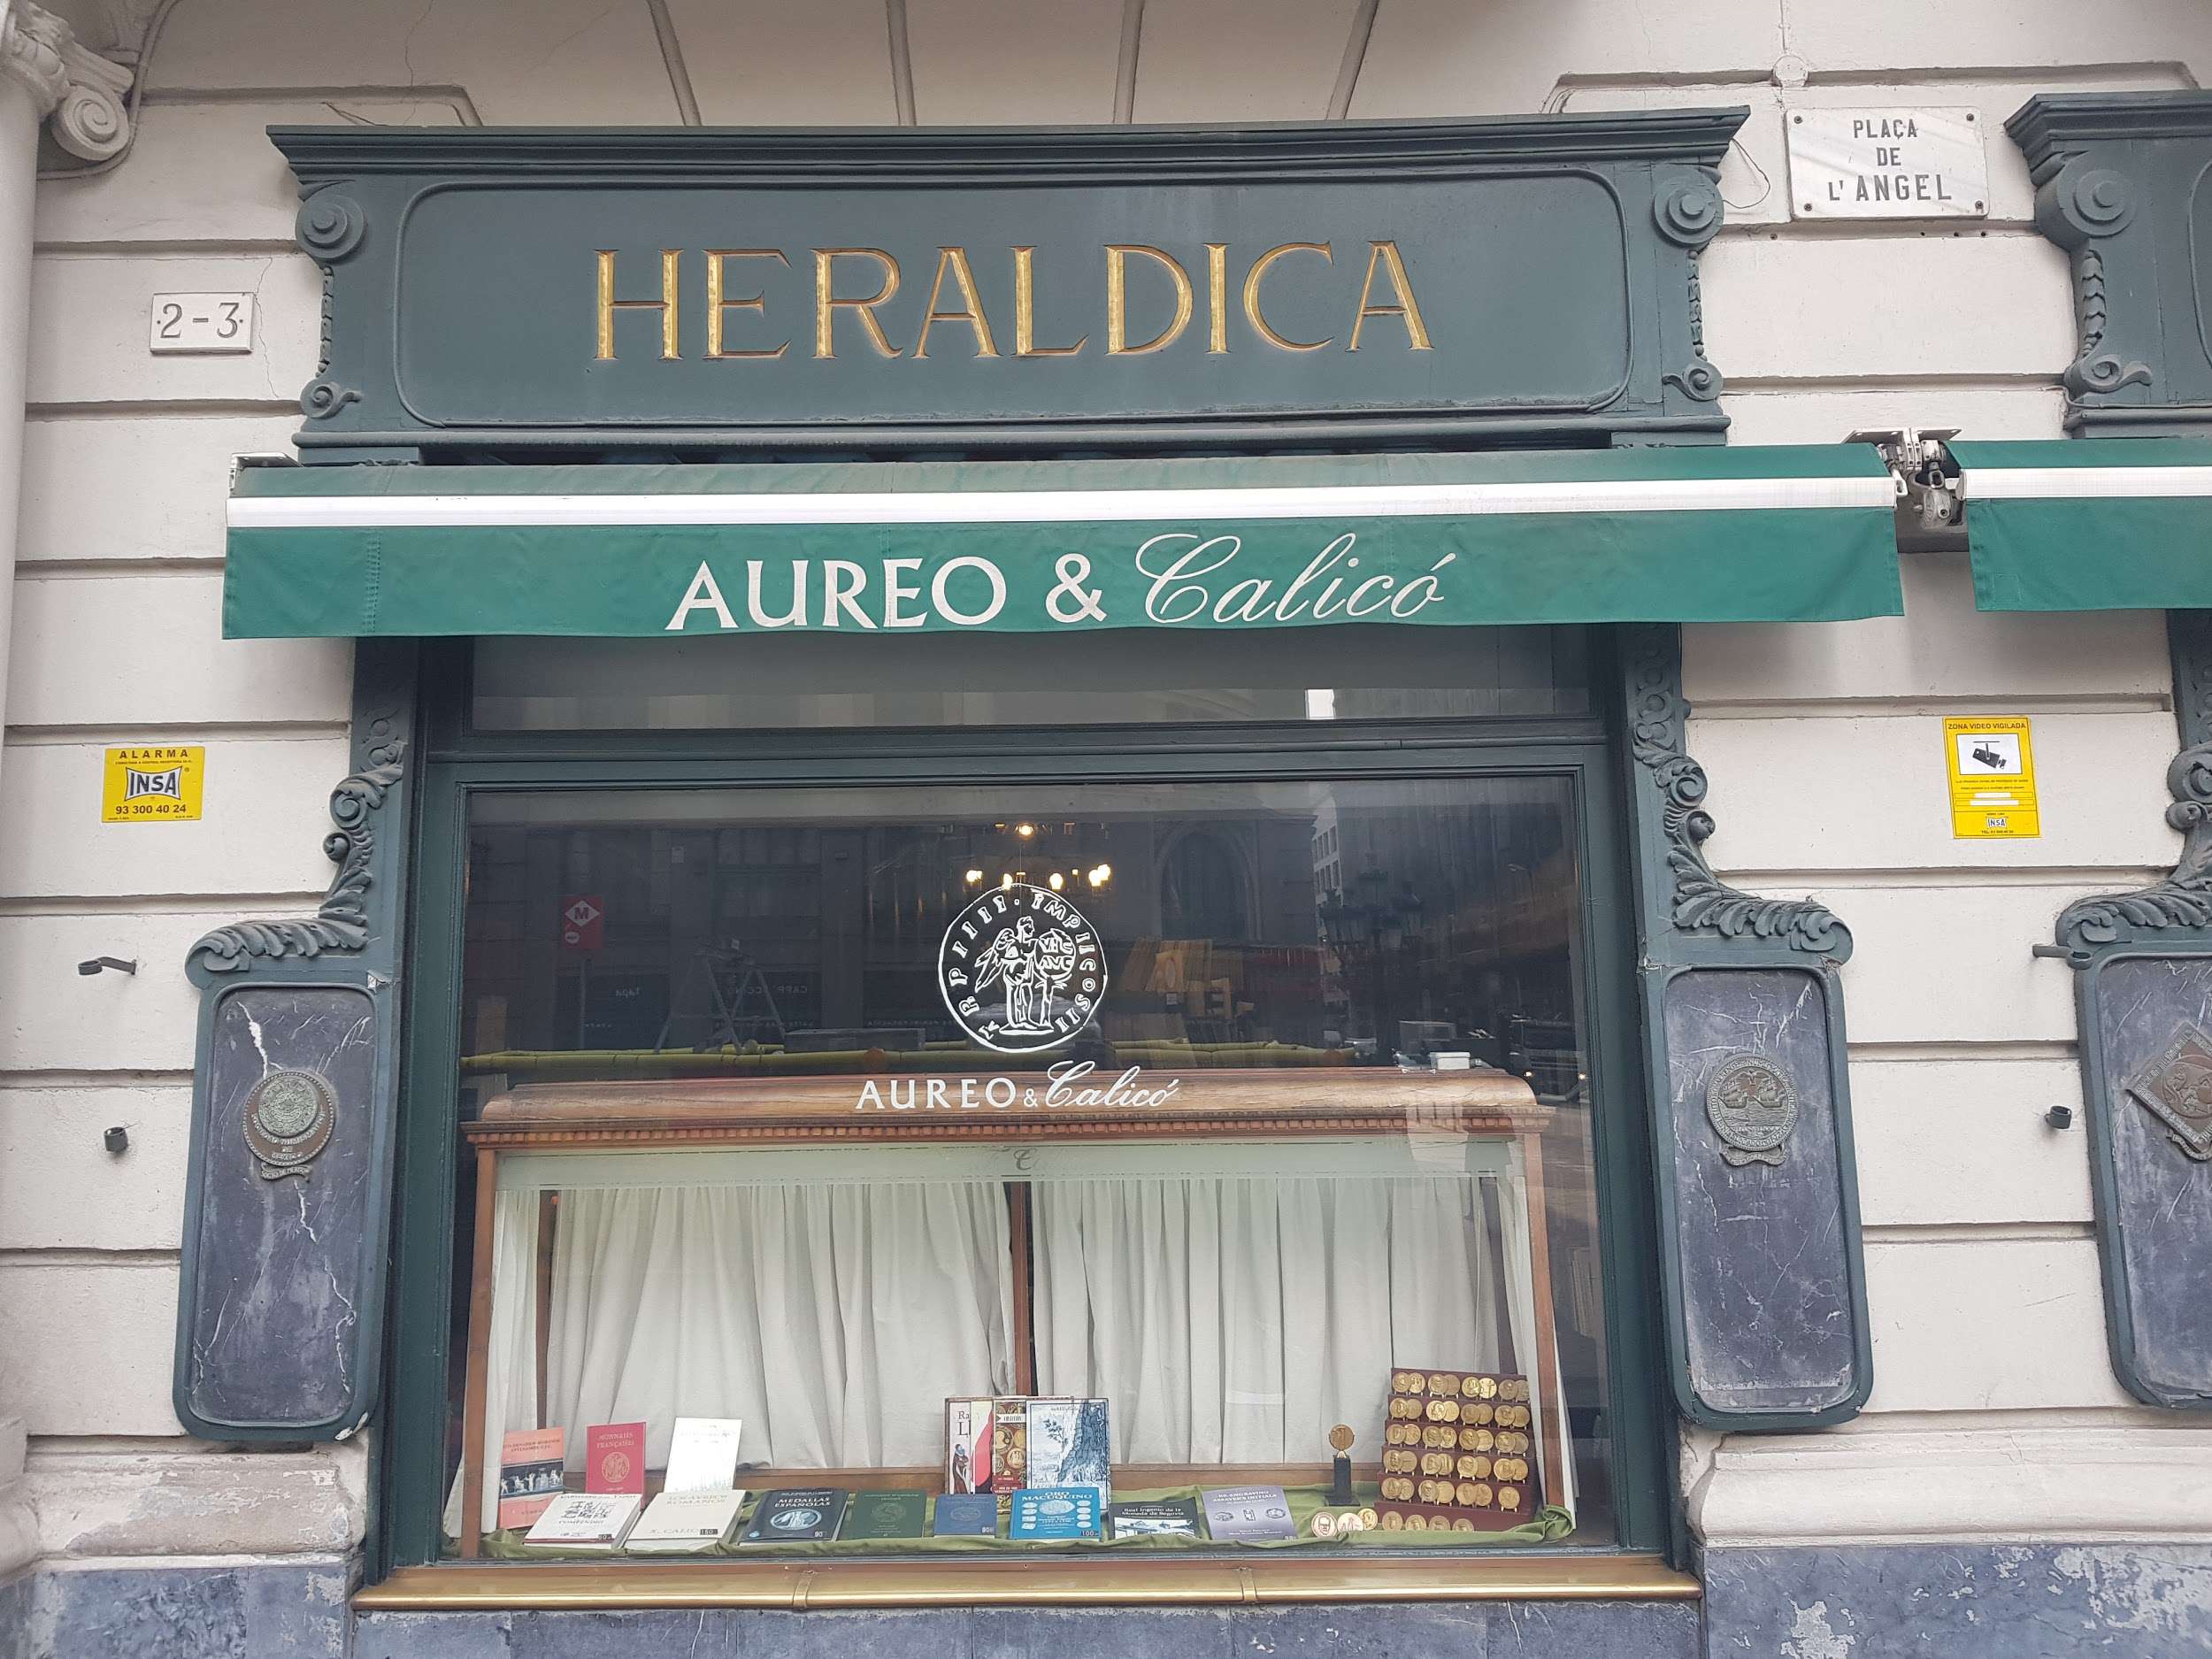

Caliçó: (1989)

Caliço is a family building, but the store has changed owners.
In the summer of 2007 Aureo purchased the firm Caliçó, the oldest numismatic company in Spain with more than a century of activity and worldwide acknowledgement. Their offices moved to the traditional home of Caliçó, in the historic centre of Barcelona.
In this store they sell medals and numismatica. They don’t have so much competition since there aren’t so many stores that sell this type of product.

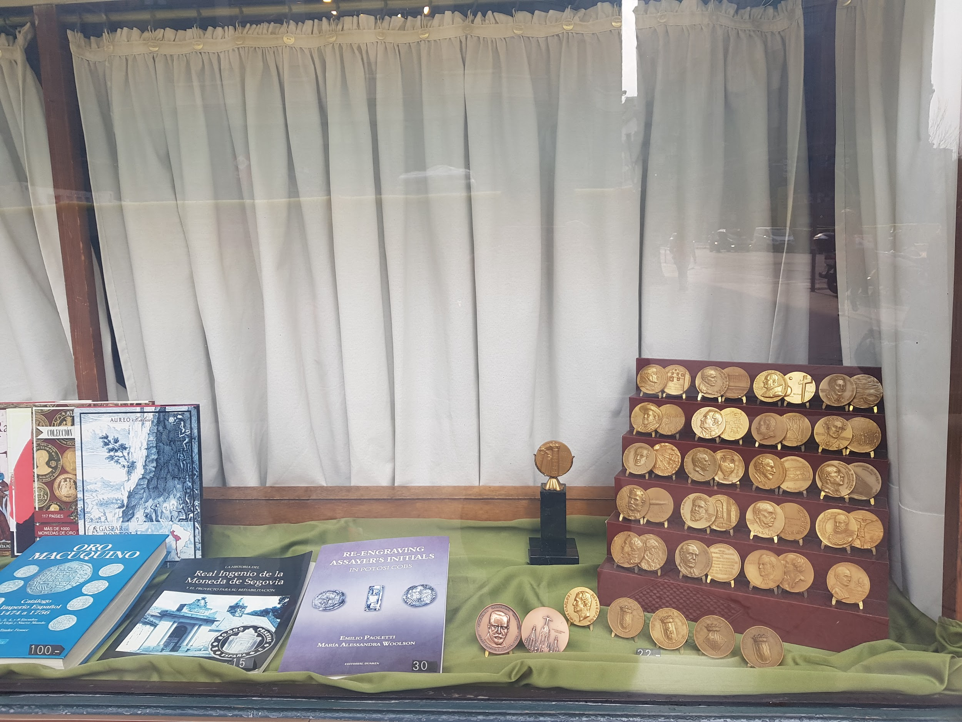

Shop Window

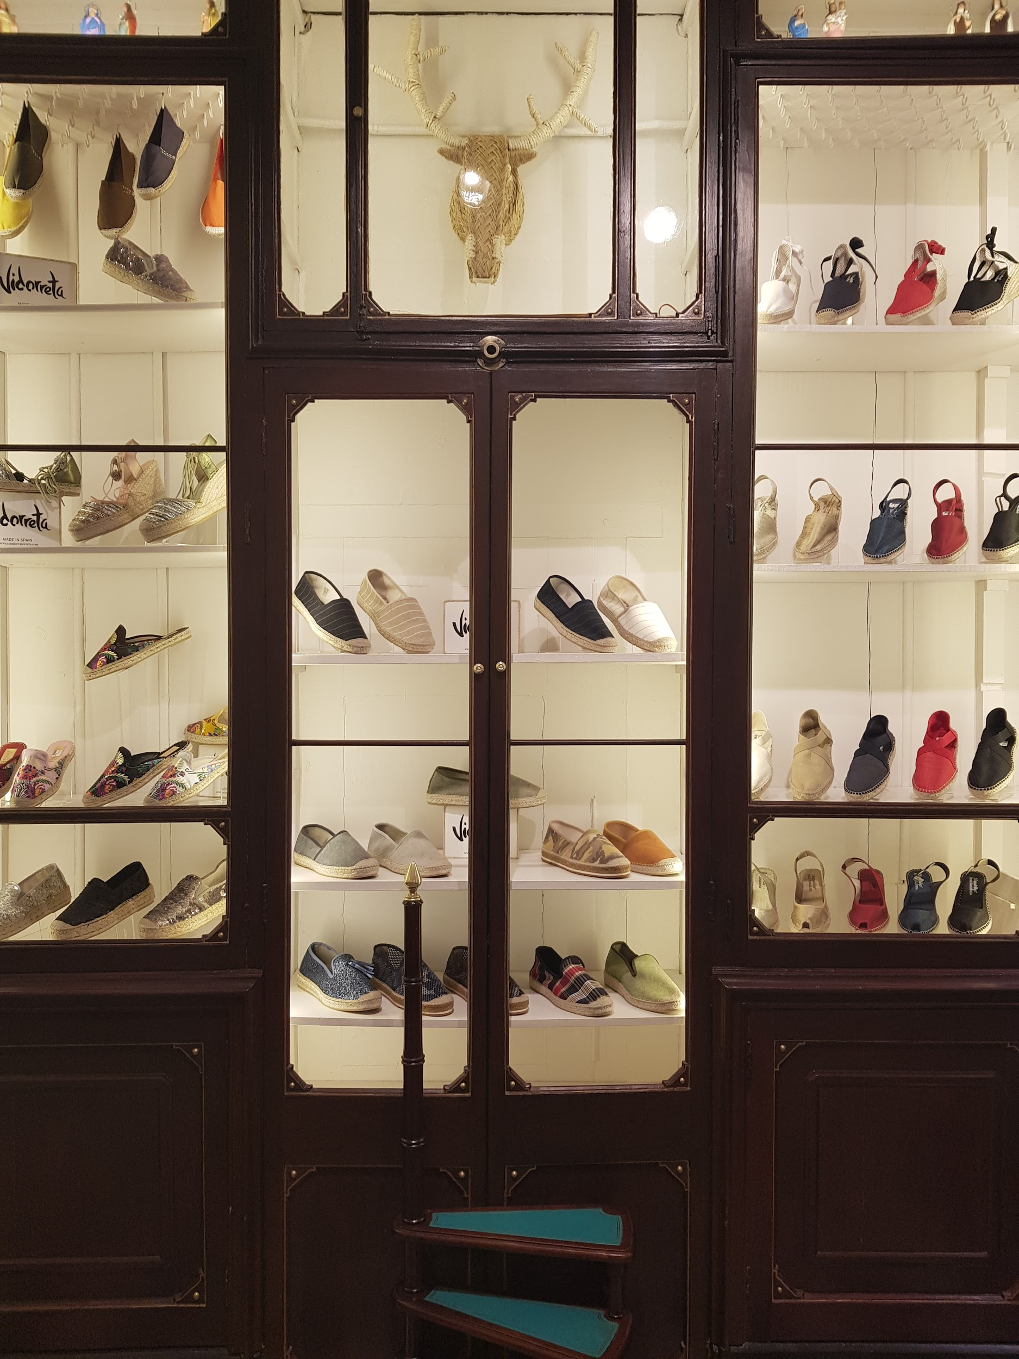

Antiga Cereria Lluis Codina: (1825)

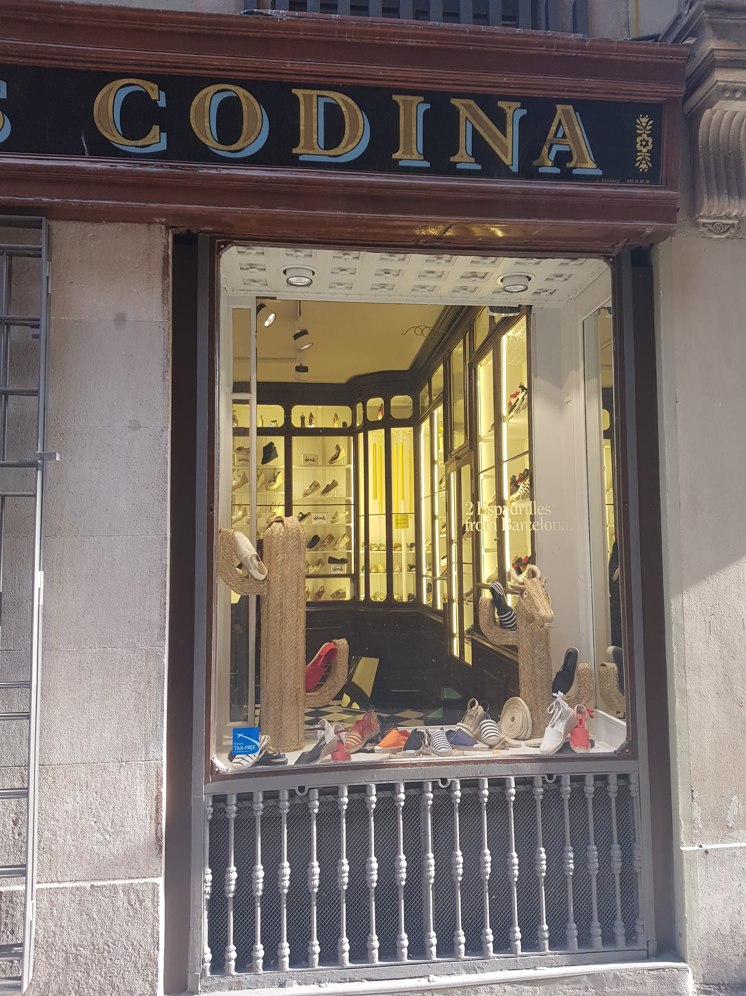
This store has new owners. It used to be one of the greatest specialist stores in Barcelona selling candles and other wax products.The aesthetic is very different from the usual and everything is handmade. Nowadays the business is different, they make and sell handmade shoes but they keep a display with the old products they used to sell
Their clients are 80% tourists and the rest are of the inhabitants of Barcelona.
They say they are not influenced by the competition because of the location factor.

Shop Window

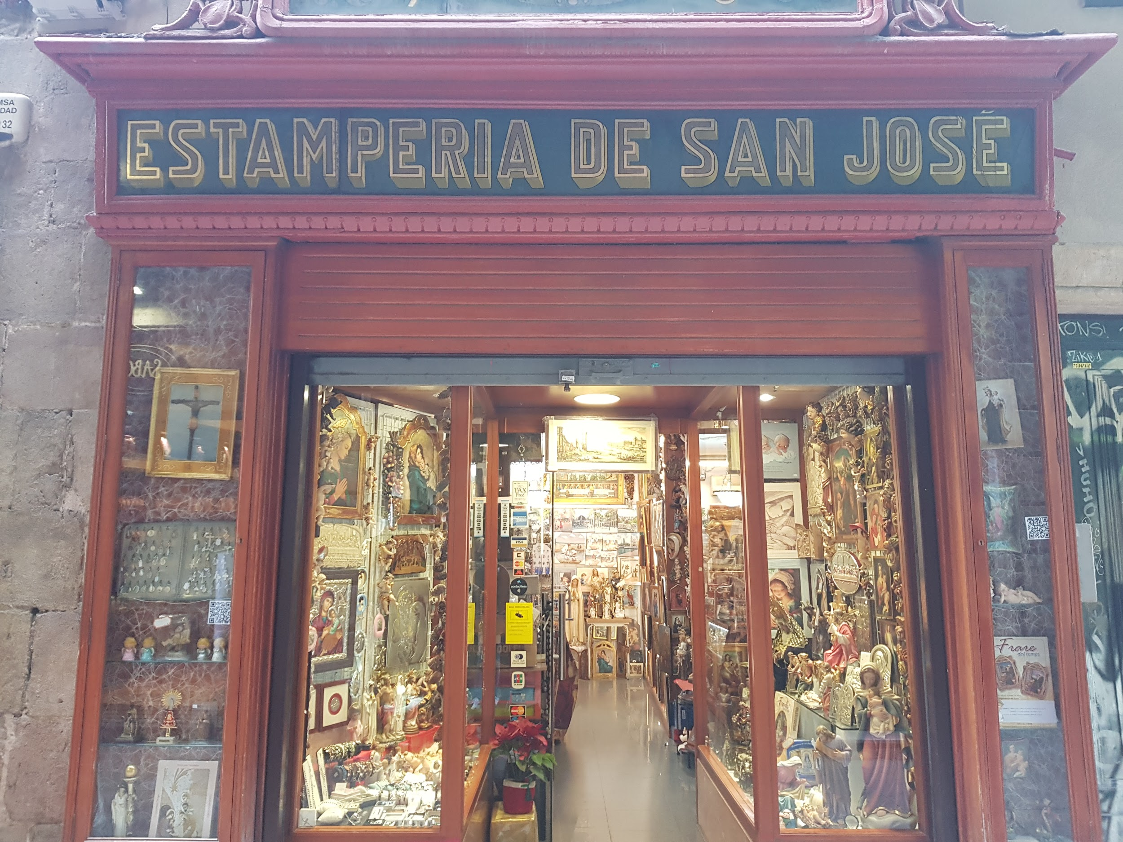

Estamperia San José: 1919

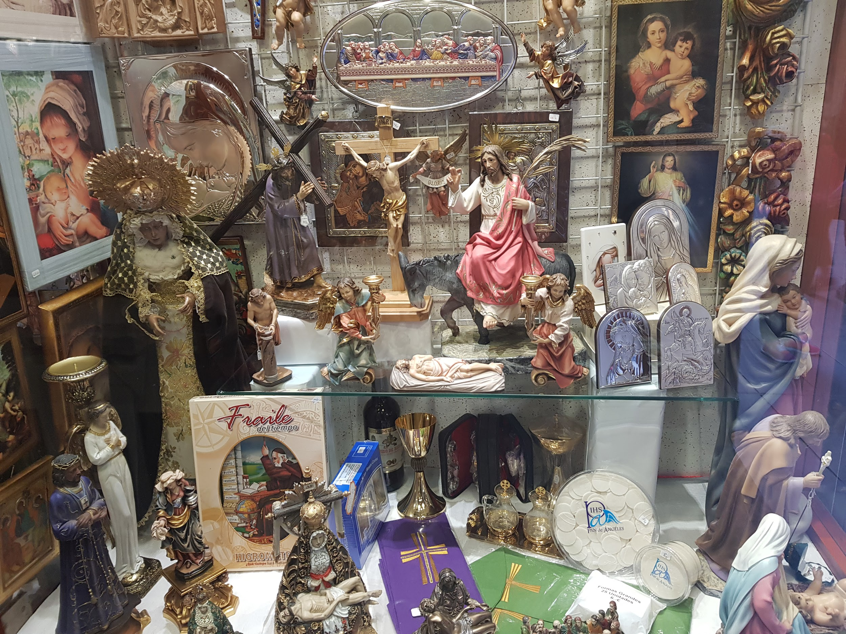
This is the 3rd generation.
The products of this store are priests' clothes (religious articles)
This store got all types of customers (youth, adults, tourists, etc ...)
It doesn’t worry about the competition since these are specific products that people would have to know very well in order to buy these products.

Shop Window

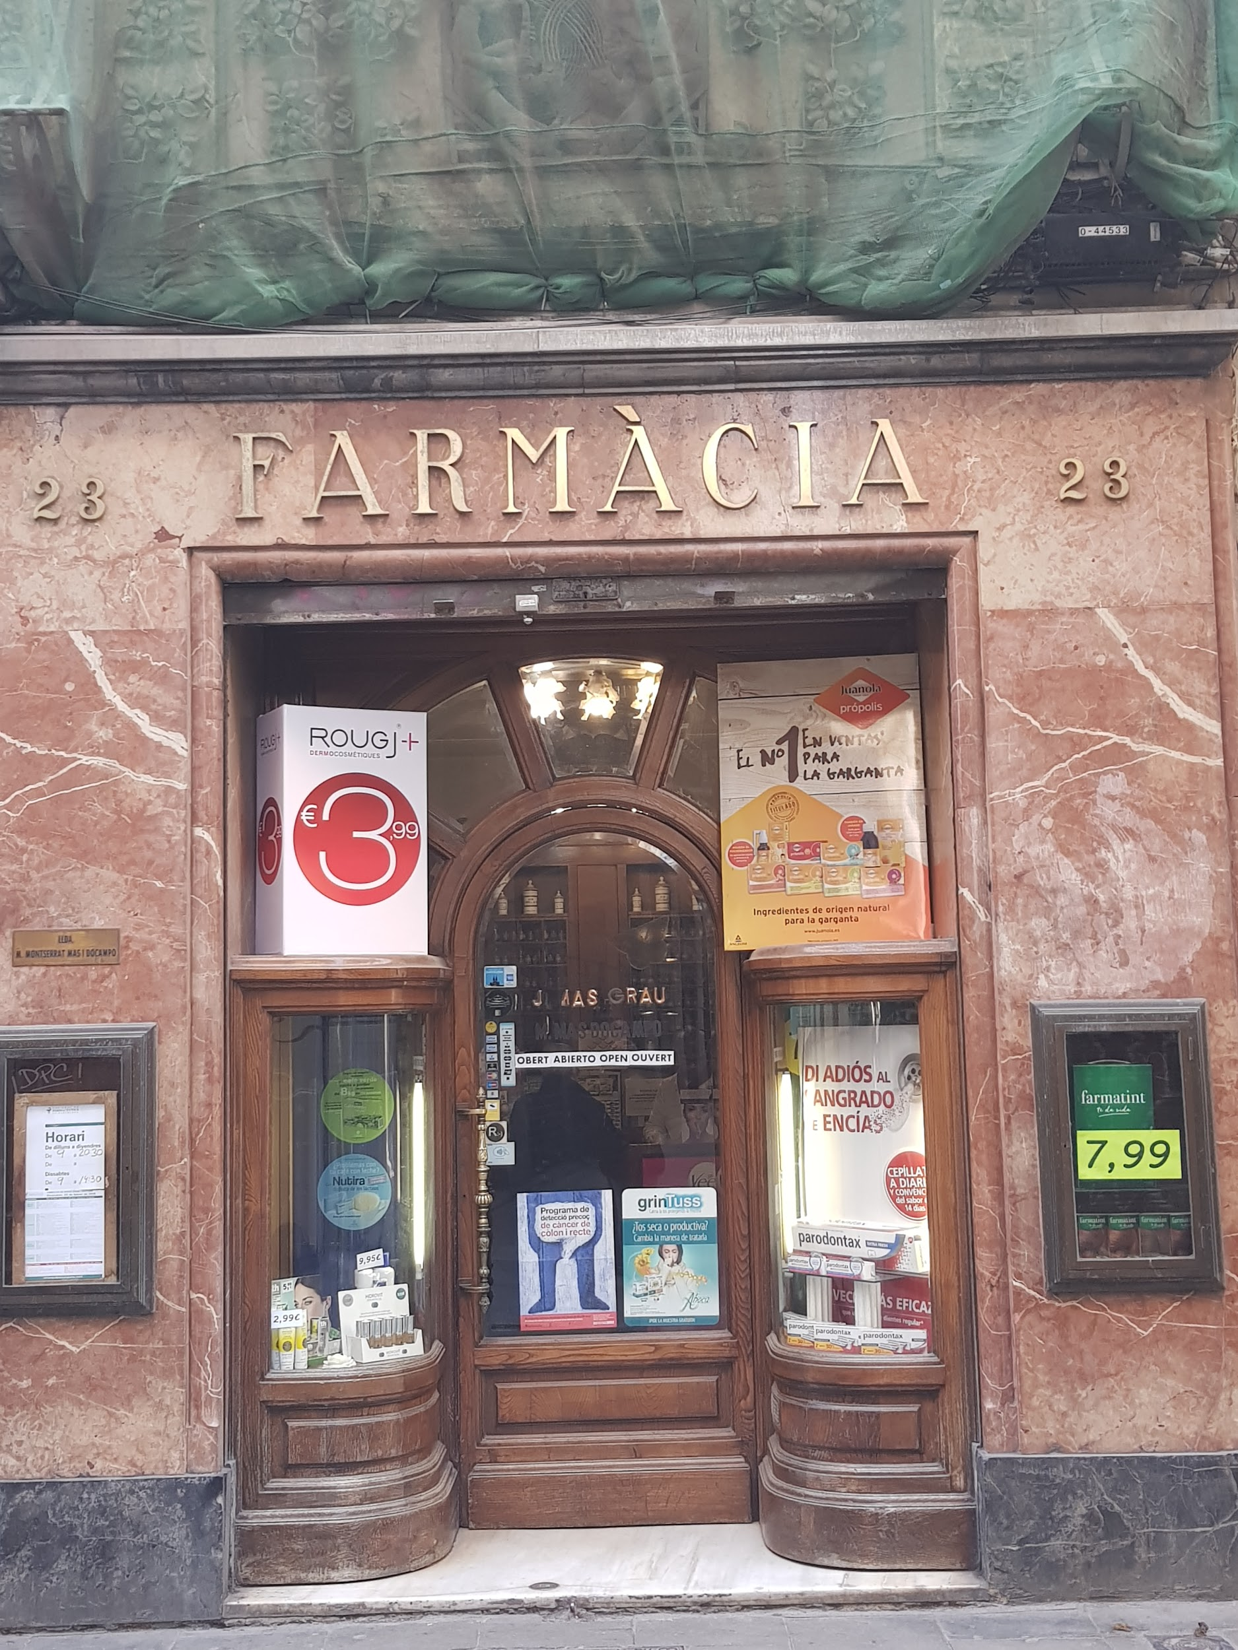
Mas do campo: 1880

This pharmacy has been in the family for 71 years. What makes it different from this is that it retains the essence of classic pharmacy.
The customers of this store are the people of the neighborhood and people who pass by on the street.
What worries him is that he has lost many sales in difference to previous years.
An anecdote of this pharmacy is that some elderly people asked for tincture of llodo.

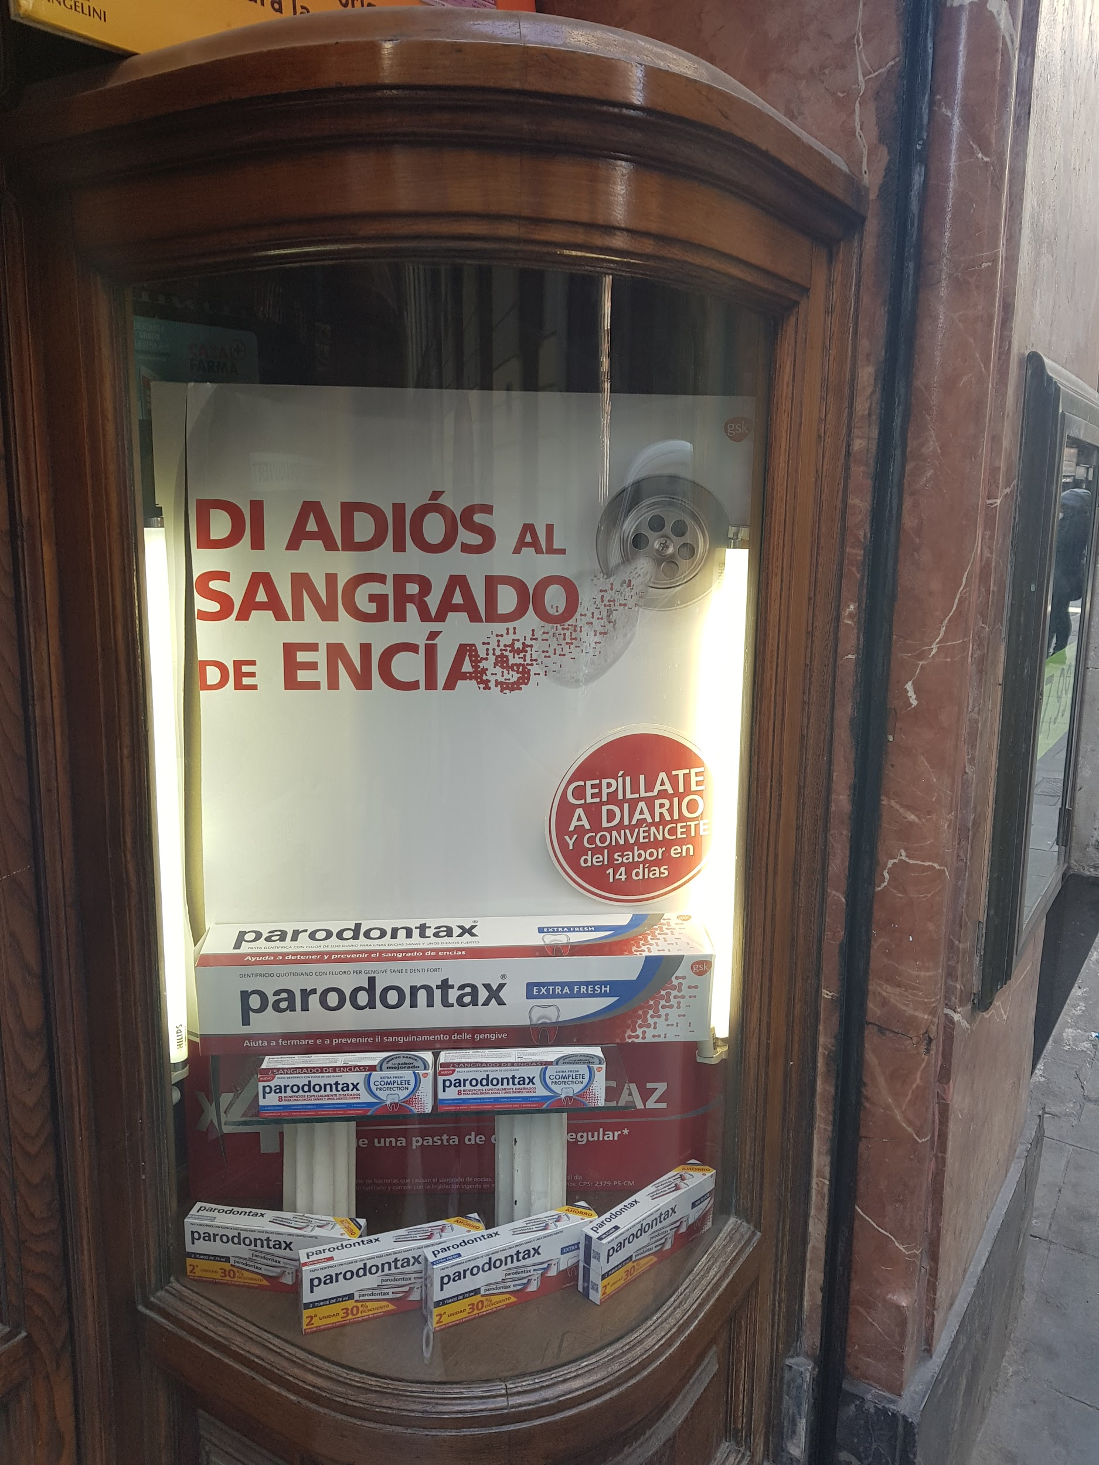

Shop Window

