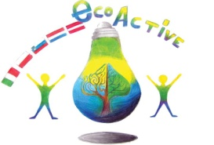 LESSON PLAN
SCHOOL | 2 Circolo Didattico Cavour Marsala- Sicilia- Italia
THEMATIC AREA | RESOURCES: PAPER
TEACHER | Matilde Fazio - Benvenuta Centonze- Cristina Mistretta
SUBJECT | Science: paper history and recycling
AGE GROUP  (approximately) | 10 - 11 years
PLACE | classroom
LESSON OBJECTIVES | Know what recycling means  Know how paper is produced
LESSONS YOU CAN USE | - English  - Science  - Nature awareness  - Art
CLASS ORGANISATION | - Pupils work individually  and in groups
MATERIALS | Reading, internet, paper, colours
ICT TOOLS | Computer, tablet, hands
PROCEDURE | Research/discover how paper is made  Bring different types of paper and experiment different features of paper (resistant, wrapping paper; fragile, printing; filtering, tea bag paper;  oiled or waxed, special for food; soft, tissues of paper; absorbent, ecc. )  Organize itself the recycle of paper, plastic, glass, organic;  Create special things with paper and recycled paper;  Make waste paper objects for a paper market;
EVALUATION | Create posters and power points
ATTACHEMENTS | Power points

