ITALY

- We spoke more about energy
- we worked a lot about wind energy that in our country is a great source;
- we have been working about food and healthy food and what to eat during the breaks as snakes.
- All the school is working in collecting plastic caps
- we are still working to make aware children and families to save water, energy, to recycle paper and we continue to separate waste
- Inform parents of form 8 about the trip to Latvia. Children wrote a letter why they should go to Latvia. We picked 4 children who went to Latvia.

POLAND
- In September Eco-classes (4c, 5c and 4d) went for a trip to Botanical Garden in Lublin as an award for collecting used batteries.
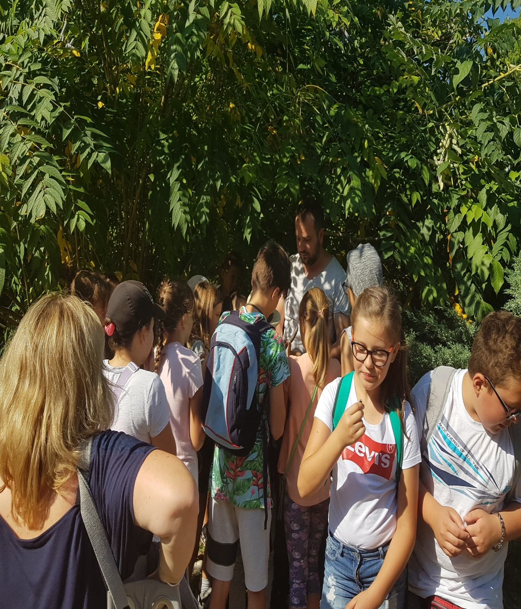
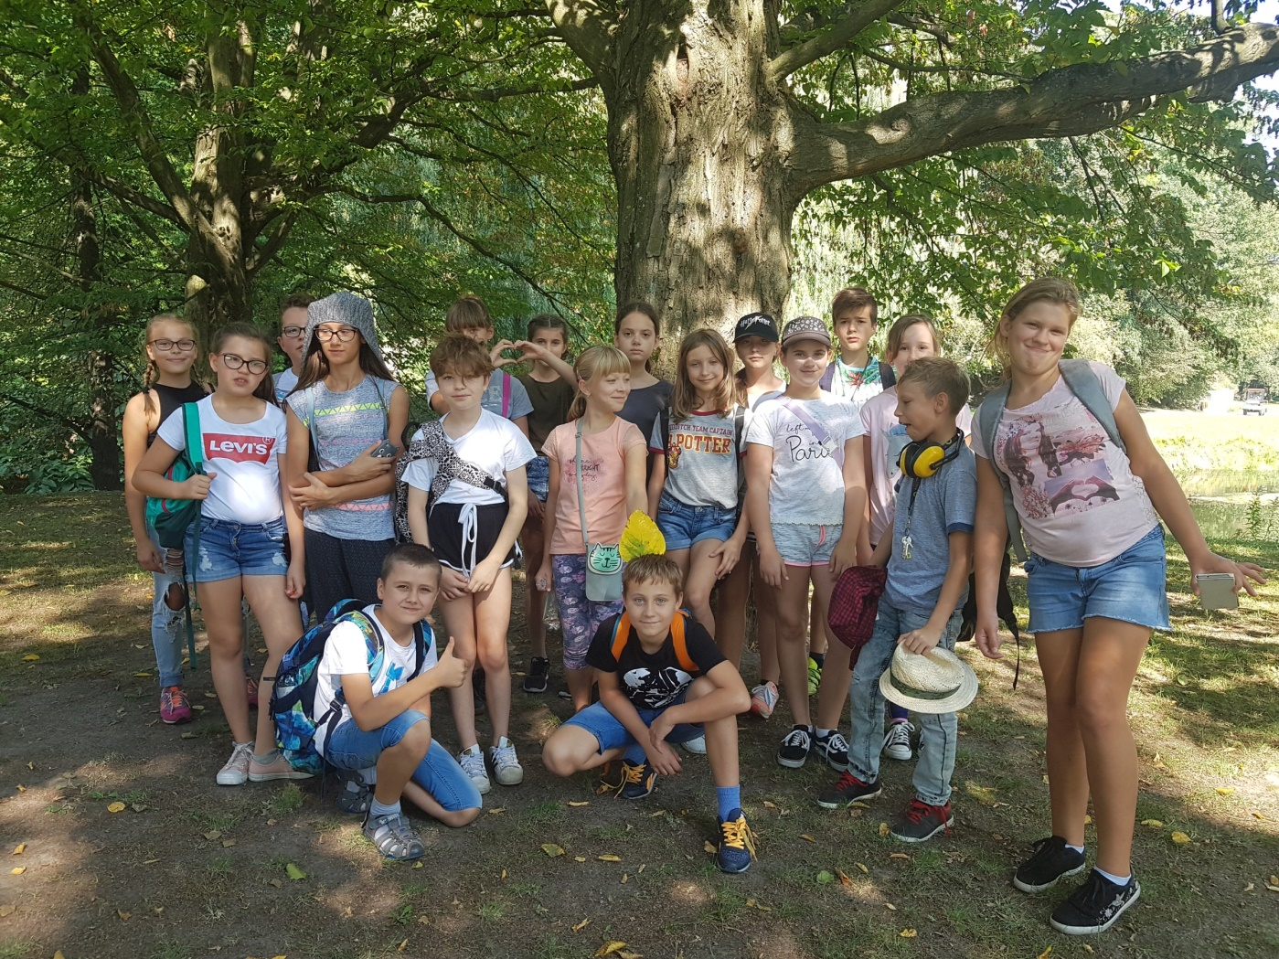
- On Wednesday 31st October 2018 we have handed in the awards for school contests related to
Erasmus + project „Eco-active”
Multimedia presentations (Year 4-8) the winners:
Oliwia Bielec (I place)
Tymoteusz Grobel (I place)
Julia Jędrzejewska (I place)
Damian Bronisz i Hubert Sawa (II place)
Jan Jabłoński (III place)

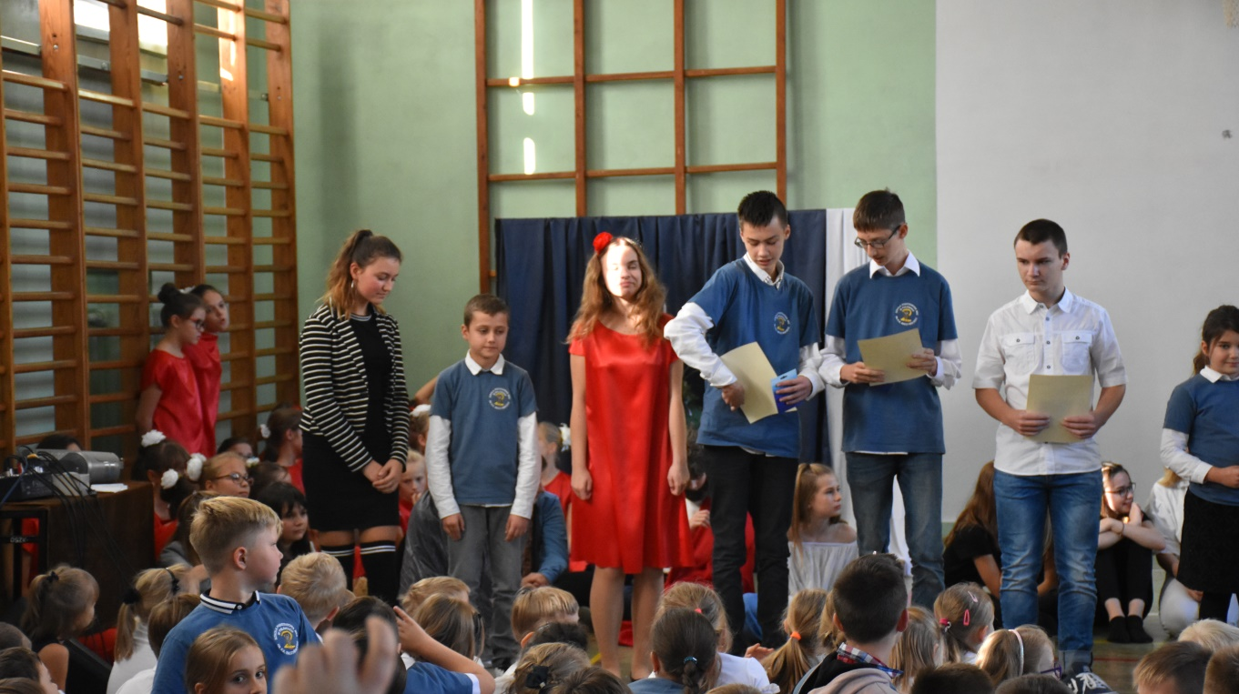

Distinction awards:
· Julia Śmich
· Antonina Nowosadzka
· Daria Lew
Board games (Year 2-8) the winners:
1. Oliwia Łaba (I place)
2. Małgorzata Maj i Natalia Maj (II place)
3. Natasza Jóźwicka (III place)

Computer game (Year 4-8) the winners:
Emil Wasiak (I place)
Jan Kowalik (II place)
Krystian Lemieszek (III place)

- Our school is collecting the PET bottle caps
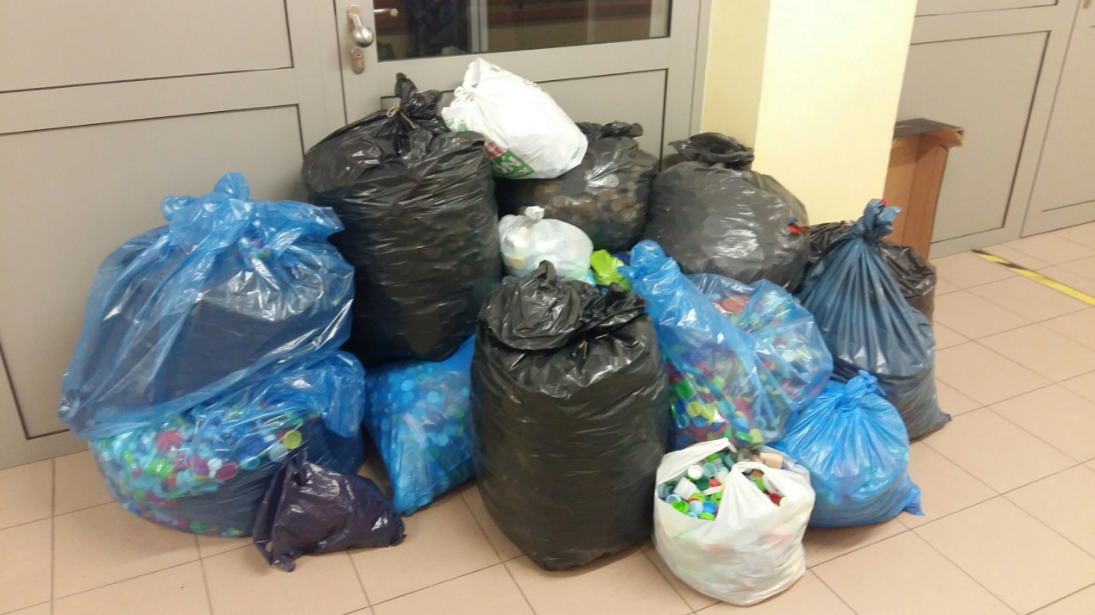

- We have chosen 5 students to go to Latvia
- The School European Club invited all students to join a competition “A doll in traditional costume of our partner countries”. The results will be announced in December

We have made 2 videoconferences. In October Year 5a took place in a meeting with Latvia and in November Year 5b met with Italian children.
