Project funded by the European Union

Ecopedia
“ENERGY”
(a teacher’s guide)

Lesson plans from Ecology
for Primary Schools
2016 / 2019

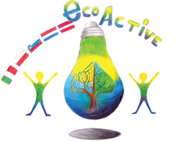

Authors of the manual

- Halina Daniel
- Magdalena Gawronska
- Teresa Bertolini
- Maija Klasupova
- Sanja Pavlinić Vidic
- Maaike van Sambeek

Design: Tomaž Bahč

Table of content.

Autors 2

Project partner schools 3

Introduction 4

Lessons 6-49

https://www.deweijerwereld.nl
DE WEIJERWERELD, Boxmeer, the Netherlands

www.dd2circolocavour.gov.it
2 Circolo Didattico Cavour Marsala, Marsala, Italy
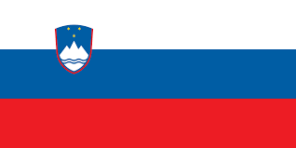

www.ostpavcka.si
Osnovna šola Toneta Pavčka, Mirna Peč, Slovenia

www.tervetesnovads.lv/annas-brigaderes-pamatskola/
Annas Brigaderes pamatskola, Zelemeni, Latvia

www.sp2.pulawy.pl
Szkola Podstawowa Nr 2 im. K.K.Baczynskiego w Pulawach, Puławy, Poland

June, 2019

INTRODUCTION

This publication contains original lesson plans on environmental issues created by teachers from the five European schools participating in the Eco-Active project. They are based on the educational systems of five countries. All lesson plans refer to ecological issues, and their subject matter mainly relates to four thematic areas which our project dealt with: Resources, Water, Energy and Health.
Ecopedia includes lesson plans for younger and older groups of pupils. Some of them were used on international lessons, during visits to partner schools, with the participation of students from the host school. The remaining lesson plans were used in partner schools during the three years of the project on tutoring lessons, other school subjects and extra-curriculum school activities. All lesson plans are in English.
This publication is a form of a guide for teachers who would like to use ready-made and interesting lesson plans to introduce their students to issues related to ecology. Each lesson plan in this document has been developed by the teachers of the school from the country whose flag it bears. Each lesson plan contains information about the age group of students and the name of the teacher (author) who created it. Lesson plans are accompanied by attachments (worksheets, presentations, etc. ). Lesson plans are arranged according to the thematic areas of our project.

Project Coordinator

ENERGY
_____________________________________
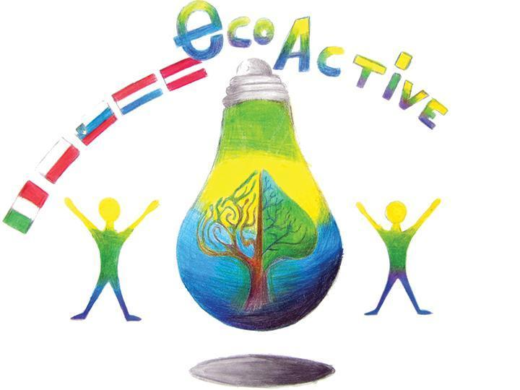 LESSON PLAN
SCHOOL | Szkoła Podstawowa nr 2 im. K.K.Baczyńskiego w Puławach
THEMATIC AREA | ENERGY
TEACHER | Katarzyna Jurak
SUBJECT | Power engineering in Poland.
AGE GROUP  (approximately) | 13-15
TIME REQUIRED | 45 minutes
PLACE | CLASSROOM
LESSON OBJECTIVES | - The student knows renewable and non-renewable energy sources and knows what types of renewable energy can be used in Poland.  • lists energy sources  • characterizes the structure of electricity production in Poland  by type of power plant and sources compared to selected European countries  • lists types of power plants  • locates the largest power plants in Poland on the map  • discusses the use of renewable energy sources in Poland
LESSONS YOU CAN USE | - Biology  - Science  - Nature knowledge
CLASS ORGANISATION | - Pupils work individually  - Pupils work in pairs  Pupils work in groups
MATERIALS | Handbook, exercise book, map, film.
ICT TOOLS | Interactive board
PROCEDURE | Introduction:  1. Organizational activities.  2. Objective of the lesson.  3. Writing the keyword "Sources of energy" on the board. Students give examples of energy sources. Question for students:  Can all types of renewable energy sources be used in Poland?  Implementation:  1. Brainstorming - students give associations with the word "alternative".  2. Explanation, summary by the teacher of the term "alternative energy"  3. Questions to students: "why are people looking for alternative energy sources?" And "what distinguishes alternative energy from traditional energy sources?"  4. Graph analysis: Structure of electricity production in Poland and Europe and maps. Power plants in Poland.  Questions for students: which energy sources do we use the most in Poland? Are the power plants evenly distributed? What factor caused such a diverse distribution of power plants in Poland? - can be compared with the map of the distribution of energy resources  5. The class is divided into pairs (two questions per pair) - Individual teams are to answer questions about a given alternative energy source (attachments). To do this, they choose the appropriate fragments from the text. (pp. 138-141) nuclear power - receives a fragment from another book.  6. The representative of each pair shares with the class the answer to the questions about the energy source assigned to the pair.  7. Can Poland develop all types of renewable energy? → The film lasts about 3 minutes. (Conditions for energy production from various sources in the Pomeranian Voivodeship(POLAND).
EVALUATION | Summary:  1. Infographics - assess whether the natural conditions occurring in the province in which you live are conducive to the development of wind and solar energy.  2. Assessment of students' work  3. Evaluation  Questions true / false:  The largest power plant in Poland is in Bełchatów  Energy in Poland comes mainly from RES(Renewable energy sources)  A nuclear power plant has been located in Poland  The most favorable conditions for the development of wind energy are found in Pomerania Voivodship  Renewable energy sources include wind, water, sun and fossil fuels
ATTACHEMENTS | Group work:  Annex 1.  GROUP I - wind energy  - what is the main barrier to using wind in energy production?  - what is the main condition for the wind farm development?  - where are the most wind farms?  - indicate the location of this type of power plant  Annex 2.  GROUP II - geothermal energy (104 - 105) + manual  - what is geothermal energy  - what is it used for in Poland?  - where do these types of plants are?  Annex 3.  GROUP III - solar energy (104- 105) + manual  - what types of power plants are connected with solar energy?  - what is the main difference between these types of power plant?  - are there other options for using solar energy?  - where are solar power plants mainly located?  - what type of energy is most often obtained in solar power plants?  - give an example location of such a power plant  Annex 4.  GROUP IV - biomass energy  - what is biomass?  - what sources can biomass come from, what can we use in such a plant?  - for the production of which energy is biomass usually used?  - give an example of a location  Annex 5.  - GROUP V - Biogas energy  - What is the most popular biogas called?  - Where is it created? What products can be used to obtain biogas?  - Give an example of the location  GROUP VI - energy of flowing waters  - How do we call plants of this type?  - Where are the largest hydropower plants located in Poland?  - Give an example of the location  Annex 6.  GROUP VII - tidal energy  - what elements of the natural environment are necessary for the tides to be used for energy production?  - where are power plants based on tidal energy?  - give an example of the location  Group VIII - nuclear energy  - what factor must be met for a nuclear power plant to be created?  - have scientists ever worked on the construction of this type of power plant in Poland?  - Give an example of the location  Group IX - thermal energy  - what fuels do we use in thermal power plants?  - what factor determines the location of the plant in a warmer area?  - where is the largest power plant of this type in Poland?

LESSON PLAN
SCHOOL | SZKOŁA PODSTAWOWA NR2 IM. K.K. BACZYŃSKIEGO W PUŁAWACH
THEMATIC AREA | ENERGY
TEACHER | JOLANTA MURAT
SUBJECT | THE ENERGY HIDDEN IN THE NATURE
AGE GROUP  (approximately) | 7-8 YEARS OLD
TIME REQUIRED | 50 MINUTES
PLACE | CLASSROOM
LESSON OBJECTIVES | Main aim: Introducting students with various energy sources and the impact of their acquisition and use on the environment.  Specific aims:  Students:  - their own words discuss the effects of electricity production from carbon,  - understand the need to search and discover new, pro-ecological energy sources,  - list exemplary renewable and non-renewable energy sources, understand the difference between them,  - list ways to save energy in the household,  - add and subtract in the range of 12,  - rewrite a sentence, draw up sentences with a words.
LESSONS YOU CAN USE | - Ecology  - Nature knowledge  - Mathematical knowledge  - Polish language knowledge
CLASS ORGANISATION | - Individual work  - Collective work  - Group work
MATERIALS | worksheets, lump of coal, paper windmill
ICTTOOLS | computer, interactive board, ActiveInspire program, film"How does a wind turbine work? "- You tube
PROCEDURE | - WELCOME  - REMINDING OF THE CLASSROOM RULES  - PRESENTING THE TOPIC OF THE LESSON:  - Picture puzzle- Attachment 1  The interactive board presents illustrations of objects, eg: electric kettle, electric blower, computer, vacuum cleaner, iron and scissors.  - Which item does not match the other?  (Scissors because they are not powered by electricity.Other devices operate thanks to the power supply.)  - GETTING TO KNOW LESSON OBJECTIVES:  - During today's class you will learn how we get electricity.  - You will know the sources and types of energy.  - You will remind what you can do every day to save electricity.  • Success standard:  After classes, you will be able to name types of energy, at least three sources of energy and ways to save energy in everyday life.  During today's class I’m going to draw attention to:  - your activeness,  - statements – using full sentences,  - group work,  -correctness of doing tasks,  - behavior.  - CONVERSATION:  - What do you need electricity in everyday life for?  - Where do we get electricity from?  - Where is the electricity produced?  Most of the electricity in our homes comes from coal-fired power plants.The energy is generated in factories, called power plants, and it is sent by a network of wires to other places, eg houses, schools, shops, factories.  - ILLUSTRATION OF THE POWER PLANT WITH THE WIRE NETWORK / interactive board- Attachment 1  - ILLUSTRATION OF POWER PLANT AND COAL / interactive board- Attachment 1  For the production of energy in power plants, there are consumed huge amounts of coal, which is burnt in blast furnaces.The lump of coal presentation.  - How do you think, is the production of energy from coal safe - clean and healthy?  - Consider, if the fumes and dust that arise during burning coal have an impact on human, animal and plant health?  - Have you ever heard about smog? What is this?  The burning of coal causes that a layer of gases rises above the Earth, which change the climate all over the world (the temperature rises, the weather is unpredictable, there are more floods, droughts, tornadoes, in Poland there are more whirlwinds, it is less snow in winter and the summers can be very hot and dry).  Energy production from coal is easy, but it is associated with air pollution. In addition, the extraction of coal from the earth causes that the landscape is destroyed, the rivers dry up, heaps of mine and coal-fired power plant waste are created.  Coal was formed from plant remains millions of years ago.  - How do you think- can coal deposits ever run out?Is there such a fear that it may goes out?  - Have you ever heard about closed mines?  When we burn coal, it disappears forever.In some time, for example for future generations, it may miss.In addition, coal is used in many industries, for example for the production of tires and medicines.So it is a very valuable resource.  - Where is the coal extracted from and how is it done?  Because the coal is extracted (excavated) from the ground it is called fossil fuel.Currently, man also uses such fossil fuels as oil and natural gas for the production of energy.They were created millions of years ago and are lying underground.Because they are extracted and burned by people all the time, they will soon be run out and therefore they are called non-renewable energy sources.  ILLUSTRATION OF CRUDE OIL, NATURAL GAS, COAL  - The inscription THE NON-RENEWABLE ENERGY SOURCES / interactive board- Attachment 1  - Due to the depletion of fossil fuels, people are forced to look for other sources, other ways of obtaining energy,that will not be run out so quickly.  - You will learn about the name of that sources by solving the activities, recorded on the worksheet no 1.  - INDIVIDUAL WORK AT THE DESKS. WORKSHEETS.- Attachment 2  - Calculate.Sort results from the smallest to the largest number and enter it in the boxes.  12 – 2= ….. 10 + 2 =……..  10 – 3 = …… 5 + 3 = …….  - Check in the board  - Cards with results are placed under the board.The teacher asks selected pupils to come up and arrange themselves with selected cards, ordering the numbers from the smallest to the largest.  - Numbers: 7, 8, 10, 12.  - After proper setting (each student has a card with a number in front of him) the teacher asks them to turn the cards over. On the back of the cards there are syllables that form the word  RENEWABLE  - Common reading of the password.  - The teacher informs that the students just got to know the name of energy sources that will never run out. This is renewable energy sources.  - You will learn,what are renewable energy sources, by doing the next exercise.  - GROUP WORK  (Reminding of the group work rules: consistent work, selecting a group leader, sharing tasks, correct task execution.)  - The teacher asks students to take out the cards from the envelopes and solve the rebuses.Then they will receive the name of the renewable energy source.The name should be written under the rebus.  - Each group receives a rebus, a solution is the name of the renewable energy source. The solutions: wind, sun, water.  - After solving the rebuses students put together puzzles (they take them out of the envelopes) presenting: a windmill, solar panels, a water dam - a hydroelectric power plant.  Checking on board.  - The teacher discusses the sources of energy (presentation on the interactive board). She draws attention to the fact that such energy will never be run out and is environmentally friendly.- Attachment 1  - film "How does a wind turbine work?" - You tube (1.30 minutes)  - SHORT BREAK/PHYSICAL ACTIVITY- movement fun with the song ,, One, two, three four .... "  - EVALUATION OF PREVIOUS WORK  - Worksheet number 2-Attachment 3  Illustrations presenting renewable and non-renewable energy sources (coal, oil, natural gas, water, sun, wind)  - Task no 1  - Circle by a green loop renewable energy sources.  - What are the other energy sources called?  - Task no 2  - Connect the energy source with the name of the received energy.  sun solar energy  water wind energy  wind water energy  - CHECKING IN THE BOARD  - Worksheet number 3- Attachment 4  Tasks:  Group I: Rewrite the sentence  Group II: Draw up the phrase from a words.  - You can colour the drawing.  - KEY QUESTION  - What would happen if one day there was no electricity?How would your life be changed then?  - DISCUSSION-SAVING ELECTRICITY  - You were supposed to talk at home with your parents about the amount of electricity charges.What did you find out?Are the fees for electricity small or high in your homes?  - So is it worth to save the electricity? Why?  - The Erasmus + program is realized in our school.As part of this program, we learn how to care for the environment andhow to save energy, the production of which is expensive.How can you save electricity? (Paying attention to stickers in toilets and in contacts - light switches.)  - Remind, what can you do in your everyday life to save energy?  Students give examples.
EVALUATION | - Worksheets, as during lesson- current evaluation  - Worksheet number 2- Attachment 3  Illustrations presenting renewable and non-renewable energy sources (coal, oil, natural gas, water, sun, wind)  - Task no 1  - Circle by a green loop renewable energy sources.  - What are the other energy sources called?  - Task no 2  - Connect the energy source with the name of the received energy.  sun solar energy  water wind energy  wind water energy  - CHECKING IN THE BOARD  - Worksheet number 3  Tasks:  Group I: Rewrite the sentence  Group II: Draw up the phrase from a words.  - You can colour the drawing.  - Game ,,True - False''  The teacher speaks sentences.Students react appropriately:  - on the true sentence - they raise their hands over their heads and clap,  - false sentence - they leave their hands and stand without move.  Example sentences:  - The sun gives wind energy.  - The sun gives solar energy.  - Coal deposits will never run out.  - Coal is a non-renewable energy source.  - Electricity charges are very low.  - It's worth to save electricity.  - The sun, water and wind are renewable energy sources.  - Renewable energy sources don't pollute the environment.
ATTACHEMENTS | ActiveInspire presentation, worksheets number 1, 2, 3

LESSON PLAN
SCHOOL | Szkoła Podstawowa nr 2 im. K.K.Baczyńskiego w Puławach
THEMATIC AREA | ENERGY
TEACHER | Magdalena Gawrońska
SUBJECT | Eco-Active save Energy.
AGE GROUP  (approximately) | 9-10 year olds (younger groups)
TIME REQUIRED | 45 minutes
PLACE | classroom
LESSON OBJECTIVES | Student:  - forms statements concerning the actions, which can be undertaken in order to save the energy in their place of living;  - enumerates energy saving activities;  - understands the importance of saving energy;  - indicates the possibilities of how we can save the energy;  - cooperates with peers during the activities;  - develops language skills;  - learns vocabulary concerning Energy.
LESSONS YOU CAN USE | - Language (English)  - Ecology  - Biology  - Nature knowledge
CLASS ORGANISATION | - collective work;  - individual work;  - group work.
MATERIALS | -worksheets, materials for group work,
ICT TOOLS | Multimedia devices – interactive board, film,, Saving Energy "- YouTube, interactive exercise ,,Plug n socket”.
PROCEDURE | 1. WELCOME  2. REMINDING OF THE CLASSROOM RULES (PP.5.1, 5.4)  3. GUESSING THE TOPIC OF THE LESSON  Students look at the pictures and try to guess first letters of the words. After that they give the solution  Attachment 1  Key:  Elephant, Night, Eggs, Rain, Grape, Yellow  4. RENEWABLE AND NON-RENEWABLE SOURCES OF ENERGY  ATTACHMENT 2  Students give the names of sources by looking at the pictures and try to remember if they are renewable or non-renewable.  Key:  BIOMASS SOLAR RADIATION  WATER OIL  THE EARTH INTERNAL’S WARMTH 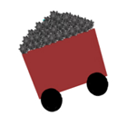 COAL  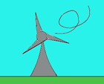 WIND 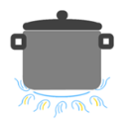 GAS  RENEWABLE: biomass, water, the Earth internal’s warmth, wind, solar radiation  NON-RENEWABLE: oil, coal, gas  5. - What does it mean “Renewable” and “Non-renewable” source?  - What may happen if we don’t save the energy?  6. WATCHING A FILM  https://www.youtube.com/watch?v=1-g73ty9v04&t=44s  Students watch the first part of the film “LET’S SAVE ENERGY”. They draw attention to the actions done by family members (0,37m). After watching this part students try to answer the questions:  “What’s wrong ?”  “What are the mistakes they made?”  “ What may happen to the Earth if we behave like the people in the film?  Students watch the next part of the video.  7. GUESS WHAT IS IT?  Students are divided into groups. Each group is given 1 description of a household device that consumes energy in the house. They have to give the name of it.  ATTACHMENT 3,4  Key:  IRON, MICROWAVE, TV, VACUUM CLEANER, BOILING POT, ENERGY-EFFICIENT BULB  8. CRACK THE CODE  http://kids.saveonenergy.ca/en/games/crack_the_code.html  Students work in groups. Teacher distributes worksheets and “English alphabet template”. Students have to crack the code on worksheets by giving the correct English letter to a corresponding number. The winner is the group which has the solution the fastest.  Key:  EVERY KILOWAT COUNTS  9. INTERACTIVE GAME “ PLUG N SOCKET”  Students try to make pairs from an expression/word and the picture concerning saving energy.  http://www.alliantenergykids.com/FunandGames/OnlineGames/KIDS_GAME_PLUG_N_SOCKET
EVALUATION | Students list the way how can we save energy in places we live. They give names of sources of energy.  10. CROSS OUT THE WORDS  For the end of the lesson groups are given worksheet and the task is to find all the words concerning Energy topic.  https://extension.colostate.edu/docs/pubs/consumer/saving-energy-home.pdf
ATTACHEMENTS | FILM  https://www.youtube.com/watch?v=1-g73ty9v04&t=44s  WORSHEETS BOOK  https://extension.colostate.edu/docs/pubs/consumer/saving-energy-home.pdf  INTERACTIVE GAME  http://www.alliantenergykids.com/FunandGames/OnlineGames/KIDS_GAME_PLUG_N_SOCKET

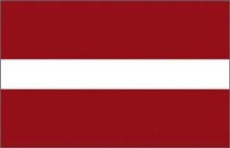
LESSON PLAN
SCHOOL | Annas Brigaderes primary school
THEMATIC AREA | ENERGY
TEACHER | Svetlana Kursina, Sandra Geislere, Maija Klāsupa
SUBJECT | Wind energy
AGE GROUP  (approximately) | 10 -14 grades
TIME REQUIRED | 60 min
PLACE | CLASSROOM
LESSON OBJECTIVES | To use wind power in practical work
LESSONS YOU CAN USE | - Language, for translation in English of course the English lesson  - Nature knowledge  - Handicrafts
CLASS ORGANISATION | - Pupils work individually  - Pupils work in pairs  Pupils work in groups
MATERIALS | required materials:  string or rope  scissors  tape  two sticks 40 cm and 60 cm  little plastic bags  7 needles with big needle eye  stickers to decorate
ICT TOOLS | https://www.youtube.com/watch?v=Ts1XZNG6wpU
PROCEDURE | Together we will remind all kinds of energy :  wind energy  water energy  electric energy  heat energy  chemical energy  solar energy  geothermal energy  kinetic energy  Today we will talk about wind energy and we will make a kite.  1. With the string or rope we tie up two sticks in a cross.  2. With the tape glue two sticks to plastic film, some cm we have to leave from the edge.  3. Fold plastic film to the sticks  4. Cut off the unnecessary part, few cm from the fold place.  5. Fold up and glue with the tape every edge.  6. Glue the kite’s bottom side from both sides.  7. Glue the kite’s upper side from both sides.  8. In the middle of the kite glue the tape crosswise.  9. Cutt off the string or a rope in the lenght of the kite  10. Sew the string to the kites in the middle through the tape.  11. Tie up three knots.  12. The other bottom side sew to the kites top.  13.Place the string in the stright angle to the kite.  14. Make a small loop, it will strengthen string for flying kite  15. Cut off a string or rope into 4 kite lenghs.  16. Make a tale for the kite  17. Make the plastic bags bouquets  18. At least six bouquets.  19. sew the tail to the kites bottom.  20.Put the string or rope to the kite for launch and decorate.
EVALUATION | Selfevaluation
ATTACHMENTS | -

LESSON PLAN
SCHOOL | Annas Brigaderes primary school
THEMATIC AREA | ENERGY
TEACHER | Svetlana Kursina
SUBJECT | Wind energy
AGE GROUP  (approximately) | 9-11
TIME REQUIRED | 40 min
PLACE | CLASSROOM
LESSON OBJECTIVES | 1. Create an understanding of wind and wind energy.  2. Find out the possibilities of using wind energy in the past and nowadays.  3. Teach students to measure wind speed with self-made anemometer.
LESSONS YOU CAN USE | - Language, for translation in English, of course the English lesson  - Science  - Nature knowledge  Integrative learning connecting skills and knowledge from multiple sources and experiences CLIL Content and Language Integrated Learning
CLASS ORGANISATION | Pairs/groups and individuals
MATERIALS | Two cardboard strips, glue, 4 plastic or paper cups, adhesive tape (or needle with thread), hairdryer for teacher
ICT TOOLS

PROCEDURE | - Introduction task (On the screen - images showing strong winds - in the appendix). During the discussion students make conclusion that all the images depict the wind. The teacher notifies the theme and tasks of the lesson.  - The teacher suggests modeling the wind in the classroom (blowing, ventilating, using a hairdryer). It is concluded that the wind is the movement of the air in the horizontal direction. Observation: The hair dryer puts the ball rolling, flinging the flag. Conclusion: The wind has energy!  - Discuss: What are the characteristics of the wind (strength - speed). Speed can be measured. This is done with a device called an anemometer. Practical work: production of an anemometer  - Two thick strips of cardboard are glued in shape of the cross. Attach the plastic or paper cups to the end of each strip  - Put the construction on the pencil or pen tip (making the hole)  - Test the costruction by blowing and using the hair dryer using different operating modes. Working in pairs / groups: How do people use wind energy? (students draw and tell how people used the wind in the past and use it nowadays)
EVALUATION | Selfevaluation (What I found out in the lesson and what I liked the most)
ATTACHEMENTS | Pictures

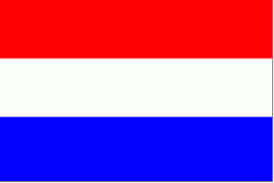
LESSON PLAN
SCHOOL | De Weijerwereld Boxmeer NL
THEMATIC AREA | ENERGY,
TEACHER | Huub Creemers
SUBJECT | Kinds of energy and what we use in The Netherlands
AGE GROUP  (approximately) | 11-12 (oldest pupils)
TIME REQUIRED | 2 lessons (2 hours)
PLACE | Classroom
LESSON OBJECTIVES | - Pupils find out about kinds of energy we have  - Pupils know how every kind of energy is working  - Pupils know about the advantage and disadvantage of every kind of energy  - Pupils know what kind of “alternative” energy is used in our country
REGULAR LESSONS YOU CAN USE | - Language, for translation in English of course the English lesson  - Nature knowledge
CLASS ORGANISATION | - Pupils work in groups
MATERIALS | ICT
ICT TOOLS | Internet, PowerPoint
PROCEDURE | - Discussion in the whole group of pupils: how do we generate energy? What kinds of energy do you know? Wind, Solar, Fossile etc.  - Then group is divided in subgroups : for example 3 pupils for every kind of energy.  - Every group goes to the internet and tries to find out:  - How do we generate energy by using (for example) wind?  - What are the advantages of wind energy?  - What are the disadvantages?  - How many percent of the Dutch energy is generated by using wind energy?  - Search for a little experiment about wind energy and describe the experiment.  - Make a PowerPoint Presentation about “Wind energy”  - Show your presentation to your classmates.
EVALUATION | Discussion about the presentations (content and design) of the presentations
ATTACHEMENTS | PowerPoint Presentation of “ENERGY”

LESSON PLAN
SCHOOL | Weijerwereld
THEMATIC AREA | ENERGY
TEACHER | Imke Kosman, Carin Overbeek
SUBJECT | Energy
AGE GROUP  (approximately) | 12
TIME REQUIRED | 60 minutes
PLACE | CLASSROOM
LESSON OBJECTIVES | What is energy?  What is windenergy?  Experiencing how windenergy works
REGULAR LESSONS YOU CAN USE | - Language, for translation in English of course the English lesson  - Nature knowledge and durability  - Physics
CLASS ORGANISATION | - Pupils work in pairs
MATERIALS | piece of sturdy cardboard 20x20 centimeters  piece of sturdy cardboard (size does not matter)  ruler  pencil  6 paper cups (preferable without print)  scissors  stick 25 centimeters  painters tape  piece of rope  hairdryer / ventilator (not needed for every 2 students)  paint  brushes
ICT TOOLS | IWB with sound
PROCEDURE | Introducing the teachers  Explaining todays goals  Watching a short movie about energy  Talking shortly about what we’ve seen  Watching a short movie about windenergy  Explanation of how to make a windmill, step by step  Working in pairs to built the windmill and to try it out  Cleaning the classroom together  Evaluation about what we learned and showing some examples ogf the made windmills.
EVALUATION
ATTACHEMENTS | PowerPoint  Foto’s of how to make the windmills.

LESSON PLAN
SCHOOL | De Weijerwereld
THEMATIC AREA | ENERGY
TEACHER | Anita van Dielen
SUBJECT | Energy
AGE GROUP  (approximately) | 9-11
TIME REQUIRED | 60 minutes
PLACE | CLASSROOM
LESSON OBJECTIVES | - What is energy?  - Different types of energy.  - What type of energy is better to use, more sustainable?  - How can I save energy at home and in school?
REGULAR LESSONS YOU CAN USE | - Language, for translation in English of course the English lesson  - Nature knowledge  - Technics
CLASS ORGANISATION | - Instruction for the whole group  - Pupils work in little groups (2-4 pupils)
MATERIALS | - Pencil and paper (word web)  - PPT “Energy” Digital board  - Energy quiz (https://eneco-energieles.podium.nl/eindquiz78) (in Dutch, also available in English, see ECOPEDIA and “Surprise page)
ICT TOOLS
PROCEDURE | - Introduction item “Energy”  - In small groups: word web “Energy”. Which words belong to eachother  - Discussion word web in the whole group  - Pupils create PowerPointPresentation ‘Energy’  - Pupils discuss how they can save energy at home and in school  - Quiz ‘Energy’
EVALUATION | - One hour fort his lesson is enough. The making of the presentation takes another hour.  - Pupils learned a lot from the presentations of all the pupils groups.
ATTACHEMENTS | PowerPoint ‘Energy’  Energy quiz (see twinspace “surprise page)
LESSON PLAN
SCHOOL | De Weijerwereld
THEMATIC AREA | ENERGY
TEACHER | Thea Willems
SUBJECT | Different types of energy
AGE GROUP  (approximately) | 6-7 years, form 3-4
TIME REQUIRED | 2 hours
PLACE | CLASSROOM
LESSON OBJECTIVES | - Pupils learn about different types of energy.  - Pupils experience what different types of energy do  - Pupils work in groups  - Pupils discuss in groups.  - Pupils find information, process and present this information
REGULAR LESSONS YOU CAN USE | - Language  - Biology  - Nature knowledge  - Technics
CLASS ORGANISATION | - Pupils work individually  - Pupils work in pairs  - Pupils work in groups  - Pupils work in a circuit model
MATERIALS | See materials list
ICT TOOLS | --
PROCEDURE | - Collect the materials  - Print the sheets for tasks and worksheets  - Divide the pupils group in sub groups (3-4- pupils each)  - Explain what is going on.  - Explain the goals of the lesson.  - Start the activities  - At the end all groups present what they found out.
EVALUATION | - Maybe 2 hours could be not enough time.  - The tasks were not to difficult for this young pupils.  - Pupils did work with great enthusiasm
ATTACHEMENTS | See Work sheets, pictures, tasks.

LESSON PLAN

SCHOOL | De Weijerwereld, Boxmeer
THEMATIC AREA | Energy
TEACHER | Gertjan Vrenken
SUBJECT | Orientation on the world
AGE GROUP  (approximately) | 8-9 years
TIME REQUIRED | 2x 1 hour
PLACE | Classroom and play ground
LESSON OBJECTIVES | - Children are introduced to different forms of energy and how they work  - Children learn what wind energy is  - Children are introduced to the power of wind (air pressure)
REGULAR LESSONS YOU CAN USE | - Language  - Reading comprehension  - Citizen chip
CLASS ORGANISATION | - Pupils work individually
MATERIALS | - Lesson about wind energy  - Craft materials
ICT TOOLS | - digiboard  - movies windmills (movie from “nature news” Dutch TV)
PROCEDURE | - Introduction movie digiboard (wind mill)  - demonstration in the classroom (experiments) wind power  - explanation concerning construction plate, handicraft of wind power car  - tinkering with a wind power car  - try out the wind power car outside
EVALUATION | Outside trying out the wind power car, the car succeeds in moving on air pressure?
ATTACHEMENTS

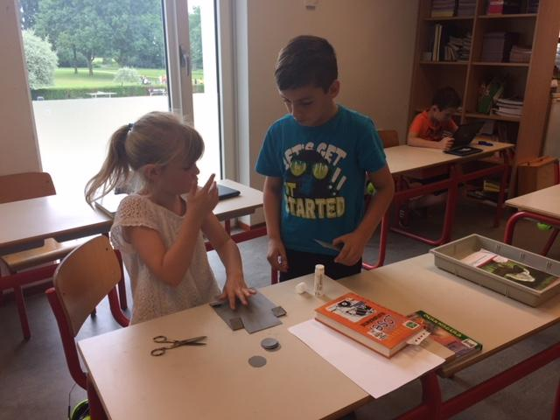
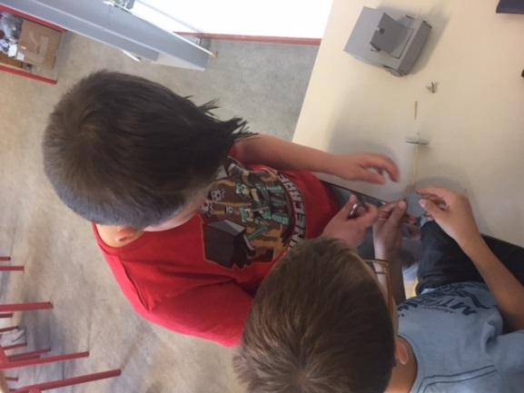

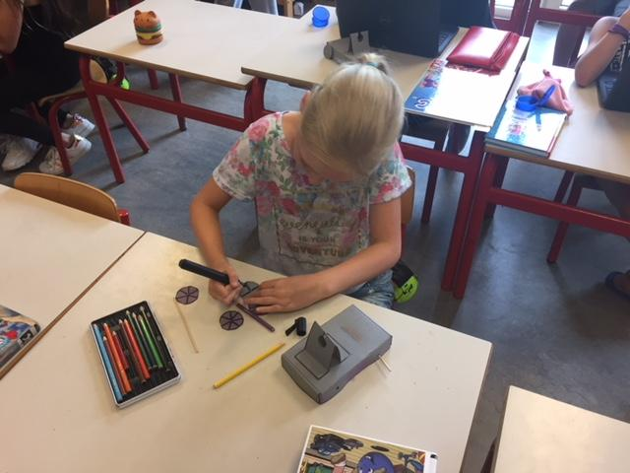
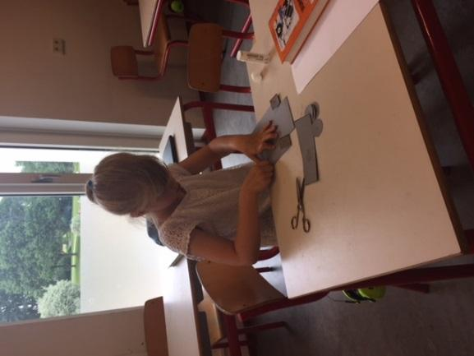
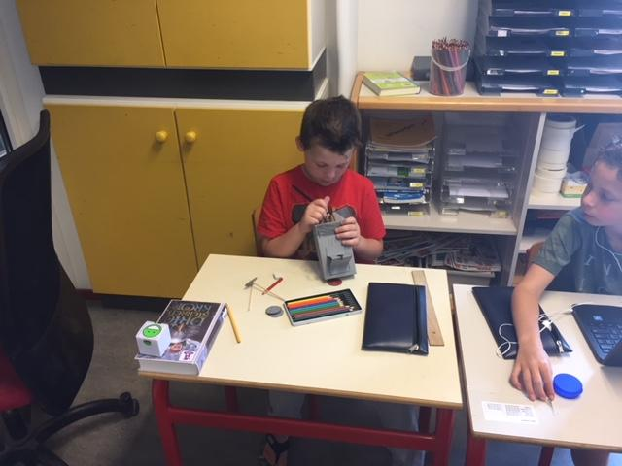
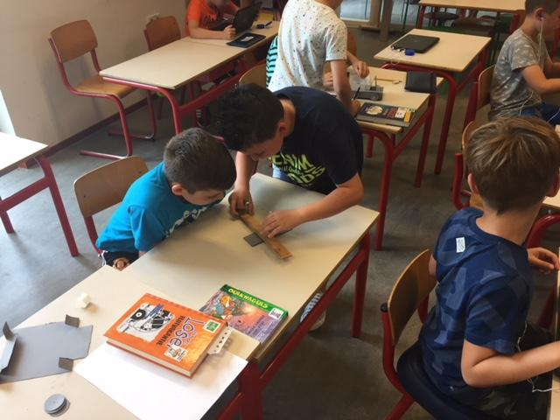
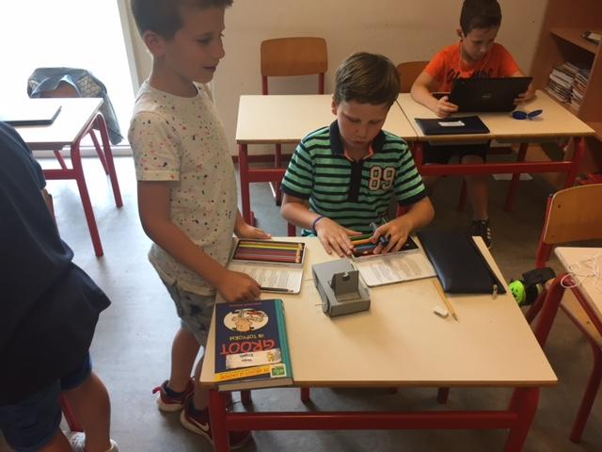
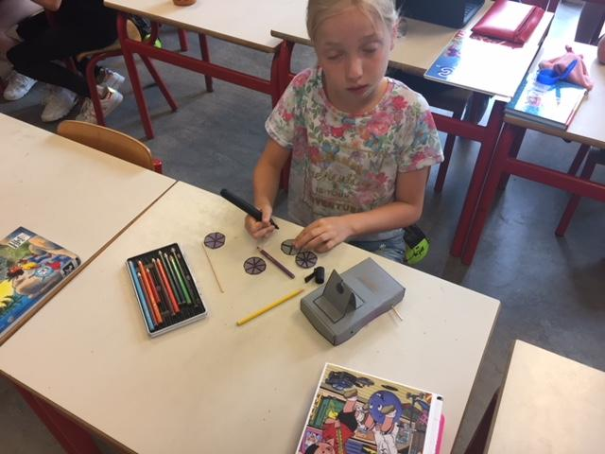

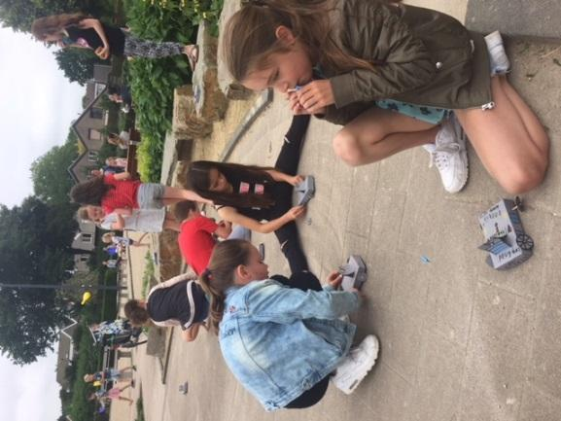

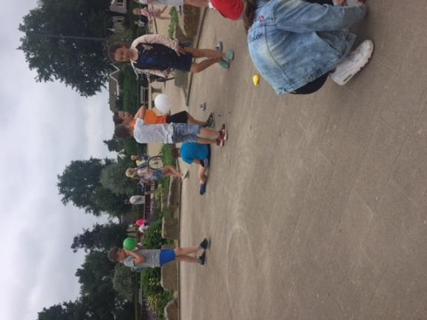
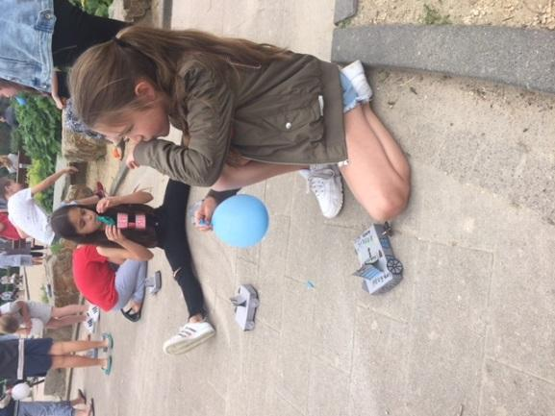
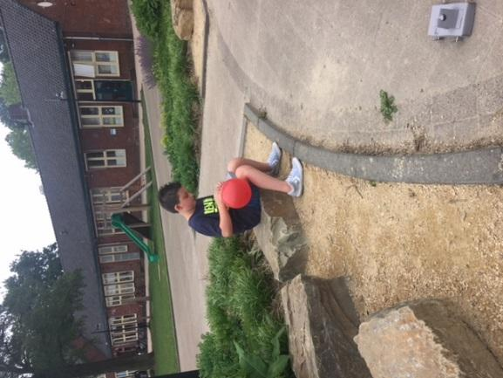
LESSON PLAN

SCHOOL | De Weijerwereld
THEMATIC AREA | ENERGY
TEACHER | Teachers oldest pupils 11-12 years old
SUBJECT | Crafts: How to make an electro-game
AGE GROUP  (approximately) | 10-12 years
TIME REQUIRED | 2x 1 hour
PLACE | CLASSROOM
LESSON OBJECTIVES
REGULAR LESSONS YOU CAN USE | - technics  - Biology  - Nature knowledge
CLASS ORGANISATION | - Pupils work individually  - Pupils work in pairs
MATERIALS | - Electricity wires  - Pictures  - Sturdy cardboard  - Split pens  - Bateries  - Littlelight  - Elastic  - Glue  - Pliers to strip the wires  - Small paperclips.
ICT TOOLS
PROCEDURE | (what happens, what we do step by step)  - We search for images with corresponding answers / pictures, for example Pictures from music starts and the corresponding name, football player and the club logo.  - The pictures are stuck on the English cardboard and underneath these plates the split pins are attached.  - At the rear, the wires (which have been stripped a bit, because only the copper transmits electrical power) of the matching plates are connected to each other via the split pins  - Then we test with a battery and a light whether the power wires are well connected.  - If they are properly connected, the light will come on  - At the end of the wires we can attach a paperclip  The whole is glued to the thick cardboard and the battery is attached to the top.
EVALUATION
ATTACHEMENTS | https://youtu.be/bmGmJhutcyw (6 minutes, without words!!!)

LESSON PLAN
SCHOOL | De Weijerwereld
THEMATIC AREA | ENERGY
TEACHER | Denise
SUBJECT | Crafts
AGE GROUP  (approximately) | 6-7 years
TIME REQUIRED | 45 minuts
PLACE | Classroom and outside
LESSON OBJECTIVES | - Students learn that you can move objects by means of wind  - Pupils learn different techniques with regard to manual skills: cutting, pasting, measuring
REGULAR LESSONS YOU CAN USE | - Crafts  - Language, speaking  - Technics  - Fine motor skills
CLASS ORGANISATION | - Pupils work individualy  - Pupils support to eachother.
MATERIALS | - milk carton or yoghurt pack  - coloured paper  - cork  - the satay stick  - iron wire  - glue  - scissors  - example sailboat
ICT TOOLS | None
PROCEDURE | - The teacher has cut a piece in all cartons and then has them cut the cartons in two.  - Teacher shows the example of the sail boat  - Pupils cut the milk carton in two parts.  - The tip of the carton is, when necessary, tied together with iron wire.  - The pupils attach the cork with a lot of glue to the bottom of the carton  - The children make a sail from coloured paper and attach it to the satay stick.  - The children attach the satay stick in the cork.  - The children add their own creativity to the sailing boat.  - The teacher and children admire each other's sailboat and experience whether the sailboat gets moving by letting it sail out in a puddle (what does the amount of wind do, how should you sail).  - The pupils adapt their sailboat when it is not sufficiently advanced
EVALUATION | - When does a sailboat sail better ?  - What influences are involved?  - What can you add to make your sailing boat sail even faster?  - What does a sailboat have to do with sustainable energy?
ATTACHEMENTS | 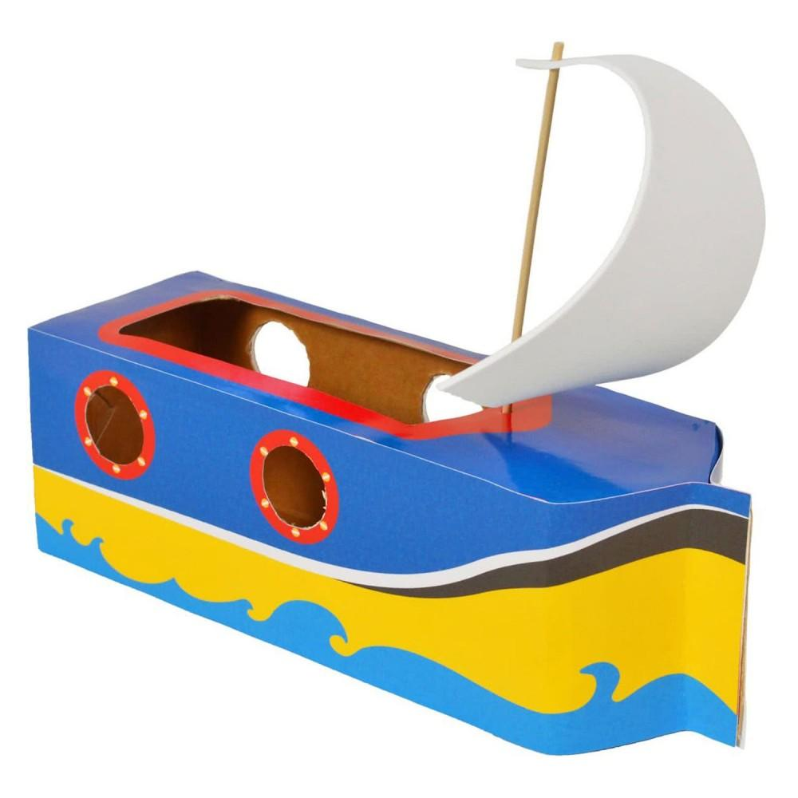
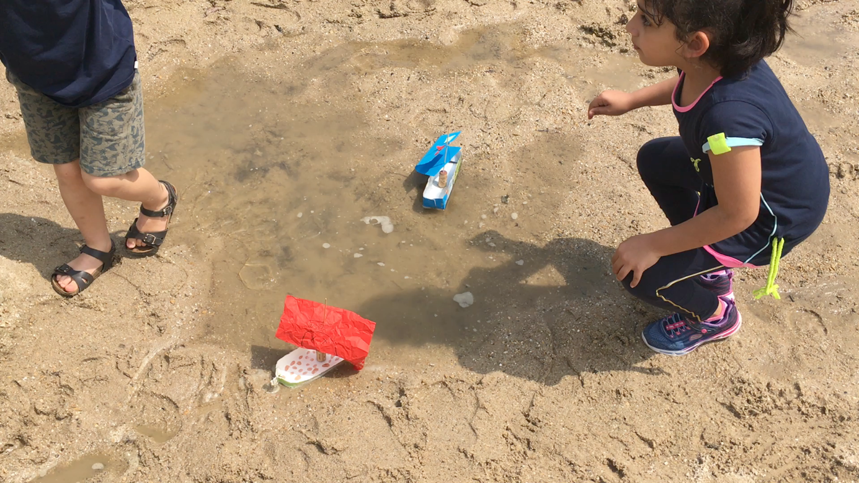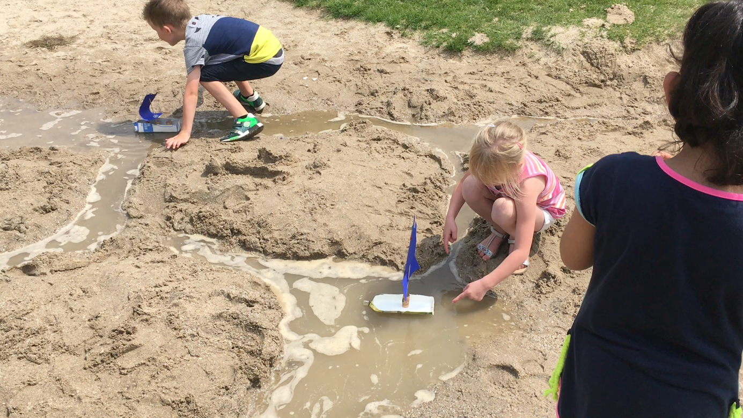

LESSON PLAN

SCHOOL | De Weijerwereld
THEMATIC AREA | ENERGY
TEACHER | Denise
SUBJECT | Orientation on the world
AGE GROUP  (approximately) | 6-7 years
TIME REQUIRED | 5 x 30 minuts
PLACE | Classroom, circle activity
LESSON OBJECTIVES | - Children are introduced to different forms of energy and how they work  - Teaching children to deal with energy in a responsible manner  - Children become acquainted with the cycle of energy
REGULAR LESSONS YOU CAN USE | - Speaking language  - Citizenship
CLASS ORGANISATION | - Classical activity, all pupils involved active
MATERIALS | - https://eneco-energieles.podium.nl/thema/34/thema-1-5 (Dutch website, in Dutch)
ICT TOOLS | - Digiboard  - https://eneco-energieles.podium.nl/thema/34/thema-1-5 (Dutch website, in Dutch)
PROCEDURE | - First introduction movie  - After this discuss different types of energy: wind, solar energy, nuclear energy, but also human energy  - Information of batteries, how they work and collecting used batteries  - Energizer: transport chain, two groups try to whisper a message as quickly as possible
EVALUATION | - make a connection to practice by making a circuit for a nerve game.
ATTACHEMENTS | - picture of the nerve play  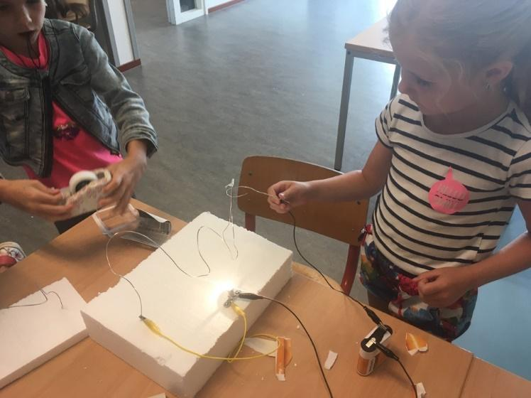

LESSON PLAN

SCHOOL | De Weijerwereld
THEMATIC AREA | ENERGY
TEACHER | Lida, Emmy en Imke
SUBJECT | Handicraft
AGE GROUP  (approximately) | 4-6 years.
TIME REQUIRED | 45 minutes
PLACE | Classroom
LESSON OBJECTIVES | - Pupils learn that wind can make things moving  - Pupils learn various technics handicraft such as neasure, cut, stick
REGULAR LESSONS YOU CAN USE | - Handicraft  - Oral language  - Technics  - Motor skills
CLASS ORGANISATION | - Pupils work individual
MATERIALS | - Paper cups  - Coloured paper  - Glitters  - Split pen  - Glue  - scissors  - Example mill
ICT TOOLS | N.a
PROCEDURE | - Teacher shows the example of the mill  - Pupils cut the paper into strips  - Pupils stick the strips to the cups  - Pupils make wicks of the coloured paper  - Pupils fasten the wicks with a split pen  - Pupils decorate their mill with glitters  - Pupils do the wicks turn by blowing to it.  - Teachers and pupils are wondering how the wicks can blow and admire the nice mills
EVALUATION | -
ATTACHEMENTS | 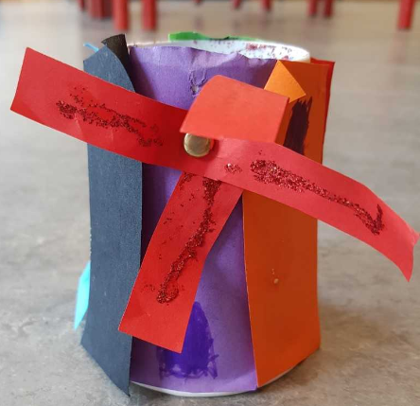

LESSON PLAN

SCHOOL | De Weijerwereld
THEMATIC AREA | ENERGY
TEACHER | Lida, Emmy en Imke
SUBJECT | Orientation on the world
AGE GROUP  (approximately) | 4-6 years
TIME REQUIRED | 30 minutes
PLACE | Classroom, activity in a circle
LESSON OBJECTIVES | - Children get acquainted of various types of energy and what energy does  - Children learn how to use energy in a responsable way  - Children get acquainted with the circle of energy
REGULAR LESSONS YOU CAN USE | - Oral language  - citizinship
CLASS ORGANISATION | - Class activity, all pupils are involved activ
MATERIALS | - https://eneco-energieles.podium.nl/thema/34/thema-2/2 (in Dutch....)
ICT TOOLS | - Digital board  - https://eneco-energieles.podium.nl/thema/34/thema-2/2 (in Dutch…..)
PROCEDURE | - First start with the introduction movie  - Then discussion about various types of energy (wind sun human energy  - Information about batteries, ho wit works and collecting old batteries  - Energizer: transpor chain, two groups of pupils pass along a word to eachother by wispering
EVALUATION | -
ATTACHEMENTS | - Picture windmill  - Picture solar cell

ITALIJA!!!!?????

LESSON PLAN
SCHOOL | Primary School Tone Pavček
THEMATIC AREA | ENERGY
TEACHER | Klemen Kramar
SUBJECT | Computers, Art
AGE GROUP  (approximately) | 12 – 14 years old
TIME REQUIRED | 5 hours
PLACE | computer room
LESSON OBJECTIVES | General objectives:  · Develop their own interests, abilities and talents.  · Through acquired knowledge and skills, they express themselves and cooperate.  · Developing thought processes and aesthetic feelings that enable the dissemination and use of knowledge, and contribute to a deeper understanding.  · Developing creativity and quality of education.  The ultimate goal:  · A group of students will create their own stop motion animation.  Gradual objectives:  · Students learn about the basic function of the classic movie tape.  · Meet some video techniques: pan, zoom, time lapse, tilt.  · Students learn about different types of stop motion animation: "pixelation", "collage", "plastic", "board" and "paper".  · Students learn about the basic characteristics of animated film.  · Students learn about filming procedures.  · Students prepare a script.  · Pupils make a recording book.  · Pupils make a movie.  · Pupils edit.  · Pupils sound the equipment.
LESSONS YOU CAN USE | · Language, art, computer science
CLASS ORGANISATION | Pupils work in groups
MATERIALS | · white sheets, collage, scissors  · dough  · white board, pens, towels / towels  · green board, chalk, towels / towels  · stands for photographic apparatus, photographic apparatus  · photographic lights
ICT TOOLS | Windows Movie Maker computers and access to the World Wide Web
PROCEDURE | The teacher welcomes the class and introduces the topic “energy” and the stop motion animation.  The teacher invites the class to share their thoughts about energy and leads the discussion.  Afterwards, the teacher introduces the students how to create the stop motion animation.  A tip for a teacher:  You can use the Youtube advise, for example:  https://www.youtube.com/watch?v=knLaovT6L0E  The teacher divides the students into pairs or small groups (3 – 4). Each group decides on the topic they would like to work on (wind energy, electricity, the energy of the water...) After that, the students prepare all the material they need and start creating the stop motion animation.  A tip for the teacher: See some student’s ideas (attachment).  To sum up:  - the students present what have they have learned about the energy  - the students present their projects (stop motion animation)  - the teacher uploads the project to Youtube.
EVALUATION
ATTACHEMENTS | · https://www.youtube.com/watch?v=knLaovT6L0E

Some examples made by students:
Number 1. Danger of lightning strike
A story: There is a man who is hit by lightning.
The students discover about:
* Risk of lightning
* How to deal with a lightning storm
* Consequences of a lightning strike

Number 2. Danger of electricity
A story: Stickman watches TV and suddenly runs out of electricity, and then he starts to fix the electric cabinet with high voltage. Stickman's shocked by electricity, the lights turn on and Stickman dies.
The students discover about:
* Electric current risk
* The consequences of an electric current for man

Number 3. Electric circuit.
A story: About electric circuit.
The students discover about:
* Water energy
* Wind energy
* Photovoltaic technology

Number 4. Mill and thermoelectric / electric flow
A story: The electric circuit consists of a power source, conductors, a switch and a bulb. When the switch is on, the source energy goes through the conductors to the bulb. It accepts this energy and converts it into light by heating the metal insert (spiral) at a very high temperature that heats up. Therefore, there can be light in the room.
Students discover about:
* ELECTRIC FLOW
* ENERGY SAVING (How to reduce electricity consumption?)

LESSON PLAN
SCHOOL | Primary School Tone Pavček, Slovenia
THEMATIC AREA | Energy
TEACHER | Mojca Žefran
SUBJECT | Wind energy
AGE GROUP  (approximately) | 7 – 9 years
TIME REQUIRED | 90 minutes
PLACE | Classroom
LESSON OBJECTIVES | Students:  - explain how people make use of the wind  - can plan, make and test wind-driven devices (a windmill and a wind cone)  - develop the ability of practical work  - learn how to make an anemometer
LESSONS YOU CAN USE | Ecology  Science
CLASS ORGANISATION | - Team work  - Individual work
MATERIALS | Crayons, pictures (wind thematic), scissors, a string, paper, a computer, compass.
ICT TOOLS | Multimedia devices – interactive board
PROCEDURE | A teacher welcomes students and invites them to play the game.  A game.  Each student gets a piece of a puzzle, then they have to find the other students to form the group to build the whole picture, for example a windmill, an anemophily, a sailboat, etc.  They have to find out what all the photos have in common. The answer is the wind.  The teacher leads the conversation, asks questions:  - How does the wind come about?  - What means of transport exploit the wind? (Sailboats, sailplanes, balloons)  - What can the wind transmit? (The wind pollinates some plants and dissects their fruits.)  - How does the nature exploit wind energy? (Anemophily, birds)  - Which are other ways of taking advantage of the wind? (Eg: windmill, wind power generation.)  - What are the benefits of such power plants? (Do not produce waste or hazardous substances that would put the environment at risk).  Make a product – an anemometer.  An anemometer is a device that is used to measure wind speed. There are many different types of anemometers suited for different environments, situations, and measurements.  Procedure  1. Take a sheet/ paper and make a drawing, after you make a roller.  2. Take the second sheet/ paper and cut it into stripes.  3. Stick the ribbons to the one part of the roller, one next to the other.  4. On the other side, make little holes and pull through the string and bind it.  5. It is an anemometer.  In the playground.  - Take the compass and the map of the town.  - Take the compass and find the north.  - Take the anemometer and determine from where the wind is blowing.  The conclusion  - What have you learned today?  The students answer, describe, what they have found out about wind energy.
EVALUATION
ATTACHEMENTS

