The Netherlands
Healthy breakfast.
We started the opening of this project by offering the children a healthy breakfast at school. This includes the following: brown bread, cheese, egg, tomatoes, corn flakes, meats such as bread spreads, milk, yoghurt, crackers and low-sugar gingerbread.

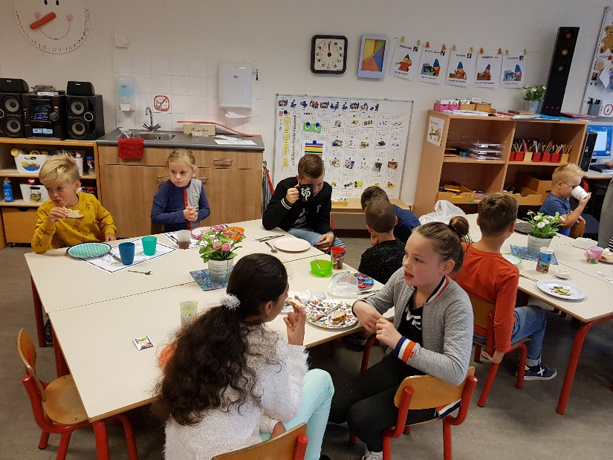
Then we started three eco weeks ‘healthy food’ with a breakfast in school for all pupils. We started on Monday with information about a healthy breakfast, on Tuesday we had the breakfast for all the pupils. The information was on different levels in the different classes. The breakfast was in mixed groups, younger and older pupils among each other.
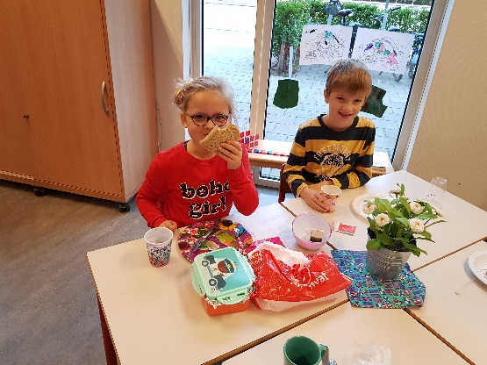

For the youngest pupils ”healthy food” has been part of the extended theme “Health”. So a real doctor visited us. Pupils prepared questions for the doctor. Then there was a consultation hour for sick “stuffed animals”. And the pupils talked with the doctor about the tools in the doctors’ suitcase.
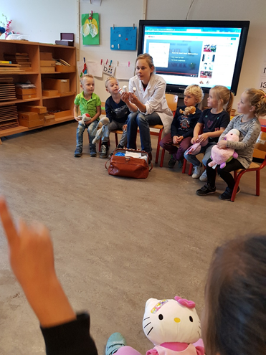
The youngest pupils eat their morning fruit or vegetable snacks at about 10 o’clock. They brought fruit and vegetables, putted these on bigger plates and cutted the stuff into peaces, with the help of parents. After cutting everything they could string some parts on the pricks and so they get acquainted with different kind of fruit and vegetables.

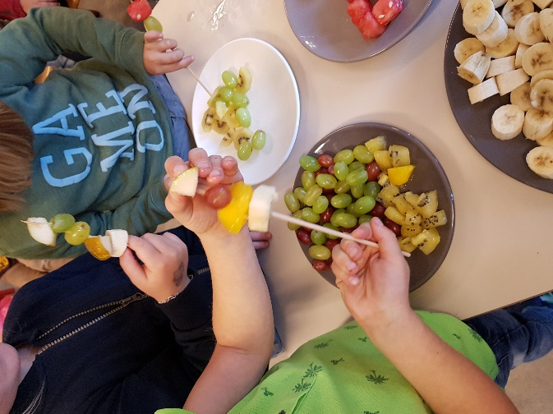
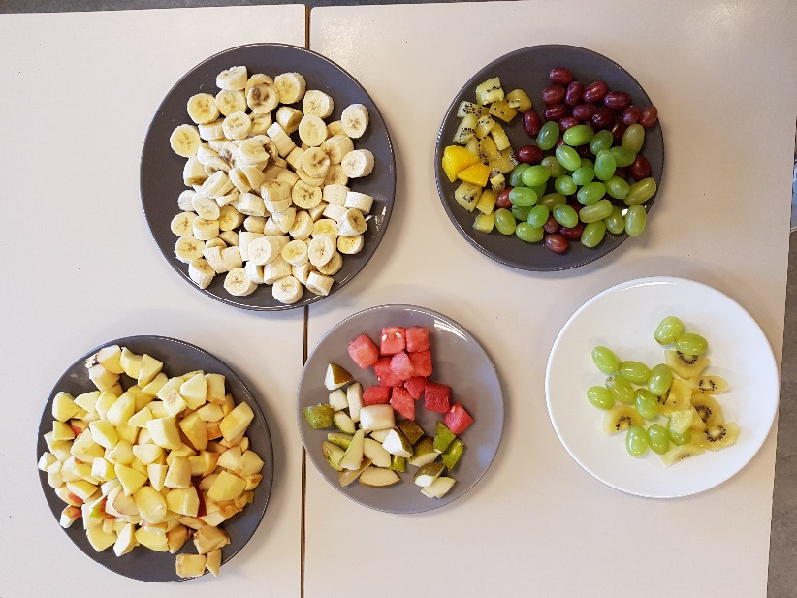

The theme ‘healthy food’ has the focus on food. Nothing more interesting then preparing your own soup! Pupils invited special guests to tast their own soup. Great fun!

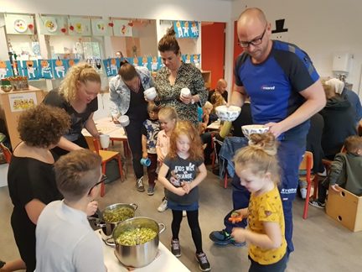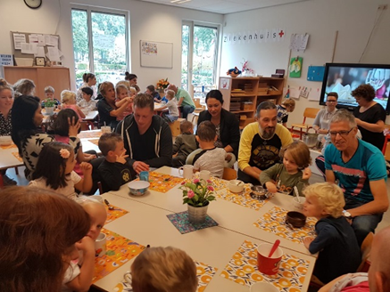
We taught different kinds of lessons during these weeks. On the pictures you see pupils work: doctors and healthy sandwiches.
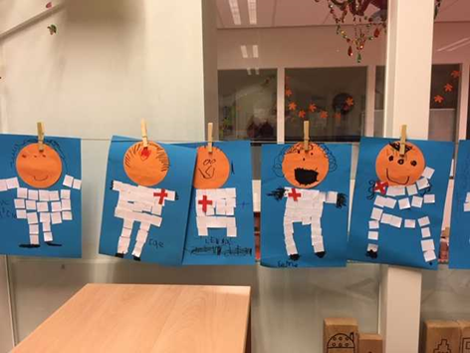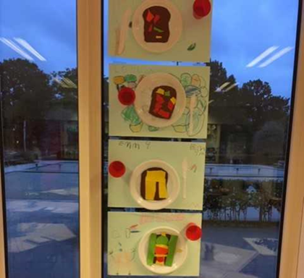

In form 3,4,5:
A circle discussion about healthy food. The questions for this include:
- What is healthy food?
- Why is a breakfast in the morning so important?
- Why do we have to eat enough fruit and vegetables?
- Where does fruit and vegetables come from?
- What is the disk of 5?
- What is unhealthy food and what is in it?

In the learning circle:
-Counting: what do pupils in form 3,4,5 eat and drink during the break in the morning.
-Counting: what do pupils in form 3,4,5 eat and drink for lunch.
-sort the snack for the break in categories: vegetables-fruit-snacks.

Excursion to the vegetable garden "The full life" in Vortum-Mullem.
Here the children get to know how the vegetables grow. They are allowed to harvest the vegetables on the land and to wash and cut the ingredients for the soup: carrots, leeks, beetroot, parsley and the like.
Finally, they can eat the soup.

Healthy cooking workshops:
Parents take care of the workshops. The parents tell something about their recipe and what is needed for it. The children can help to make the dish and finally they can eat it.

Creative activity:
-The children make bread or fruit from vegetables. This is shown on the play-leath and can be taken home after the project has ended.
- creating food piramyd by using pictures in flyers.
- Drawing: fill the shop window with vegetables and fruit
- Vegetables and fruit song.

Played games around the item “healthy products:
-“what is it”.... small cards with pictures of (un)healthy food. Pupils have discover what picture is on their own card (they do not know) by asking questions.
-mini loco with pictures of healthy food.
-box and healthy food in it: pupils thry to discover what food product they feel in the box without watching in it. They also can ask questions about it.
Form 6, 7 en 8
In the different classes we have been busy with the taste lessons. In these flavor lessons we talked about the different types of flavors (sweet, sour, salt and bitter) and also about the mouthfeel (spicy, filming, crunchy, slippery, juicy, stimulating, smooth, dry, fresh).
We have talked about using your senses for testing. How does it smell? How does it look? How does it feel? What do I hear when I put it in my mouth?
Afterwards, the children were allowed to taste all kinds of products in pairs.
Questions were: What did you taste? What does the re look like? How does it smell? How does it feel in your hand? How does it feel in your mouth? How does it taste? Do you like it? Why?
We also gave a lesson about energy. The disk of five explained. You have to eat something from every box every day. The size of the course indicates how much you can eat.
We have looked at how many sugar cubes there are in a can of cola and in a bottle of cola. How much sugar is there in a can of energy drink?
Afterwards, with the children they look at what they eat in between meals and how many calories you get. How much you have to move and exercise a day (1 hour) (3 times a week, about 20 minutes each time). What is a good energy balance? How much do you have to eat? And how much do you burn in a day?
We have also given a lesson about Faire Trade products, regional products and seasonal products. What that contributes to the environment, but also to farmers in poor countries.
The last lesson was about additions. Colorants, emulsifiers, thickeners, anti-oxidants, fragrances and flavors. Also during this lesson the children were allowed to do experiments. Place smarties in water. What is happening? Does it taste different? Vitamin C pills with orange flavor. Compare pudding powder with fragrance and flavorings. It smells like strawberries, is there strawberry in it?
Make mayonnaise with egg yolk, oil and vinegar.
We went to the taste center. There the children were given an explanation about healthy eating and they were also allowed to cook dishes with healthy products.
In the spring we started planting potatoes, grain, beet and corn. In the autumn we were allowed to harvest our own sown products. Digging up potatoes, pulling beetroot out of the ground, picking grain and grinding between two stones and our hands.

We also made a recommendation poster, with everything we learned during the Healthy Food weeks. We have hung those posters so that other people can learn from them too.

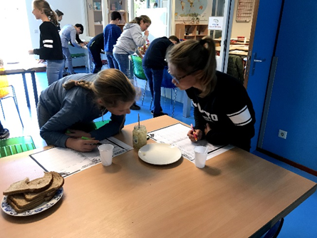

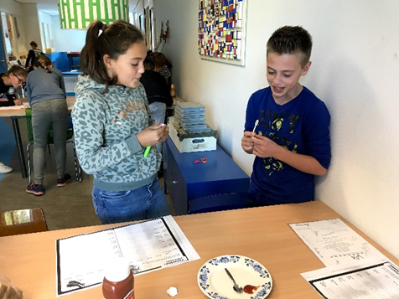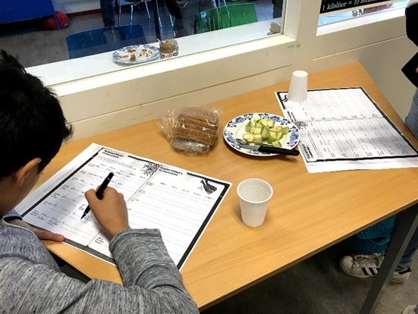

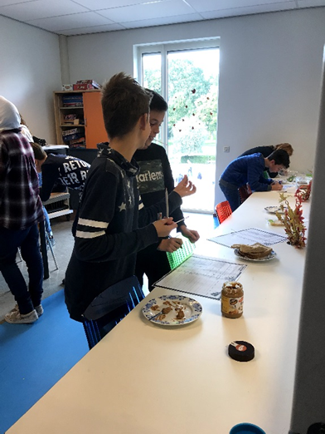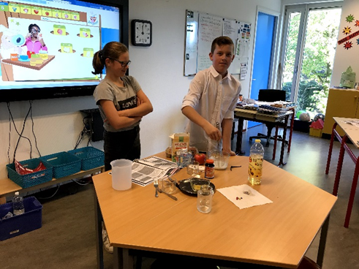

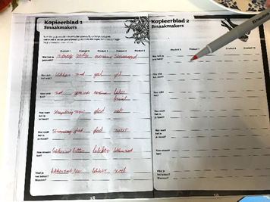
Collection of old clothes. Someone came to the school and picked them up. They will be re-used.
-children were collecting paper.
Collecting batteries 56 kilos .
Collecting all kind of broken electric apparatus. Someone came to the school and picked them up for recycling. (75 different).

