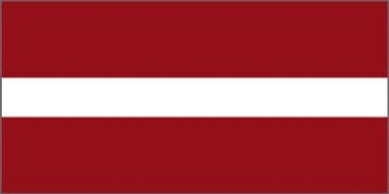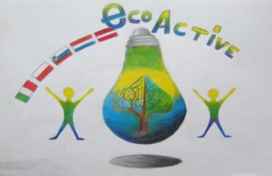**LESSON PLAN**

|  |  |
| --- | --- |
| **SCHOOL** | Annas Brigaderes primary school |
| **THEMATIC AREA** | Healthy |
| **TEACHER** | Sandra Geislere, Svetlana Kursina |
| **SUBJECT** | Healthy. An Apple |
| **AGE GROUP** | 10-12 |
| **TIME REQUIRED** | 40 min |
| **PLACE** | CLASSROOM |
| **LESSON OBJECTIVES** | Healthy eating - apples in daily diet |
| **LESSONS YOU CAN USE** | * Language, for translation in English, of course the English lesson * Science * Nature knowledge * Handicrafts   **Integrative learning** connecting skills and knowledge from multiple sources and experiences CLIL Content and Language Integrated Learning |
| **CLASS ORGANISATION** | Pupils work individually |
| **MATERIALS** | Paper plate, green paper, glue, scissors, black marker |
| **ICT TOOLS** | Ppt presentation |
| **PROCEDURE** | \*)We start the lesson with the puzzle: It's round. It can be green, yellow, red. It is loved by many people It's healthy. What is it?  \*)Teachers introduce pupils with popular facts about apples.  IMG_6046.JPG\*)Demostration – there is an apple in the bowl. Pupils observe that an apple does not sink.  \*)Conversation with pupils, what kind of dishes are made from apples in different countries.  \*Creative work - make an apple from colored paper, stick it to the paper dish. Write down on the one side of the apple a food prepared in the pupi's family. On the other side, write down a healthy apple dish.  IMG_5998.JPG  \*)Teachers offer to taste dried apples  \*) At the end of the lesson pupils can make a dessert - Cut out the core of the apple, fill with sugar and cinnamon in it, bake in the oven. |
| **EVALUATION** | Selfevaluation |
| **ATTACHEMENTS** |  |

****



****