

**ITEM 3: SUSTAINABLE ENERGY**

In this section you will learn what sustainable means, how important sustainable energy is and which renewable energy sources there are.

Introduction movie (in Dutch!) <https://youtu.be/vBpIj8S3ny0>

**Definition of sustainability**

Sustainable means that people can do and use the same things in the future as we do now.

**ITEM 3: INFORMATION**

**The earth is in trouble.**

In the Netherlands we still burn a lot of fossil fuels to make energy. Fossil fuels are for example: gas, oil and coal. They originated from plant remains and animal remains. Nature has taken millions of years to make them. Unfortunately, humans use more fossil fuels than nature produces.

So gas, oil and coal eventually end up once. And what is also bad: its use is harmful to the environment. Harmful substances are released during combustion. By those substances

the air is getting warmer on earth. The climate is changing. People suffer from one place

from harder storms, heavy rain showers and floods. In other places it becomes very dry.

**One Planet Thinking**

We ask a lot of the earth. Yet we only have one planet earth! If we ruin it there is no second chance. That is why it is important that we do things differently.

'One Planet Thinking'. That is English for 'one planet thought'.

It means: everything we do must fit within the possibilities of our planet. We should not ask more of the earth than the earth can supply. Using sustainable energy is one of the solutions.

**What does sustainable mean?**

Sustainability is about people, the environment and earning money. Simultaneously! If you work sustainable, you do not just think about make money, but also about the environment and other people. You do not think just about “ now”, but also about the future. So sustainable means that people in the future can do and use the same things as we do now. If we drive now, it must be possible in 100 years too. We pay attention to the fact that we still have enough energy in 30, 50 or 200 years and that the world looks just like it does now. Or even better of course!

If we do not do anything about climate change, that is bad for the future. If we use all the raw materials there is nothing left for the future.

Renewable energy is energy that is not polluting and does not run out. Using sustainable energy will save our future!

**Renewable energy**

The energy of the sun does not rise quickly. That takes an estimated 5 billion years! By the sun

to use for light, heat and electricity, you do not have to burn anything. You do not have to do anything do that is bad for the environment. You can also use the sun yourself. Use the heat around the let it dry and the light to see something, or let your plants grow through it.

**Wind** is a movement of air. So movement. There will always be wind. Sometimes that wind is in us

land quite powerful. With that movement you can run a dynamo and generate energy.

**Biomass** is more sustainable than fossil fuels. Biomass is a collective name for snippets

made from recycled wood, grass, or manure. Burning them also gives you energy. Which

happens in a kind of large factories: biomass power plants. The (biological) substances of which the

snippets have been made, quickly grow up again and do not become so fast.

When making biomass and the burning of it is unfortunately released. But fortunately there are

much less harmful substances than in the combustion of fossil fuels. That makes a difference

so something.

**Heat-cold** solution: Certainly in winter in the Netherlands, we need heat. In many places

we already make extra heat. In factories where something is made, for example, heat comes

free. Using smart techniques, we can capture this heat and use it again for our homes

to heat. That is sustainable, because you use something that is already there. And you do not need extra use energy to create new heat.

If you use sustainable energy, you can look forward to the future in a cheerful way!

Movie: Green house effect <https://youtu.be/SLnu46SgAkc>

**WORK SHEET**

Task 1

First read the information sheet . Take a good look at the sustainable photos below.

(This task is about the photos, not the drawings with numbers.)

Examples sustainable energy

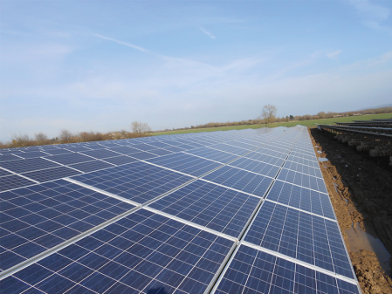https://eneco-energieles.podium.nl/images/prev.png

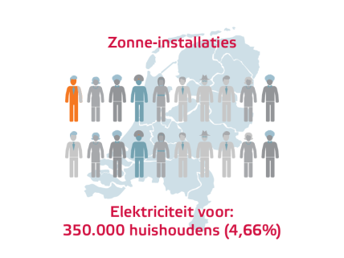

2020

Solar paners: Electricity for 350.000 households  
(32%)

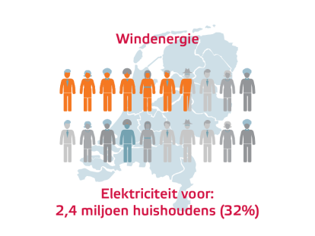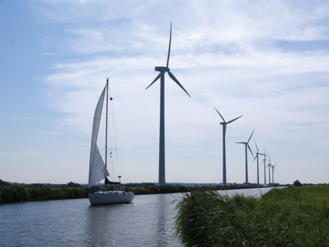

2020

Wind energy: Electricity for

2.400.000 households (96%)

https://eneco-energieles.podium.nl/images/prev.png

https://eneco-energieles.podium.nl/images/prev.png

https://eneco-energieles.podium.nl/images/prev.png

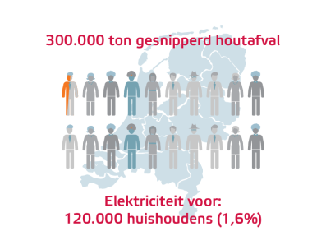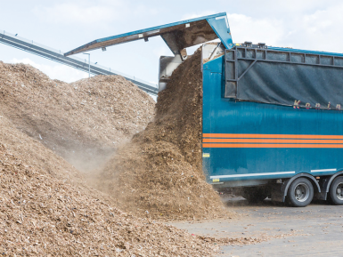https://eneco-energieles.podium.nl/images/next.png

300.000tons shredded wast, electricity for 120.000 households (1,6%)

Biomassa (houtsnippers)

Eneco heeft in Delfzijl een elektriciteitscentrale die geheel werkt op afvalhout. Jaarlijks wordt daar 300.000 ton gesnipperd houtafval omgezet in elektriciteit voor 120.000 gezinnen. Er is dus 2.500 kilo houtsnippers nodig om de 3.500 kilowattuur elektriciteit te maken die een gezin in een jaar nodig heeft.

https://eneco-energieles.podium.nl/images/prev.png

https://eneco-energieles.podium.nl/images/prev.png

Come up with a caption that people will think:

"Indeed, sustainable energy is super important!"

Tell two things:

Which renewable energy source do you see?

Why should we use it?

For example: Solar energy for a bright future without fossil fuels!



1: ……………………………………………………………………………………………………..

………………………………………………………………………………………………………….

2. …………………………………………………………………………………………………….  
  
…………………………………………………………………………………………………………

3. ………………………………………………………………………………………………………  
  
…………………………………………………………………………………………………………



Task 2.

What is more sustainable?

Research wind and solar energy and compare the advantages and disadvantages.

Work in triples and choose one of the following tasks.

WIND I - online research

Why do you prefer to use wind energy? First think carefully. What do you expect?

Then look for additional information on the internet.

Answer the following questions:

When does a windmill work best? …………………………………………………………………………………………

………………………………………………………………………………………………………………………………………………..

Does a windmill always work? ……………………………………………………………………………………………….

Name two advantages of windmills. ……………………………………………………………………………………….

…………………………………………………………………………………………………………………………………………………

Name two disadvantages of windmills. …………………………………………………………………………………..

…………………………………………………………………………………………………………………………………………………

TIP: are you looking for information about the wind? Look at [www.knmi.nl](http://www.knmi.nl) under the heading 'Netherlands now' and then under 'Climatology'.

WIND II fieldwork

Why do you prefer to use wind energy? First think carefully. What do you expect? Then examine a real windmill and / or a windmill that you have made yourself in an experiment.

Answer the following questions:

When does a windmill work best? ………………………………………………………………………………………………

……………………………………………………………………………………………………………………………………………………

Does a windmill always work? …………………………………………………………………………………………………….

Name two advantages of windmills. ……………………………………………………………………………………………..

………………………………………………………………………………………………………………………………………………………

…………………………………………………………………………………………………………………………………………………………

SUN I - online research

Why do you prefer solar energy? First think carefully. What do you expect?

Then look for additional information on the internet. Answer the following questions:

When does a solar panel work best?............................................................................................

……………………………………………………………………………………………………………………………………………………

Does a solar panel always his work?................................................................................................

Name two advantages of solar panels…………………………………………………………………………………………..

………………………………………………………………………………………………………………………………………………………

Name two disadvantages of solar panels………………………………………………………………………………………

……………………………………………………………………………………………………………………………………………………..

TIP: are you looking for information about the sun? Look at [www.knmi.nl](http://www.knmi.nl) under the heading 'Nederland nu' and then under

'Climatology'.

SUN II - field work

Why do you prefer solar energy? First think carefully. What do you expect? Then examine solar panels nearby.

When does a solar panel work best?...............................................................................................

……………………………………………………………………………………………………………………………………………………..

Does a solar panel always do it’s job?................................................................................................

Name two advantages of solar panels……………………………………………………………………………………………

………………………………………………………………………………………………………………………………………………………

Name two disadvantages of solar panels…………………………………………………………………………………………..

………………………………………………………………………………………………………………………………………………………….

Task 3

Use the advantages and disadvantages that you wrote down in task 2. Discuss with another person

group all the advantages and disadvantages of wind and solar energy that you have come up with.

At each point, consider which energy source you prefer. Sun or wind?

What is the best sustainable energy source for you?.........................................................................

Why do you think that?.....................................................................................................................

………………………………………………………………………………………………………………………………………………………..

**What did we learn?**

* What means sustainable and sustainability
* What kinds of sustainable energy do we have
* How important is sustainable energy