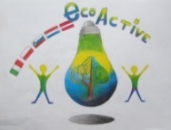 LESSON PLAN 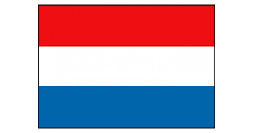
SCHOOL | Primary School “De Weijerwereld” in Boxmeer
THEMATIC AREA | HEALTH
TEACHER | Hanneke Bongarts
SUBJECT | Healthy food
AGE GROUP  (approximately) | 10-11 years
TIME REQUIRED | 3 days, 9.00 to 12.00
PLACE | The “Taste centre” in Boxmeer
LESSON OBJECTIVES | - Explanation about the so called “Disk of five”, the Dutch idea about healthy food.  - What could be healthy food?  - How often a snack every day?  - How much sugar is in frizzy drinks?  - Which drinks are healthy?  - What nutrients are necessary? (protein, vitamins, minerals, carbohydrates).  - Seasonal vegetables, what part of the plants do we eat.  - Bread: what nutrients are in bread, which bread can you call healthy, is it correct: “more brown/dark bread, more healthy???  - Cooking: pupils learned how to cut certain vegetables into pieces. How to use a sharp knife in a safe way. How to cook on a fire.
REGULAR LESSONS YOU CAN USE | - Biology  - Nature knowledge
CLASS ORGANISATION | Pupils work in groups, cooking a starter, main dish and dessert)
MATERIALS | Various ingredients and things you need for cooking.
ICT TOOLS | PowerPoint about healthy food and the “disk of five” (is a circle divided into 5 parts, in every part kinds of food you should eat every day)
PROCEDURE | Two groups of pupils.  First part: One group starts cooking, the second group has a theoretical lesson about healthy food.  After the break second part: change the tasks.  At the end of the session: joint meal together with the volunteers. Every group of pupils tells the other pupils about the ingredients of the dish the group prepared, the ingredients of the dish and how they prepared the dish.
EVALUATION | Pupils learned a lot about new dishes, ingredients and healthy food. And they did learn a lot about the quantity of snacks they did eat in one week.
ATTACHEMENTS | - Recipes en PowerPoint presentations  - Visiting the “Taste centre” in Boxmeer (pupils 10-12 years)  “taste centre” Boxmeer  - Where does our food come from?  - How does it taste?  - What is the influence on your body, health?  - How to prepare a healthy meal?  - How can you prevent waste of food?  PARTS OF THE LKEWSSONS ARE, AMONG OTHER:  - Taste lesson theory;  - Discover the authentic taste of natural products;  - Purchase of healthy ingredients for a meal;  - Coocking fres products;  - Re-use of residual products;  - How to enjoy the prepared meal;  - The vegetable garden;

The so called “disk of 5”.
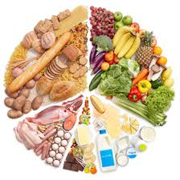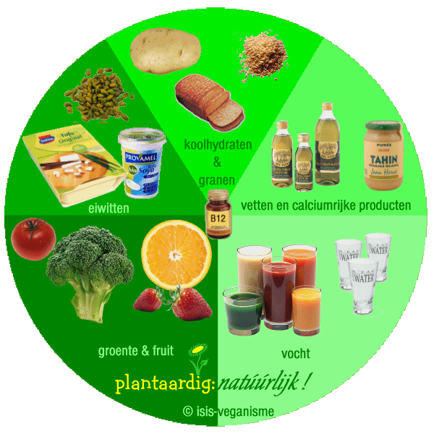
Remember to eat the five basic food groups

The visit in the so called “Taste centre”
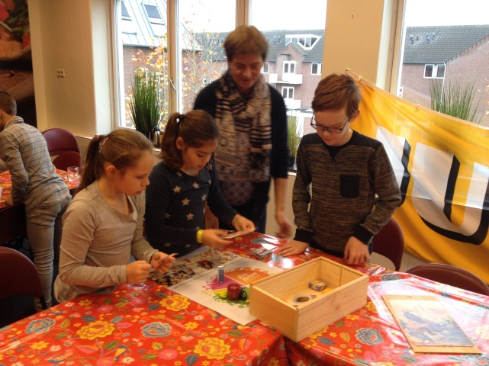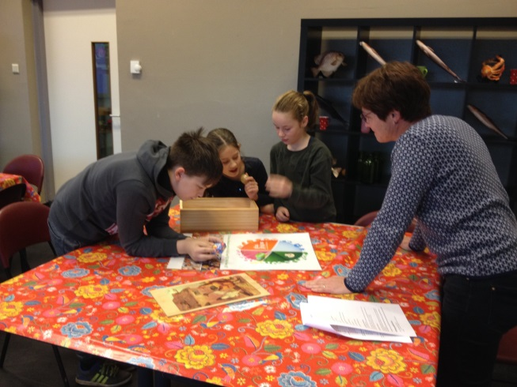
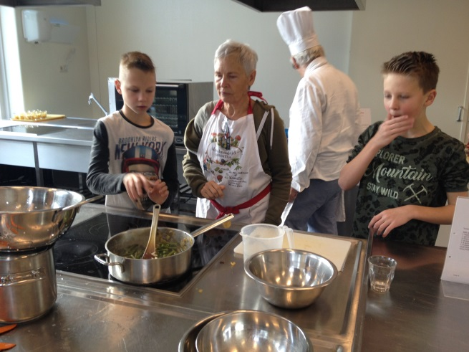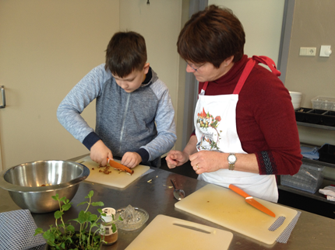
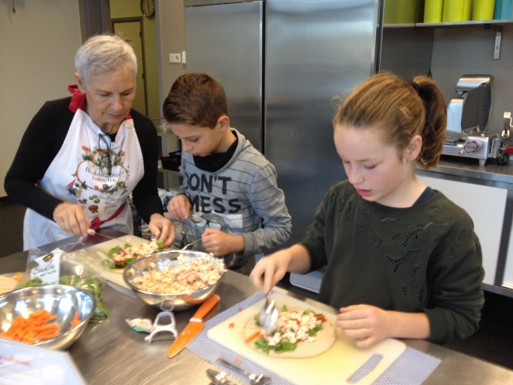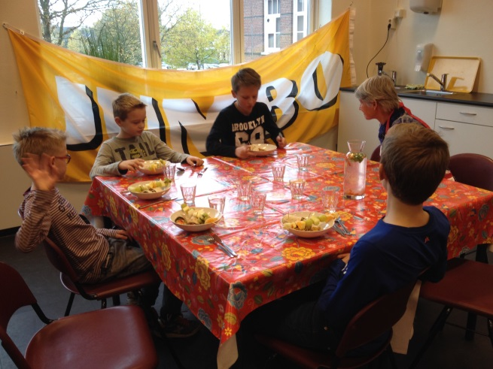
In the taste centre volunteers work with pupils to learn them about healthy food and how to prepare a healthy meal.

