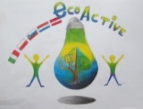 LESSON PLAN 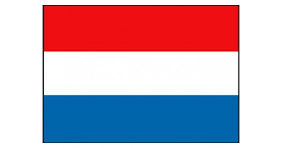
SCHOOL | De Weijerwereld
THEMATIC AREA | ENERGY
TEACHER | Anita van Dielen
SUBJECT | Energy
AGE GROUP  (approximately) | 9-11
TIME REQUIRED | 60 minutes
PLACE | CLASSROOM
LESSON OBJECTIVES | - What is energy?  - Different types of energy.  - What type of energy is better to use, more sustainable?  - How can I save energy at home and in school?
REGULAR LESSONS YOU CAN USE | - Language, for translation in English of course the English lesson  - Nature knowledge  - Technics
CLASS ORGANISATION | - Instruction for the whole group  - Pupils work in little groups (2-4 pupils)
MATERIALS | - Pencil and paper (word web)  - PPT “Energy” Digital board  - Energy quiz (https://eneco-energieles.podium.nl/eindquiz78) (in Dutch, also available in English, see ECOPEDIA and “Surprise page)
ICT TOOLS
PROCEDURE | - Introduction item “Energy”  - In small groups: word web “Energy”. Which words belong to eachother  - Discussion word web in the whole group  - Pupils create PowerPointPresentation ‘Energy’  - Pupils discuss how they can save energy at home and in school  - Quiz ‘Energy’
EVALUATION | - One hour fort his lesson is enough. The making of the presentation takes another hour.  - Pupils learned a lot from the presentations of all the pupils groups.
ATTACHEMENTS | PowerPoint ‘Energy’  Energy quiz (see twinspace “surprise page)

