Project funded by the European Union

Ecopedia
“WATER”
(a teacher’s guide)

Lesson plans from Ecology
for Primary Schools
2016 / 2019

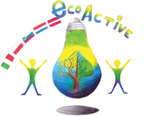

Authors of the manual

- Halina Daniel
- Magdalena Gawronska
- Teresa Bertolini
- Maija Klasupova
- Sanja Pavlinić Vidic
- Maaike van Sambeek

Design: Tomaž Bahč

Table of content:

Authors 2

Project Partner Schools 3

Introduction 4

Lessons 5-32

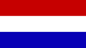

https://www.deweijerwereld.nl
DE WEIJERWERELD, Boxmeer, the Netherlands

www.dd2circolocavour.gov.it
2 Circolo Didattico Cavour Marsala, Marsala, Italy
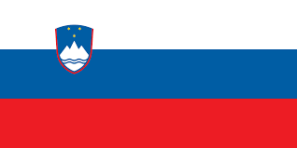

www.ostpavcka.si
Osnovna šola Toneta Pavčka, Mirna Peč, Slovenia

www.tervetesnovads.lv/annas-brigaderes-pamatskola/
Annas Brigaderes pamatskola, Zelemeni, Latvia

www.sp2.pulawy.pl
Szkola Podstawowa Nr 2 im. K.K.Baczynskiego w Pulawach, Puławy, Poland

June, 2019

INTRODUCTION

This publication contains original lesson plans on environmental issues created by teachers from the five European schools participating in the Eco-Active project. They are based on the educational systems of five countries. All lesson plans refer to ecological issues, and their subject matter mainly relates to four thematic areas which our project dealt with: Resources, Water, Energy and Health.
Ecopedia includes lesson plans for younger and older groups of pupils. Some of them were used on international lessons, during visits to partner schools, with the participation of students from the host school. The remaining lesson plans were used in partner schools during the three years of the project on tutoring lessons, other school subjects and extra-curriculum school activities. All lesson plans are in English.
This publication is a form of a guide for teachers who would like to use ready-made and interesting lesson plans to introduce their students to issues related to ecology. Each lesson plan in this document has been developed by the teachers of the school from the country whose flag it bears. Each lesson plan contains information about the age group of students and the name of the teacher (author) who created it. Lesson plans are accompanied by attachments (worksheets, presentations, etc. ). Lesson plans are arranged according to the thematic areas of our project.

Project Coordinator

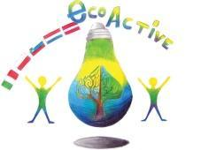 LESSON PLAN
SCHOOL | Primary School number 2 in Puławy
THEMATIC AREA | WATER
TEACHER | Jolanta Ciesielska
SUBJECT | Water – nature’s treasure – let’s save it every day!
AGE GROUP  (approximately) | 7 – 10 year olds ( younger pupils)
TIME REQUIRED | 60 minutes
PLACE | classroom
LESSON OBJECTIVES | Pupil:  - knows the importance of water in the life of man, plants and animals,  - understands why water is a treasure,  - speaks about the water and the actions to be taken to save it,  - understands why saving water is so important  - indicates the possibilities of limiting waste of water,  - is aware that excessive water consumption may cause shortages in the future,  - cooperates with peers while performing tasks,  - decrypts words,  - puts words in the correct order to make a sentence,  - multiplies in the range of 50,
LESSONS YOU CAN USE | • Ecology  • Nature knowledge  • Mathematical knowledge
CLASS ORGANISATION | - Individual  - Group work
MATERIALS | world map, globe, one liter bottle of water, water, laboratory glassware, 100 cm long paper strip, interactive whiteboard charts, individualized work cards, group work materials
ICT TOOLS | multimedia devices - interactive whiteboard, ActivInspire computer programme, Task Magic, movie "Saving water" - YouTube
PROCEDURE | 1. Welcome.  2. Reminding of the rules of the class.  - What are the rules of working in class?  3. Getting to know the subject of the lesson.  Calculate. Interactive exercise.  25 s 32 s 15  36 s 12 s 28  24 42 16  40 30 50  5 ∙ 5 = 25 box 4 ∙ 8 = 32 box 3 ∙ 5 = 15  6 ∙ 6 = 36 box 4 ∙ 3 = 12 box 4 ∙ 7 = 28  3 ∙ 8 = 24 6 ∙ 7 = 42 2 ∙ 8 = 16  5 ∙ 8 = 40 5 ∙ 6 = 30 5 ∙ 10 = 50  - What is this?  - What can be a treasure?  - In today's lesson, we will answer the question: why is water a treasure?  Getting to know the objectives of the lesson.  * During today's lesson you will learn why water should be saved.  * You will learn how to save water  5. Success criteria.  * After today's classes you will be able to enumerate at least 5 ways to save water.  In today's classes the teacher will pay attention to:  - pupils’ being active,  - using full sentences while speaking,  - work in a group, correct performance of tasks,  - behaviour.  I remind you that everyone has the right to make a mistake.  We do not laugh at the mistakes of children, it is important not to repeat them.  6. Curiosities about water.  - What is the color of water? (is transparent)  - Where does the blue color of water in the water reservoir come from? (From the color reflection of the sky).  - What shape does the water have?  - Pour water into dishes of various shapes. Watch what its shape is.  The liquid takes the shape of the container in which it is located.  - Conclusion: Water is a liquid.  [Most countries in the world suffer from a water deficit, only a dozen have so-called surplus. This is, for example, Norway, which due to its relatively low population and moderate climate has plenty of water in abundance. The worst situation prevails in Africa and some Asian countries. Poland is not doing well in this context - it is one of the poorest countries in Europe as it comes to water and water consumption is constantly growing. On average, in Europe there is 5100 m³ of life-giving fluid per person, while in Poland only 1,700 m³.]  - Looking at the globe, say what is more, water or land?  - To visualize how much water is useful for us on our planet, you can do a simple demonstration:  A 100 cm long paper strip constitutes 100% of the Earth's water resources.  The seas and oceans represent 97% of water on our planet. However, it is salt water, unsuitable for use - measure out and cut 97 cm from a long strip.  It has been 3 cm, or 3% which is fresh water. Unfortunately, 2% is stored in glaciers - cut a 2 cm long strip.  The water available to us is 1% of water resources. That's a lot?  - And what is the water needed for? (for drinking, washing, cleaning, cooking, washing, watering plants, for animals ...)  - Water occurs in all living organisms,  For example, the body of jellyfish is 95% water.  In humans, water is about 65% of body weight. It is a component of blood and all body fluids, it occurs in such organs as the liver, heart, brain and muscles.  Every day, we lose about 2.5 liters of water from the body (through the skin - sweat, along with breathing, through the urinary and digestive systems). It is therefore necessary to remember to refill this liquid.  - How many days can a man survive without drinking? (Without water, humans can survive from 4 to a maximum of 7 days. Long-term dehydration leads to loss of strength, weakening of the body's immunity, loss of consciousness, damage to internal organs and death.)  - There is not enough of water, but the needs are greater. In that case, what should be done in such a situation?  (Water should be saved.  That is why it is important to realize how important it is to manage water properly.)  - How can we save water?  7. Watching a film. „Saving water”  - Why should you save water?  • To pay smaller bills and have more money.  • Africa has a water shortage.  • Scientists say that in 2050, 7 billion people in 60 countries can  suffer from shortages of drinking water.  - List the actions you can take to save water.  • Turn off the faucet while brushing your teeth.  • You should take a shower instead of a bath.  • The tap must be leak-proof.  • Water the garden once a week for 20 minutes in the evening, because the water evaporates less at night.  • Do not wash dishes under constantly running water.  • It is good to use the dishwasher.  8. Solution to the text task.  If you do not turn the tap when brushing your teeth, you will lose 15 liters of water with a medium stream within 3 minutes.  How much water will you lose when brushing your teeth twice a day (morning and evening)?  (Answer: 30 liters of water.)  How many liters of water will be lost with a family of four while brushing in the morning and evening?  (Answer:. 120 liters of water.)  9. Conversation - What other actions can be taken to save water?  * Do not open the tap completely when washing your hands. To clean the face and hands, the water does not have to spurt; it is enough as it flows in a calm stream. If you collect water in the wash basin during washing, you can use it to soak stained clothing before washing.  * Change all taps to ones that save water. In the old tap you can install the aerator - a kind of fine mesh sieve that aerates the outflowing water, making the stream stronger. However, if you do not want to stop at half measures, the best solution will be installing a Roca Atlas battery which, thanks to an innovative aerator, reduces water consumption to 1.32 liters per minute.  * Only run the washing machine and the dishwasher when it is full. If you follow this rule, you will get a lot of savings compared to washing or handwashing. If you buy new household appliances, pay attention not only to the energy class of the device, but also to whether it has ECO programmes to shorten the washing or washing process, and to reduce water consumption.  * Collect water from rainwater and use it to water the gardens. (This water is usually soft, so it's even better for watering plants.)  10. The song "Four Elements". Movement improvisation.  11. Group work.  Reminding the rules of a group work.  - Read the task. Put these sentences, which talk about saving water in the column "I save water", and those that point to wasting water in the column "I waste water".  "I save water", "I waste water".  I turn off the tap while brushing my teeth. In the evening I take a quick shower. I collect rainwater and use it to water the plants in the garden. I only switch on the washing machine and the dishwasher when they are full. While taking a shower, I turn off the water while soaping. I repair a leaking faucet. I wash the dishes in the dishwasher. I do not fix a leaking tap. I bathe every day in a tub full of water. I wash dishes under constantly running water. I do not turn the tap off while brushing my teeth.  12. Self-assessment on the interactive board.  13. Independent work at the tables.  Individualized work card:  Here is the magic square that encrypts words.  A B C D E  1 ć o i ż e  2 a w l b ó  3 n ą k s m  4 ł ę r t c  5 z y j d e  Decrypt a password:  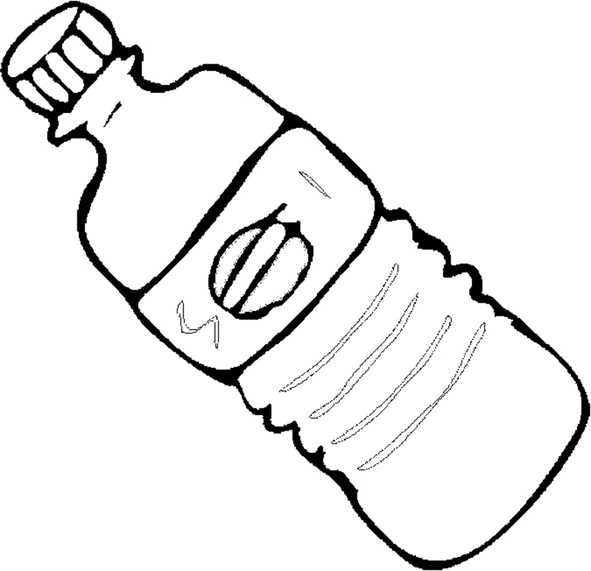  2B 1B 5D 2A 4D 1B  W o d a t o  3D 3C 2A 4C 2D  s k a r b  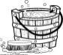  2B 1C 4B 4E 3A 2A 2C 1E 1D 5B  w i ę c n a l e ż y  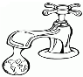  5C 3B 3D 5A 2A 3A 1B 2B 2A 1A  j ą s z a n o w a ć  Password:  Water is a treasure, so it should be respected.  - Why is water a trasure?
EVALUATION | 14. Summary of classes  Evaluation.  Interactive task: TRUE - FALSE.  Water is needed for people, plants and animals. (TRUE)  Bathing in a bathtub is more economical than showering. (FALSE)  Excessive water consumption can cause shortages in the future. (TRUE)  Garden should be watered in the evening, because the water evaporates less. (TRUE)  By saving water, you pay smaller bills. (TRUE)  Rainwater can not be used to water plants in the garden. (FALSE)  You do not need to turn off the water when brushing your teeth. (FALSE)  15. Assessment.  - You have achieved the goal of today's activities. You can enumerate at least 5 ways to save water.  - HOW TO USE YOUR KNOWLEDGE IN EVERYDAY LIFE?  - Which advice, which we talked about during the lesson, will you use at home?  - Finally, we can ask ourselves: Why is it worth to save water?  - By saving water - we save money that we can spend on something else.
ATTACHEMENTS

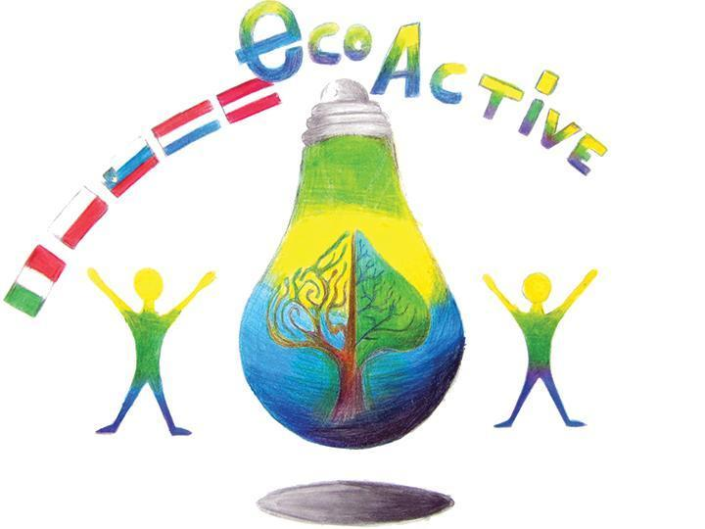 LESSON PLAN
SCHOOL | Annas Brigaderes primary school
THEMATIC AREA | Water as resource
TEACHER | Sandra Geislere
SUBJECT | Socialy science
AGE GROUP  (approximately) | 13 -14
TIME REQUIRED | 40 min
PLACE | CLASSROOM
LESSON OBJECTIVES | Water resources in the world - for sustainable global development
LESSONS YOU CAN USE | - Language, for translation in English of course the English lesson  - Biology  - Nature knowledge  Integrative learning connecting skills and knowledge from multiple sources and experiences CLIL Content and Language Integrated Learning
CLASS ORGANISATION | - Individual work  - Collective work
MATERIALS | Worksheet (What do I know about water, efficient use of water)  „National Geographic” 10 tips on how to save water resources
ICT TOOLS | https://www.youtube.com/watch  http://www.waterwise.org.uk/
PROCEDURE | Students get worksheets and answer the question – What do I know about water?  Discussions, debates.  Watch video and write down the new information in the worksheets.  Discussion - How to save water resources?  Every-one gets „National Geographic” 10 tips on how to save water resources.  At the end of the lesson students write down the answers to two questions – What I found out about water as a resource?  This lesson made me think about... .
EVALUATION | Selfevaluation  Students actively participated in the discussion. With interest and excitement watched video material and filled the worksheets  Students expressed their opinion and argued their views on the water in a global perspective.
ATTACHEMENTS | Waterwise 10 tips on saving water at home

Waterwise 10 tips on saving water at home
• Turn off the tap when you brush your teeth – this can save 6 litres of water per minute.
• Place a cistern displacement device in your toilet cistern to reduce the volume of water used in each flush. You can get one of these from your water provider.
• Take a shorter shower. Shower can use anything between 6 and 45 litres per minute.
• Always use full loads in your washing machine and dishwasher – this cuts out unnecessary washes in between.
• Fix a dripping tap. A dripping tap can waste 15 litres of water a day, or 5,500 litres of water a year.
• Install a water butt to your drainpipe and use the water collected to water your plants, clean your car and wash your windows.
• Water your garden with a watering can rather than a hosepipe. A hosepipe uses 1,000 litres of water an hour. Mulching your plants (with bark chippings, heavy compost or straw) and watering in the early morning and late afternoon will reduce evaporation and also save water.
• Fill a jug with tap water and place this in your fridge. This will mean you do not have to leave the cold tap running for the water to run cold before you fill your glass.
• Install a water meter. When you're paying your utility provider for exactly how much water you use, laid out in an itemised bill, there's an incentive to waste less of the stuff.
• Invest in water-efficient goods when you need to replace household products. You can now buy water-efficient showerheads, taps, toilets, washing machines, dishwashers and many other water-saving products.
Used website: http://www.waterwise.org.uk/
LESSON PLAN
SCHOOL | Annas Brigaderes primary school
THEMATIC AREA | Water
TEACHER | Sandra Geislere, Evita Deičmane, Maija Klāsupa
SUBJECT | Nature knowledge
AGE GROUP  (approximately) | 12-15
TIME REQUIRED | 40 min
PLACE | CLASSROOM
LESSON OBJECTIVES | Water filtering
LESSONS YOU CAN USE | - Language, for translation in English of course the English lesson  - Biology  - Nature knowledge  Integrative learning connecting skills and knowledge from multiple sources and experiences CLIL Content and Language Integrated Learning
CLASS ORGANISATION | - Pair work or group work
MATERIALS | Worksheet, water, 3 liter jar, sand, woodchips,  coal powder, dirt/soil, small rocks, gauze, cotton, plastic cups,  10 empty 2 liter PET bottles
ICT TOOLS | -
PROCEDURE | Preparing:  Divide the class into teams, let choose a leeder, name the team  Teacher asks:  1.What is the chemical name of this solution? (Water in the jar)  2. What do we know about water? (it can be sweet, salty etc.)  Teacher explains:  3.Today we are going to make water unclean.  We will add: sugar (mmm delicious), salt, coffee grind thickness, paper, black coal  4.What we have? A pond (writes down on the blackboard)  5. Our task is: make it clear, clean, useful for drinking.  6. The teacher gives to their students the worksheets.  7. Teacher lets students write down their team’s name.  8. From all materials on the desk, each team has to choose 3 materials to work with. Advise: Put coal in the middle! Don’t put it on the top or on the 1.1ayer! Coal absorbs smell and bacterias.  Students choose 3 materials in the little cups (sand, coal, woodchips, stones, dirt)  9. Students choose a material for filtering (cotton or coffee filter) and put it in the bottle as a filter.  10. Students lay layers of choosen materials.  11. Teacher pour unclean water in the glass and give it to each team, another empty glass is given to each team.  12. Pour very slowly!  13. Students filter many times till water is clear (use second bottle)  14.Compare and show to whole class (students can put all glasses on the teacher’s desk, then sit down)  15. Teacher asks: What have you absorved?  Would you like to taste it? Where can we use it? Etc.
EVALUATION | selfassesment
ATTACHEMENTS | worksheet

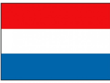
LESSON PLAN
SCHOOL | Primary school “De Weijerwereld’
THEMATIC AREA | WATER
TEACHER | Huub
SUBJECT | “ASPECTS OF WATER”
AGE GROUP  (approximately) | 11-12
TIME REQUIRED | Lesson about 45 minutes, then making presentations about 2 hours
PLACE | Classroom
LESSON OBJECTIVES | - Learning about the importance of “Water”  - Learning that usable water is not naturally  - Learning about different aspects of “Water”  - Discussing: aspects of “Water”  - Searching and finding information  - Making presentations  - Presenting the found information to the classmates
REGULAR LESSONS YOU CAN USE | - Language, for translation in English of course the English lesson  - Biology: pollution  - Nature knowledge: water circle, pollution, physics, weather  - History: safety, floods  - Geography: safety, water management, pollution  - Technics: safety, water management,  - Mathematics: water consumption, specific weight of liquids
CLASS ORGANISATION | - Pupils work individually  - Pupils work in pairs  - Pupils work in groups
MATERIALS | Computer
ICT TOOLS | Internet  Presentation software like PowerPoint, Prezi
PROCEDURE | - Introduce the theme  - Explain what we will do, how we will work, what the final result could/should be  - Discussion about “Aspects of water”, resulting in a mind map. The result could be like the image in the attachment. Making such a mind map is done by using www.bubble.us (free software)  - Divide the pupils in little groups. If you use the orange items in the mind map there would be 10 groups  - Every group works out one of the items (the orange ones) in a presentation, using computer, software and internet  - After finishing the work every little group presents its work to the classmate in a presentation.  - Classmates become the possibility to ask questions
EVALUATION | Classmates value the work and the presentations in terms of “what was very good” and what could have been done (a bit) better.
ATTACHEMENTS
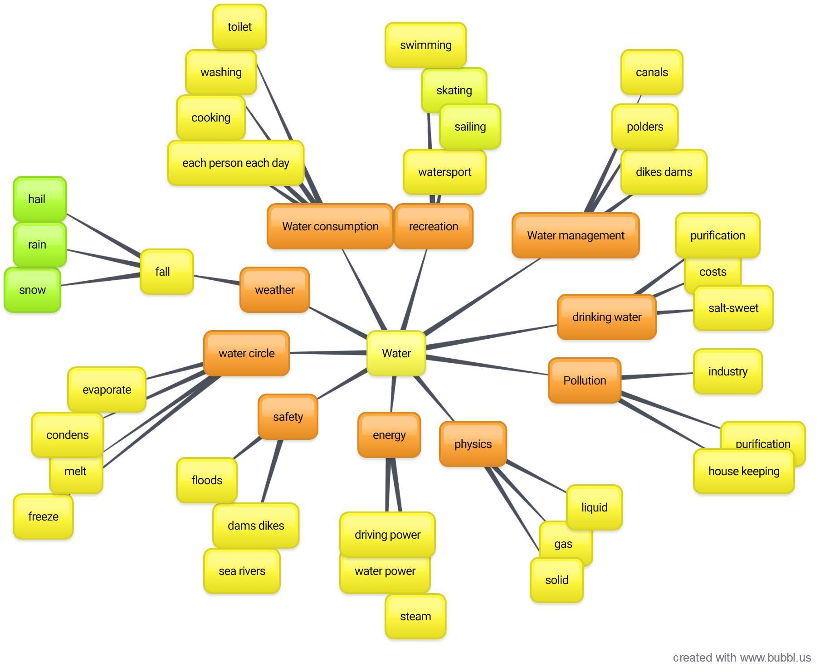
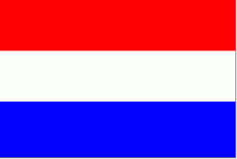
LESSON PLAN
SCHOOL | Primary school ‘De Weijerwereld’ Boxmeer The Netherlands
THEMATIC AREA | Water
TEACHER | Frieda Heutink
SUBJECT | Handicraft
AGE GROUP  (approximately) | 10- years old pupils. They are mixed from different countries.
TIME REQUIRED | 45 minutes
PLACE | Mirna Peč, classroom
LESSON OBJECTIVES | - Enlarge cooperation  - Enlarge creativity  - Show the pupils how beautiful the ocean can be in a drawing.
LESSONS YOU CAN USE | - English  - Drawing  - Biology
CLASS ORGANISATION | - Pupils work individual
MATERIALS | - Papers for protecting the tables  - white drawing paper and a pencil  - crayons  - tassels  - ecoline/colored blue ink
ICT TOOLS | - I use a Powerpoint to explain the assignment.
PROCEDURE | - Preparation: I made a Powerpoint and a lesson plan. I made a list of all the materials we need and send this to the school in Slovenië.  - I don’t know all the pupils, so before I start the lesson I introduce myself  - Then I show all the pupils the materials and explain step by step what they have to do.  - I show the pupils the final product so they can see what they are going to make.  - Then I divided all the materials over the different groups, so the students can share the materials. They work individual.  - When the pupils start with the activity I walk around in the classroom and give instructions, compliments and help to the pupils.
EVALUATION | All the pupils clean up their table. When they are finished we ask the pupils what they were thinking of the activity. After that they take look at each other’s work.
ATTACHEMENTS | -

LESSON PLAN
SCHOOL | Primary School “De Weijerwereld” Boxmeer The Netherlands
THEMATIC AREA | Drawing lesson: how to create a sticker about “Saving water” and/or “saving energy”
TEACHER
SUBJECT | How to develop an advertising sticker
AGE GROUP  (approximately) | 4-12 years: can be used for every age of pupils, just adapt the words you use
TIME REQUIRED | Two lessons, about two hours overall
PLACE | Classroom
LESSON OBJECTIVES | - Environmental education  - Changing behaviour concerning use of “water” and “energy”  - Improving drawing skills  Aspects of drawing lessons:  - What colours do we use?  - What kind of font style?  - Surface division?
REGULAR LESSONS YOU CAN USE | - Drawing lessons
CLASS ORGANISATION | - Discussion in groups  - Pupils work individually
MATERIALS | Paper, pencils, colour markers, paint
ICT TOOLS | Internet: search for good practice/examples of usable stickers
PROCEDURE | - Announce the subject of the drawing lesson.  - What are we going to do?  - What should we achieve?  - What should be the result at the end?  Discussion:  - Why is it necessary to reduce the use of water or energy?  - How can we make people (pupils) mindful on the need of redusing the use of water and energy? What do we need? What can we use?  - (TV commercial, radio, magazine, newspaper, sticker)  We are going to create a sticker.  - What are the characteristics of a usable sticker? Think about:  - Form  - Colour(s), signal colours  - Size  - Text  - Now start developing and drawing your sticker.  - Make your choice for:  - Subject  - Form  - Colours  - Text
EVALUATION | Halfway through:  - Admire each others creations: what are the ideas?  - Tell each other. What is the form you used? Why this form?  - And what about the colours?  - The text?  At the end:  Feedback to the pupils by:  - The teacher  - The pupils between themselves  The stickers:  - Will be printed on plasticized paper.  - Used on different places in school:  - Next to electricity swichtes  - Water taps
ATTACHEMENTS

LESSON PLAN
SCHOOL | Bs De Weijerwereld
THEMATIC AREA | WATER
TEACHER | Thea Willems
SUBJECT | Water-circuit
AGE GROUP  (approximately) | 7-8 years
TIME REQUIRED | 60-70 minutes
PLACE | Classroom,
LESSON OBJECTIVES | Experiences with different subjects and situations of/with water.  What does water do in different situations?  Characteristics of water
REGULAR LESSONS YOU CAN USE | - Language, for translation in English  - Biology  - Nature knowledge
CLASS ORGANISATION | - Pupils work in groups
MATERIALS | Exersises-games-experiments  - movie: origine of the water pipe (Video lesson: Thirst with Wouter and Wiesje)  - creating a water pipe: tubing, from high position to a low position  - filtering dirty water: bottle filled with mud, cloth used as filter  - water cycle: watching movie and drawing the cycle  - float and sink: various little materials  - water organ: bottles filled with water in different levels, little sticks  - water-resistant: various materials: which are water-resistant, which are not  - game blowing away a little boat: water basin, little boats, straws (influence of the wind on the boat)  - goose board game: theme “water”” ,  - freeze water: making ice
ICT TOOLS | Computer: various movies, experiment with water
PROCEDURE | The pupils group is broken apart into small groups of 5 pupils (max.)  All the groups can work/ experiment 10 minutes on each exercise/game/experiment.  After 10 minutes every group goes on tot he next item of the workshop.  Parents explain the pupils what they have to do and support them if necessary.
EVALUATION | You8ng pupils experience in a playful way, that water is very important and that people can’t live without water.
ATTACHEMENTS | See the report about the ECO-week, written by these young pupils.

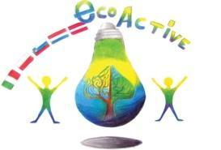 LESSON PLAN
Primary school | Primary school “2 Circolo Didattico “Cavour” Marsala Italy
thematic area | Water
Teacher | Stefania Vinci, Silvana Li Volsi, Maria Barraco; Graziella Pellegrino
-SUBJECT | Science
Age Group | 8-9 years
Time required | 60 minutes
Place | AREA
LESSON  OBJECTIVES | - Identify characteristics and properties of the water;  - Understand the water cycle; water phases: vapor, fluid, ice;  - Describe and recognize atmospheric phenomena.  - Reflection on daily water uses aimed at preventing the Waste
LESSONS YOU CAN USE | ∙ practical activtivities: experimentation  ∙ science  ∙ english  ∙ Information Technology  ∙ Art: pictures of the water phase
CLASS ORGANISATION | - Pupils work individually  - Pupils work in pairs  Pupils work in groups
MATERIALS
ICT TOOLS | ∙ ICT (informatic): power point production  ∙ Researches about water and its importance
PROCEDURE | - Detection and recording of the presence of water in all its forms in  the surrounding environment;  - Experiences to discover some water features;  - Experiments on water-phase changes;  - Reconstruction of the complete hydro-geological cycle through schematization and animation  - Experimental Simulation of a Cycle Made of Two-Three State  Steps;  - Reflection on daily water uses aimed at preventing the Waste  - Create a power point presentation about water: use-protection-Preciosity
EVALUATION | -Represents and describes the cycle of water;  -Make difference between correct and incorrect use of water;  Produce a power point about water
ATTACHEMENTS | Power point about water  Representation: water is life  https://www.youtube.com/watch?v=Arrf-J8wCdo&index=8&t=0s&list=PLBFZJhQ48r5-MQhQy43j1_ixe1sXcHqIj

LESSON PLAN
SCHOOL | Primary school : 2° Circolo Didattico “Cavour” Marsala-Italy
THEMATIC AREA | Water
TEACHER | De Marco Antonina
SUBJECT | Water is life
AGE GROUP  (approximately) | 7 – 8 years old pupils
TIME REQUIRED | 10/12 ore
PLACE | CLASSROOM
LESSON OBJECTIVES | .Describe basic phenomena of daily life related to liquids.  • Observe and interpret transformations of the natural environment  • Reflect on your habits in the use of water.  • Recognize that water is everywhere and is a fundamental element for life.  • Understand the water cycle.  • Know how the water changes status  • Understand water characteristics and actions.  • Make hypotheses and verbalizing experiences.  • Represent through icons
LESSONS YOU CAN USE | - Science experiments  - manual activities  - drawing
CLASS ORGANISATION | - pupils work individual, in pairs and in groups
MATERIALS | -Science books, magazines - newspapers, internet  -Glass-made saucepan, electric hotplate, glass plates / containers, fridge with freezer, album and drawing material.
PROCEDURE | 1. Teacher guides the discussion in class through stories and observations of images.  Pupils recognize how water is everywhere as a fundamental element for life and learn not to waste water.  2. Research material for in-depth analysis (video-books and scientific journals).  internet.  3. Reading narrative / descriptive texts and viewing images to understand the processes and transformations related to the following contents:  ⎫ Water characteristics and actions.  ⎫ Water as a source of life.  ⎫ Use of water in everyday life.  ⎫ The utility of water.  ⎫ Water conditions.  ⎫ The water status changes.  ⎫ The water cycle.  ⎫ Proper use of water.  4. Formulation of hypothesis:  "The temperatures and water conditions, changes and characteristics"  5. Practical experimentation - laboratory activities and formalization of experiential knowledge.  Simulation.  Description of activities-actions and related water changes.  Recording of data (processes and change of water status) graphic / photographic representations and related captions.
EVALUATION | Systematic observation.  Active listening.  Guided conversations.  Graphic / written productions.  Completion of tables / simple textbooks.
ATTACHEMENTS | Creation of a conclusive conceptual map.
LESSON PLAN
SCHOOL | Tone Pavček Primary School, Slovenia
THEMATIC AREA | Water around us
TEACHER | Sanja Pavlinić Vidic
SUBJECT | Science
AGE GROUP (approximately) | 11–13 (older groups)
TIME REQUIRED | 90 minutes
PLACE | Classroom
LESSON OBJECTIVES | Students:  - Explain the difference between surface waters and groundwater.  - Justify the importance of protecting water.  - Explain the importance of groundwater as a source of drinking water.  - Identify and describe contaminants of surface waters and groundwater.
LESSONS YOU CAN USE | - Chemistry  - Science  - Foreign Language (as vocabulary extension)  - Ecology
CLASS ORGANISATION | - Pair work  - Group work  - Individual work
MATERIALS | Plastic bottles, water from rivers, lakes; rainwater; conical, filter paper, glass; EcoLabBox; paper, photos…
ICT TOOLS | Interactive board
PROCEDURE | The teacher welcomes the class and introduces the topic: Water around us.  The teacher invites the students to make groups and give them two glasses filled with different kind of water.  You need: two plastic bottles; fill the first bottle with rainwater and the second one with water from the river.  The teacher introduces the two bottles and invites the class to share their thoughts about what can they see.  The teacher asks some questions, such as:  - What can you notice?  - Why is the water dirty?  - What made it dirty?  - Is it drinkable?  - Is it contaminated?  The teacher asks the students to think about causes of water pollution. The students and the teacher talk about the causes. (The teacher can bring litterature, use websites.)  The causes are for example: separation of wastewater from industry and households; wrong and excessive use of fertilizers and sprays in agriculture; high precipitation; natural disasters; traffic; industry.  - Practical work. Students work in groups of 4.  You need: an Erlenmeyer, a filter, water from the river, distilled water, fungus.  - Take a bottle nr. 1 (water from river, lake) and pour it through the filter.  Ask: »What can you notice?«  - Take bottle nr. 2 (artificial fertilizers) and pour it through the filter.  Ask: »What can you notice?«  Discuss the questions:  - Is the water clear now?  - Is it good for drinking? What do you think?  - How can we check?  The teacher sums up: Distilled water is not drinkable, including water from the river, since it is not purified. There are numerous micro-organisms and many harmful substances in the water. Using the Ecolabbox set, we will investigate what is in the water and what percentage of this substance is.  - Practical work - Analysis of harmful substances in water  You need: “Ecolabbox”.  The teacher presents the phosphates, nitrates, ammonium in water and invites the student to analyse for example: the water from river, rainwater…  - Water analysis-phosphate (sample glass with blue code)  - Fill the sample glass with water sample to the mark.  - Add 10 drops of reagent 1, close sample glass with plastic stopper again, and shake sample glass.  - Open sample glass, add 1 drop of reagent 2, close the sample glass with plastic stopper, shake sample glass.  - Colour matching after 5 minutes.  Now look through the colour solution from above and compare the colour of the solution with the colour of field around the circle.  - Ammonium in water (sample glass with green code)  - Fill the sample glass with water sample to the mark.  - Add 10 drops of reagent 1, close sample glass with plastic stopper, shake sample glass.  - Open sample glass, add 1 measuring spoon of reagent 2, close sample glass with plastic stopper again, shake and leave for 5 minutes.  - Open sample glass, add 15 drops of reagent 3, close the sample glass with plastic stopper, shake sample glass.  - Colour matching after another 7 minutes.  Now look through the colour solution from above and compare the colour of the solution with the colour of field around the circle.  Conclusion: The teacher divides the students into the groups and offers them some pictures/photos. The students look at the photos and write down some tips on How to save the environment?  For example:  - Never throw rubbish away anyhow. Always look for the correct ways of disposing the waste.  - Use water wisely. Do not keep the tap running when not in use.  - Do not throw chemicals, oils, paints and medicines down the sink drain, or the toilet..  - Buy more environmentally safe cleaning liquids for use at home and other public places. They are less dangerous to the environment.
EVALUATION
ATTACHEMENTS

LESSON PLAN
SCHOOL | Tone Pavček Primary School, Slovenia
THEMATIC AREA | Drinking water
TEACHER | Zdenka Mežan
SUBJECT | Science
AGE GROUP (approximately) | 8 – 9 years old
TIME REQUIRED | 90 minutes
PLACE | Classroom
LESSON OBJECTIVES | Students:  · explain the dangers of drinking polluted water,  · describe the way water makes from the reservoir to the tap,  · make a sand filter,  · develop practical work skills,  · estimate the suitability of the final product,  · clean polluted water.
LESSONS YOU CAN USE | ● Chemistry  ● Science  ● Foreign Language (as vocabulary extension)  ● Ecology
CLASS ORGANISATION | ● Pair work  ● Group work  ● Individual work
MATERIALS | A plastic bottle, cotton wool, charcoal, stones, sand, three yoghurt cups, water taken from different sources.
ICT TOOLS | Interactive board
PROCEDURE | The teacher reads a riddle:  We use it in traffic, we need it for appropriate body functioning, it enables us to produce energy, we cook in it, it is important in food production. What is it?  Students answer WATER.  The teacher explains that water has no colour, smell or taste. We find it in three states of matter: solid, liquid and gaseous. It is important for survival of all living creatures.  In the developed countries people get water from taps, but in underdeveloped countries they pump water from wells or bring it from rivers.  The teacher asks:  · Is all the water in nature drinkable?  · What mustn't drinking water contain?  · If water is clean, is it also drinkable?  · Where does water come from into our taps?  · How is quality of water established?  · What happens if we drink polluted water?  · Name a few water pollutants.  · Can we clean water? How?  Students answer the questions.  Making the sand filter  Note: the work is done outside  Students need:  · a plastic bottle,  · stones and sand,  · cotton wool,  · charcoal.  The teacher gives instructions:  An adult cuts off the bottom of the bottle. Then you cram up the bottle neck with cotton wool, turn the bottle round and put inside layers of charcoal, fine sand, sand and smaller stones.  Pour rainwater, wastewater and water mixed with some soil into three separate cups. Pour each one into the sand filter and observe what happens. Put an empty cup under the bottle.  Students present their findings by answering the questions:  What is the water that pours out of the filter like? Why?  Is this water now drinkable water?
EVALUATION
ATTACHEMENTS

