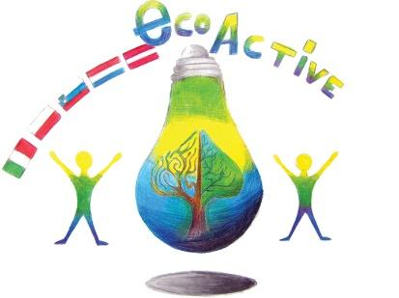
LESSON PLAN
SCHOOL | Tone Pavček Primary School, Slovenia
THEMATIC AREA | Drinking water
TEACHER | Zdenka Mežan
SUBJECT | Science
AGE GROUP (approximately) | 8 – 9 years old
TIME REQUIRED | 90 minutes
PLACE | Classroom
LESSON OBJECTIVES | Students:  - explain the dangers of drinking polluted water,  - describe the way water makes from the reservoir to the tap,  - make a sand filter,  - develop practical work skills,  - estimate the suitability of the final product,  - clean polluted water.
LESSONS YOU CAN USE | - Chemistry  - Science  - Foreign Language (as vocabulary extension)  - Ecology
CLASS ORGANISATION | - Pair work  - Group work  - Individual work
MATERIALS | A plastic bottle, cotton wool, charcoal, stones, sand, three yoghurt cups, water taken from different sources.
ICT TOOLS | Interactive board
PROCEDURE | The teacher reads a riddle:  We use it in traffic, we need it for appropriate body functioning, it enables us to produce energy, we cook in it, it is important in food production. What is it?  Students answer WATER.  The teacher explains that water has no colour, smell or taste. We find it in three states of matter: solid, liquid and gaseous. It is important for survival of all living creatures.  In the developed countries people get water from taps, but in underdeveloped countries they pump water from wells or bring it from rivers.  The teacher asks:  - Is all the water in nature drinkable?  - What mustn't drinking water contain?  - If water is clean, is it also drinkable?  - Where does water come from into our taps?  - How is quality of water established?  - What happens if we drink polluted water?  - Name a few water pollutants.  - Can we clean water? How?  Students answer the questions.  Making the sand filter  Note: the work is done outside  Students need:  - a plastic bottle,  - stones and sand,  - cotton wool,  - charcoal.  The teacher gives instructions:  An adult cuts off the bottom of the bottle. Then you cram up the bottle neck with cotton wool, turn the bottle round and put inside layers of charcoal, fine sand, sand and smaller stones.  Pour rainwater, wastewater and water mixed with some soil into three separate cups. Pour each one into the sand filter and observe what happens. Put an empty cup under the bottle.  Students present their findings by answering the questions:  What is the water that pours out of the filter like? Why?  Is this water now drinkable water?
EVALUATION
ATTACHEMENTS

