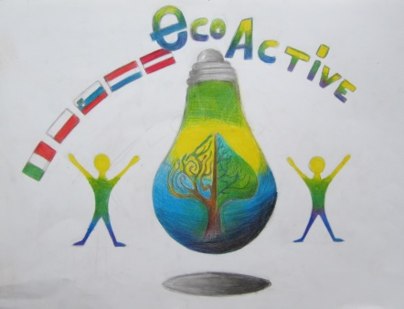
ECO-ACTIVE
Erasmus+ programme
newsletter 1.03.2018 – 1.06.2018

LATVIA 01.03.2018. – 21.05.2018.
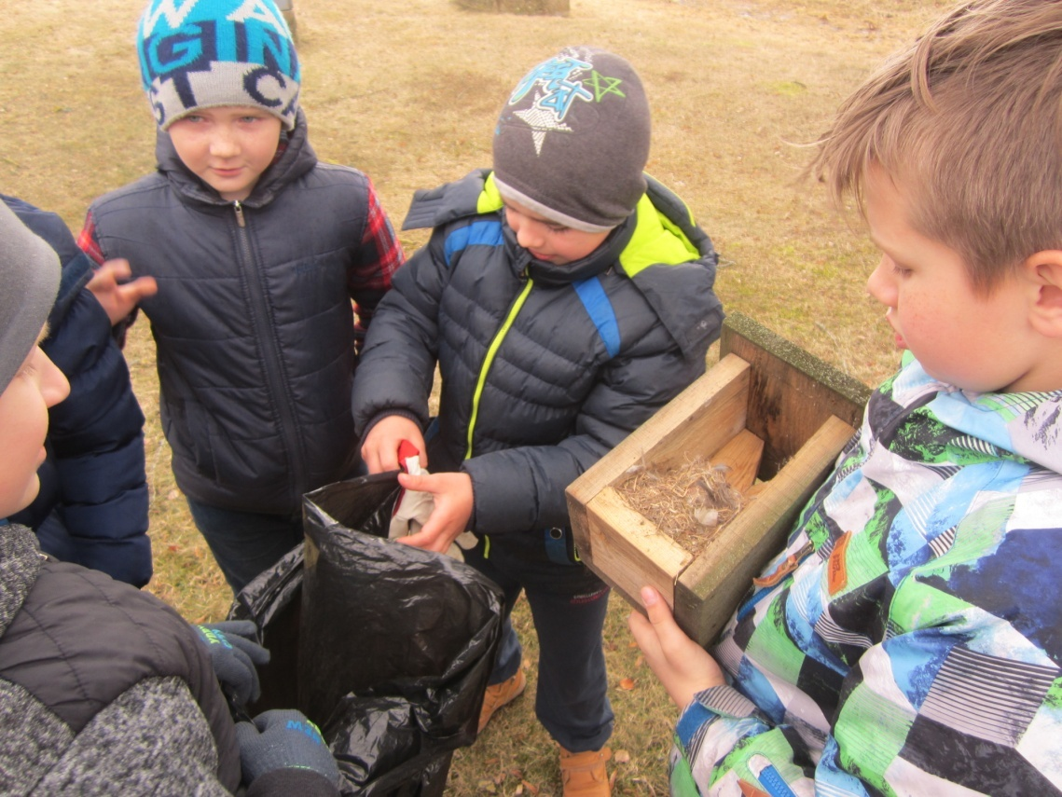
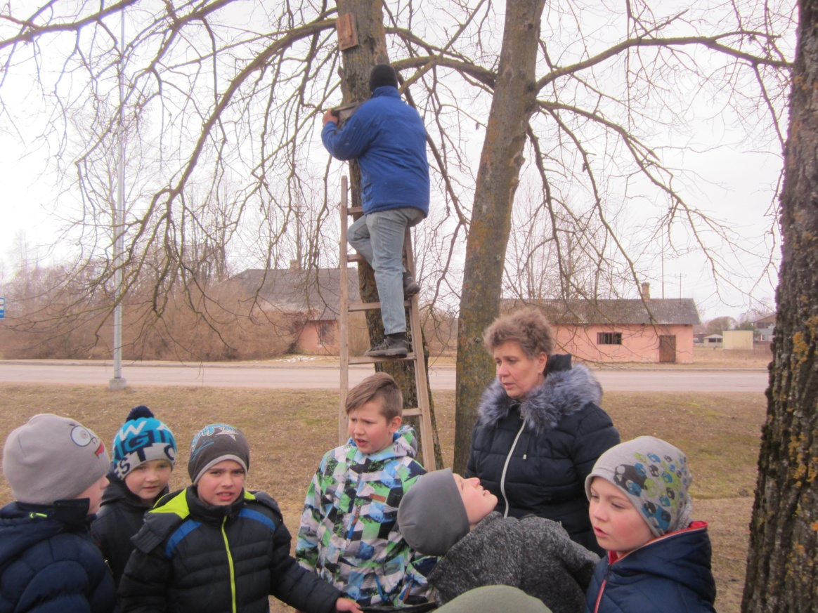
*) At the beginning of the spring, Anna’s Brigaderes primary school students participated in various environmental activities. The 2nd grade pupils prepared bird houses. . The 3d grade pupils cleaned bird houses in the school area, while the 6th and 8th grade students went to the nature park in Tērvete to clean the bird houses there, waiting for the return of small migratory birds.

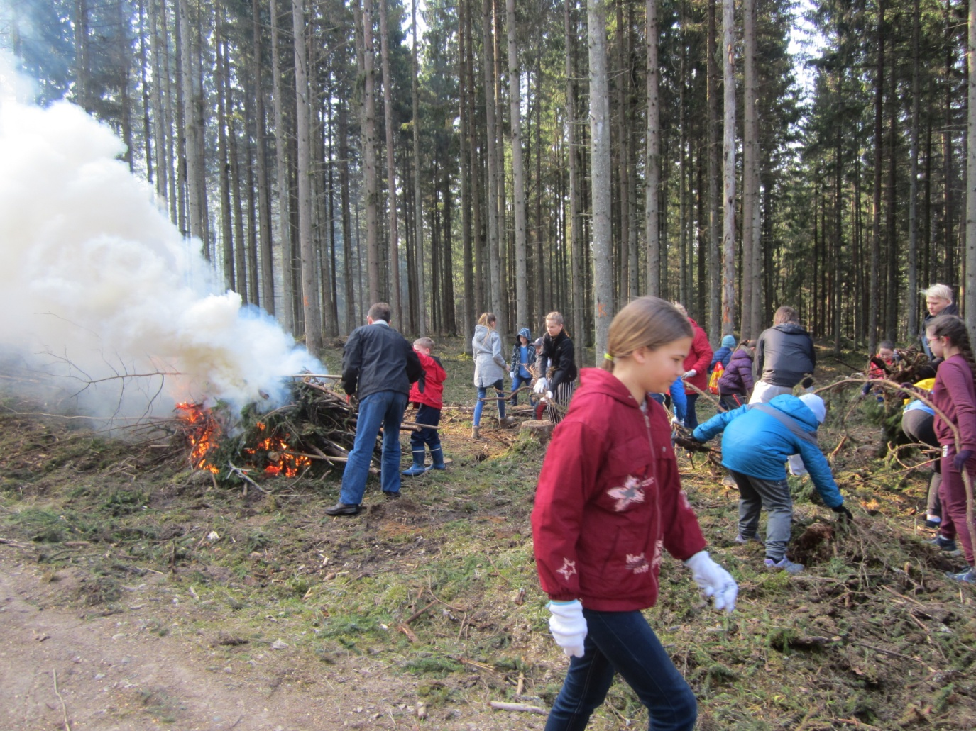
*)The 2nd, 3rd, 4th, 5th, 7th grade students went to the Pokaini Forest to participate in the Great Cleaning. The pupils cleaned the forest, picked up small twigs. This day students also became acquainted with the secrets of the famous Pokaini Forest.

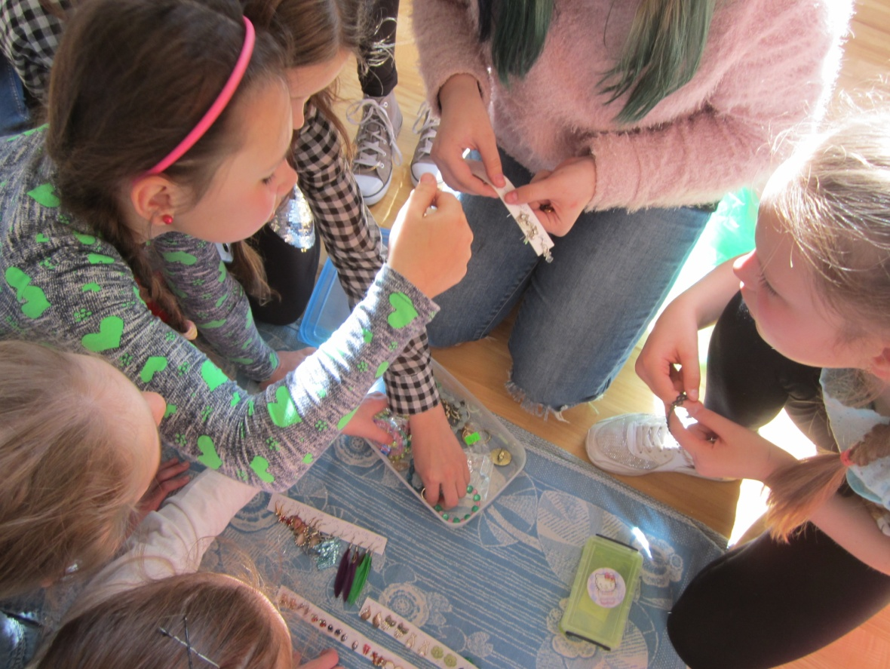
*)At the end of April there was an eco week in the school. Each day of the week was dedicated to a specific topic. On Monday, there was a market for self-made and unnecessary things.

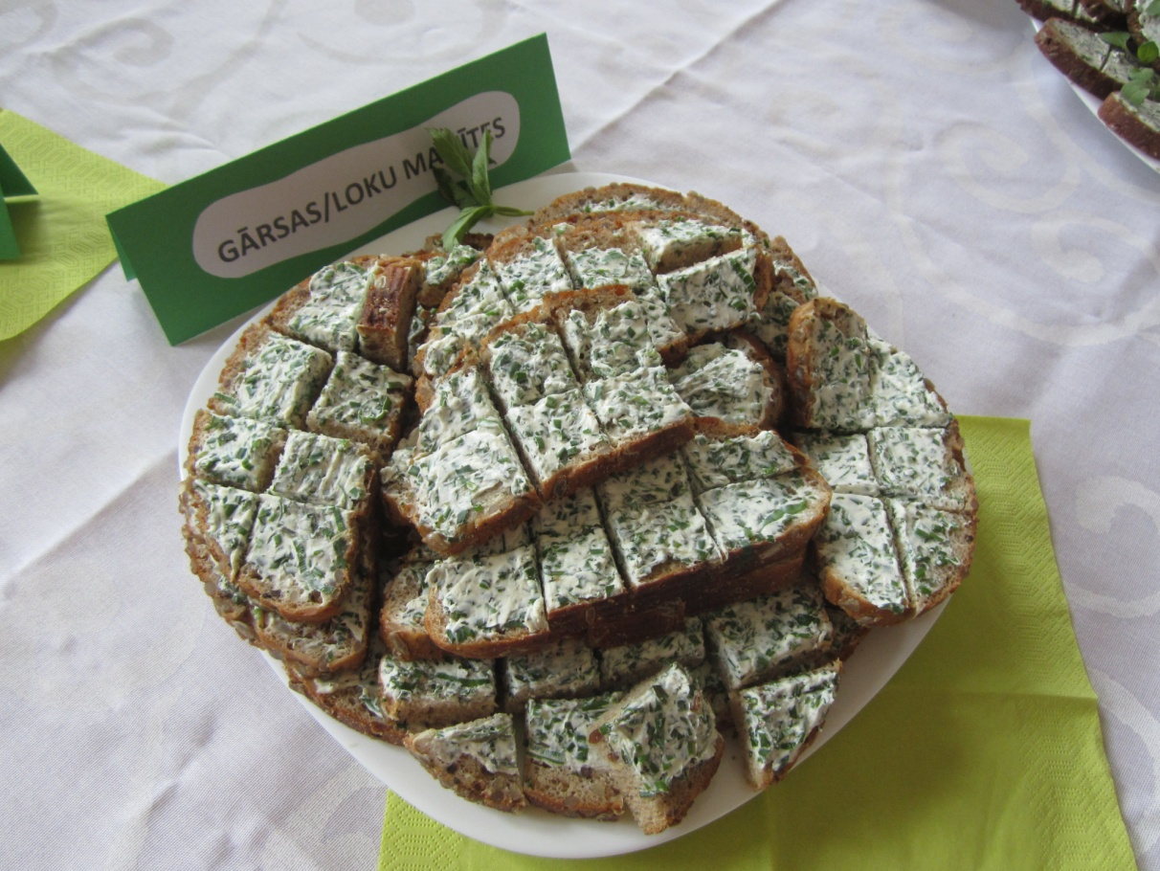
Tuesday was a healthy diet - the Latvian Green menu. Pupils could enjoy a variety of spring herbs that can be eaten.
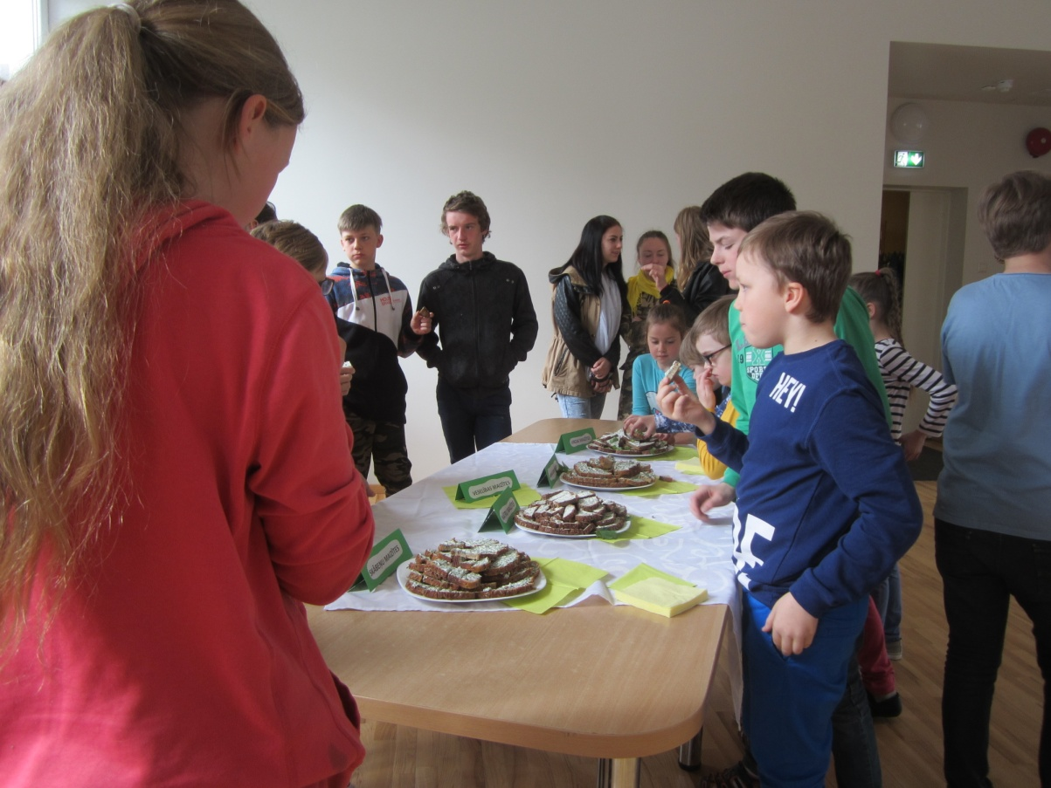

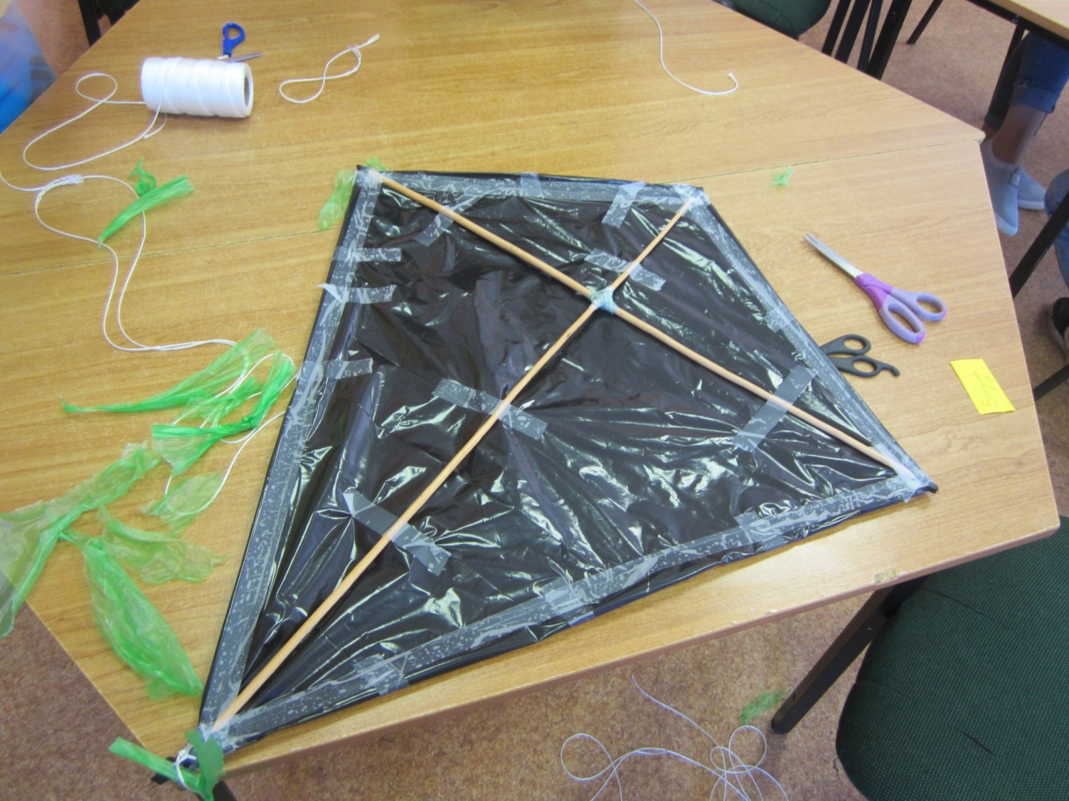
On Wednesday we learned about energy. Pupils made kites, then they tested them in fresh air. The 5th grade student presented his presentation about forms of energy in Latvia.

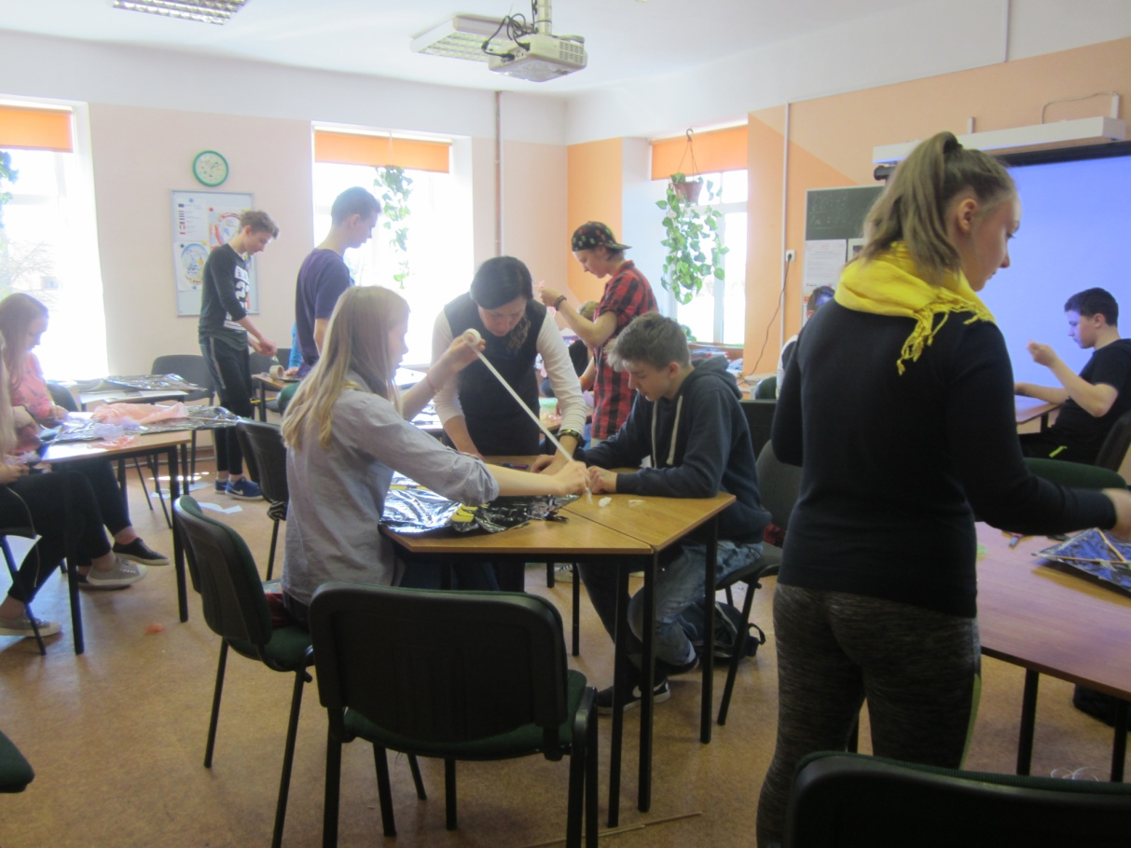

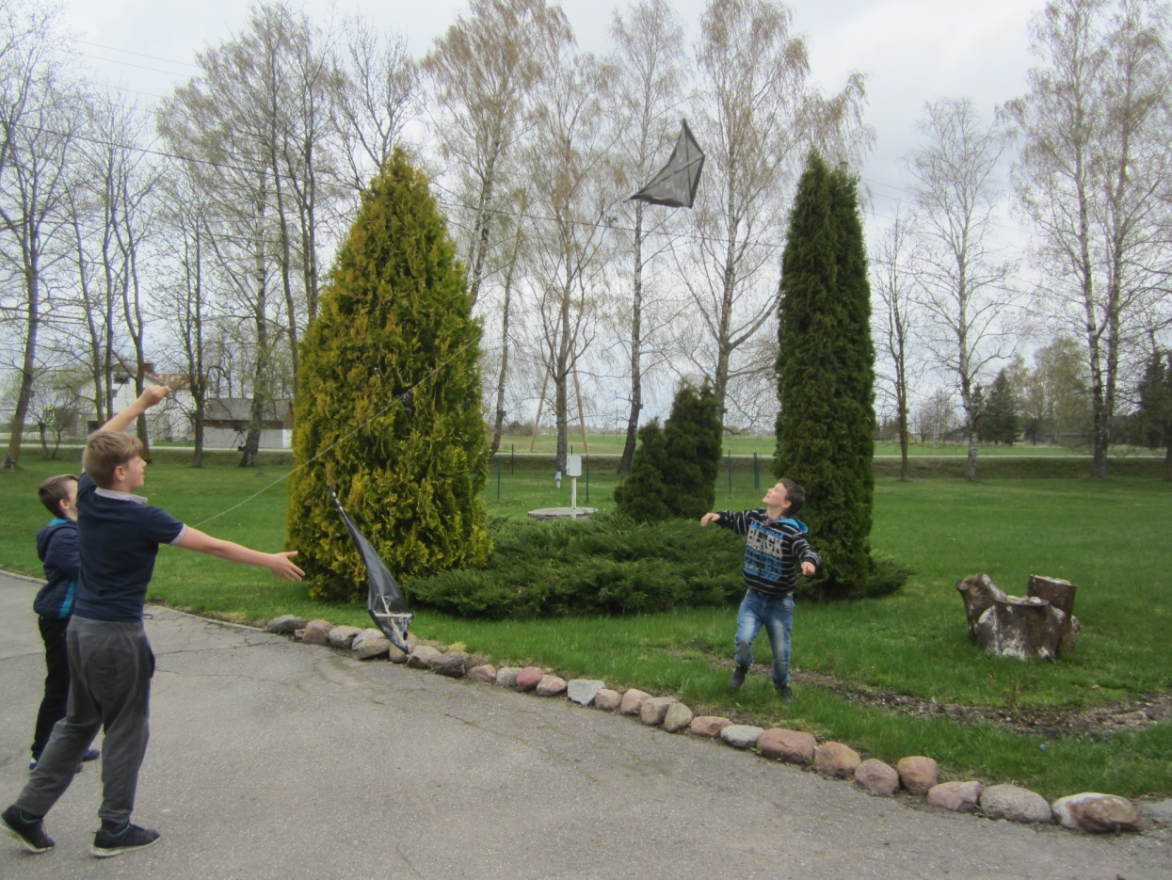

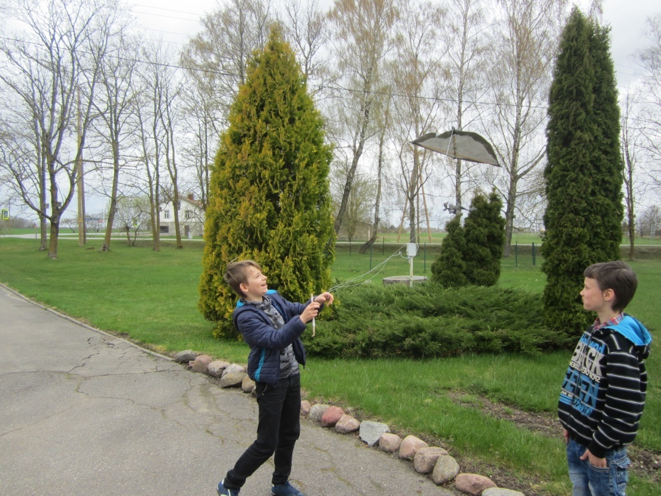

On Thursday, students presented their own eco-games. On Friday, friends from Estonia visited the school. The students took part in the eco-fashion show and together participated in environmental cognitive activities at the Tervete Nature Park.
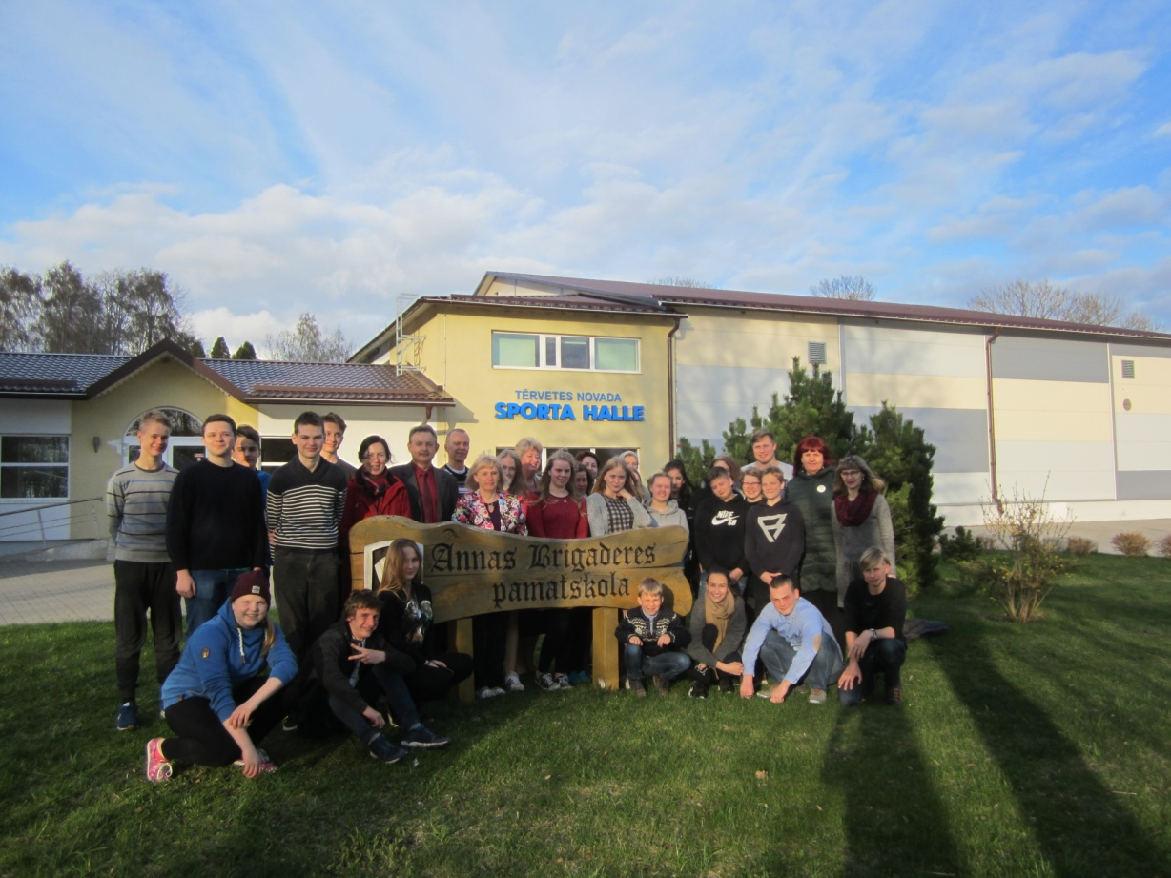
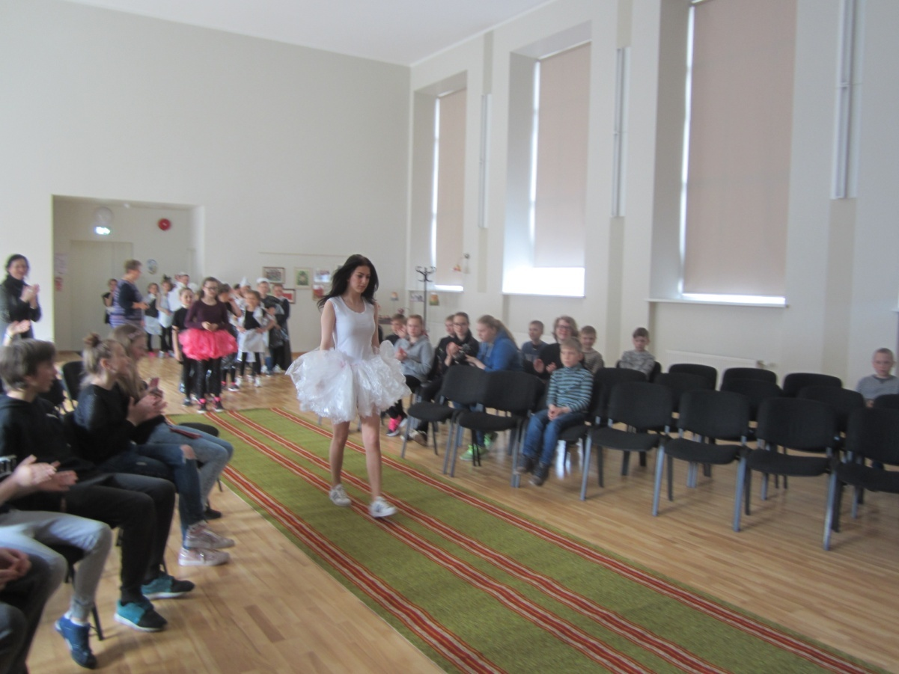
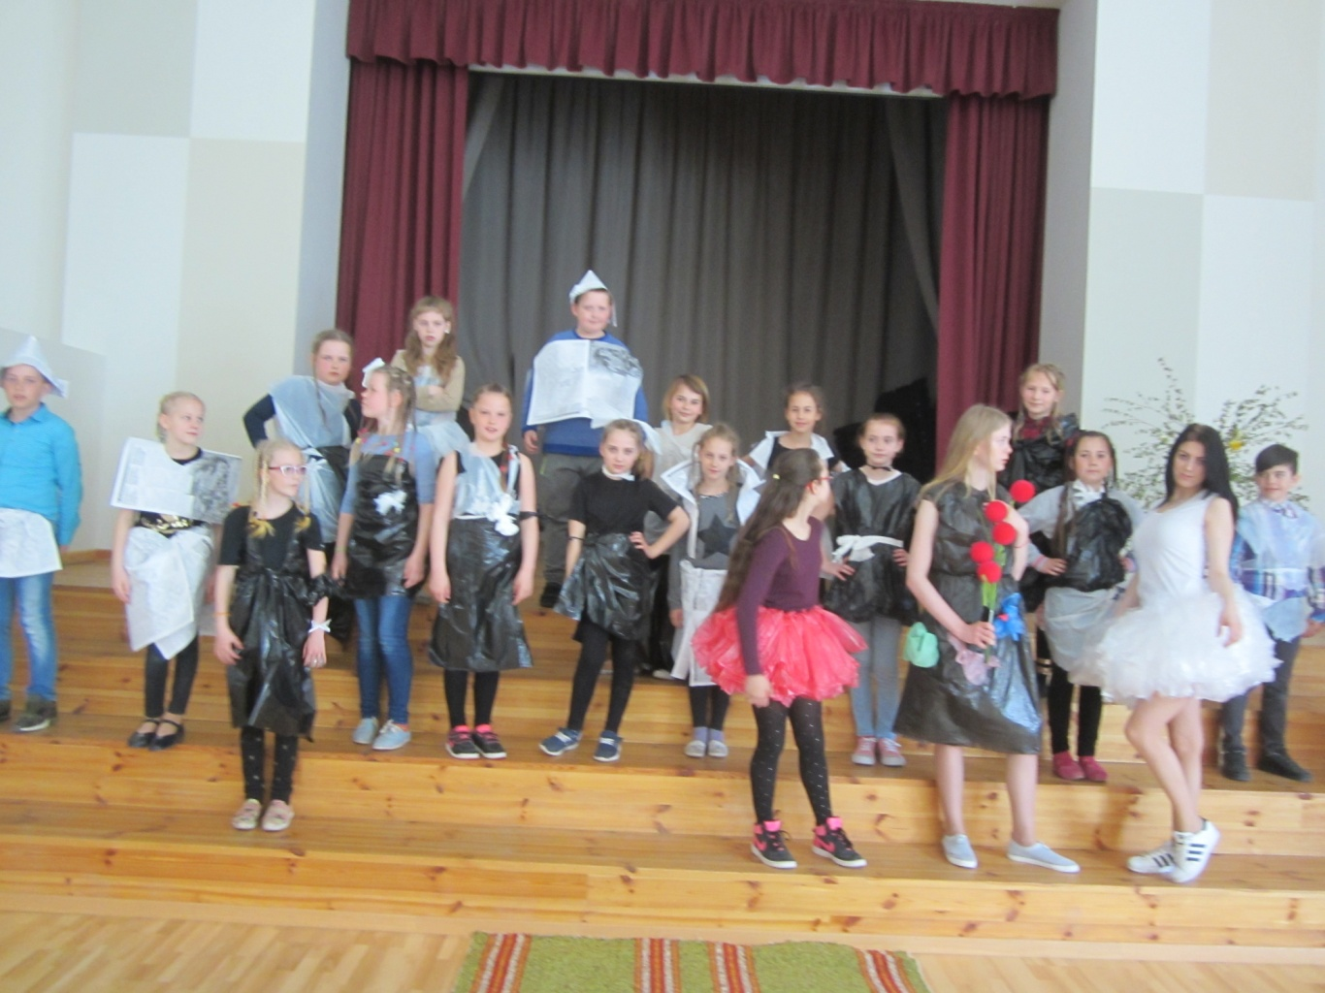
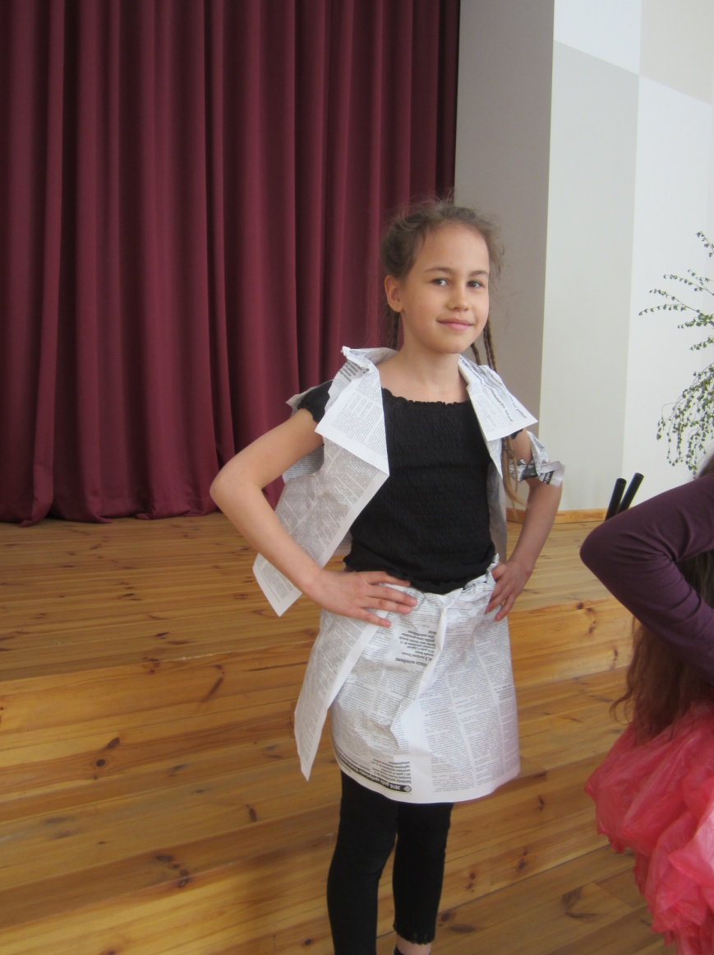

*)
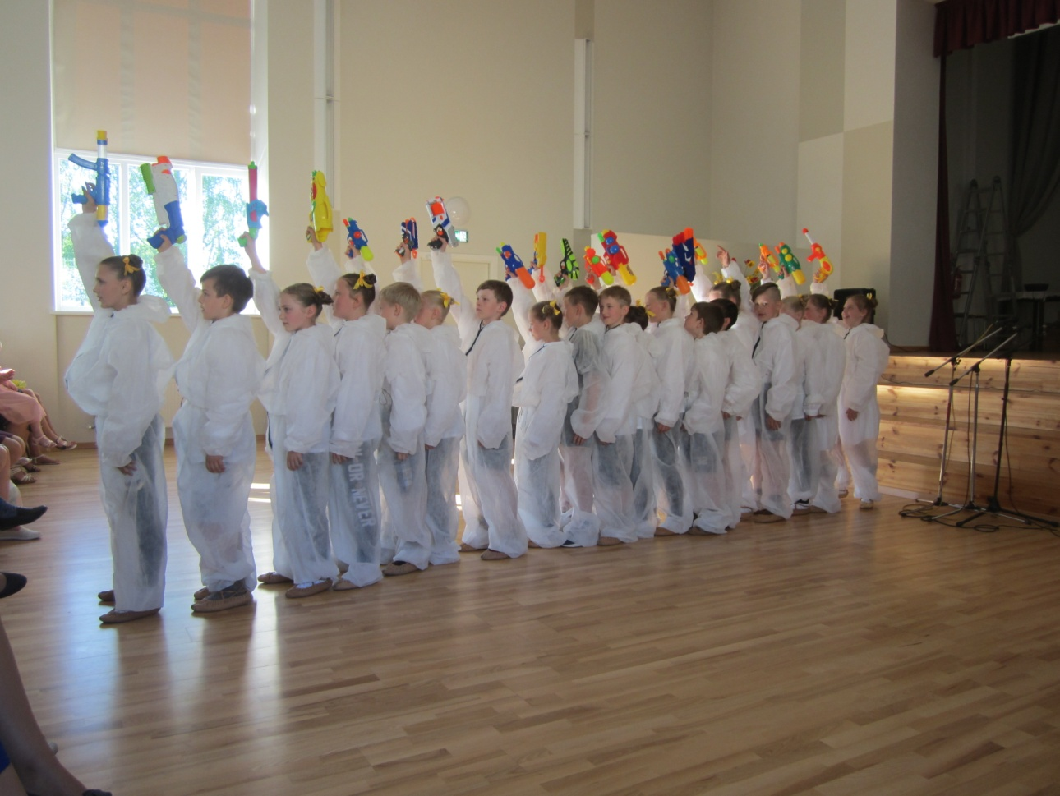
The school dance group participated in the environmental festival with the new dance.
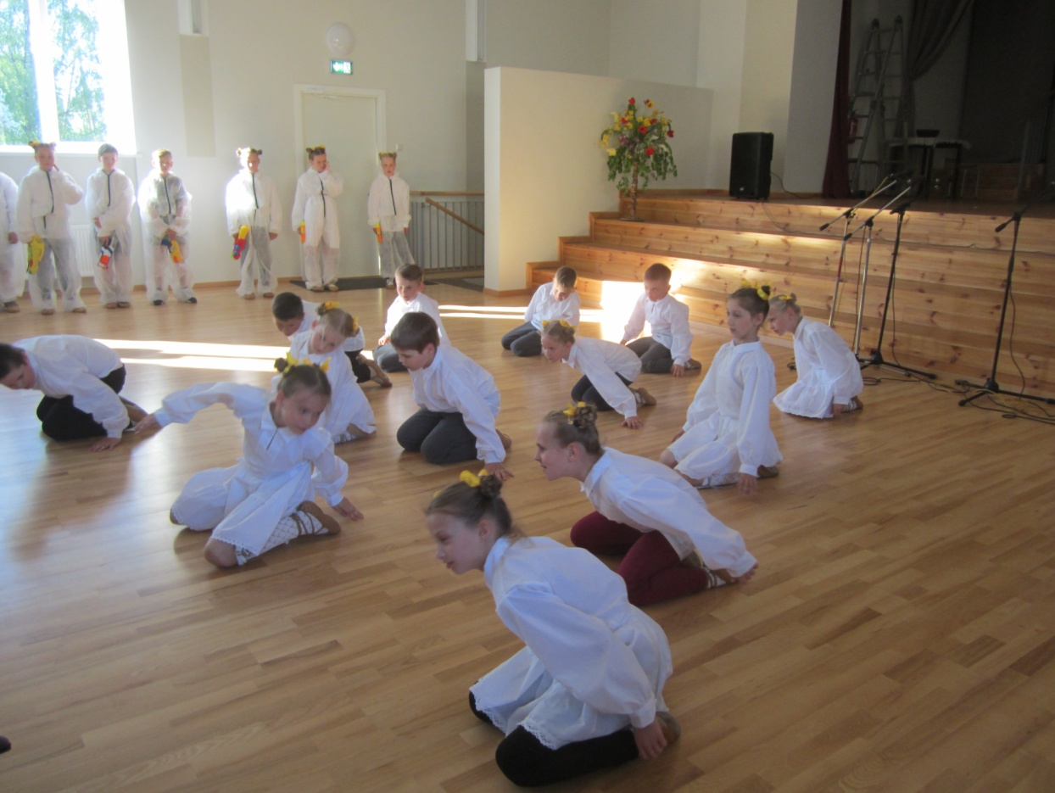

We congratulate the winners of all three competitions: winners of the battery collection contest (we collected 370, 515 kg); winners of the waste collection competition (we collected 1746 kg this year); the winners of the "My Family Menu for the Week" contest
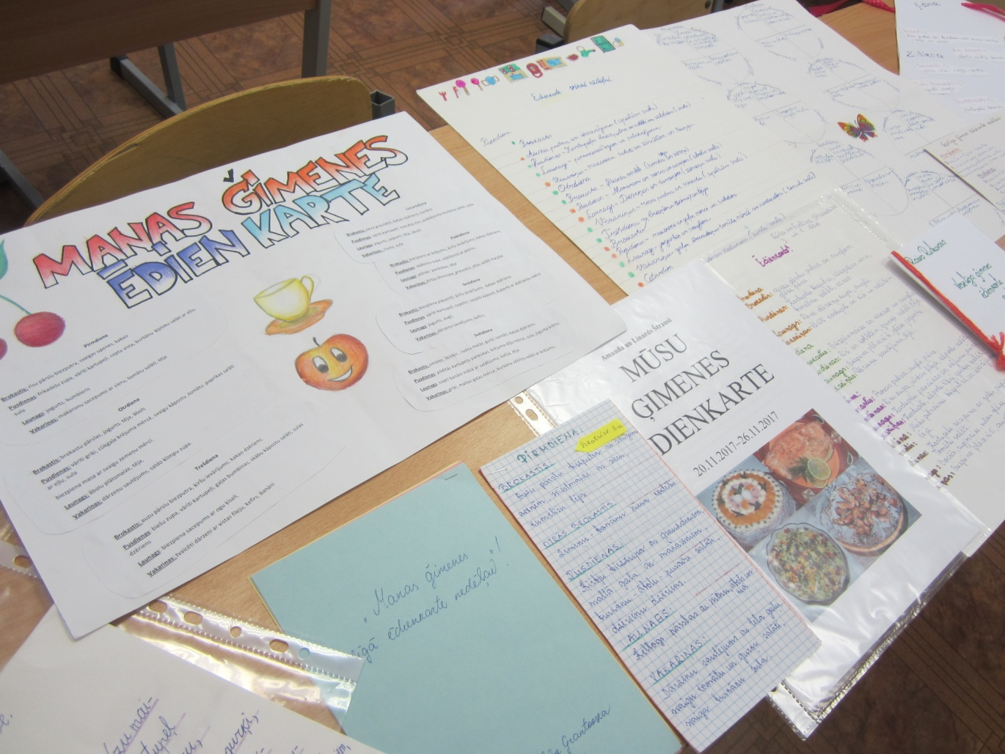

There were videoconferences with Slovenia, Italy and Poland.

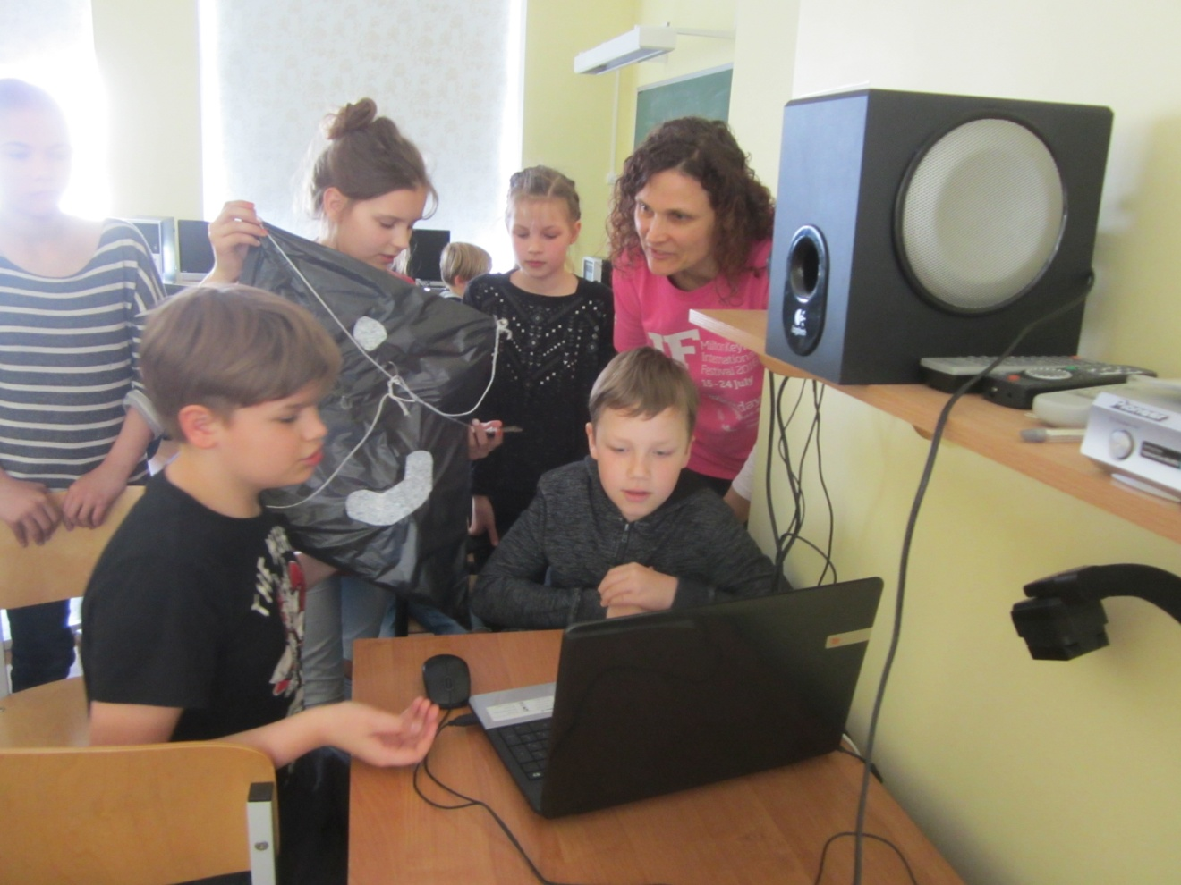

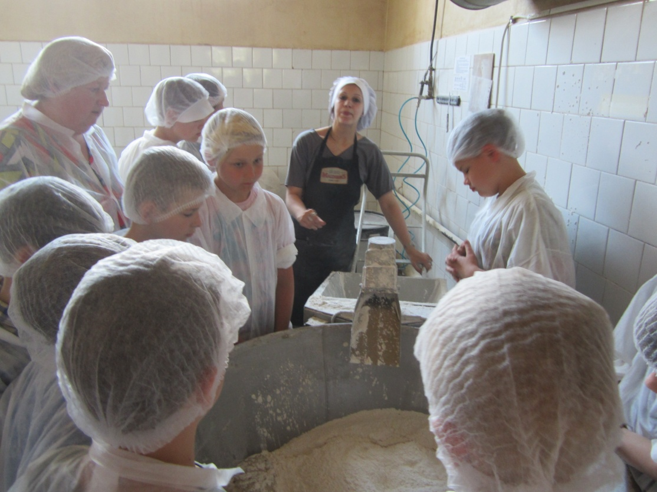
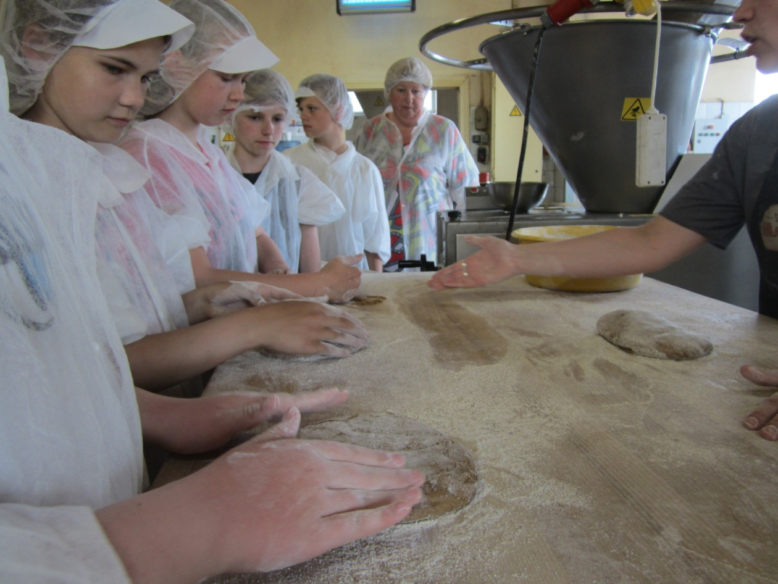
3rd, 4th and the 5th grade students went to the company "Saldus Bacery" and got acquainted with the bread making
POLAND:
A lot of competitions about Energy were announced and conducted in the Polish school. The awards were given to the pupils who took place in the competitions.
A competition for:
1. A board game concerning Energy
2. A computer game concerning Energy
3. PPT presentation concerning Energy
4. „European monuments 3D”
5. „Easter decoration 3D” – pupils’ initiative
6. “Eco-Easter Basket” - pupils’ initiative

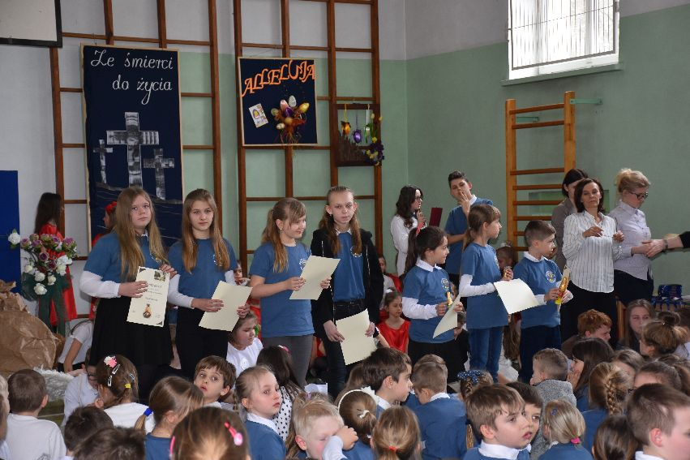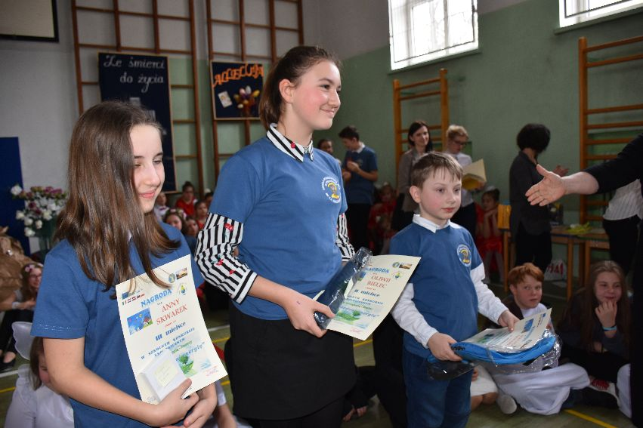

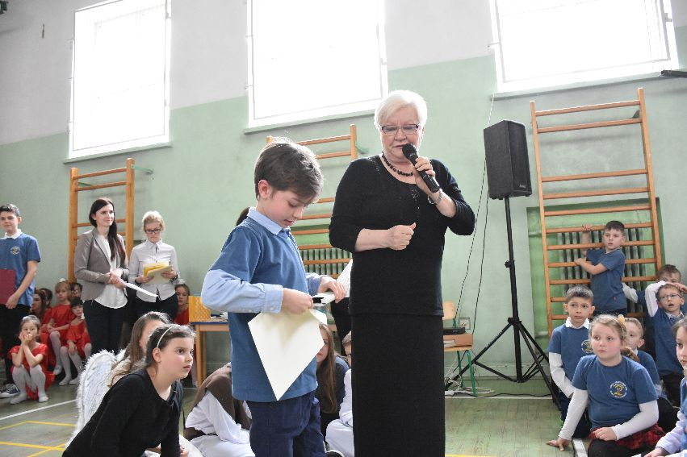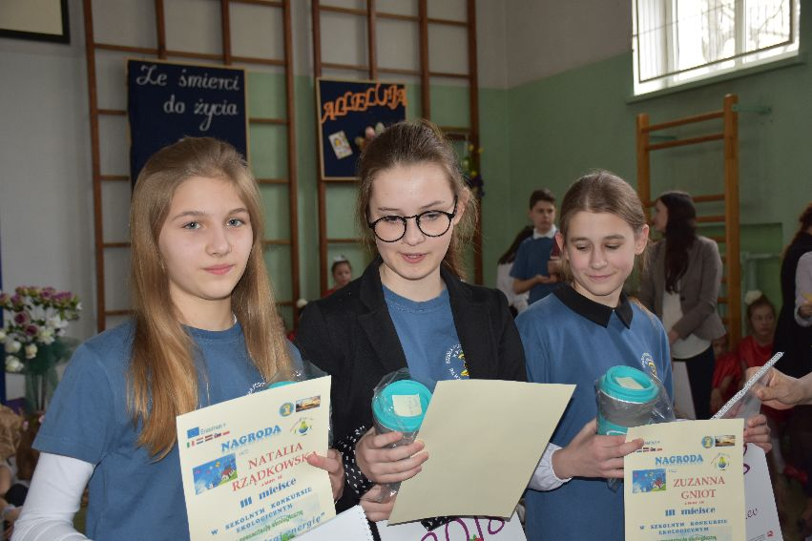

Health on the plate
Class 5 a made fruit salads. The students know that healthy lifestyle means being active but also healthy eating.

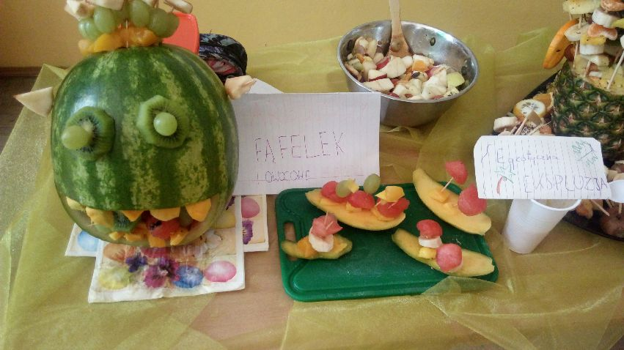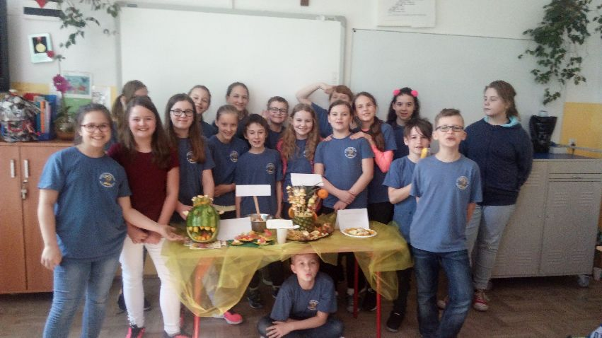

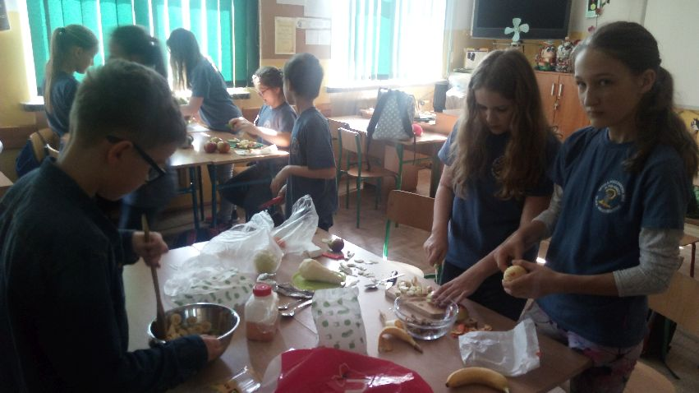
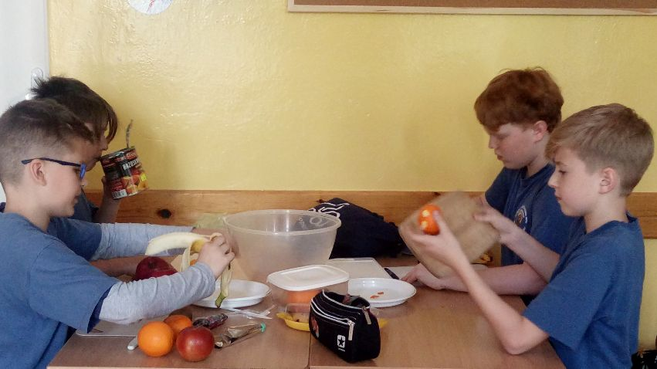
Competition Eco-Flowerbed organised by Leroy Merlin in Puławy
Szkoła Podstawowa nr 2 w Puławach won the 2nd place in the competition "TAKE CARE OF NATURE - CREATE ECO-FLOWERBED WITH LEROY MERLIN IN PUŁAWY". Customers visiting the shop voted for the flowerbed they liked the most.
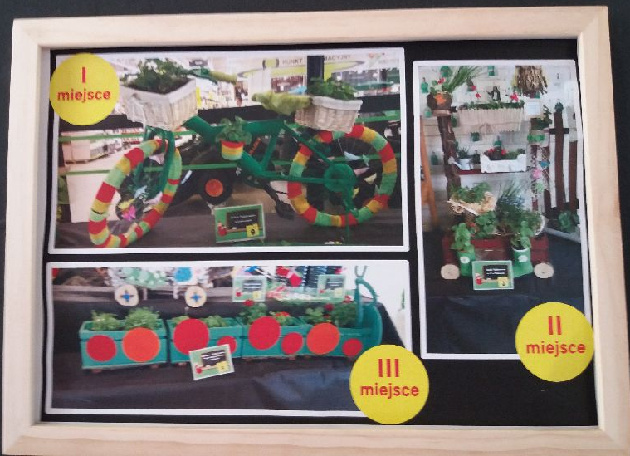
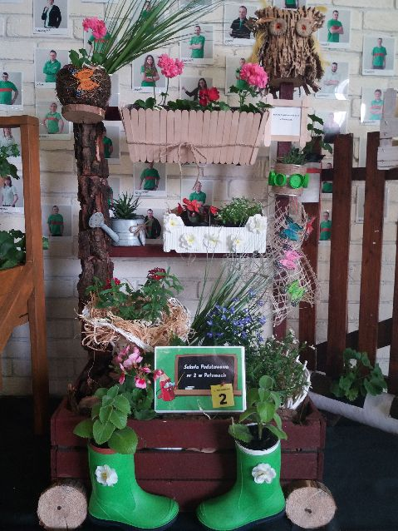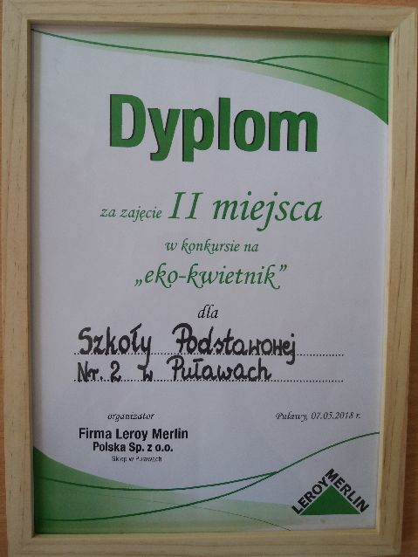
SLOVENIA:

* the collection of paper, plastic caps and batteries. Plastic caps were given to charities.
* children wrote poems about energy, made some games in scratch and some board games.
* students did some presentations about water, energy.
* there is PPT made in Eco Club
* the best eco-class was chosen. This class is going on an eco-trip in June as a reward.

THE NETHERLANDS:

* Four videoconferences took place – with Poland, Slovenia, Italy and Latvia.
* Three Ecoweeks are planned: the week before the visit in Italy, the week during the visit in Italy and then the week after that week.
* Three Ecopaedia lesson plans were added: two about energy, one for “health” the week menu..
* A new game was created: energy monopoly, (Twinspace), one piece for every school will be broight to Italy

* A special lesson for the children of form 7 was conducted by Huub Creemers (children from this class are going to Sicily). A lesson about energy, how pupils can search for information about energy, make a presentation and how to present it. How can children learn from each-other ( see Twinspace ). Think about a game about energy and realise this, the board, the rules and playcards.

*Healthy weekly menu, made by the oldest pupils. ( see Twinspace ). Also a lesson plan about it was created and added to eTwinning.

*There was a survey about the use of electricity, gas and water in order to check what the costs are for one person.

*Pupils collected old paper and batteries. They also collected old clothes and brought them to a special place.

*Pupils are preparing ( with all the teachers ) a project about energy. It starts 23th of May and the 8th of June.

*A meeting with parents and children who go to Sicily took place.

