ECO-WEEK PROGRAM IN LATVIA 07.10.2018. – 13.10.2018.
SUNDAY 07.10.2018. | MONDAY 08.10.2018. | TUESDAY 09.10.2018. | WEDNESDAY 10.10.2018. | THURSDAY 11.10.2018. | FRIDAY 12.10.2018. | SATURDAY 13.10.2018.
Arrivals:  06.10.2018. Slovenia (5) at 17:50  Italy (11) at 14:04 (stay in Riga) | 8:00 – breakfast  8:30 – going to school  9:00 – arriving at school | 8:00 - breakfast  8:30 - going to school  9:00 - arriving  at school | 8:00 – breakfast 8:30 – going to school  9:00 - arriving  at school | 8:00 – breakfast 8:30 – going to school  9:00 - arriving  at school | 8:00 – breakfast  8:30 – going to Riga | Eco-walking in the nature park in Tērvete
Arrivals:  The Dutch (8) at 11.30  Poland (8) at 1:25 | 9:00 - official start of the eco week,  Meeting the school.  Snacks at school  10:30 – acquaintance with the pre-school education group "Sprīdītis"  11:10-12:00 – education system in Latvia  11:10-12:00 –  Creative activities for students | 9:00-9:35 – Lesson for international group led by Latvia  9:40-10:20  a lesson led by The Netherlands  9:40-10:20  a lesson led by Poland  10:20 – snacks  10:30-11:10  a lesson led by  Italy  10:30-11:10  a lesson led by Slovenia  11:30-12:10 – students show the presentation "Healthy Family week menu” | 9:00-17:00- eco-activities in the nature park in Tērvete  (appropriate clothing for outside activities) | 9:00 –ecohappening  Sports day, (appropriate chlothing and shoes for activities in gym)  Giving out Certificates | 9:30 - Excursion and workshop in the factory of juice candies | Departures:  Poland at 14:05  Slovenia at 14:15  Italy at 14:30
 | 12:15 – lunch | 12:15 – lunch | 12:15 – lunch | 12:15 – lunch | lunch boxes
14:00 – Visit to the National Library | 13:15-14:15 – meeting with the chairman and officials of the Tervete municipality  14:30-16:00 – excursion to the Tervete bakery  16:30-18:00 – creative activity in the "Peppermint house" | 13:00-15:00 – Coordinators' meeting; evaluation of lessons  13:00-14:00 – eco games  14:00-15:30 – master class "Mēnestiņā"  16:00 – Dobele candles  16:30-17:30 – Visit to the Institute of Horticulture | 17:30- Tervete castle | 13:00 – masterclass for teachers with Visvaldis Bebrišs  13:00 – Students present a healthy regional dishes  14:30 – Tērvetes beer, kvass, water tasting | 12:00-14:00- eco Riga  Old Riga  14:30 -TV tower
supper in Lāči | 18:30 - supper | 18:00 – supper | 18:30 - supper | Final evening with project guests | 16:30-18:00- Lido leisure centre | 14.10.2018.  Departures:  The Netherlands 11:55
arriving at hotels and guest houses | arriving  at hotels and guest houses  free time | arriving  at hotels and guest houses  free time | arriving  at hotels and guest houses  free time | arriving  at hotels and guest houses | arriving  at hotels and guest houses

NATURAL PARK OF TERVETE
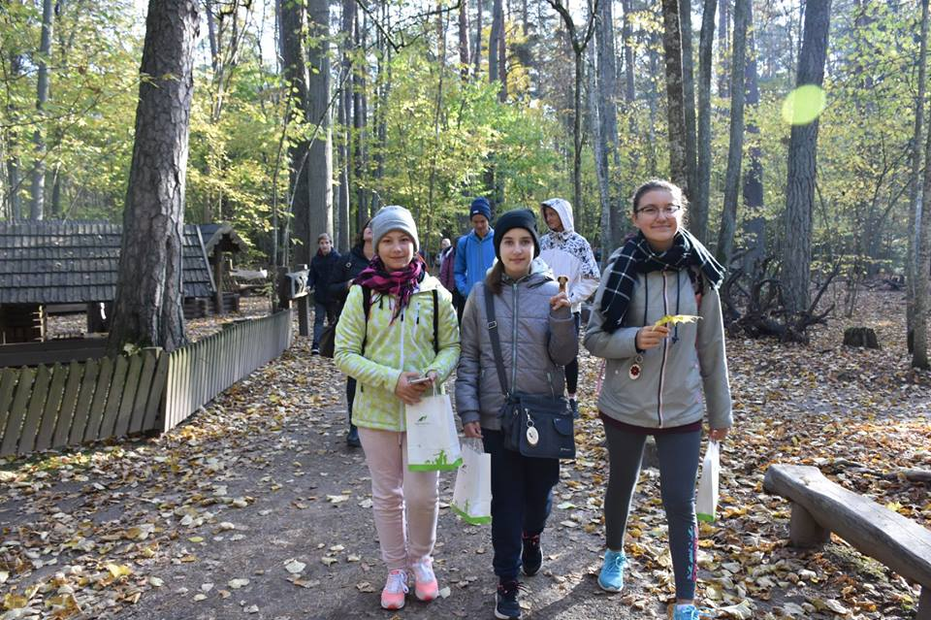
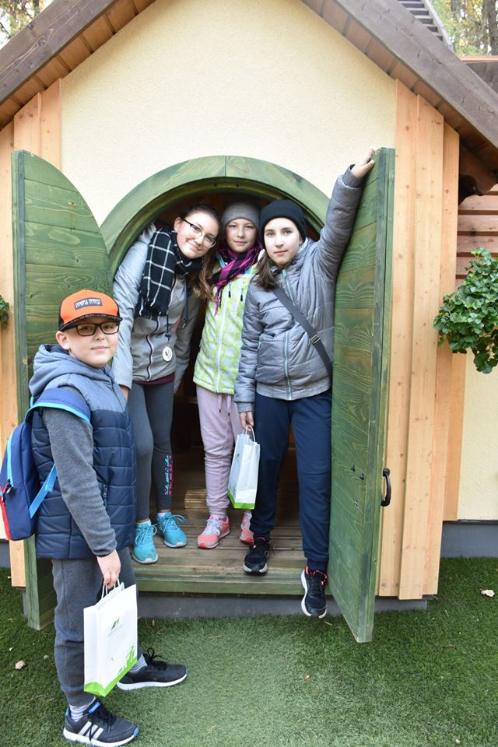

WORKSHOPS
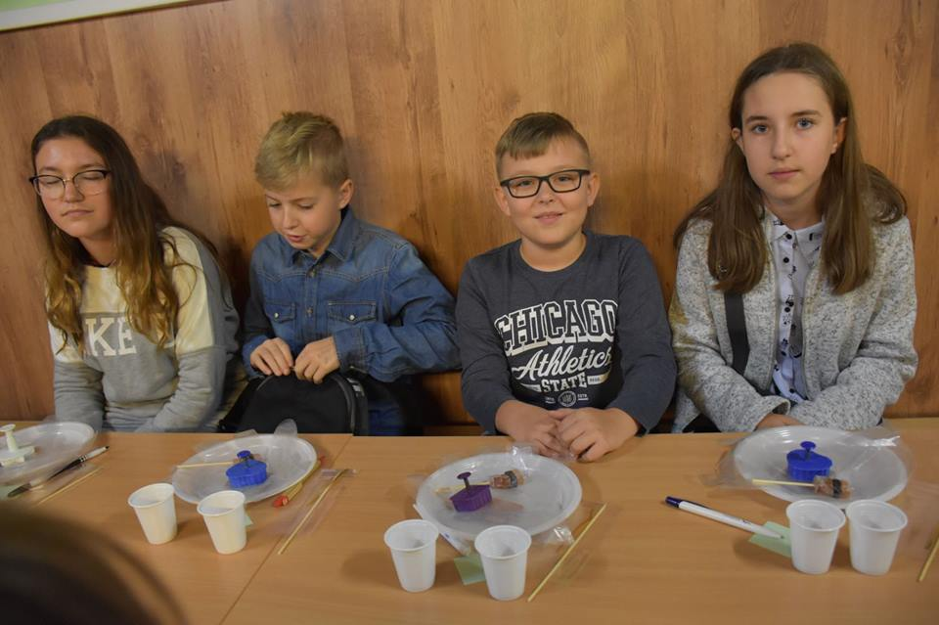

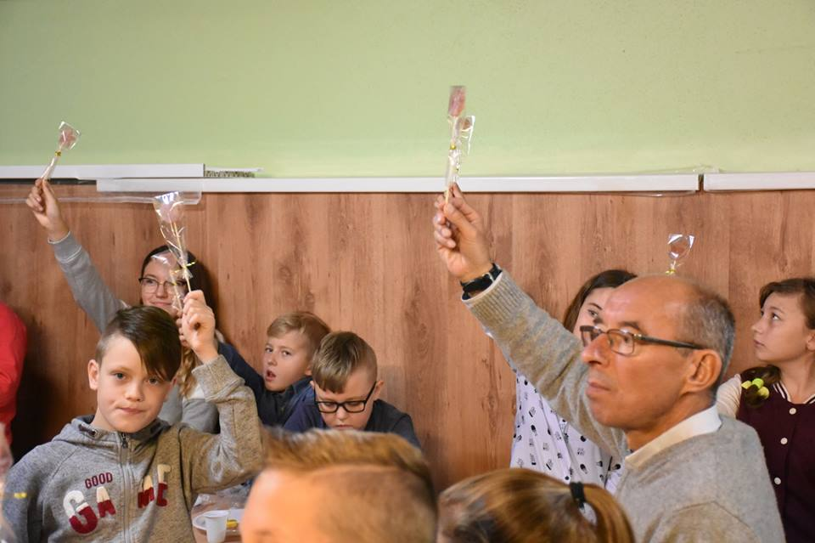

A TRIP TO RIGA

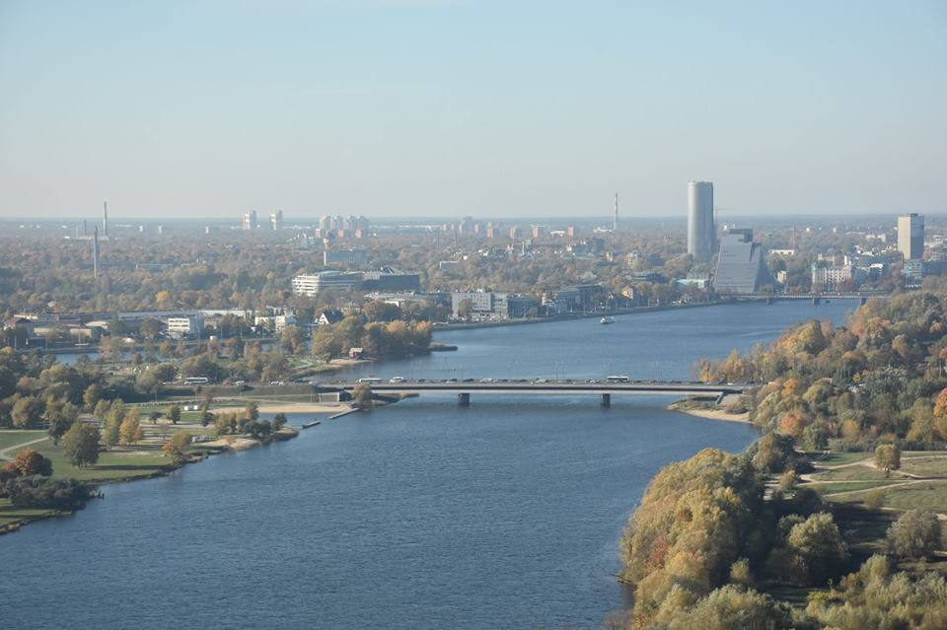

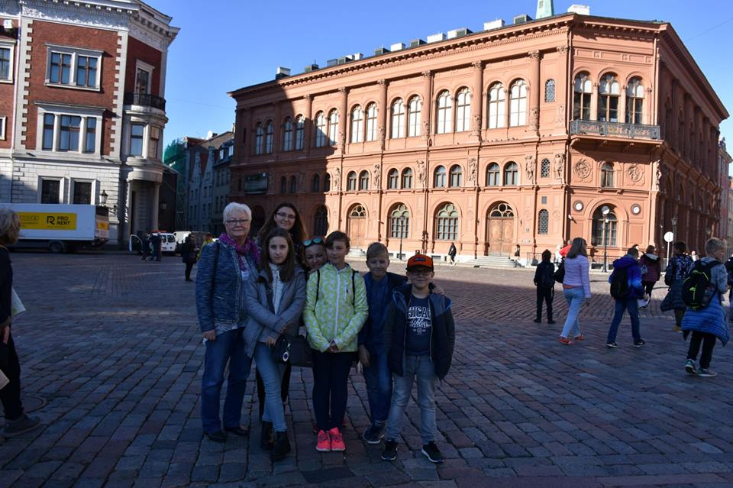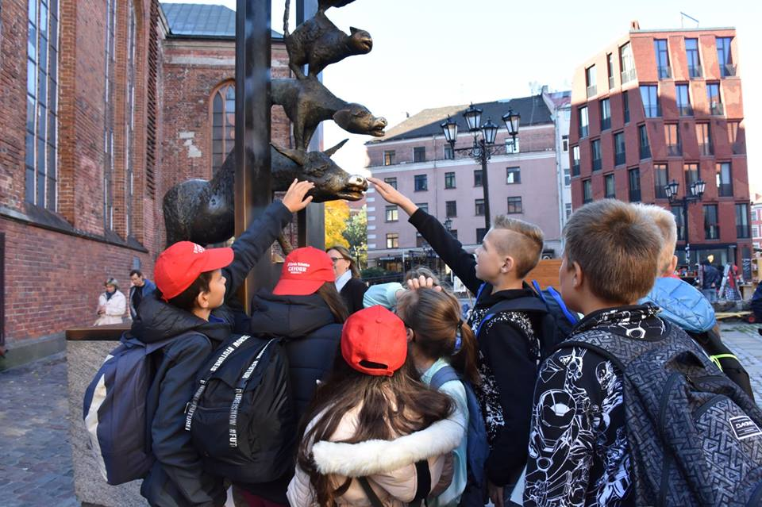

LESSONS
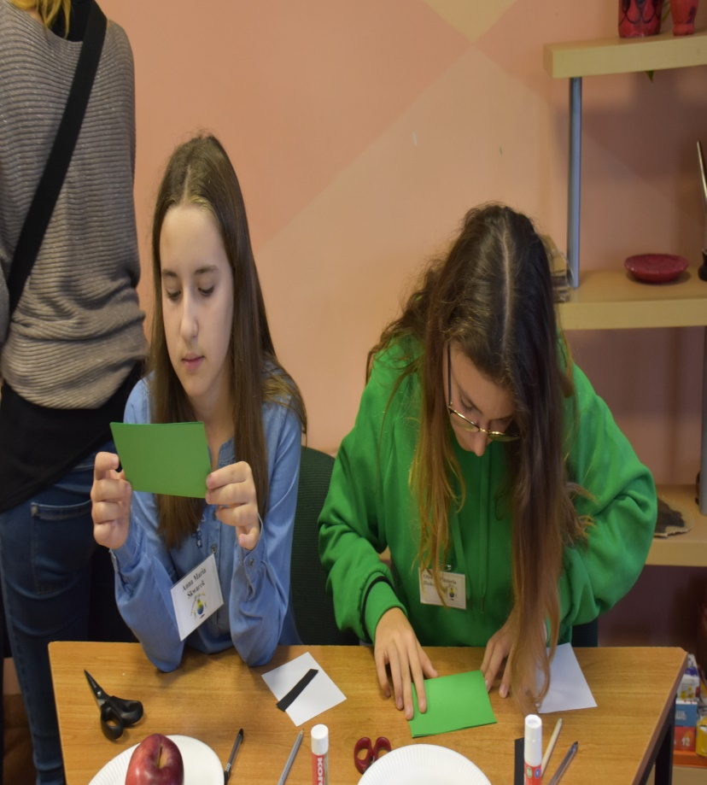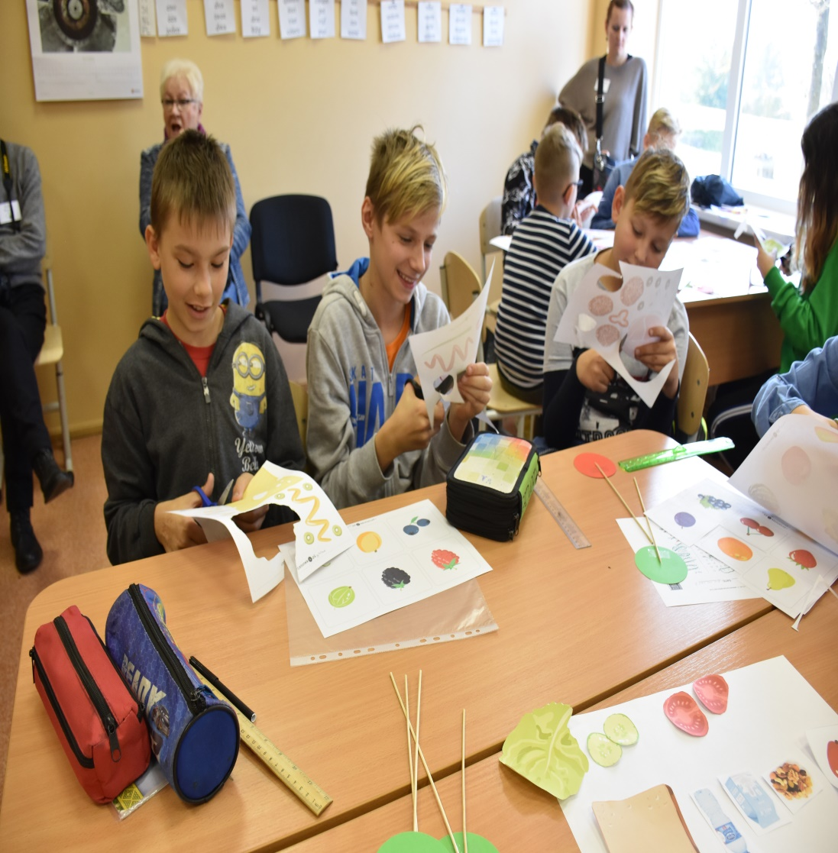

PRESENTATIONS
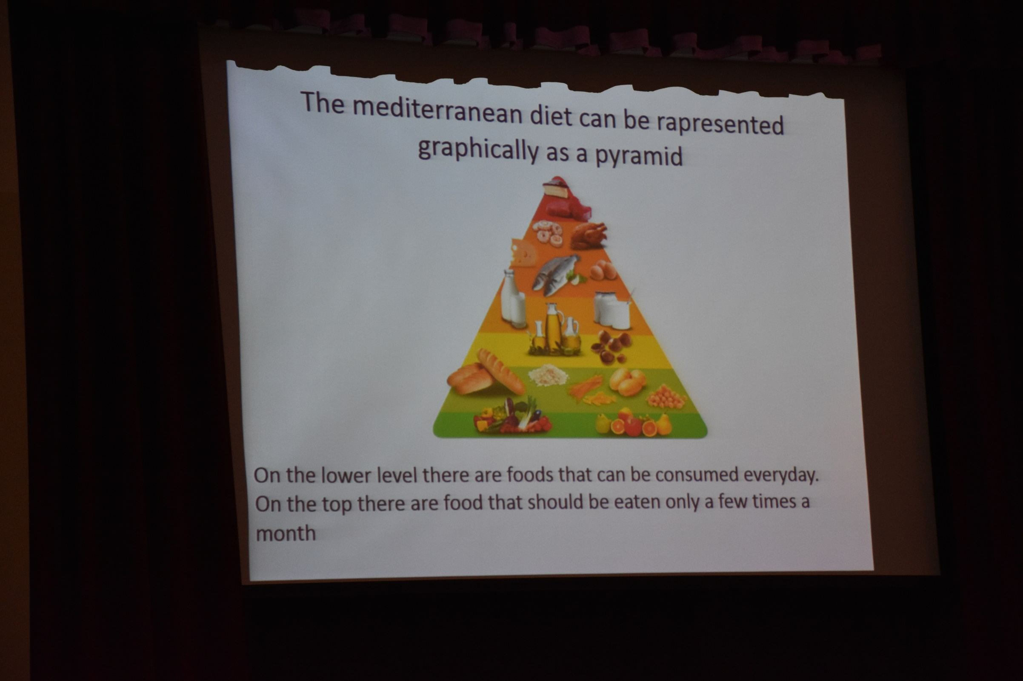

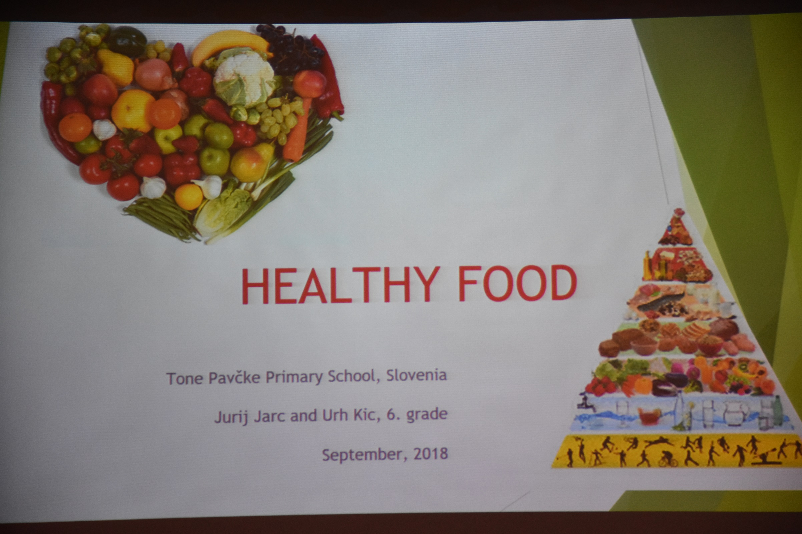
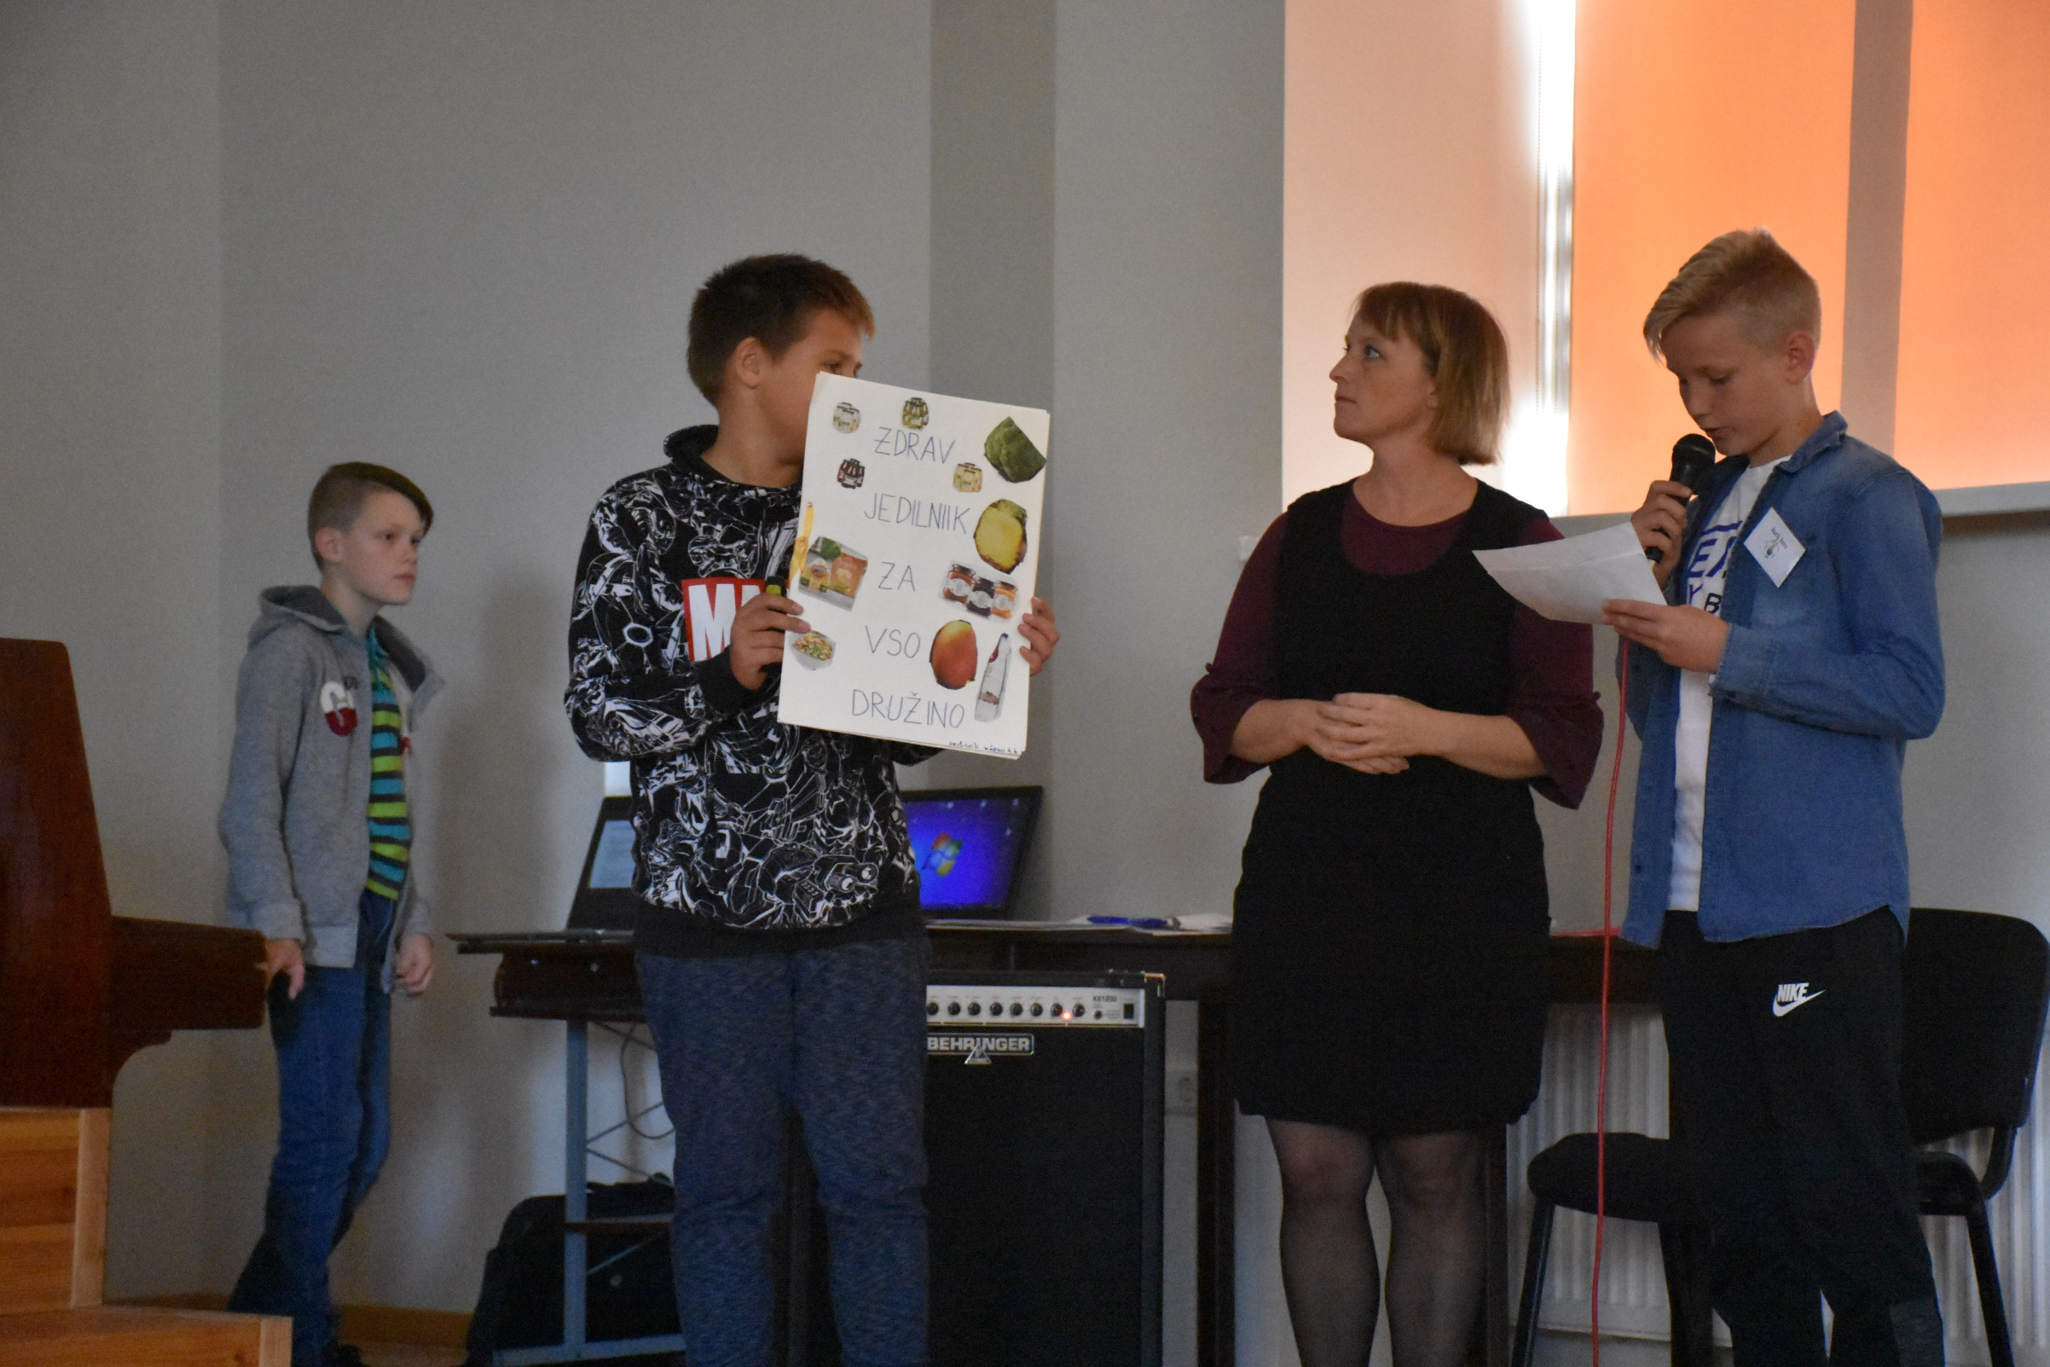
A VISIT IN BAKERY
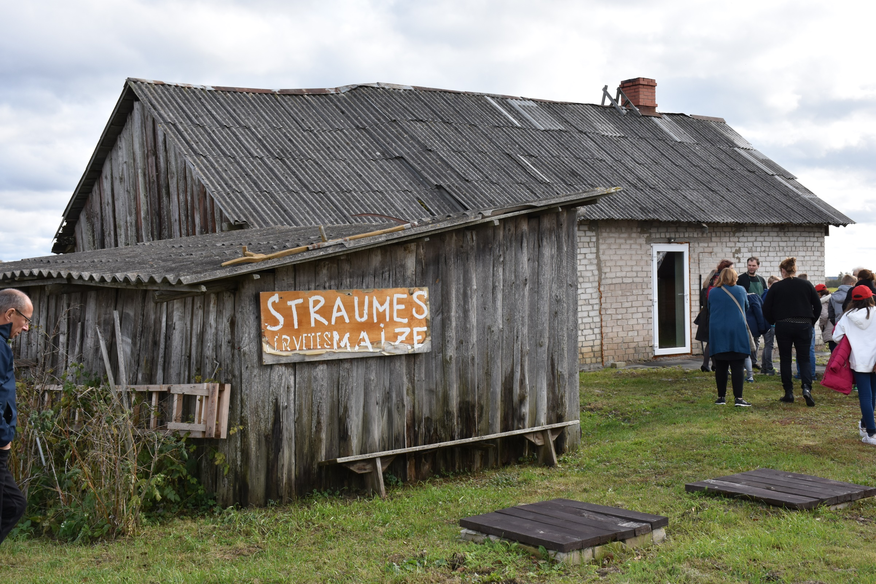
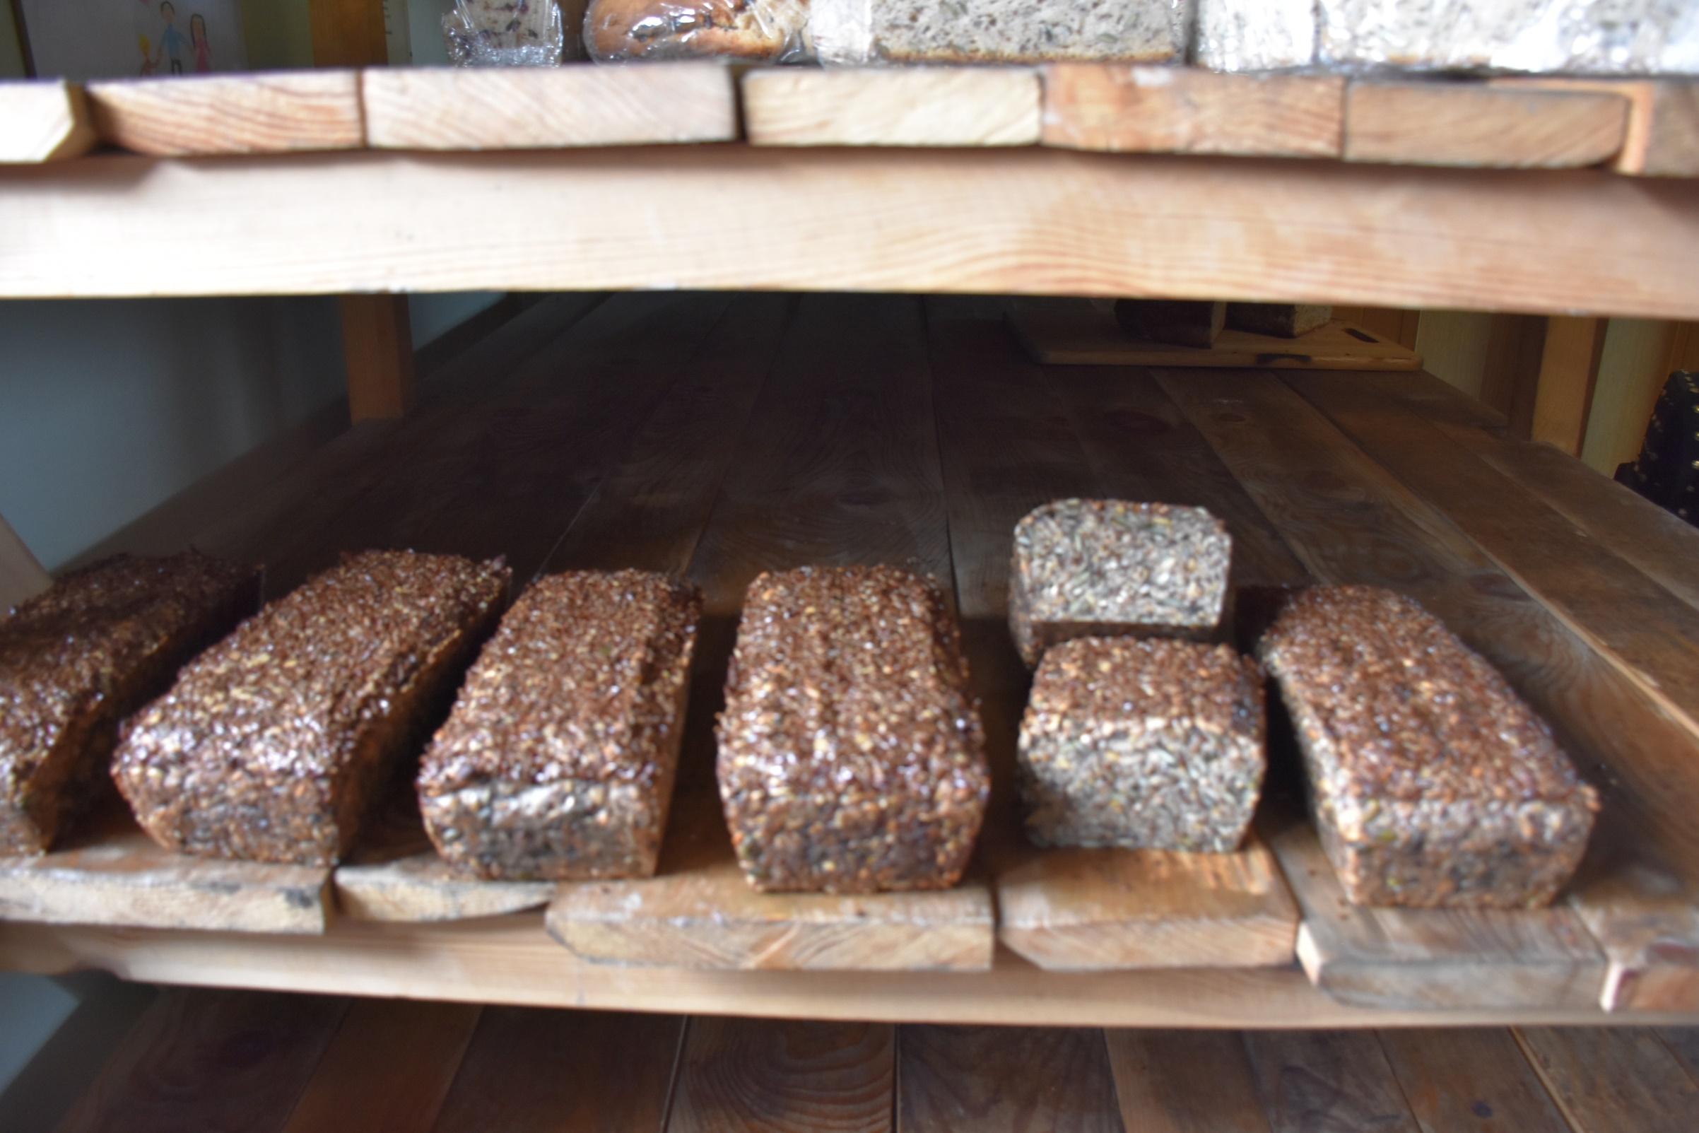
VISIT IN TOWN HALL
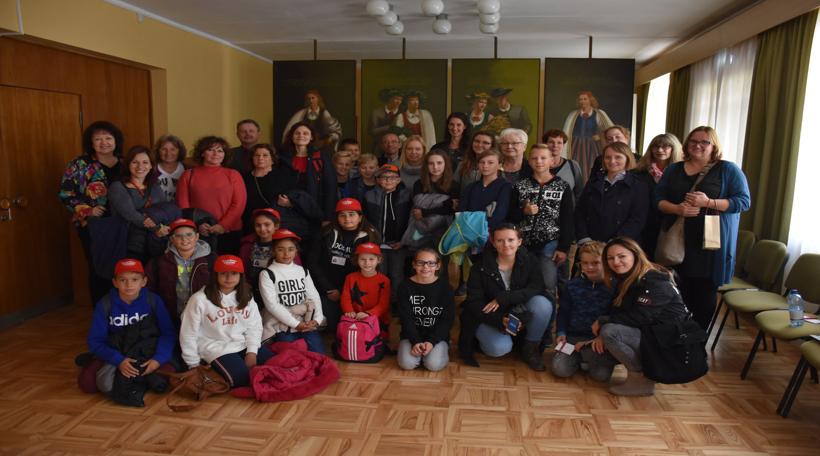

HORTICULTURE INSTITUTE
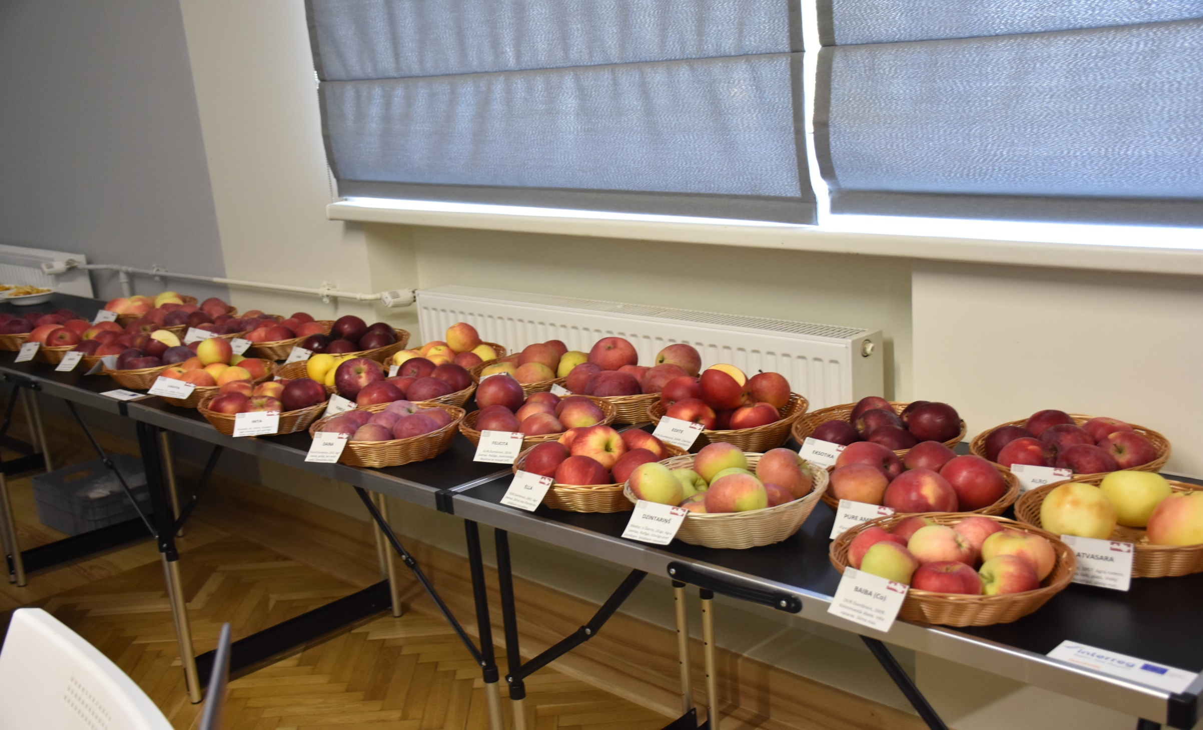
ECO-GAMES
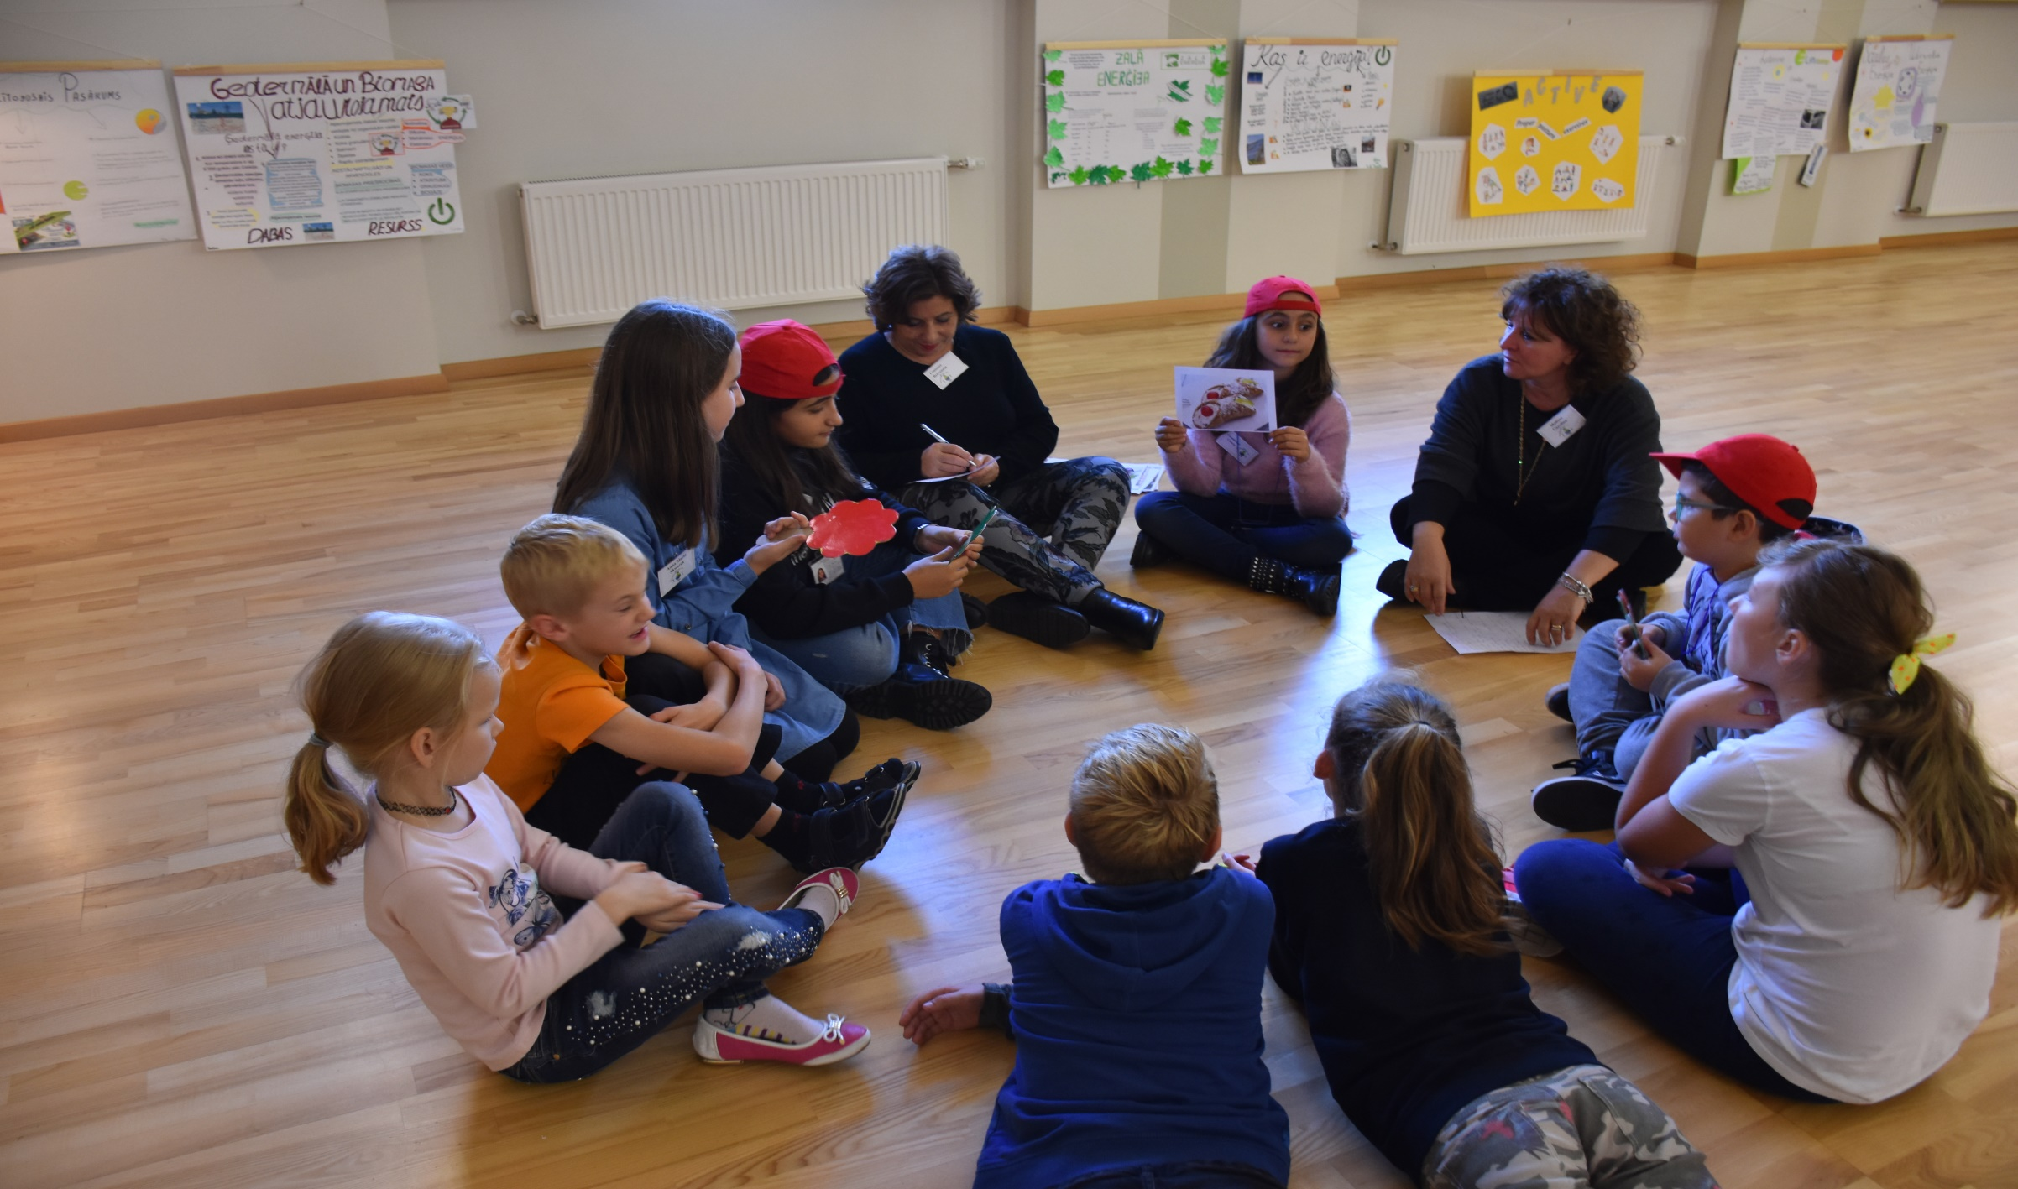
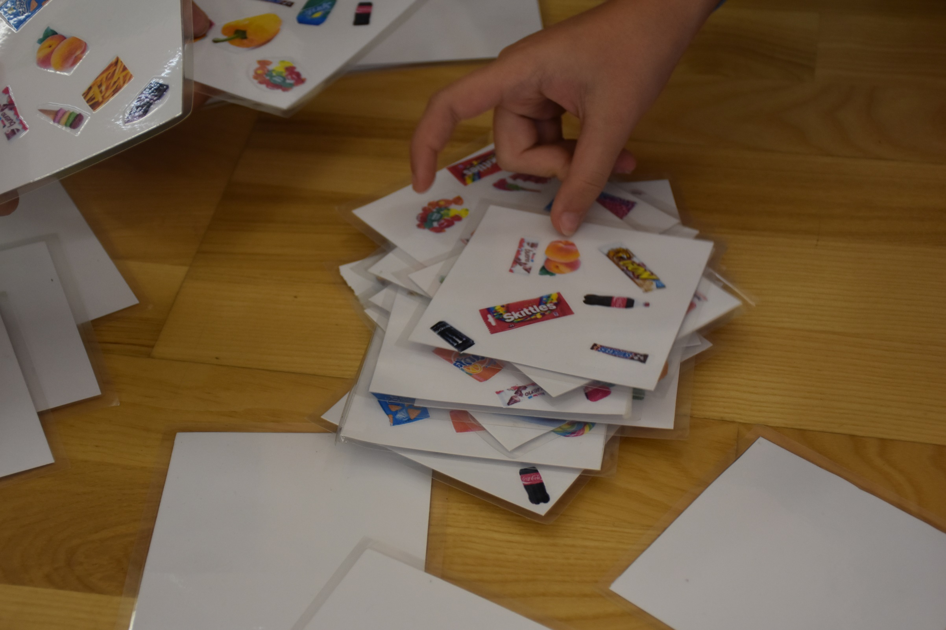
VISIT IN PEPPERMINT HOUSE
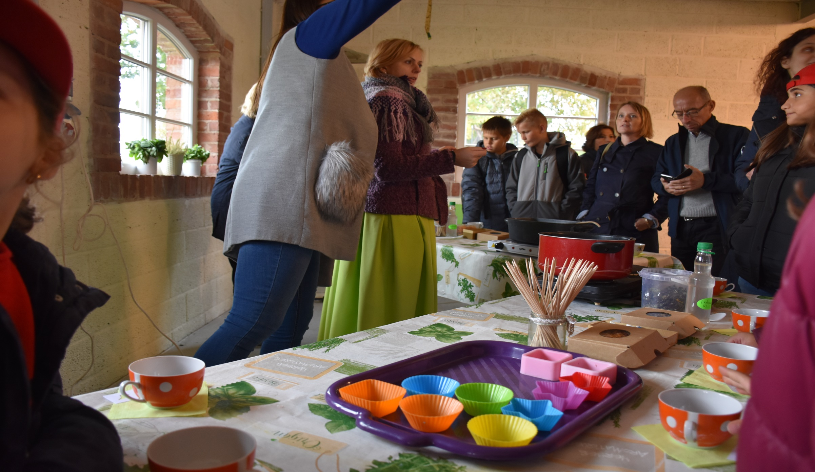
- Until the 30th November we have carried out 5 Videoconferences .
COUNTRY | VIDEOCONFERENCES
Poland | 2
Italy | 2
Latvia | 1
Slovenia | -
The Netherlands | -

