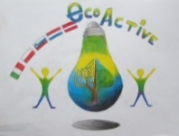 LESSON PLAN 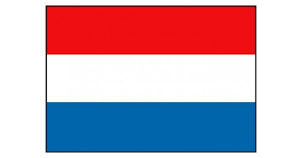
SCHOOL | De Weijerwereld
THEMATIC AREA | ENERGY
TEACHER | Lida, Emmy en Imke
SUBJECT | Handicraft
AGE GROUP  (approximately) | 4-6 years.
TIME REQUIRED | 45 minutes
PLACE | Classroom
LESSON OBJECTIVES | - Pupils learn that wind can make things moving  - Pupils learn various technics handicraft such as neasure, cut, stick
REGULAR LESSONS YOU CAN USE | - Handicraft  - Oral language  - Technics  - Motor skills
CLASS ORGANISATION | - Pupils work individual
MATERIALS | - Paper cups  - Coloured paper  - Glitters  - Split pen  - Glue  - scissors  - Example mill
ICT TOOLS | N.a
PROCEDURE | - Teacher shows the example of the mill  - Pupils cut the paper into strips  - Pupils stick the strips to the cups  - Pupils make wicks of the coloured paper  - Pupils fasten the wicks with a split pen  - Pupils decorate their mill with glitters  - Pupils do the wicks turn by blowing to it.  - Teachers and pupils are wondering how the wicks can blow and admire the nice mills
EVALUATION | -
ATTACHEMENTS

