Project funded by the European Union

Ecopedia
“HEALTH”
(a teacher’s guide)

Lesson plans from Ecology
for Primary Schools
2016 / 2019

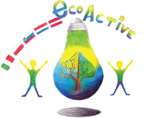

Authors of the manual

- Halina Daniel
- Magdalena Gawronska
- Teresa Bertolini
- Maija Klasupova
- Sanja Pavlinić Vidic
- Maaike van Sambeek

Design: Tomaž Bahč

Table of content.

Authors 2

Project Partner Schools 3

Introduction 4

Lessons 5-55

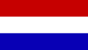
https://www.deweijerwereld.nl
DE WEIJERWERELD, Boxmeer, the Netherlands

www.dd2circolocavour.gov.it
2 Circolo Didattico Cavour Marsala, Marsala, Italy
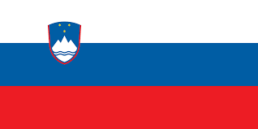

www.ostpavcka.si
Osnovna šola Toneta Pavčka, Mirna Peč, Slovenia

www.tervetesnovads.lv/annas-brigaderes-pamatskola/
Annas Brigaderes pamatskola, Zelemeni, Latvia

www.sp2.pulawy.pl
Szkola Podstawowa Nr 2 im. K.K.Baczynskiego w Pulawach, Puławy, Poland

June, 2019

INTRODUCTION

This publication contains original lesson plans on environmental issues created by teachers from the five European schools participating in the Eco-Active project. They are based on the educational systems of five countries. All lesson plans refer to ecological issues, and their subject matter mainly relates to four thematic areas which our project dealt with: Resources, Water, Energy and Health.
Ecopedia includes lesson plans for younger and older groups of pupils. Some of them were used on international lessons, during visits to partner schools, with the participation of students from the host school. The remaining lesson plans were used in partner schools during the three years of the project on tutoring lessons, other school subjects and extra-curriculum school activities. All lesson plans are in English.
This publication is a form of a guide for teachers who would like to use ready-made and interesting lesson plans to introduce their students to issues related to ecology. Each lesson plan in this document has been developed by the teachers of the school from the country whose flag it bears. Each lesson plan contains information about the age group of students and the name of the teacher (author) who created it. Lesson plans are accompanied by attachments (worksheets, presentations, etc. ). Lesson plans are arranged according to the thematic areas of our project.

Project Coordinator

HEALTH
_____________________________________

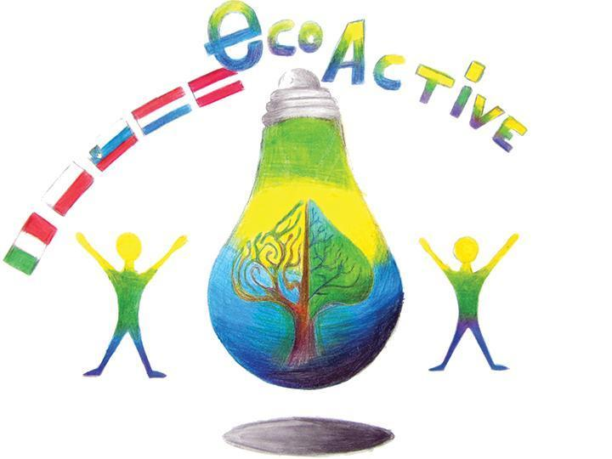 LESSON PLAN
SCHOOL | Szkoła Podstawowa nr 2 im. K.K.Baczyńskiego w Puławach
THEMATIC AREA | HEALTH
TEACHER | Joanna Sowa
SUBJECT | Healthy lifestyle
AGE GROUP  (approximately) | 12 year olds (older kids)
TIME REQUIRED | 45 minutes
PLACE | classroom
LESSON OBJECTIVES | Making students aware of the role of physical activity in their lives.  Student:  - • knows what health is and what affects their condition  - • knows the basic principles of healthy eating  - • understands the importance of physical activity  - • can calculate how many calories they will burn during a certain physical activity.
LESSONS YOU CAN USE | - Language (English)  - Biology  - Nature knowledge  - Maths  - Tutoring lesson
CLASS ORGANISATION | - collective work  - individual work  - group work
MATERIALS | − a board with a pyramid and labels with each of its floors,   carton paper, markers,   "December activity" work cards (Attachment 1),   cards with a table showing the amount of calories consumed during the time of performing various activities (Attachment 5),   cards with sports disciplines (Attachment 2),   questions for the test (Attachment 4),
ICT TOOLS | − interactive whiteboard, projector, laptop,   a presentation created in the Power Point program " Moving is healthy" (Attachment 6),   phones.
PROCEDURE | I. Introduction  Students sit on chairs arranged in a circle, the teacher acquaints students with the purpose of the lesson and the topic. We remind you about the rules of working at the lesson.  Fun to start - students play a “Deaf phone” game and give themselves a password  "In a healthy body, healthy mind".  II. The proper lesson  The teacher asks the question: What is health?  After the students' answers, the teacher gives the definition of health according to the World Health Organization: Health is a state of good physical, mental and social well-being, not just a lack of disease. We discuss it and repeat what needs to be remembered.  The teacher asks the question: What determines our health? Children give answers, and then we display a diagram showing the percentage impact of various factors on human health. Students read the individual elements from the diagram and their percentage impact, and then answer the question: What has the greatest impact on our health? Students notice that lifestyle and then we brainstorm what is a lifestyle. Children indicate, for example: diet, movement, hygiene, no addictions.  The teacher says that if our nutrition has a big impact on our health, we will repeat the principles of healthy eating, recalling how the pyramid of nutrition and physical activity looks like.  Task: please arrange a pyramid of healthy nutrition and physical activity.  Pupils arrange the pyramid on the pyramid template on the board, and then discuss its floors and the teacher says that the pyramid's support is physical activity.  The teacher asks the question: What is a physical activity? Students give examples of physical activity, until finally the answer is that it is every muscle movement. If the answer is not answered, the teacher guides the students to it.  The teacher says that young people of their age should be physically active for 60 minutes a day, and then displays a pyramid of physical activity on the slide, and students read its individual floors.  Students are tasked with the method of sunshine to describe on Bristol why is it worth being active?  After saving the ideas of students, the teacher displays on the board a movie titled "Sport: what exactly does your body have from this" from http://zdrowie.gazeta.pl/Zdrowie/10,112276,18826954,sport-co-konkretnie-ma-z-tego-twoj-organizm.html  Students receive cards with a table of various activities with a specific number of calories that we burn during their performance for one hour (attachment 1) and tasks to be performed in "DECORATIONS OF ACTIVITY". Students solve the tasks and then check the results on the forum.  Students talk about sports and sports achievements.  Guessing game of sports disciplines, which is shown in gestures by one of the students (cards with disciplines, Attachment 2).
EVALUATION | - Students solve the test created on the kahoot website on the phones.
ATTACHEMENTS | 1)December Activities  2)Sports  3) Description of a film  4)Questions  5)Table

LESSON PLAN
SCHOOL | Szkoła Podstawowa nr 2 im. K.K.Baczyńskiego w Puławach
THEMATIC AREA | HEALTH
TEACHER | Monika Bełczyk
SUBJECT | HOW IS FRUIT JUICE PRODUCED?
AGE GROUP  (approximately) | 7-8 year olds (kids)
TIME REQUIRED | 50 minutes
MIEJSCE | classroom
LESSON OBJECTIVES | Main OBJECTIVE: To familiarize students with the stages of juice formation and its nutritional values.  OPERATIONAL OBJECTIVES:  START:  - listens carefully to the information contained in the educational film,  - recognizes and names the stages of juice formation,  - understands what the pasteurization process is all about,  - speaks about the nutritional value of juices,  - arranges words in alphabetical order,  - decodes hidden information,  - reads with understanding,  - improvises with movement to a given melody,  - writes from memory,  - calculates in memory and gives the result.
LESSONS YOU CAN USE | - - Healthy eating  - - Natural knowledge  - - Mathematical knowledge  - - Polish language knowledge
CLASS ORGANISATION | - - INDIVIDUAL  - - TEAM  - - COLLECTIVE
MATERIALS | worksheets 1 and 2, juices, drinks and fruit nectars, letters with words (fruit names)
ICT TOOLS | Computer, interactive whiteboard, ActiveInspire, film “How much juice is in juice";, application “Healthy shopping";, film “Zigzag Dance"  PowerPoint evaluation,  Web site online-stopwatch. com
PROCEDURE | 1. WELCOME  2. A REMINDER OF THE RULES APPLICABLE TO CLASSES  - Activity evaluation - sticker  - Behavioural evaluation - yellow and red cards, playing with the Agent  3. INTRODUCTION TO THE SUBJECT OF THE CLASSES  - “Encrypted password";  Students are given a work card with a letter field. Following the teacher's instructions (up, right, left, down) they find the three letters that make up the slogan: JUICE.  4. GETTING ACQUAINTED WITH THE OBJECTIVES OF THE CLASSES:  - In today's class you will learn how fruit juice is produced.  - You will get to know the pasteurization process  - You will explain why it is worthwhile to drink natural fruit juices  - Success criteria:  -After the classes you will be able to tell how the juice formation process proceeds in turn, explain the purpose of juice pasteurization and exchange the advantages of consuming juice.  - Key question:  How much juice is in the juice?  5. looking at the film “How much juice is in juice";.  Pay attention to listening attentively to the information contained in the film (stages of juice formation).  6. CREATING A PICTURE STORY  On the basis of the information obtained from the film, the students jointly determine the order in which the juice is produced, name and number the images on the interactive whiteboard. The teacher explains that pasteurization is a process that is often used when making winter preserves. The juice is heated and then quickly cooled. This ensures that the juice does not spoil and is safe to consume.  7. INDIVIDUAL WORK WITH A WORK CARD  - Command: Sign the images with the correct sentences.  Successful points:  -You choose the correct sentence for the picture.  -You write carefully and do not make mistakes.  -You remember the big letter at the beginning of the sentence and the dot at the end.  Students read sentences and sign pictures on their own. For students with learning difficulties, there is a second variant of the card - with fewer sentences.  8) Lesson break - movement game with the song “Zigzag Dance";.  N: The consumption of fruit and vegetables is very important because they contain vitamins and ingredients that allow us to maintain excellent health. But remember that the most important place in the pyramid is occupied by physical activity, so now I invite you to play with movement.  9. WORK IN PAIRS  - Dictation in motion  The teacher places three lists of fruit names in the classroom. Children work in pairs - runner and writer. The runner's task is to dictate all the names from the list to the writer, while the writer's task is to write a flawless record. The couple cooperates in silence.  Successful points:  You work together in silence.  The runner reads and dictates all words from the list.  The writer writes words correctly.  After the time for the task has elapsed, a check takes place. Selected pairs read the written words, the teacher checks the correctness of writing.  - Alphabetical order  The second task in pairs is to arrange the names of the fruit in alphabetical order. After the time for the task has elapsed, a check takes place.  The teacher informs students that all fruits whose names appeared in the dictation contain vitamin C. Vitamin C supports the immune system, so it is worth consuming it in the autumn-winter period, when a cold occurs more often.  10. MATHEMATICAL TASK  The teacher presents the pupils with orange juice squeezed by hand (in a glass). He informs that he needed juice from three oranges for one glass. He asks a question:  - How many oranges do I need for two glasses of juice?  - How many oranges do I need for three glasses of juice?  Children count and show the answer on their fingers.  - How much juice is in my juice? (100%)  11. “HEALTHY SHOPPING” APPLICATION  The teacher scans the barcodes of juices and nectars that he brought to the classroom. In this way it checks which juice also contains 100% juice. Draws children's attention to reading labels on products
EVALUATION | 12. TRUE OR FALSE – A GAME  The teacher displays on the interactive whiteboard questions about the classes. The children's task is to raise the green crayon when the sentence is true or red when it is false.
ATTACHEMENTS | Prezentacja w programie ActiveInspire, ewaluacja w programie PowerPoint, karty pracy

LESSON PLAN
SCHOOL | Szkoła Podstawowa nr 2 im. K.K.Baczyńskiego w Puławach
THEMATIC AREA | HEALTH
TEACHER | Kinga Sołtan-Miazga
SUBJECT | Healthy lifestyle
AGE GROUP  (approximately) | 9-10 year olds (younger groups)
TIME REQUIRED | 45 minutes
MIEJSCE | classroom
LESSON OBJECTIVES | Student:  - knows what to eat to be healthy  - creates a pyramid of healthy lifestyle  - makes a healthy lunchbox in groups  - learns how much sugar is found in popular products  - cooperates with peers during the activities;  - understands the importance of healthy eating  - develops language skills;
LESSONS YOU CAN USE | - Language (English)  - Biology  - Nature knowledge
CLASS ORGANISATION | - collective work  - individual work  - group work
MATERIALS | - worksheets,  - materials for group work
ICT TOOLS | Multimedia devices – interactive board, film  “Short animated story for kids - Fit and Healthy –English” - YouTube,  film - “7 Tips for Healthy Living” – YouTube, ClassFlow,  Presentation in PowerPoint
PROCEDURE | 1. WELCOME  2. GETTING TO KNOW LESSON OBJECTIVES:  Today we will talk about healthy lifestyle:  - what to eat to be healthy  - we will create a pyramid of healthy lifestyle  - you will make a healthy lunchbox in groups  - you will see how much sugar is found in popular products  3. CROSS OUT THE WORDS  Each student receives a worksheet and the task is to find all the words concerning healthy eating.  4. HEALTHY & UNHEALTHY PRODUCTS  Each student receives two-colored markers (red and green circle on the stick). Its task is to raise the appropriate marker: red - if the product is unhealthy or green - if it is healthy.  Teacher displays the illustrations on the blackboard using the program ClassFlow.  HEALTHY UNHEALTHY  - lettuce - carrots - fruit juices - water - bananas - eggs - homemade sandwiches - rice - nuts - fish - honey - apples - milk - cookies - popcorn - coca-cola - hot-dog - hamburger - donuts - fries - chips - sugar - cake - bars - fish and chips  5. Educational film - “Short animated story for kids - Fit and Healthy –English” https://www.youtube.com/watch?v=_VczK2zV2sE  6.Common creation of a healthy lifestyle pyramid.  Each group has squares with products from the pyramid of a healthy lifestyle. Together, we create individual floors of the pyramid, attaching  the images with glue to the big paper sheet.  Each floor is discussed by the teacher and displayed to students using a presentation made in PowerPoint.  7. Creating a healthy lunch box in groups.  Students work in groups. Their task is to create a healthy lunch with the pictures prepared by the teacher. After selecting the appropriate products and cutting them out, the students stick them to colored sheets of paper.  8. Where is sugar hiding?  Groups receive cubes of sugar from which they will build a "sweet tower".  The teacher presents the content of sugar cubes in selected products consumed frequently by children (PowerPoint presentation). After each presented product, students place as many sugar cubes in front of them as the product contains.  - One OREO cookie = 1 sugar cube  - Mars bar = 7 sugar cubes  - A can of Coca Cola = 8 sugar cubes  - 100 g Milka chocolate = 11 sugar cubes  - Skittles = 13 sugar cubes  - Ketchup HEINZ = 17 sugar cubes  - Cappy apple juice = 20 sugar cubes  9. Educational film summarizing a healthy lifestyle.  https://www.youtube.com/watch?v=eFn4F4q5fIs
EVALUATION | Each student has two-colored markers (red and green circle on the stick). They raise the appropriate marker: green – TRUE, red- FALSE.  - I found out that fruit juices contain a lot of sugar,  - I know how to make a healthy lunch  - I can identify healthy and unhealthy products
ATTACHEMENTS | Film - “Short animated story for kids - Fit and Healthy –English” https://www.youtube.com/watch?v=_VczK2zV2sE  Film “7 Tips for Healthy Living ”  https://www.youtube.com/watch?v=eFn4F4q5fIs

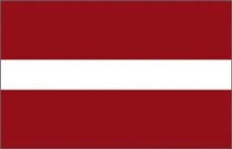
LESSON PLAN
School | Annas Brigaderes pamatskola
Thematic area | Healthy food
Time | 40 – 45 min
Age group | for Grades 4-6 (9-12 year - olds)
Teacher | Maija Klāsupa
Lesson plan | *At the beginning of the lesson the teacher gives each student colorful sheet of paper, they should write down some foods they believe are healthy  *)There is a sheet of paper on the blackboard with drawn dish on it, students come and stick their clorful paper sheets on the dish  *)The teacher reads the answers aloud and discuss if students' answers conform healthy eating patterns  *)The teacher talks about the food pyramid and explain that in order to be healthy children should be eating more of certain foods and less of others  *)Group work – students get food flashcards  - the Task: make a healthy food – salad, soup etc. - breafast, lunch, dinner. Each groap represents, what they have made.  *)Each student get a worksheet „My family's recipe” and writes down her or his favorite family's recipe. When students have finished they present their recipes and discuss what are the most popular foods in their families.
Forms | - Individual work;  - collective work;  - group work.
Materials and tools | Post-it Super Sticky notes, worksheets
Evaluation | Selfevaluation
Attachements | Sets of flashcards
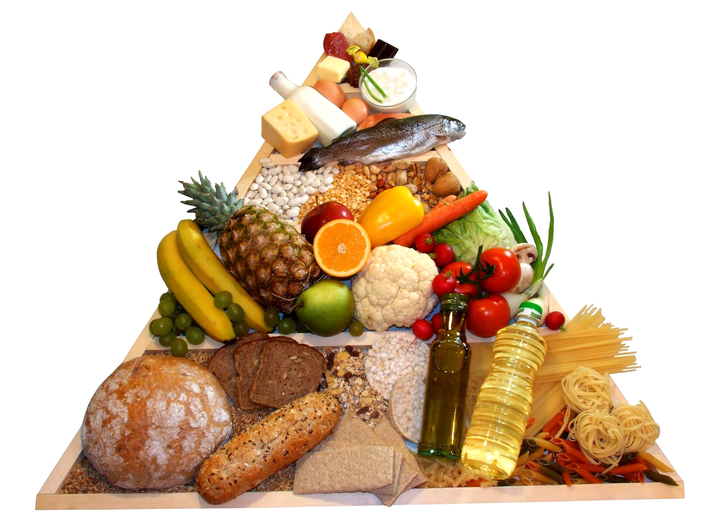
www.google.lv/search?q=uztura+piramīda&biw=1047&bih=481&source=lnms&tbm=isch&s
My Family's recipe

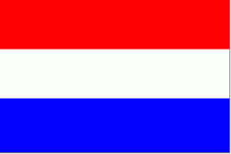
LESSON PLAN
SCHOOL
THEMATIC AREA | HEALTH
TEACHER | Frieda Heutink
SUBJECT | A healthy breakfast
AGE GROUP  (approximately) | 9-10 years
TIME REQUIRED | 4 hours lesson, 1 hour breakfast
PLACE | Classroom
LESSON OBJECTIVES | - Pupils think about what they eat for breakfast  - Pupils realise that having breakfast is very important for functioning during the day  - Pupils know the consequences of having no breakfast  - Pupils know what is a healthy breakfast  - Pupils know where they can read about the ingredients of healthy food  - Pupils learn how to implement data in charts by using ICT  - Pupils learn how to read and interpret chats
REGULAR LESSONS YOU CAN USE | - English, for translation (one hour/lesson)  - Biology and/or Lessons in healthy behaviour (two hours/lessons)  - Mathematics, for reading and interpreting charts (one hour/lesson)
CLASS ORGANISATION | - Pupils work individually  - Pupils work in pairs  - Pupils work in groups
MATERIALS | - Different packaging of foods  - List of healthy foods  - List of unhealthy foods
ICT TOOLS | - Internet  - ICT for creating charts
PROCEDURE | - Pupils fill in a survey of what they eat for breakfast  - Pupils summarize all the data of the survey  - Pupils learn how to implement data in a chart  - Pupils study the list of healthy and unhealthy foods  - Pupils try to find how many kcal a child of your age needs every day  - Use the packaging’s and try to find out how many kcal the foods contains  - Try to find out how many kcal your breakfast contains  - Compare the healthy breakfast with the unhealthy one.  - Why is the unhealthy breakfast unhealthy?
EVALUATION | For the teacher:  - You carried out all the lessons in the regular curriculum. Not additional to the daily activities.  - In the English lessons you can skip the lesson about food because you already teached this during this “healthy breakfast project”.  - In the mathematics lessons you can skip or shorten the lesson about charts. Or just a short repeat is enough.  For the pupils:  One month later: fill in the survey again and compare both surveys. Is there a (positive) difference between both?
ATTACHEMENTS | - See the summary of the data of the survey in the charts.  - Pictures of the breakfast
LESSON PLAN
SCHOOL | Primary School “De Weijerwereld” in Boxmeer
THEMATIC AREA | HEALTH
TEACHER | Hanneke Bongarts
SUBJECT | Healthy food
AGE GROUP  (approximately) | 10-11 years
TIME REQUIRED | 3 days, 9.00 to 12.00
PLACE | The “Taste centre” in Boxmeer
LESSON OBJECTIVES | - Explanation about the so called “Disk of five”, the Dutch idea about healthy food.  - What could be healthy food?  - How often a snack every day?  - How much sugar is in frizzy drinks?  - Which drinks are healthy?  - What nutrients are necessary? (protein, vitamins, minerals, carbohydrates).  - Seasonal vegetables, what part of the plants do we eat.  - Bread: what nutrients are in bread, which bread can you call healthy, is it correct: “more brown/dark bread, more healthy???  - Cooking: pupils learned how to cut certain vegetables into pieces. How to use a sharp knife in a safe way. How to cook on a fire.
REGULAR LESSONS YOU CAN USE | - Biology  - Nature knowledge
CLASS ORGANISATION | Pupils work in groups, cooking a starter, main dish and dessert)
MATERIALS | Various ingredients and things you need for cooking.
ICT TOOLS | PowerPoint about healthy food and the “disk of five” (is a circle divided into 5 parts, in every part kinds of food you should eat every day)
PROCEDURE | Two groups of pupils.  First part: One group starts cooking, the second group has a theoretical lesson about healthy food.  After the break second part: change the tasks.  At the end of the session: joint meal together with the volunteers. Every group of pupils tells the other pupils about the ingredients of the dish the group prepared, the ingredients of the dish and how they prepared the dish.
EVALUATION | Pupils learned a lot about new dishes, ingredients and healthy food. And they did learn a lot about the quantity of snacks they did eat in one week.
ATTACHEMENTS | - Recipes en PowerPoint presentations  - Visiting the “Taste centre” in Boxmeer (pupils 10-12 years)  “TASTE CENTRE” BOXMEER  - Where does our food come from?  - How does it taste?  - What is the influence on your body, health?  - How to prepare a healthy meal?  - How can you prevent waste of food?  PARTS OF THE LKEWSSONS ARE, AMONG OTHER:  - Taste lesson theory;  - Discover the authentic taste of natural products;  - Purchase of healthy ingredients for a meal;  - Coocking fres products;  - Re-use of residual products;  - How to enjoy the prepared meal;  - The vegetable garden;

LESSON PLAN
SCHOOL
THEMATIC AREA | HEALTH: a healthy week menu
TEACHER | Maaike van Sambeek (form 8)
SUBJECT | A healthy week menu
AGE GROUP  (approximately) | 11-12 years
TIME REQUIRED | 3 hours lesson
PLACE | Classroom
LESSON OBJECTIVES | - Pupils think about what they eat for breakfast, lunch and dinner every day  - Pupils realise that having a healthy meal is very important for functioning during the day, and for health in the future  - Pupils know about healthy and unhealthy nutrients  - Pupils know where they can read about the ingredients of healthy food  - Pupils know the meaning of the list of ingredients on the food packaging  - Pupils know about the amount of nutrients they need every day  - Pupils know about what they eat every day and if it is (un)healthy
REGULAR LESSONS YOU CAN USE | - Biology and/or Lessons in healthy behaviour (two hours/lessons)  - Searching, finding, processing and presenting information (ICT, one hour/ lesson)  - English, for translation (one hour/lesson)
CLASS ORGANISATION | - Pupils work individually  - Pupils work in pairs  - Pupils work in groups
MATERIALS | - Different packaging of foods  - List of healthy foods  - List of unhealthy foods
ICT TOOLS | - Internet  - ICT software: Word, PowerPoint
PROCEDURE | - Pupils fill in a survey of what they eat for breakfast-lunch-dinner  - Pupils make an inventory of what they eat during a day/week  - Pupils summarize all the data of the survey  - Pupils search in the internet: what is healthy food, which nutrients do we need as human beings of 11-12 years old  - Pupils study the list of healthy and unhealthy foods  - Pupils try to find how many kcal a child of your age needs every day  - Use the packaging’s and try to find out how many kcal the foods contains  - Try to find out how many kcal your breakfast-lunch-dinner contains  - Compare the healthy meals with the unhealthy ones.  - Create healthy meals: one group creates a breakfast, one group for the lunches and one group for the dinners  - Search for the recipes for all the meals
EVALUATION | For the teacher:  - You carried out all the lessons in the regular curriculum. Not additional to the daily activities.  - In the English lessons you can skip the lesson about food because you already teached this during this “healthy menu’s project”.  - In the lessons “information processing” pupils work for the presentations  For the pupils:  One month later: fill in the survey again and compare both surveys. Is there a (positive) difference between both?
ATTACHEMENTS | - See the summary of the week menu  - See the recipes of the breakfast-Lunch-Dinner

LESSON PLAN
SCHOOL | De Weijerwereld Boxmeer
THEMATIC AREA | Crea
TEACHER | Lida, Mariëlle, Imke
SUBJECT | Healthy food
AGE GROUP  (approximately) | 4-5-6 years
TIME REQUIRED | 45 minutes
PLACE | Classroom
LESSON OBJECTIVES
REGULAR LESSONS YOU CAN USE | Lesson cut and past
CLASS ORGANISATION | Groups 6 pupils.
MATERIALS | Paste, paper, scissors
ICT TOOLS | -
PROCEDURE | Sandwich and healthy food. First search for pictures and healthy food in flyers. Put the pictures on the sandwich. Then put the paper sandwich on a plate, then the plate and sandwich on a placemat. Add a cup and cutlery. We talk about healthy breakfast and lunch
EVALUATION | It was difficult for the pupils to think about healthy food, what is healthy food. And after this cut and paste the pictures it depends on the level of their fine motor skills.
ATTACHEMENTS | 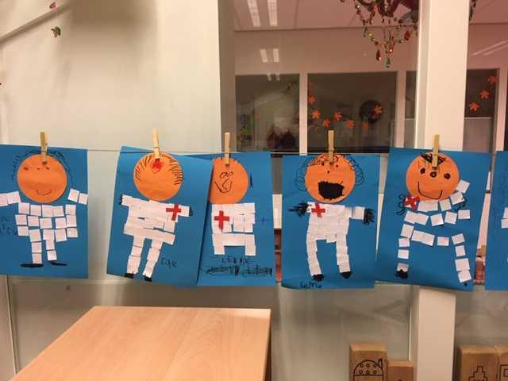  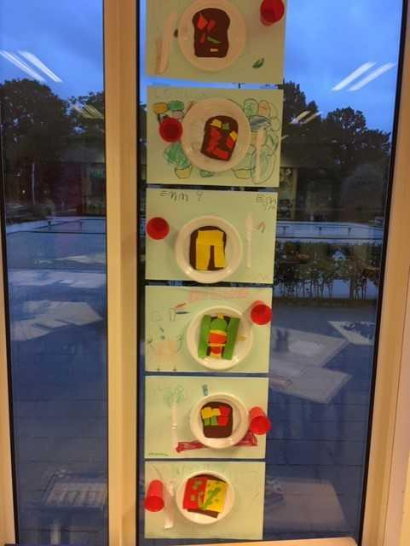

LESSON PLAN

SCHOOL | De Weijerwereld Boxmeer
THEMATIC AREA | Health
TEACHER | Lida, Mariëlle, Imke
SUBJECT | Visit the doctor
AGE GROUP  (approximately) | 4-5-6 years
TIME REQUIRED | 45 minutes
PLACE | Classroom
LESSON OBJECTIVES | Health in combination with healthy food
REGULAR LESSONS YOU CAN USE | Biology
CLASS ORGANISATION | Visiting the doctor's office in groups at the doctor's. The play corner in the classroom was arranged as a doctor's office.
MATERIALS | Doctor's suit, bandages
ICT TOOLS | In preparation for the visit of the doll doctor, the method “kleuterplein” used.
PROCEDURE | Explanation by using the digital board. Afterwards, a few children were allowed to visit the doctor at the same time.  Stuffed animals brought sick were examined and taken care of together with the doctor
EVALUATION | It was a good lesson. Children were very enthusiastic and learned how to care for a sick patient and how important it is to eat and drink healthy.  In addition, they have learned what the attributes of a doctor are.
ATTACHEMENTS | 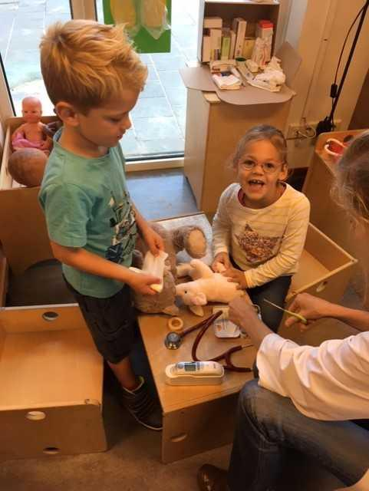  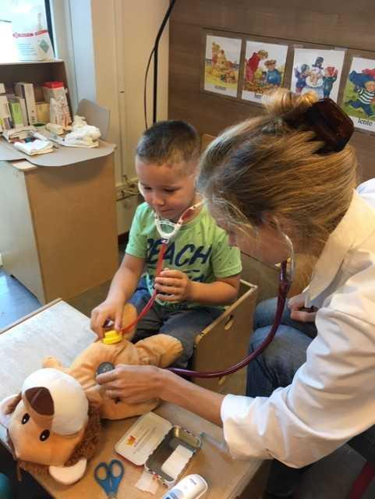  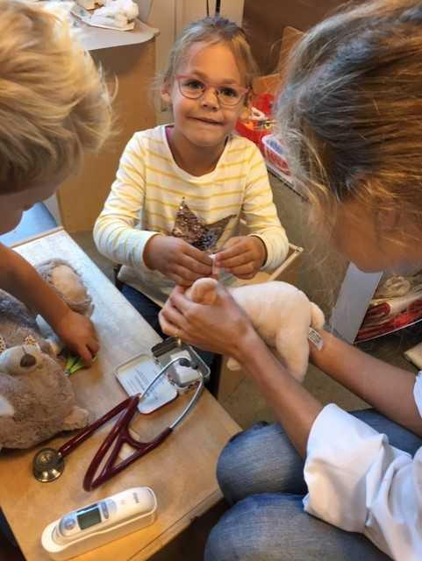

LESSON PLAN
SCHOOL | De Weijerwereld
THEMATIC AREA | Health Workshop cooking
TEACHER | Hetty Bardoel, Thea Willems, Denise de Vlam, Gertjan Vrenken
SUBJECT | Workshops cooking
AGE GROUP  (approximately) | Form 3-4-5 (6-7-8 years)
TIME REQUIRED | ± 1,5 hour
PLACE | Classroom, play-an-learn-square and at home in mothers kitchen
LESSON OBJECTIVES
REGULAR LESSONS YOU CAN USE | - Mathematics (conversion of weights)  - Vocabulary  - Language  - Social skills
CLASS ORGANISATION | - Pupils work in groups
MATERIALS | Groceries from supermarket and cooking utensils
ICT TOOLS | --
PROCEDURE | Children are divided into groups and with the help of parents they prepare / cook a dish. They also carry out the preparatory work themselves and at the end they clean up everything too
EVALUATION | Children liked it very much and it was nice to make a dish yourself, to be allowed to eat. They did not like cleaning up everything!
ATTACHEMENTS | Pictures of the activity
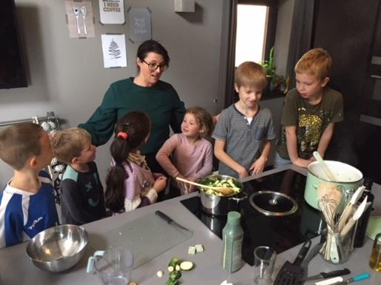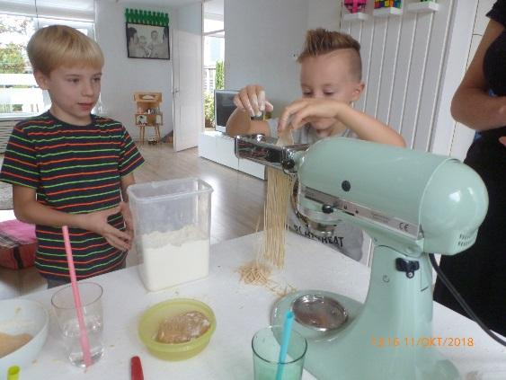

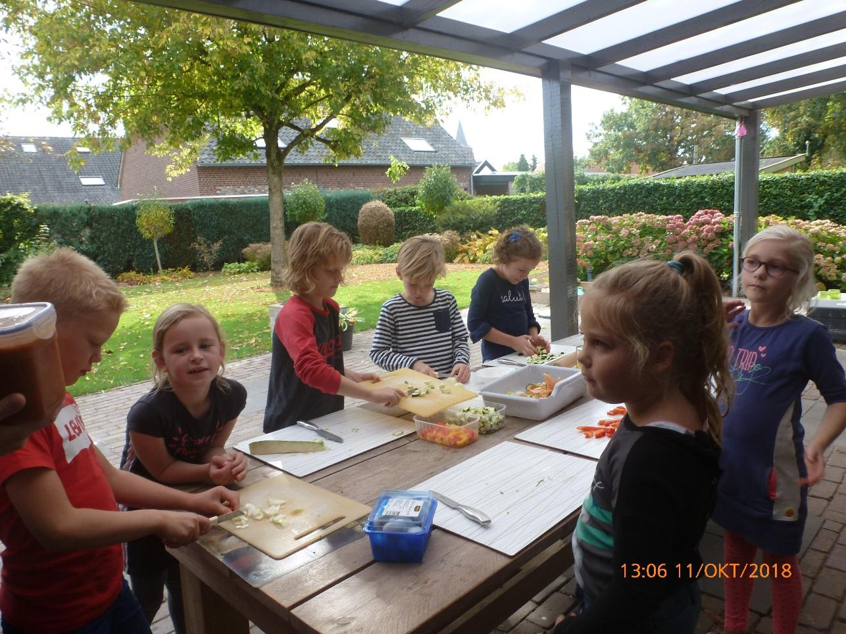

LESSON PLAN

SCHOOL | Bs De Weijerwereld
THEMATIC AREA | Eco Active Healthy Food.
TEACHER | Thea Willems, Hetty Bardoel, Denise de Vlam, Gertjan Vrenken
SUBJECT | Healthy Food
AGE GROUP  (approximately) | 6-7-8 years
TIME REQUIRED | 60-80 minutes, each part of lessons (5)
PLACE | In school: classroom,  Out of the school: vegetable garden, workshops
LESSON OBJECTIVES | - Healthy breakfast  - Lesson: the need of healthy food  - How and where grow the healthy vegetables (visit vegetables garden)  - Workshops: create recipes for healthy food  - Manual skills: making fruit or vegetables from salty bread-dough
REGULAR LESSONS YOU CAN USE | - Language: how to name the vegetables and fruits  - Reading lessons  - Biology: what your body needs to stay healthy  - Nature knowledge: how fruits and vegetables grow  - Cooking skills. Reading and preparing recipes.
CLASS ORGANISATION | - Pupils work in groups, mixed up the pupils from the 3-4-5th class  - Visiting a fruit-vegetable garden (out of the school)  - Workshops with parents (in and outside the school)
MATERIALS | - Various movies about healthy food(School TV, news from nature etc.)  - In the garden: harvest various vegetables for vegetable soup  - Workshops: Ingredients for receipts  - Handy crafts: ingredients for slaty bread dough: flou rand salt
ICT TOOLS | Digibord:  - School TV  - Schoolbordportal  - News from nature  - Powerpoint presentation how to make bread dough.
PROCEDURE | - The introduction meetings on the theme Healthy Food take place in the own group.  - For the creative assignment the groups 3-4-5 are mixed and divided into groups of 6 children  - They can make their own choice for the cooking workshops, but there are also 6 children in a group here
EVALUATION | Children have experienced in a playful way that a healthy diet is important for health, growth and development. Very important here is starting a healthy breakfast in the morning for enough energy to learn and play. They have also learned that vegetables and fruit are grown outside in nature and grow. Each season has its own harvest moments.
ATTACHEMENTS | See report Project eco-active form 4

LESSON PLAN

SCHOOL | Bs De Weijerwereld
THEMATIC AREA | Eco Active Healthy Food.
TEACHER | Thea Willems, Hetty Bardoel, Denise de Vlam, Gertjan Vrenken
SUBJECT | Healthy Food
AGE GROUP  (approximately) | 6-7-8 years
TIME REQUIRED | 80 minutes,
PLACE | In school: classroom,
LESSON OBJECTIVES | Manual skills: making fruit or vegetables from salty bread-dough
REGULAR LESSONS YOU CAN USE | - Language: how to name the vegetables and fruits  - Reading lessons  - Biology: what your body needs to stay healthy  - Nature knowledge: how fruits and vegetables grow  - Cooking skills. Reading and preparing recipes.
CLASS ORGANISATION | - Pupils work in groups, mixed up the pupils from the 3-4-5th class
MATERIALS | - Some movies about healthy food (Dutch school TV and News from the nature)  - In the vegetable garden: various vegetables harvest for vegetable soup  - Handy crafts: ingredients for salty bread dough: flour and salt
ICT TOOLS | Digibord:  - Schooltv)  - Schoolbordportal  - News from the nature  - Powerpoint presentation making bread dough.
PROCEDURE | - The introduction meetings on the theme Healthy Food take place in the own group.  - For the creative part the pupils of the forms 3-4-5 are mixed up, every group has 6 members, they can/will help eachother
EVALUATION | Children have experienced in a playful way that a healthy diet is important for health, growth and development.  Very important here is starting with a healthy breakfast in the morning for enough energy to learn and play  They have also learned that vegetables and fruit are grown outside in nature and grow. Each season has its own harvest moments.  In closing, they have created fruit and vegetables from bread dough
ATTACHEMENTS | Report Project eco-active form 4

LESSON PLAN

SCHOOL | De Weijerwereld
THEMATIC AREA | HEALTH – Healthy food
TEACHER | Teachers form 6-7-8 oldest pupils
SUBJECT
AGE GROUP  (approximately) | 9 t/m 12 years
TIME REQUIRED | 1 hour
PLACE | CLASSROOM
LESSON OBJECTIVES | The children know at the end of this lesson why too much sugar is bad for them. In addition, they can read through a label of a product how much sugar is in it.
REGULAR LESSONS YOU CAN USE | - Language ,for translation in English of course the English lesson  - Biology  - Nature knowledge
CLASS ORGANISATION | - Pupils work in pairs
MATERIALS | - sugar cubes  - 1 bottle cola (1.5l)  - drink different packages and cans  - 1 poster  - Tube of glue Bisonkit
ICT TOOLS | https://schooltv.nl/video/suiker-lekker-maar-ook-een-dikmaker/#q=suiker
PROCEDURE | (what happens, what we do step by step)  - On the digiboard is a picture of a label (including the ingredients) of a bottle of cola.  - On the basis of this label we calculate together how many sugar cubes there are in a bottle of cola and these lumps are also visualized by stacking them  - Then the broadcast of school TV is watched (see ICT tools)  - In class, this broadcast is discussed with the emphasis on why too much sugar is not good for you.  - The children receive a package or can (1 for 2 pupils) drink and will figure out how much sugar is in it. Then this is also pasted on the poster. (see picture)
EVALUATION | The goals have been amply achieved. In the beginning it was difficult for some pupils to read the labels, but with some help that went very well.  A number of children also told afterwards that through this lesson they pay more attention to what they eat and drink.  For example, they drink more water and sometimes leave products in the supermarket because they contain too much sugar.  The result of the sugar poster was also great and OK. This poster still stands as a kind of eye-opener in the classroom.
ATTACHEMENTS | 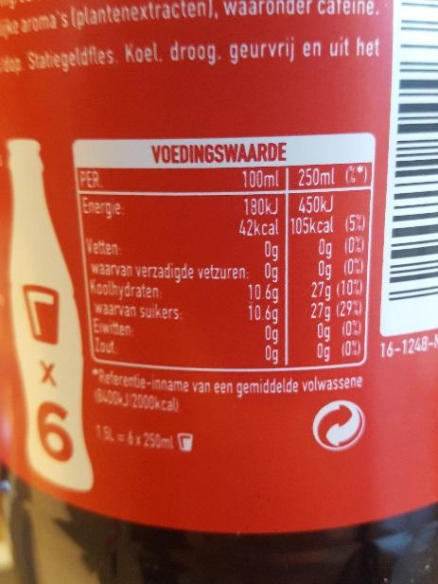  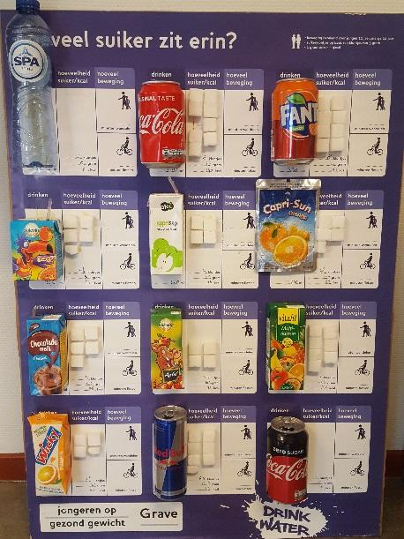  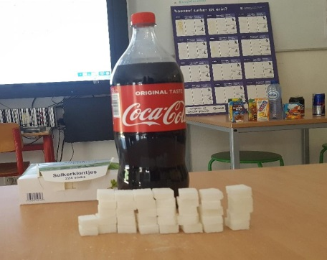

LESSON PLAN

SCHOOL | De Weijerwereld
THEMATIC AREA | HEALTH
TEACHER | Denise de Vlam and Stijntje van Esch
SUBJECT | Recognise and name fruit or vegetable and flavours
AGE GROUP  (approximately) | 9-10-11
TIME REQUIRED | 1 our
PLACE | CLASSROOM
LESSON OBJECTIVES | Speak English – meet and communicate with the other students  Recognise fruit or vegetables  Learn the different flavours and taste them
REGULAR LESSONS YOU CAN USE | - English  - Nature knowledge
CLASS ORGANISATION | - Pupils work in pairs  - Pupils work in groups
MATERIALS | - Picture of fruit and pictures of vegetables. On the back of the picture is the name of the picture in English.  - 4 flavours in plastic cups: lemon, saltwater, sugar water, bitter lemon, blindfolds for every two children – working paper  - Fresh fruit and vegetables – knives and plates -
ICT TOOLS | - Pp presentation
PROCEDURE | - Start: mix en change. Every child has a picture and is walking in de classroom. When you meet someone you give a high-five and you ask what’s on your picture. The other one says the name, and says if it’s a fruit or vegetable. Then they do the same with the other picture. After that they changes pictures walk around to find another student.  - Middle: we speak about the 5 senses: taste, eyes, ears, nose and hearing. We talk about the 4 flavours: bitter, salt, sweet and sour. Each two student gets the 4 flavours in cups to taste with a blindfold. So they can taste. They also can taste which there nose closed. Is it more difficult then??  The student can write down there conclusions on a paper.  - The Class is split up in 3 groups. Every group gets a plate. Knives and fruit and vegetables. They have to make a beautiful artwork in 7 minutes. After we make a picture of the group with the artwork and then they can eat.
EVALUATION | The students communicated white each other. They recognized the fruit and vegetables. They also taste the different flavours.  The time was too short. We had only 40 minutes. So the last activity was a race against the clock.
ATTACHEMENTS | Working paper.

LESSON PLAN
SCHOOL | De Weijerwereld
THEMATIC AREA | HEALTH – Healthy food
TEACHER | Oldest pupils 10-11-12 years
SUBJECT
AGE GROUP  (approximately) | 9 t/m 12 jarigen
TIME REQUIRED | 4 x 1 hour
PLACE | CLASSROOM
LESSON OBJECTIVES | o.a. Senses / origin / disc of five  Lesson 1: Tastemakers: Taste and the role of the senses  Lesson 2: The energy balance: Relationship between eating and exercising  Lesson 3: Fair Trade: Fair Trade products  Lesson 4: Tests with additives: Additions and the label
REGULAR LESSONS YOU CAN USE | - Language ,for translation in English of course the English lesson  - Biology  - Nature knowledge
CLASS ORGANISATION | - Pupils work in pairs  - Pupils work in groups  The teacher gives instruction and we exchange information in the group. Children will also taste / discover in pairs.
MATERIALS | Materials as described in the teacher manual:  This involves kitchen materials, foodstuffs, copy sheets. In addition, via the site a game / videos belonging to the lesson.
ICT TOOLS | http://www.smaaklessen-online.nl/ (form 8)
PROCEDURE | (what happens, what we do step by step)  - Print the manual and view the contents. Buying food.  - Prepare materials per lesson: food + kitchen equipment + copy sheets.  - Start the lesson on the IWB: prepare game / video.  - The course of the lesson is described in the manual.
EVALUATION | Lesson 1: children view / smell / taste products more consciously. For some students it is difficult to try something new, others discover flavors that they like.  Lesson 2: children aware of the amount of sugar in productive  Lesson 3: Fair Trade explained. Comparing the chocolate did not come into its own; one chocolate was in fact purer than the other. Because of this, it was partly a taste issue.  Lesson 4: awareness of additions; you do not always eat what you expect. For example, there is no gram of strawberry in strawberry custard pudding.  Within the informative lessons, various approaches to nutrition have been discussed.
ATTACHEMENTS | Manual as pdf ◊ 'Taste lessons group 8.pdf' (Dutch)
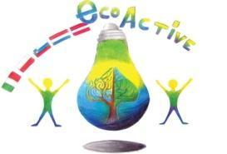 LESSON PLAN
SCHOOL | Secondo Circolo Didattico Cavour Marsala
THEMATIC AREA | Resourse/ Healt
TEACHER | Centonze Benvenuta
SUBJECT | ECO-ALIMENTAZIONE
AGE GROUP  (approximately) | 8 years
TIME REQUIRED | 2 months from February to April- (one hour a week).
PLACE | Classroom
LESSON OBJECTIVES | - Know food necessary for a child body  - Prevent the new social diseases: obesity, anorexia and bulimia.  - Consider the value of traditional food
LESSONS YOU CAN USE | - Science  - Geography  - Ctizenship
CLASS ORGANISATION | - Individual work  - small groups work
MATERIALS | Cropped images, cardboard, scissors, various types of colors, glue, pins, brads, cardboard, notebooks.
ICT TOOLS | Computer, hands.
PROCEDURE | - Reading a fun and challenging text. Create a discussion on how to spot healthy and necessary food: "Food Magic".  - Pupils identify and cut out food from a magic card that help story characters to become adults  - Pupils discover, identify and draw food to:  - protect against diseases (fruit and vegetables);  - give energy (pasta, bread, rice, etc ..);  - help to grow (eggs, meat, fish, cheese, etc ..).  - Survey: pupils color different amount of squares to indicate the amount taken (1 to 10 squares) to find out a correct diets.  - Direct observation and transcription in the notebook of the information from labels of food packaging (product type, expiry dates and ingredients)  • Pupils identify harmful and necessary ingredients for their growth.  - Pupils create two traffic lights with heavy paper  - Collection and / or drawing of images representing food and ingredients.  - Pupils divide these images into three groups: carbohydrates, vitamins and fats.  - Realization of the wallcharts "THE traffic LIGHT of the nutrition" where red indicates the foods to avoided, yellow the food to be alternated and green the food to be eaten every day.  • Development of a team game. The class is divided into two groups: the "Reds" and the "Greens", each group is headed by a team leader who has a traffic lights; time by time each of the team members choose a food and show it to the opposing team; The team leader, after a brief consultation with his own group, shows the color of the light to which, according to the team, the chosen food belongs. The winner is the team who has the most points.  • Class snack: Castelvetrano black bread and olive oil (olives grows in Marsala (Nocellara).
EVALUATION | Team games.
ATTACHEMENTS | Video
LESSON PLAN
SCHOOL | Secondo Circolo Didattico “Cavour” Marsala- Sicilia- Italia
THEMATIC AREA | Health
TEACHER | Valeria De Vita
SUBJECT | Know why and when food si healthy  find a correct snack and helathy meal
AGE GROUP  (approximately) | 9-10 years old
TIME REQUIRED | 6 hours ( in two weeks)
PLACE | Classroom, supermarket
LESSON OBJECTIVES | - understand that healthy food is essential for the well-being at any age  - . distinguish carbohydrates, proteins, lipids, sugars, vitamins  - Know when a menu is healthy  - know its own need to have a snack
LESSONS YOU CAN USE | - English lesson  - Biology  - Nature knowledge  - Science  - Art  - Maths, for buying food
CLASS ORGANISATION | - Large group (for general information)  - Pupils work individually  - in pairs  - in groups
MATERIALS | Paper, colours, pencils  Different food (bought before)
ICT TOOLS | LIM, computers
PROCEDURE | 1) invite children to tell about what they generally consume, for the different meal and snacks  2) carry out interviews to the classmates to find correct and incorrect abits about meals and snacks  3) identify the energy required by its own body in the different parts of the day.  4) go to the supermarket to buy the most used products to prepare a snack at school  5) find out which products are healthy  6) analize the snack: proceed to tabulate an ideal snack in nutritional terms.  7) read the labels of the products one buis.  8) write in colored tables the nutritive value of each product  8) proceed to comparison to identify the best product to be consumed as snack
EVALUATION | Organize an healthy snack at school, Produce different wallcharts about healthy family menu, healthy snack, video.
ATTACHEMENTS | Photos  Video Healthy snack: https://www.youtube.com/watch?v=LOXt0Ot2Xw4
LESSON PLAN
SCHOOL | Secondo Circolo Didattico “Cavour” Marsala- Sicilia- Italia
THEMATIC AREA | Health
TEACHER | Di Marco A. - Benivegna L. – Giacalone C.
SUBJECT | Know how to read the food labels, to be able to choose a meal
AGE GROUP  (approximately) | 7-8 years old
TIME REQUIRED | 10/12 hours
PLACE | Classroom
LESSON OBJECTIVES | - Read food labels to get information and know how to buy food consciously  - Know food and food categories  - Identify tipe of conservation and using instruction of preserved food  - Identify place of origin of the preserved food, its production and packaging  - Know the composition of "READY" food and the different ingredients contained  - Know the energy value in kcal and average nutritional values per 100g and per portion  - Identify the rules of proper nutrition by limiting the consumption of some "ELABORATED" food  - Knowing how to discover "HIDDEN things" in some food  - Identify the problems related to the theme of nutrition (obesity - malnutrition)  - Making hypothesis and verbalizing experiences  - Represent by drawing.
LESSONS YOU CAN USE | - English lesson  - Biology  - Nature knowledge  - Science  - Art  - Maths, for buying food
CLASS ORGANISATION | - Large group (for general information)  - Pupils work individually  - in pairs  - in groups
MATERIALS | - Paper, colours, pencils  - The labels of food packages and bottles that pupils usually find / use at home  - Dictionary  - Magazines  - Magnifying glass
ICT TOOLS | LIM, computers
PROCEDURE | 1.Teacher guides discussions about ready and fast food  2. Survey on food preferences ... and use of industrialized food.  3. Collect food packaging labels and bottles that are usually found and used at home  4. Prepared food and their labels,  5. subdivide food into 3 groups: proteins - energy -protective  6. Guided reading of labels and identification of:  -Type of food -category (milk, cheese, meat, dessert, vegetables, fruit.).  -Treatement of food for conservation (frozen, freeze-dried, long-life, pasteurized ...)  - Instruction for conservation at home (at room temperature, fridge, frized ...), use / consumption (pre-cooked, cooked ...), maximum storage term (by ... / preferably by ...).  -Identification of place of origin of different food, place of production and packaging.  -Barcode: use and function.  7. Identification of contained ingredients:  - Food: (flour, sugar, butter, daisies, eggs, milk, milk proteins ...);  -non-food (preservatives -additives- colorants- raising agents-aroma ...) Research on the web use and collaterial effects of non food ingredients  8. The nutritional value - average energy per 100g of product and per potion (packaging, single biscuit, recommended daily amount ...)  9. Calories and our diet  -Definition of a balanced diet ... in relation to the necessary EQUILIBRATION between ingested energy and spent energy.  (caloric... biological ... chemical ....needs, subdivided into five daily meals-breakfast - snack - lunch - snack - dinner).  -Discrimination between IPERCALORIC food, to be consumed in moderation, IPOCALORIC food ...  -Identification of non-HEALTHY food, to be consumed in moderation.  10. Formalization of acquired knowledge: realization of Wallchart and summaries  "If I know I can choose ...”  knowing and discovering is always useful
EVALUATION | Produce different wallcharts  Fill charts
ATTACHEMENTS | Photos

SCHOOL | Secondo Circolo Didattico “Cavour” Marsala- Sicilia- Italia
THEMATIC AREA | Health
TEACHER | Di Marco A. - Benivegna L. – Giacalone C.
SUBJECT | Proper nutrition:  "EATING GOOD AND GROWING BETTER ..."
AGE GROUP  (approximately) | 7-8 years old
TIME REQUIRED | 10 hours
PLACE | Classroom
LESSON OBJECTIVES | - Know food and food groups.  - Know the nutritional functions of different types of food  - Know the energy value of food and the relative unit of measure  - Quantify the energy value of some types of food (SUGAR-PROTEIN-FAT).  - Know and quantify the consumption of calories in the various daily activities  - Know the food pyramid.  - Identify the rules of proper nutrition.  - Make hypothesis and verbalize experiences.  - Represent by drawing
LESSONS YOU CAN USE | - storytelling  - manual actiivities  - drawing
CLASS ORGANISATION | - Pupils work individually  - in pairs  - in groups  - in large group
MATERIALS | Paper, colours, pencils, wallcharts, books, internet, videos,
ICT TOOLS | LIM, computers
PROCEDURE | 1.Teacher guides the discussion about food and eating habits  2. Make a survey on preferences about favorite food.  3. Research material for further information (video-books and scientific journals) to understand the following contents:  ⎫ Food  ⎫ Function of nutrients  ⎫ Function of food reach in colories and energetic food.  ⎫ Correct eating habits for a balanced diet  4. Read and understand the text "Eat and Grow".  5. Creation of the first walchart:  ⎫ Subdivide food into groups: reach of proteins – reach of energy –able to protect our body;  ⎫ The chemical composition of a man and food (water - proteins - fats - mineral salts and sugars)  "Man is what he eats".  6. Creation of the second wallchart:  ⎫ food pyramid.  ⎫ function of nutrients.  ⎫ calories of different food / food groups.  ⎫ Tables on calorie consumption in a day  ⎫ Proper nutrition in relation to the necessary EQUILIBRATION between ingested energy and used energy.  7. realization of the third billboard:  conclusion
EVALUATION | Active listening  Guided conversation  Grafic and written production  Completation of charts  Simple textbooks
ATTACHEMENTS | Image of wallcharts

LESSON PLAN
SCHOOL | Tone Pavček Primary School, Slovenia
THEMATIC AREA | Health
TEACHER | Sanja Pavlinić Vidic, Polona Rozman
SUBJECT | Science, Art
AGE GROUP  (approximately) | 11 – 14 years
TIME REQUIRED | 90 minutes
PLACE | Classroom
LESSON OBJECTIVES | Students:  · learn about the importance of bees in the nature  · learn about beekeeping and Slovenian traditional breakfast  · make a bee
LESSONS YOU CAN USE | Ecology  Science
CLASS ORGANISATION | • Team work  • Individual work
MATERIALS | Crayons, pictures (the bee), scissors, a string, paper, a computer, Kinder eggs (the yellow part); honey, bread, milk, apples, cups, knives, butter.
ICT TOOLS | Multimedia devices – interactive board
PROCEDURE | A teacher welcomes students, show them the Albert Einstein picture and puts on the sound of bees.  A teacher asks, “What Albert Einstein and the bees have in common?”  The teacher introduces (Look PPT):  · the beekeeping and the Slovenian bee, The Carniolan honey bee, Apis mellifera carnica ,  · apriary,  · bees colonies,  · a beekeeper,  · honey,  · traditional Slovene breakfast.  Traditional Slovene breakfast.  We need:  - butter  - bread  - milk  - an apple  - honey (Slovenian)  Make a product: How to make a bee from the waste material.  For example:  · kinder egg (the chocolate toy)  · black marker  · string  · old curtains  · glue  · scissors  Procedure  1. Take a kinder egg and draw the bee’s eyes.  2. Cut out the wings, and stick them on the “egg”.  3. Take a string and wrap the string around the egg.  The conclusion  - What have you learned today?  The students answer, describe, what they have found out about bees and Slovenian traditional breakfast.  Sourses:  · https://www.slovenia.info/uploads/publikacije/cebele/follow-the-bees-en.pdf  · https://www.augustin.si/einsteinove-cebele/  · http://www.rtvslo.si/news-in-english/slovenia-is-a-land-of-honey/329429
EVALUATION
ATTACHMENTS

LESSON PLAN
SCHOOL | Primary school Tone Pavček
THEMATIC AREA | HEALTH
TEACHER | Tatjana Kupljenik, Polona Zoran Perko,  External associates - medical staff from the health center
SUBJECT | Science
AGE GROUP  (approximately) | 6 – 11 years old
TIME REQUIRED | 4 – 5 hours
PLACE | Classroom for home economics
LESSON OBJECTIVES | Students:  · get acquainted with the importance of personal hygiene;  · they can read food declarations;  · practise measuring, weighing;  · identify which beverages contain more / less sugar;  · identify which beverages are healthy / unhealthy;  · prepare healthy spreads and bread;  · learn about the importance of healthy eating habits;  · learn how essential is food for growth and functioning;  · learn that the enjoyment of various healthy foods helps maintaining health
LESSONS YOU CAN USE | · Natural sciences and technology  · Knowledgeable environments  · Home economics
CLASS ORGANISATION | · Team work  · Group work  · Individual work
MATERIALS | 2 kg of wheat flour, 1 kg curd, 4 cubes of yeast, 1 l of milk, 2 large cups of sour cream  Ties, drilling machine, 2x scales, sugar weighing bags, funnel, cuffs  Kitchen accessories  Small salts / oils, little butter, 2 eggs, 2 large bread crumbs, 4 kitchen towels, boards and knives, soup bowls, 2 baking trays, 2 wooden spoons, knives and spoons  Various drinks - juices, carbonated drinks
ICT TOOLS | /
PROCEDURE | Footnote:  Hygiene of hands and work space - the teacher warns the students about the hygiene of the hands and the work area. Before starting, everyone thoroughly wash their hands and protect the work area.  Introductory part  The teacher welcomes students and invites them in a circle. Together they discuss today’s topic and the activities of the day.  1. activity  Pupils name the ingredients we need to make bread, after that they prepare them and make bread. The teacher helps them. The prepared dough needs to rest for one hour.  2. activity  Pupils attend lectures on personal hygiene, which are lead by the medical staff from the Novo mesto Health Center.  3. activity  Pupils place the dough in a baking tray and put it in the oven, bake it for one hour.  4. activity  Every student gets a bottled drink. On the declaration, the student has to find out how much sugar contains a selected beverage (the amount is expressed in grams). After that students measure the quantity of sugar on the scale and put the sugar into a transparent bag.  Use a welding machine. Each student fastens his bag on a wooden board and puts a bottle of a drink that he has "studied" next to the board.  Next, they prepare an exhibition and discuss findings (which beverage contains the most / the least sugar, how does this impact our health, which is the most healthy drink, which is the least healthy, etc.).  5. activity  Prepare a spread: use the ingredients (curd, sour cream, various seeds).  6. activity  Use the bread we baked, put on the spread you have prepared and enjoy the meal.  Finishing part  Talk to students about what they have learned today and what they have found out. Pupils express what is healthy / unhealthy for drinking, spreads, bread...
EVALUATION
ATTACHEMENTS

