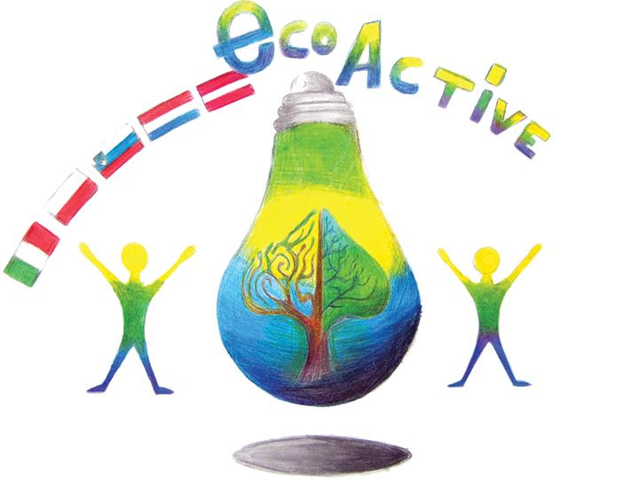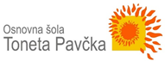
LESSON PLAN
SCHOOL | Tone Pavček Primary School, Slovenia
THEMATIC AREA | Waste management  Resource recovery  Eco-conscious consumers
TEACHER | Slavka Pečjak
SUBJECT | Home Economics
AGE GROUP (approximately) | 11–13 (older groups)
TIME REQUIRED | 90 minutes
PLACE | Classroom
LESSON OBJECTIVES | Students:  - learn about proper waste management,  - learn how to classify waste to properly dispose it into recycling containers,  - recognize hazardous waste and ways of working with it,  - understand the importance of waste separation,  - understand the concept of waste separation and recycling.  New concepts:  - packaging, hazardous waste, bio-waste, ecological islands, recycling
LESSONS YOU CAN USE | - Chemistry  - Science  - Foreign Language (as vocabulary extension)  - Ecology
CLASS ORGANISATION | - Pair work  - Group work  - Individual work
MATERIALS | Household waste, poster board paper A2, coloured markers, student Eco-Notebook (made for the Eco-Active project), a Waste Management powerpoint presentation
ICT TOOLS | Interactive board
PROCEDURE | The teacher welcomes the class and introduces the topic of waste management and resource recovery.  The teacher invites the class to share their thoughts about creating and managing waste in students’ households. The teacher ask some questions, such as:  What kind of waste did you create at home yesterday?  How much did you make?  Did you separate the waste? How?  The teacher asks the students to open student Eco-Notebooks on page 2 (a chapter about waste).  Students work in pairs. While reading the information in the Eco-Notebook booklet, they talk to each other about waste, the ways they separate it at home, and discuss whether they find the tips written in the booklet useful or not.  Teacher invites individual pairs to share their findings (slide 2 on Waste Management powerpoint presentation; additional teacher resources at www.recycling-guide.org.uk).  The teacher sums up important information about managing waste and outlines the importance of reducing the consumption of waste, separating waste in specially marked containers within the households, and ways of dealing with hazardous waste.  The teacher tells the students about ways of managing waste in students' local environment (slide 3 Waste Management powerpoint presentation; additional teacher resources at www.komunala-nm.si).  The teacher leads a discussion on “Ecological Islands”, resource recovery areas that are placed in most villages around Mirna Peč. (slide 4 Waste Management powerpoint presentation; additional teacher resources at www.komunala-nm.si).  The students are divided into (5 to 7) small groups . Each group takes a poster board paper, some coloured markers, and takes out a slip of paper from a bag. On the slip there is a topic (PAPER, GLASS, PLASTIC, ORGANIC WASTE, METAL; additional groups LINEN, HAZARDOUS WASTE).  Student prepare the waste items, they have brought from their homes, and take each to the group with the appropriate topic.  Each group then draws a big container on the poster, separates the waste and glues only the waste belonging to their topic.  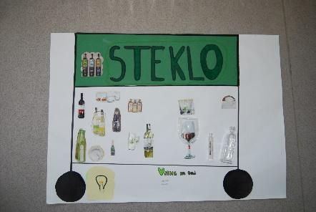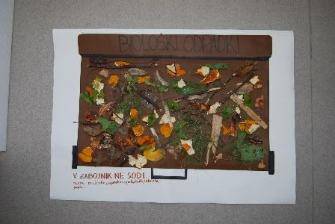  In conclusion, the whole class writes down their findings of Eco-conscious consumers. For example:  - Separate and recycle  - Support groups that fight for a clean and green planet  - Use public transport or cycle  - Reduce pollution  - Use environmentally-friendly cleaning products
EVALUATION
ATTACHEMENTS | PPT

