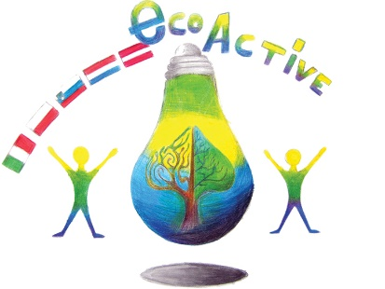
LESSON PLAN
SCHOOL | Tone Pavček Primary School, Slovenia
THEMATIC AREA | Waste management  Reusing
TEACHER | Mojca Starešinič
SUBJECT | Art
AGE GROUP (approximately) | 9–12
TIME REQUIRED | 90 minutes
PLACE | Classroom
LESSON OBJECTIVES | Students:  - make use of discarded objects to create a piece of art,  - develop creative and innovative thinking processes,  - develop the ability of independent choice-making,  - monitor the creative process of making art forms,  - develop the sense of responsibility for completing the tasks given,  - develop the sense of eco-friendly behaviour and sustainable development,  - develop entrepreneurial skills,  - acquire skills and knowledge for lifelong learning,  - contribute to waste reduction by presenting their finished products to friends or family,  - contribute to waste reduction and grow as eco-friendly citizens of Earth,  - prepare regular exhibitions of finished products.
LESSONS YOU CAN USE | - English (CLIL)  - Biology  - Science
CLASS ORGANISATION | - Pair work  - Individual work
MATERIALS | Discarded plastic bottles, scraps of wool, a glue gun, adhesive tape, a utility knife, scissors, a hole punch
ICT TOOLS | A computer and a projector
PROCEDURE | Introduction: Brainstorming  In pairs students discuss how discarded plastic bottles (which represent one of the major environmental problems in the world) can be reused. The teachers writes plastic bottles as the keyword on the board and notes down the ideas that the students come up with.  Main part:  Technique 1  Students prepare the necessary materials and tools: discarded plastic bottles, scraps of wool, a glue gun, adhesive tape, a utility knife, scissors, a hole punch.  The teacher explains the steps of making bracelets, while the students create them.  - You make the first cut into the plastic bottle using a utility knife. Be careful not to cut yourself! Cut out a ring 2 cm in width using scissors.  - Fix the wool on the inside of the plastic ring with adhesive tape. Then wrap the wool around the ring. The thread has to be tight and accurate.  - After completely covering the ring with wool, glue the end of the wool on the inside of the ring using the glue gun.  - To make your bracelet more interesting, use wool of different colours or add other ornaments.  Technique 2  Making bracelets from plastic bottles and wool:  - Make holes using a hole punch in the plastic ring cut out from the bottle.  - Thread the wool inside the holes and around the ring in random order and color combination.  Students create any number of bracelets, applying their creative ideas. In doing so, they make sure that their product is as aesthetically pleasing and technically perfect as possible.  Summary:  Students present their products and exhibit them. If during the creative process, they have new ideas on other ways of making bracelets from plastic bottles, they present them to their classmates. Afterwards they tidy their working space, and facilities and regulate waste.
EVALUATION
ATTACHEMENTS | PPT: Bracelets made from plastic bottles and wool

