

**ITEM 5: THE FUTURE**

In this section you will learn thinking about the future, what we can do now to face the future in a cheerful way

**INFORMATION SHEET 5.**

How can we switch to sustainable energy as quickly as possible? A matter of time?! The future is the time that is yet to come. The future is tonight, tomorrow, next year.

Happy into the future

What should the future look like? Together we can ensure a livable earth. Otherwise, there may not even be a future. Sustainable energy from and for everyone. That is a beautiful vision of the future!

We will only use sustainable energy in the future. But when do we use really only sustainable energy? No more petrol, no coal-fired power stations, no gas. How long is that going to last?

Do something for the future

A bright future does not come automatically. A lot still needs to be done. What stops us?

Unfortunately, there are things that make switching difficult, or that make it take a long time. New items are needed for a new world. Electric cars for example and charging stations to charge them. That must all be built and made and that takes time.

Some things can and should be better. The technology is not yet good enough everywhere. Electric cars, for example, have to be cheape, so that more people want to buy one. It takes a long time before the car is charged. You cannot drive that far yet and there are only a few places to recharge them. That's why many people buy a petrol car. As long as there are still petrol cars driving around, gas will still be needed.

We do not have to use all fossil fuels before we switch to others energy sources. But many Dutch people now have a gas stove at home. You do not just buy an electric hob. For the time being, therefore, gas pipes must remain in the houses.

Collaborate

Nobody can decide on his own that we switch to sustainable energy. We must work together, in the whole world. That means making appointments. Who does what? How do you do that? Can we learn from each other? Can we help each other?

Some countries in the world have a lot of oil in the ground. That is not good for the environment, but they will get a lot of money for it. The countries and companies that sell that energy do not want to stop it. So we have to make agreements so that everyone is satisfied and wants to work with them. It takes time.

Your future

What do you have to do with it? Everything of course! It is also your future!

What are you going to notice in 20 years?

As a consumer you use energy and you have to pay for it. Or are you going to buy solar panels and

to generate your energy yourself? As a resident or road user you can suffer from unhealthy

air. Worse, you can face floods due to climate change.

You can also start working somewhere where you are dealing with energy. For example as a designer,

builder or mechanic of solar panels, or windmills.

Maybe you become someone who makes the rules, for example at a municipality or in the government.

Then you decide where windmills should come and you can ban cars that are on

drive petrol.

You are going to notice something, but are you going to look forward to the future in a cheerful way?



**WORKSHEET 5.**

Task 1

How sustainable is your neighborhood already?

Choose which assignment you want to find out. a or b.

a. Interview fellow citizens

Interview 5 people at different addresses in the neighborhood. Use the input fields for the first person 1, for the second the boxes with number 2. And so on.

Explain that you examine how sustainable your neighborhood is. Ask them the following questions:

1. Do you use green electricity?

Yes No, but we want to No

5

4

3

2

1

5

4

3

2

15

5

4

3

2

1

2. Do you want solar panels?

Yes, we already have Yes, but we do not No

have them yet

5

4

3

2

1

5

4

3

2

15

5

4

3

2

1

3. In what kind of car do you drive?

We do not have a car Hybrid car Petrol car Diesel/petrol car

5

4

3

2

1

5

4

3

2

15

5

4

3

2

1

4. Do you have double glazing?

Yes, everywhere Yes, but not everywhere No

5

4

3

2

1

5

4

3

2

15

5

4

3

2

1

5. What do you use to cook?

Electricity Gas, but we want Gas  
(induction / ceramic) to switch to electric cooking

5

45

3

2

1

5

4

3

2

15

5

4

3

2

1

The first answer is always the sustainable answer.

The second answer shows that we are on our way to a sustainable world.  
The third answer is not sustainable.

Add up all the first answers together. ……………………………………………………………..

What percentage of the total number of answers is that?..................................

Add up all the second answers. What percentage is that?..................................

Add up all third answers. What percentage is that?............................................

Which percentage is highest?.............................................................................

Is your neighborhood already sustainable?........................................................

Are you satisfied with the results? ………….. Why yes / not?................................  
………………………………………………………………………………………………………………………….

b. Neighborhood research

Choose four streets in the neighborhood and go on research.

What is sustainable, what is not?

Count the following things:

Electric cars Hybrid cars ……………………………………………….  
Petrol cars (and diesel cars)………………………………………….  
Parking places with charging stations Regular parking places……………………………  
Houses with solar panels Houses without solar panels………………………………………

All information collected?

Calculate the percentage of electric cars……………………………………………………………..

Calculate the percentage of parking spaces with charging stations………………………  
Calculate the percentage of houses with solar panels……………………………………………

Which percentage is highest?...................................................................................

Is your neighborhood already sustainable?

Are you satisfied with the results? ………………Why yes / not? ?................................  
………………………………………………………………………………………………………………………….

Task 2

Read the information sheet first.

How can we help the world to sustainable energy as quickly as possible?

Who has the best idea to help the world get to sustainable energy as quickly as possible?

Work in groups of 2 or 3.

Draw, cut and paste, or film your idea!

TIPS:

- Think of your plan for the future based on something you want to become later.

- Think of your plan for the future based on something you want to create or invent later.

- Think of your plan for the future based on something you can do at home later

A lot still needs to be done

What do you see in this picture that ensures that we can not switch so quickly to sustainable energy?

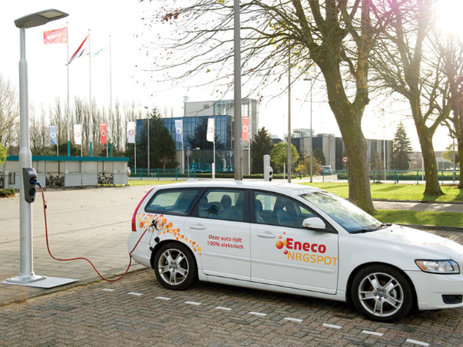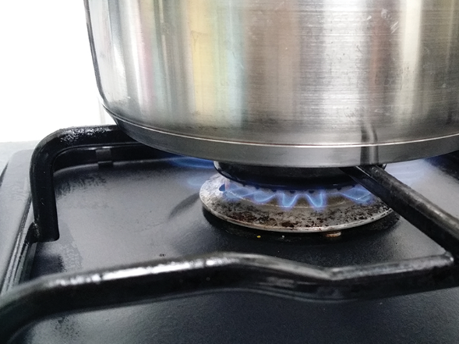

https://eneco-energieles.podium.nl/images/prev.png

…………………………………………. …………………………………………..

https://eneco-energieles.podium.nl/images/prev.png

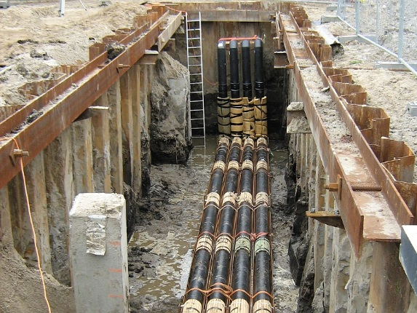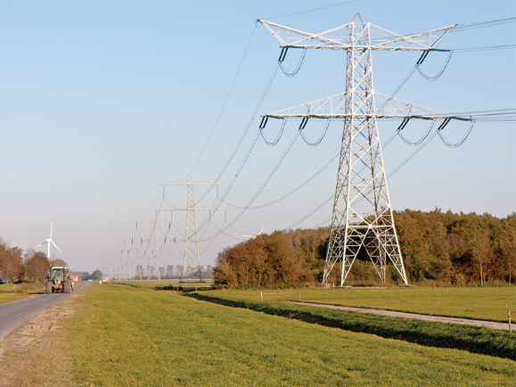

https://eneco-energieles.podium.nl/images/prev.png

………………………………………. …………………………………………

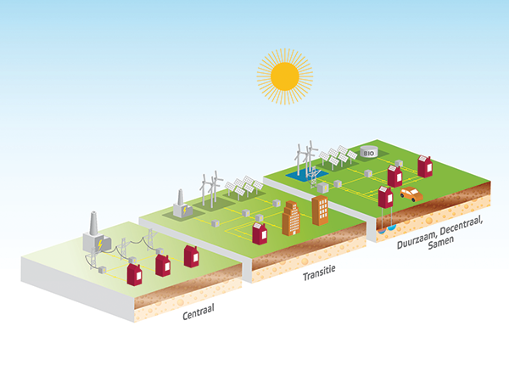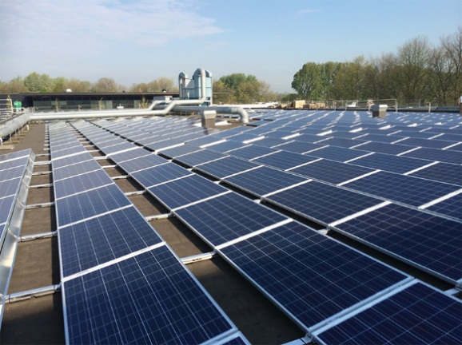https://eneco-energieles.podium.nl/images/prev.png

https://eneco-energieles.podium.nl/images/prev.png

https://eneco-energieles.podium.nl/images/prev.png

https://eneco-energieles.podium.nl/images/next.png

Samenwerken

Niemand kan in zijn eentje bepalen dat we overstappen op duurzame energie. We moeten samenwerken. Op de hele wereld. Dat betekent afspraken maken. Wie doet wat? Hoe doe je dat? Kunnen we van elkaar leren? Kunnen we elkaar helpen? Sommige landen in de wereld hebben veel olie in de grond. Dat is niet best voor het milieu, maar je krijgt er (nog altijd) wel veel geld voor. De landen en bedrijven die veel werken met energie die niet duurzaam is, of die die energie verkopen, willen daar niet zomaar mee stoppen. Dan verdienen ze namelijk minder. Afspraken maken en overleggen, kost tijd.

Aansluiten (net als de vorige)

Hoe komt energie van de ene op de andere plek? Als je het anders wilt doen, moet je meestal verbouwen.

……………………………………………………………… ……………………………………………………………………

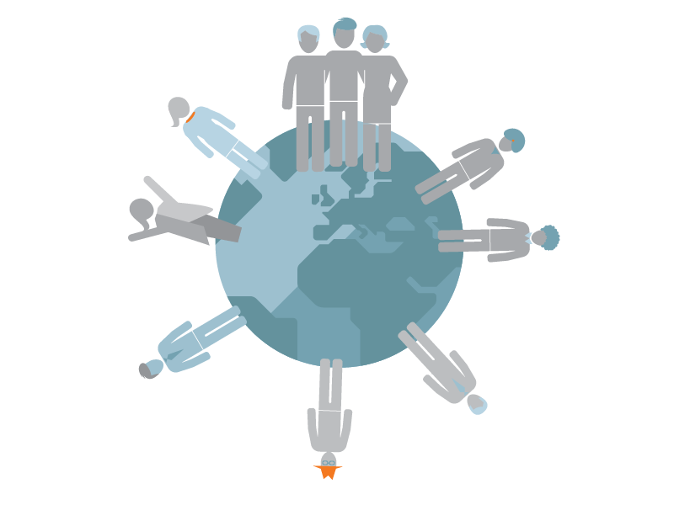

Your future

We are looking forward to the future in a cheerful way.

What is needed for this?

Watch the video.

<https://youtu.be/0SEvsgDyyO0>

Task 3.

How can we help the world to sustainable energy as quickly as possible? Who has the best idea to help the world get to sustainable energy as quickly as possible?

Draw, cut and paste, or film your idea!

View here as an example what group 8A of the Lorentzschool in Leiden has made of it  
<https://youtu.be/UF8lGKxuP00>

What did you learn?

• Working towards a better future starts now.

• Everyone uses energy, so everyone has to deal with it.

• If we all cooperate, we will only use clean energy that never runs out.