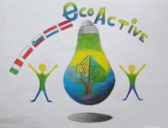 LESSON PLAN 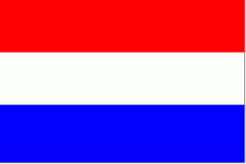
SCHOOL | Primary school ‘De Weijerwereld’ Boxmeer The Netherlands
THEMATIC AREA | Water
TEACHER | Frieda Heutink
SUBJECT | Handicraft
AGE GROUP  (approximately) | 10- years old pupils. They are mixed from different countries.
TIME REQUIRED | 45 minutes
PLACE | Mirna Peč, classroom
LESSON OBJECTIVES | - Enlarge cooperation  - Enlarge creativity  - Show the pupils how beautiful the ocean can be in a drawing.
LESSONS YOU CAN USE | - English  - Drawing  - Biology
CLASS ORGANISATION | - Pupils work individual
MATERIALS | - Papers for protecting the tables  - white drawing paper and a pencil  - crayons  - tassels  - ecoline/colored blue ink
ICT TOOLS | - I use a Powerpoint to explain the assignment.
PROCEDURE | - Preparation: I made a Powerpoint and a lesson plan. I made a list of all the materials we need and send this to the school in Slovenië.  - I don’t know all the pupils, so before I start the lesson I introduce myself  - Then I show all the pupils the materials and explain step by step what they have to do.  - I show the pupils the final product so they can see what they are going to make.  - Then I divided all the materials over the different groups, so the students can share the materials. They work individual.  - When the pupils start with the activity I walk around in the classroom and give instructions, compliments and help to the pupils.
EVALUATION | All the pupils clean up their table. When they are finished we ask the pupils what they were thinking of the activity. After that they take look at each other’s work.
ATTACHEMENTS | -

