**The water workshop in form 3 and 4 in October 2017 during the ECO-week.**

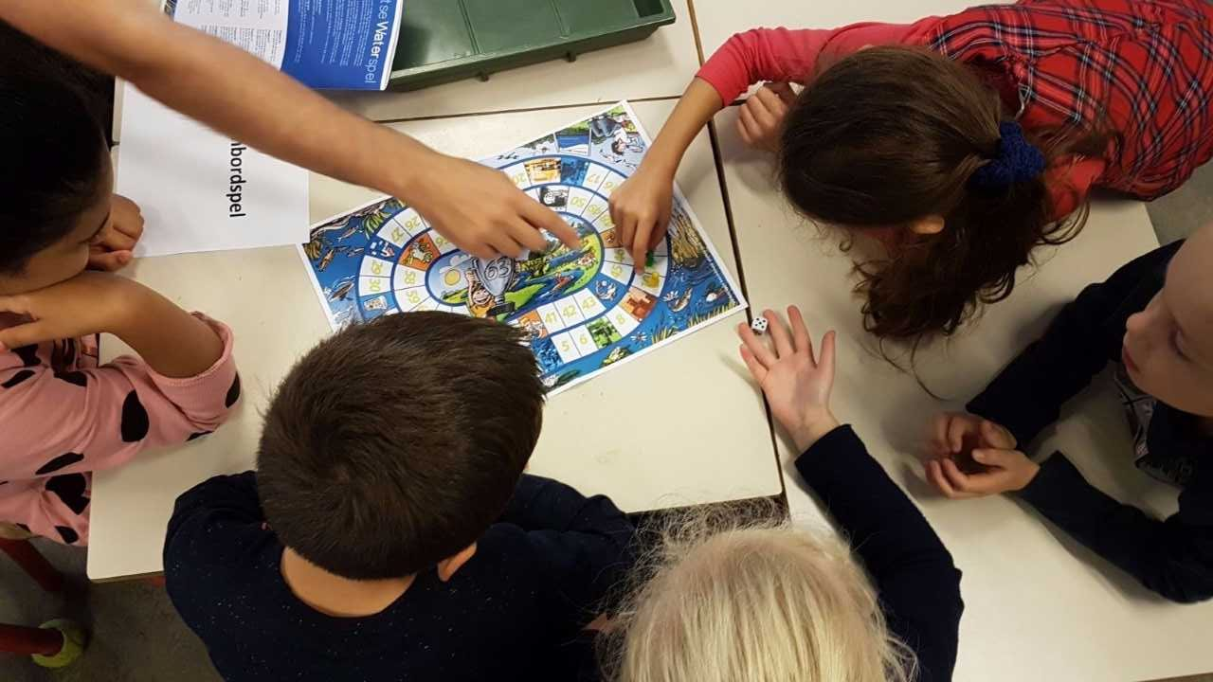 **Goose board game**

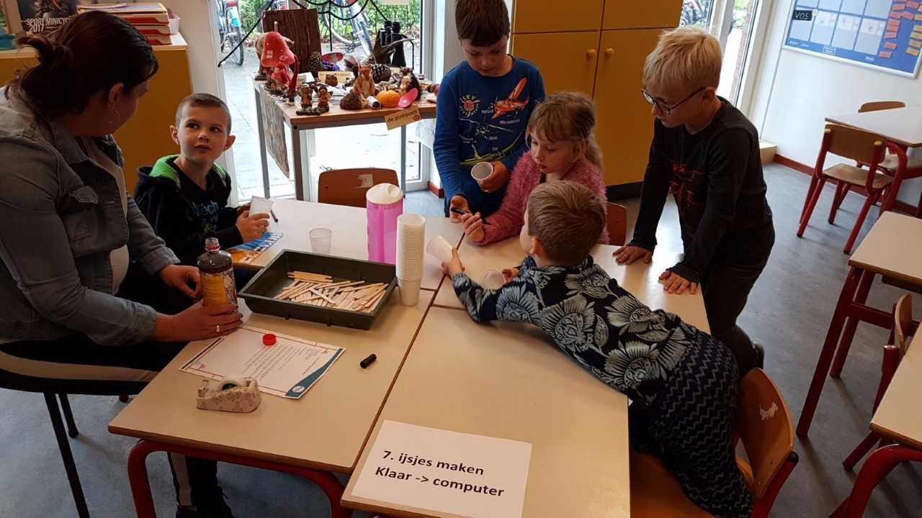

**Making ice cream**

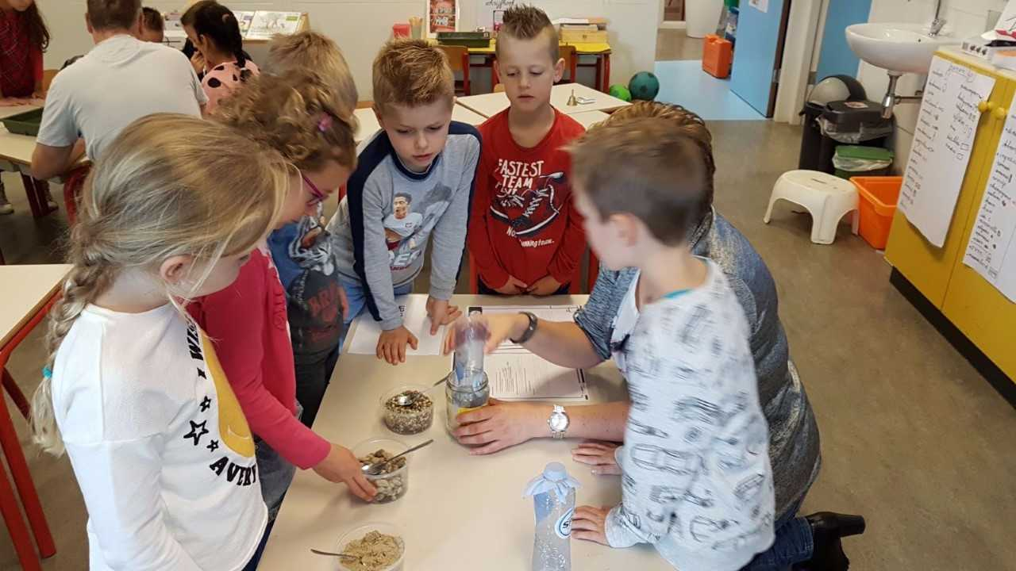

**Cleaning/filtering dirty water**

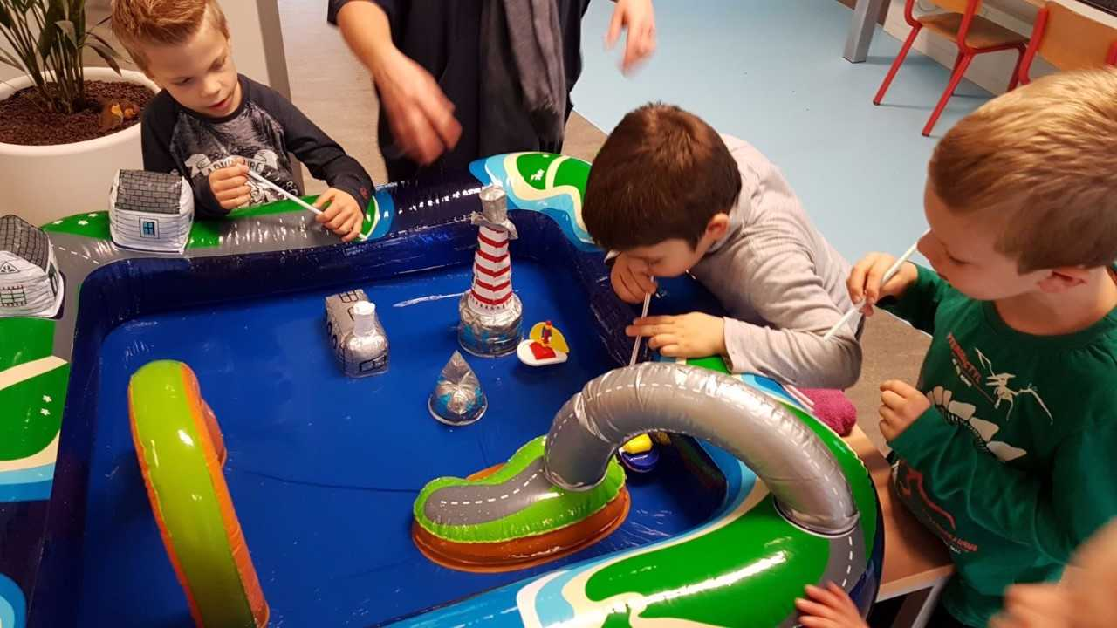

**Blowing boats**

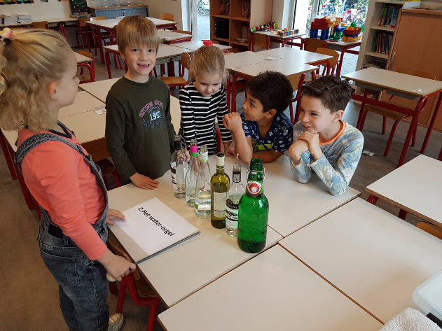

**Water organ**

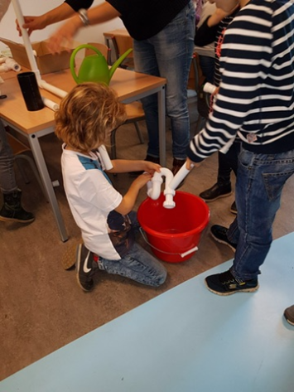

**Constructing sewerage**