 |  |  |  | RE-USE RE-DUCE RE-CYCLE
1 | 2 | 3 | 4 | 5 | 6 | 7 | 8 | 9 | 10 | 11 | 12 | 13 | 14 | 15 | 16 | 17
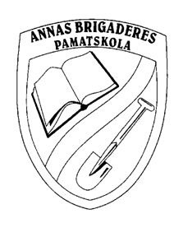 |  |  |  |  |  |  |  |  |  |  |  | FINISH  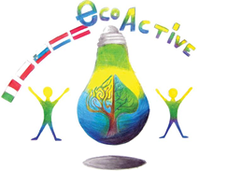  ECO-ACTIVE |  |  |  | 18
 |  |  |  |  |  |  |  |  |  |  |  |  |  |  |  | 19
De Weijerwereld Tone Pavček Primary School Secondo Circolo Didattico Annas Brigaderes P.S. Szkola Podstawowa nr 2  Boxmeer Mirna Peč Marsala Tervete Pulawy  Netherlands Slovenia Italy Latvia Poland |  |  |  |  |  |  |  |  |  |  |  |  |  |  |  | 20
45 | 46 | 47 | 48 | 49 | 50 | 51 | 52 | 53 | 54 | 55 | 56 |  |  |  |  | 21
44 | 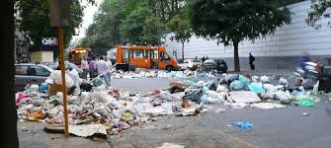 |  |  |  |  |  |  |  |  |  |  |  |  |  |  | 22
43 |  |  |  |  |  |  |  |  |  |  |  |  |  |  |  | 23
42 |  |  |  |  |  |  |  |  |  |  |  |  |  |  |  | 24
41 | 40 | 39 | 38 | 37 | 36 | 35 | 34 | 33 | 32 | 31 | 30 | 29 | 28 | 27 | 26 | 25

How to play the game?
- What you need? Pawns and a dice.
- Start is next to number one. Put your pawn there. The player who’s first name is first in the alphabet has the first turn. Then continue clockwise. Move your pawn as many squares as the number of your throw.
- Coming on a red or a green square, do as written in the rules below.
- The winner? The player who ends as first exactly on the Eco-active logo. Example: Your pawn is on number 55, your throw is 5, then count 56-logo-56-55-54.
2: You collected waste separated again. Will done. Have another throw.
4. The tap was running while cleaning your these. Wasting of water!! Miss one throw!
7. My computer never is more than 5 minutes in the standby modus. You save energy! Go to square 11
9. I am a lazy person. I do not separate waste. Go back to number 1
10. You brought your rubbish to the rubbish dump. That is where it belongs. Go on the square 13
12. My computer, TV etc. always are in the standby modus. Wasting energy!!! Miss two throws
15. Last Saturday you collected, with a friend, the street litter. Well done. Have another throw.
18. All your waste, batteries, glass and paper in the same rubbish bag? Ai ai ai! Go back to square 6.
20. You dispose of someone else’s waste. How nice. Go to 24.
21. You threw waste into the woods. Scandalous! Go back to 1.
23. You brought your used batteries to the collecting centre, great. Go further 3 squares.
28. You decided to go to school by bike instead of the car. Good idea, go further to 31.
30. You threw frying oil into the pond. You killed all the fish! Go to the shop and buy new ones. Miss two throws!
33. Your family decided to use solar cells on the roof. Very Eco-active! Go to square 40.
36. This week you dumped waste into the ground. The police arrested you. Wait until someone passes you. Then you can have your next throw.
37. You bought a chair of Swedish pine wood instead of tropical hardwood. Good for the environment. Go to number 40
42. You bought a container to collect organic waste and you produces compost. Excellent. Have another throw and go on the double of the number of dots of the throw.
43. You throw a banana peel on the rad instead of the compost container. An old man slipped, broke his leg and is in the hospital. Go to visit him and miss one throw.
47. In your family every week you write down the quantity of used water, gas and electricity. That is the best way to see if you live Eco-active. Go to the finish! You become an Eco-active award.
49. You cut down a tree without permission. Go back 3 squares.
50. You brought used , but still useful clothes to the recycling shop. Well done. Have another throw.
54. you decided to use alternative energy in future. Great. Go to the finish!!!
55. You sneakily put your waste alongside the highway. Bad behaviour. Have another throw and go back the number of dots of the throw.

