ECO WEEK
Tone Pavček primary school had an eco week from 18th to 21st April 2017. There were many different activities.
On Tuesday, Mr Jože Cvetko, the president of Water agency in a practical way presented to pupils how and where the water comes into our homes and which home appliances use it. He paid special attention to our habits in terms of water usage. In this school year, first three classes of pupils are integrated in the so-called Water agent project, in which they weekly follow the amount of used water in their classrooms.
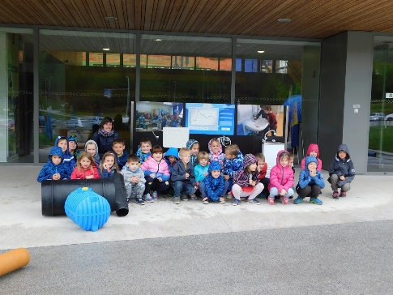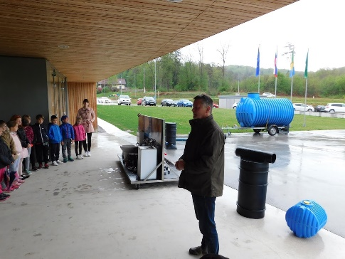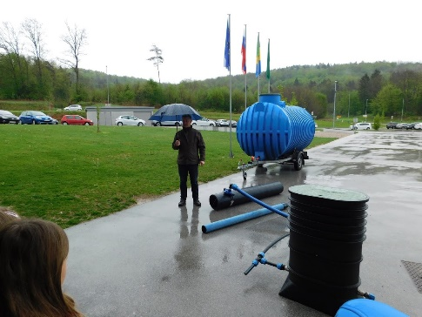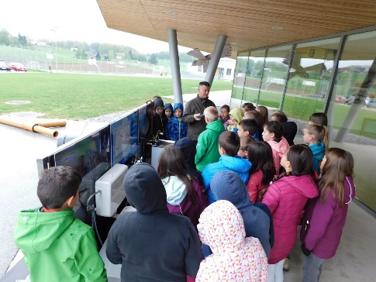
On the same day, there was a lecture about waste for all students. The lecturer was Mr. Simon Štukelj who works at Utility services in Novo mesto. He presented the cyclic waste management and the system of waste sorting.
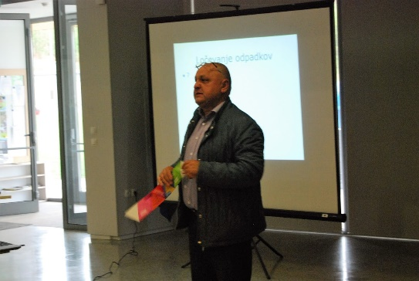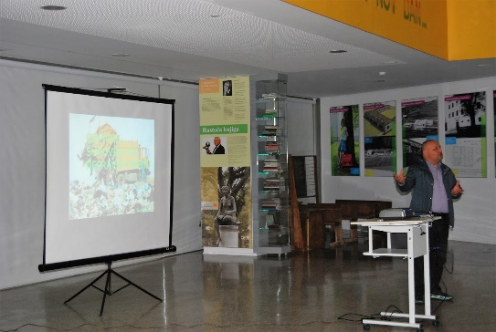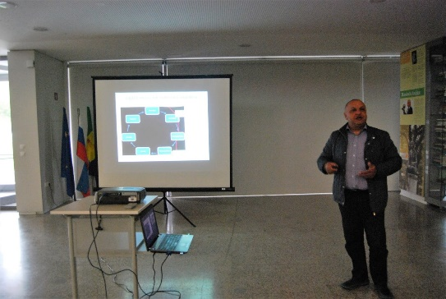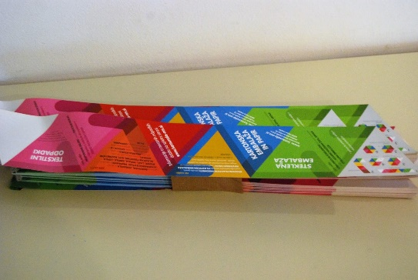
On Wednesday second and third-graders were taken to the forest by the forester Ms Jasmina Čanželj, who works at Slovenia Forest Service. While walking through the woods, she taught the pupils about proper behaviour in the woods. She also presented her job and the tools and accessories foresters use.
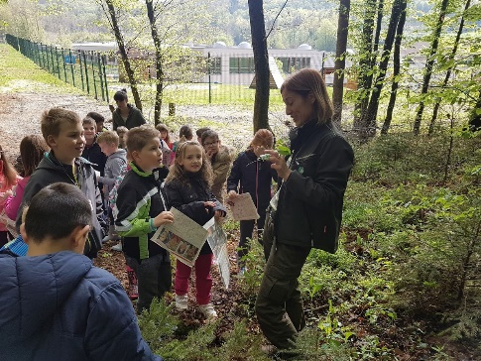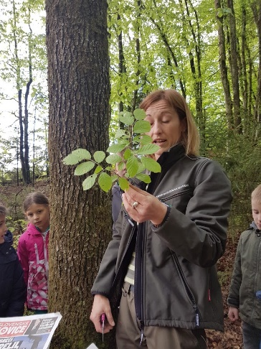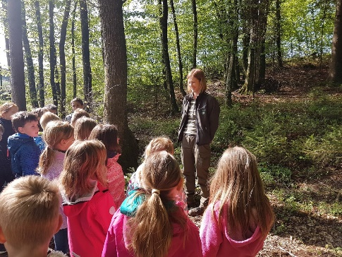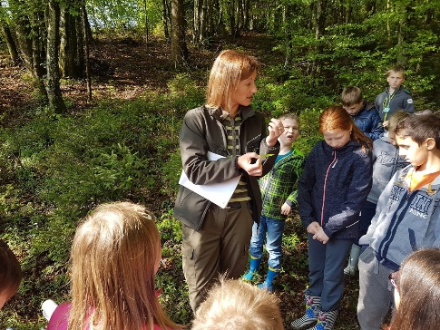
Students who attend the club called »Recycling« visited »the recycling centre« in Novo mesto on Wednesday. They were welcomed by the manager Ms Polona Žalec who works for the association Rokoroki. She presented the association's activities and the purposes behind them. The pupils looked at the fabric that is currently held there, then there was a workshop in which they produced shopping bags out of old jumpers and T-shirts and decorated them according to their own taste.
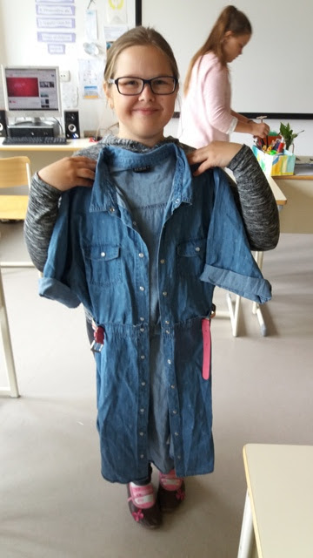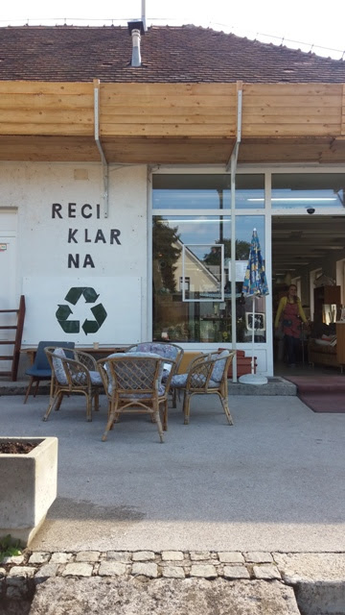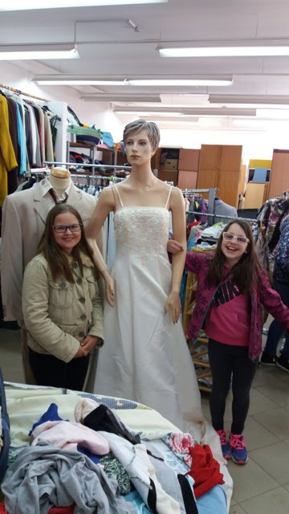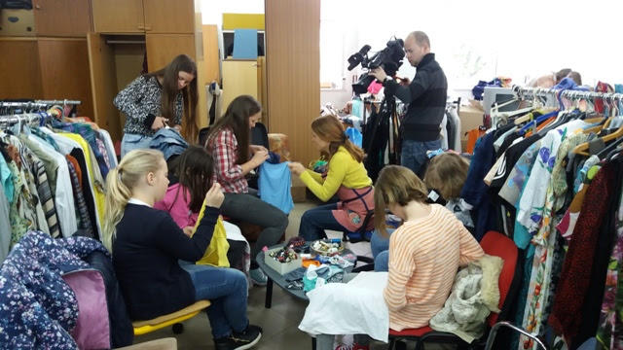
On Thursday first-graders were visited by the forester Mr Miloš Kecman, who also works at Slovenia Forest Service. He took the pupils to the nearby forest and presented the tree types, forest animals, the forester's tools and his work.
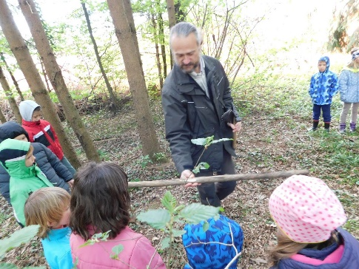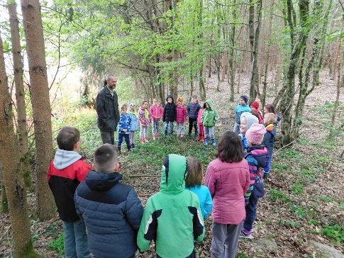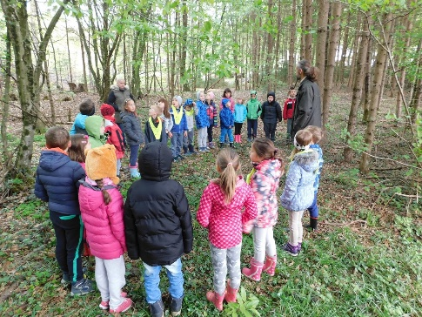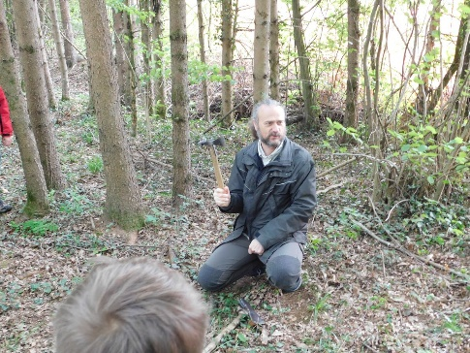
On Thursday seven pupils attended open day at Utility services in Novo mesto. First they watched a video about the company, then they had a tour of Recycling Facility and saw how the waste is sorted. Finally, they had a tour of the Cleaning plant in Novo mesto.
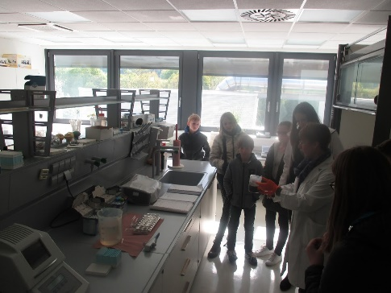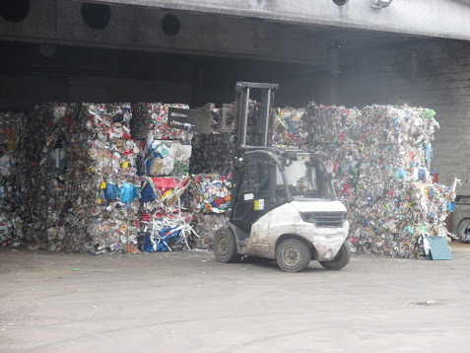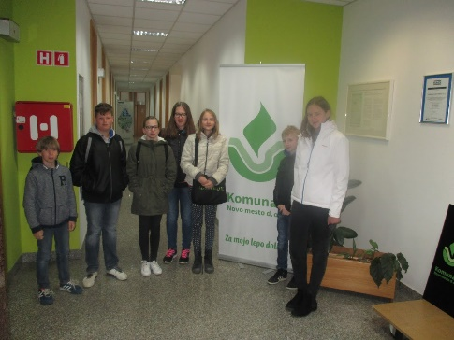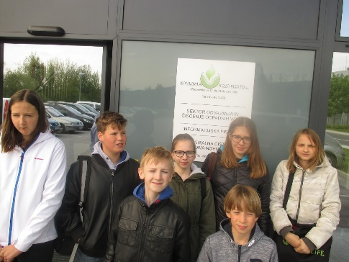
On Friday there was the 12th event celebrating international Mother Earth Day on Main Square in Novo mesto. Pupils from different schools put on display their products, prepared workshops and performed on stage. Pupils from our school exhibited products made at the »Recycling« club, which is led by Ms Mojca Starešinič. All products were made from recycled materials. They also presented the musical act Voda (»water«) by the famous Slovene pop group Dan D.
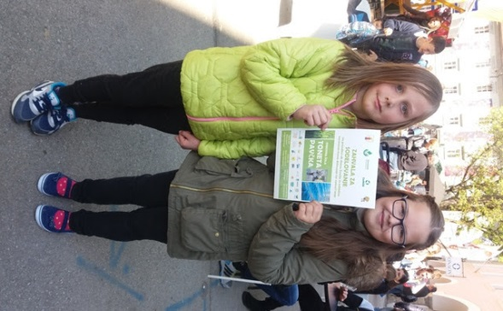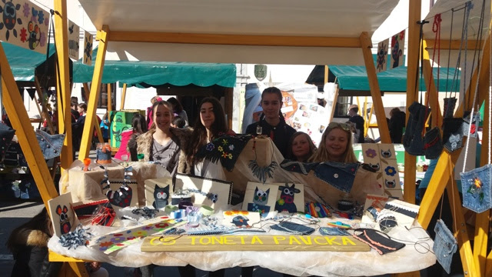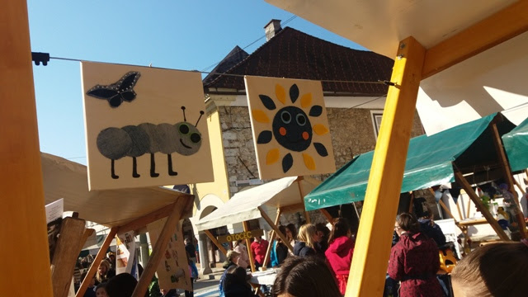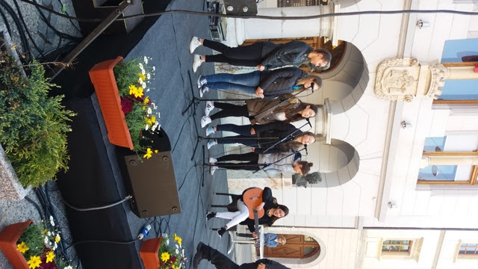
Pupils attending class 4a had the assignment to clean the school surroundings during our eco week. It is an assignment that is weekly passed from one class to another. Each day three pupils did the cleaning. On Wednesday the whole class dedicated one lesson to this assignment. Although trash is picked every day, they managed to collect a lot of paper wrappings, different candy containers and corks.
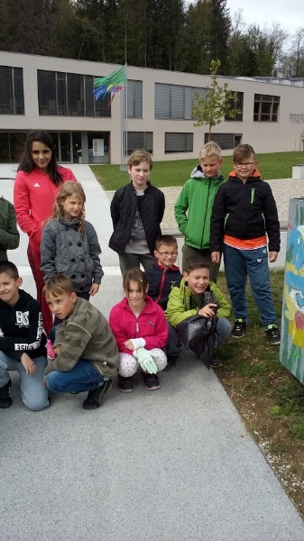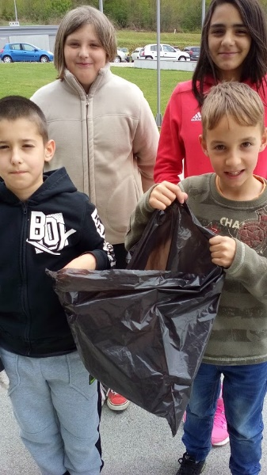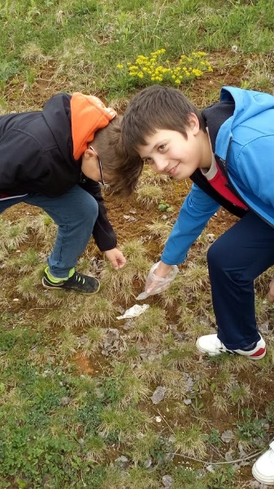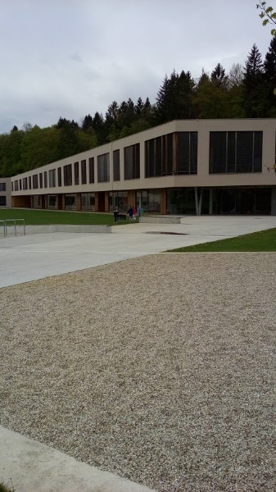
On Friday second-graders decided to clean the centre of Mirna Peč. It took them only a little more than an hour to fill six trash bags.
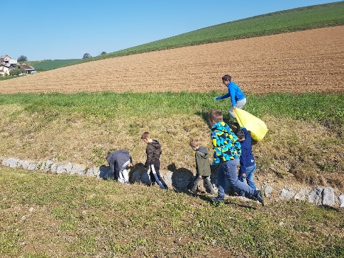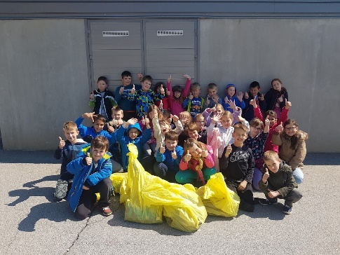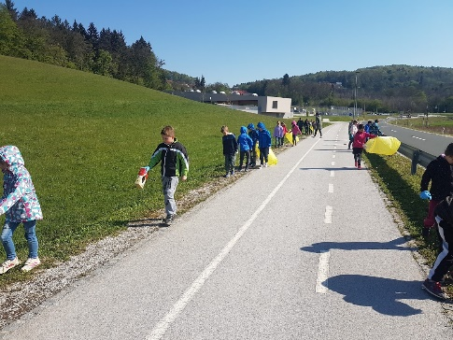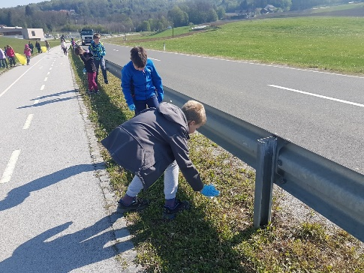

Soglasje za učno izmenjavo v okviru projekta Ekoaktivni

Spodaj podpisani/-na, _____________________________________, soglašam, da se moj/-a
sin/hči ________________________________________ udeleži načrtovane izmenjave v poljski šoli Szkola Podstawowa Nr 2 im. K. K. Baczynskiego w Pulawach v kraju Puławy. Izmenjava bo potekala v času od 27. maja do 4. junija 2017. Ob štirih sodelujočih učencih bodo na srečanje potovali tudi štirje učitelji OŠ Toneta Pavčka.
Podatki o učencu/-ki:
Ime in priimek: _________________________________________________ razred: ___________
Datum in kraj rojstva: _____________________________________________________
Naslov stalnega prebivališča: _____________________________________________________
Št. osebnega dokumenta: ______________________ velja do: ______________________
Emšo: ______________________
Telefonska številka starša: ______________________
Telefonska številka učenca/-ke: ______________________
Elektronska pošta učenca/-ke: _____________________________________________________
Elektronska pošta starša: _____________________________________________________
^{*Podatki niso obvezni.}

Datum: Podpis:

Izvedbo projekta Ekoaktivni financira Evropska komisija.

