

**ITEM 2: WHERE DOES ENERGY COME FROM AND HOW DOES IT COME TO YOU? (FORM 78)**

**ITEM 2: INFORMATION**

In this section you will learn which energy sources there are and how you can use the energy

can use.

Energy sources

What is energy? Everywhere. So actually everything is a source of energy.

In order to generate electricity, we use energy sources from which we easily generate a lot of energy can pick up. Which major sources are there?

The sun

The biggest source of energy is the sun. The sun gives warmth and light. We can handle that and use. We can also convert it into electricity with solar panels. Trees use the heat and the light of the sun to grow. So the solar energy is actually in the branches.

Plant and animal remains that have been printed together for millions of years change into oil and gas. The energy from the sun is therefore also stored there.

The wind

The wind is movement of air. We can let something move with wind. That movement can

we use. We can convert various forms of energy into other forms. So can for example, we make electricity from kinetic energy. And we use electricity to make devices work.

Fuels

When you burn something, you get warmth and light. This is how we burn fossil fuels for heat to create. Examples of fossil fuels are: coal, natural gas and petroleum. In coal-fired power plants we convert that heat into electricity.

We also burn gas to make energy. For example, for cooking or in a power plant

heat or electricity.

We make petrol from oil. We use gasoline to burn. That happens in the engine

of a car. The engine turns the heat from burning into motion. That's how the car comes in

movement.

In biomass power plants, waste from recycled wood, grass and manure are burned for electricity to make.

There are more things that we burn so that we have warmth and light. Think of wood (matches) or paper. When you light a candle at home, you have light and heat where you want it. What

you burn, substances are always released. That is not just as harmful in every situation, but always a little bit.

Energy transport

You use electricity at home or at school. You obviously do not want a coal-fired power station or huge windmill in the garden. Where are they? On business parks for example or in a port. Windmills are also often at sea. There is enough space and there is often strong wind.

The place where the energy is generated is therefore not always the same as the place where the energy is converted into electricity.

We can move energy in the form of electricity in a smart way via a wire.

From a power plant to an outlet at your home for example. Transport electricity cables

the electricity to buildings. You can no longer see electricity pylons in the streets. The

electricity enters your home via thick cables under the ground. Then you can unplug the electricity pick up and use. We use electricity to power devices.

Gas pipes are also underground. Through these pipes, the gas comes into your gas cooker or central heating boiler. There you burn it for cooking or for heating water to heat your house.

It is also possible that your house is heated by hot water that you do not burn yourself. The

warm water then comes under the ground through thick tubes. That water is heated in a heat plant. Your home then has no gas pipeline.

Petrol is brought to service stations with special trucks. There it becomes big

preserved. With the car you can refuel the petrol at a gas station. Via tubes underneath

the soil and the tank hose, it flows into the car.

There is also energy in a battery. You can easily take out batteries. Do you have a mobile phone? Then you always have a little bit energy with you.



**ITEM 2: WORKSHEET**

Task 1

Look at the pictures on the screen in section 2.1.

Use the information sheets of parts 1 and 2

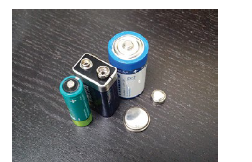1. What do you see here? ……………………………………………………………………………………………

Do you ever use them? Give an example.

……………………………………………………………………………………………

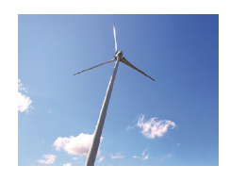 2. What do you see here? ………………………………………………….

What kind of energy do you absorb?.....................................

What can you do with that energy? …………………………………..

Have you ever seen a place somewhere? Where was that?

……………………………………………………………………..……………………

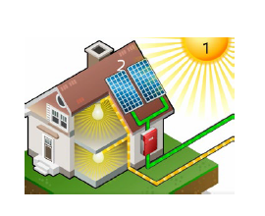

3. Which energy source do you see in figure 1? ……………………  
 ………………………………………………………………………………………….

What do you see in number 2?.............................................

What kind of energy do you absorb?....................................

What can you do with that energy?......................................

………………………………………………………………………………………….

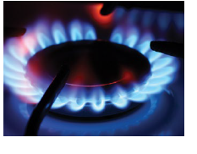 4. Which energy source do you see here?............................

……………………………………………………………………………………..

Do you use it at home?.....................................................

What do you use it for?....................................................  
 ……………………………………………………………………………………..

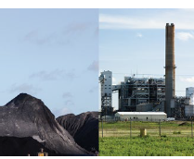5. What do you see here?.....................................................................  
………………………………………………………………………………………………………….

How can you take that energy to another place so that you can do it

use?.......................................................................................................  
…………………………………………………………………………………………………………

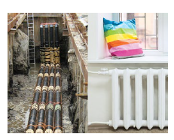6. What do you see here?.....................................................................  
…………………………………………………………………………………………………………

What do the left and right photos have to do with each other?  
…………………………………………………………………………………………………………  
………………………………………………………………………………………………………….  
………………………………………………………………………………………………………….

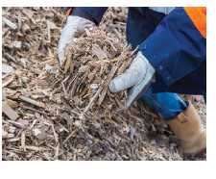7. What do you see here?....................................................................

How is the energy extracted?..............................................................  
…………………………………………………………………………………………………………  
………………………………………………………………………………………………………..  
…………………………………………………………………………………………………………

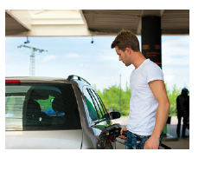8. What do you see here?.......................................................................  
…………………………………………………………………………………………………………..

Describe the path that oil travels from the moment it is found

is up to the petrol tank.  
…………………………………………………………………………………………………………….  
…………………………………………………………………………………………………………….

……………………………………………………………………………………………………………………………………………..  
…………………………………………………………………………………………………………………………………………….

In some substances, electrons can move easily. You call these substances conductors.

You also have insulators. These are substances in which electrons do not move.

In order to send power from the socket through the lamp, you need a conductive substance. Electricity wires are often of the conductive substance copper.

Task 2

How is it possible that you can touch the outside of a plug or socket without one get an electric shock?

………………………………………………………………………………………………………………………………………………..  
……………………………………………………………………………………………………………………………………………………………………………………………………………………………………………………………………………………………….

Task 3

If you would look at the inside of a plug and a plug wire, what would it look like?

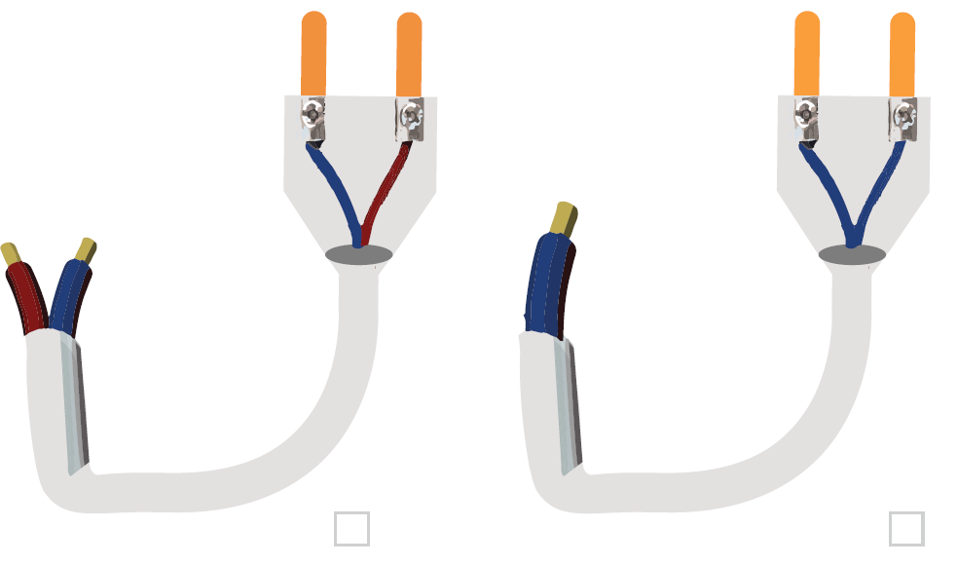

**ITEM 2: WHAT DID I LEARN?**

• There are different energy sources. For example: the sun, wind, biomass, coal, oil, gas.

• You can move energy through cables, tubes or batteries.

• You can also relocate some energy sources, such as gas or petrol.