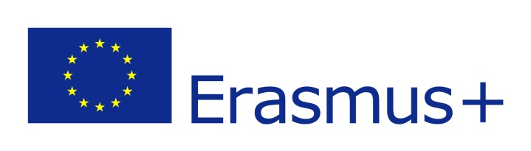

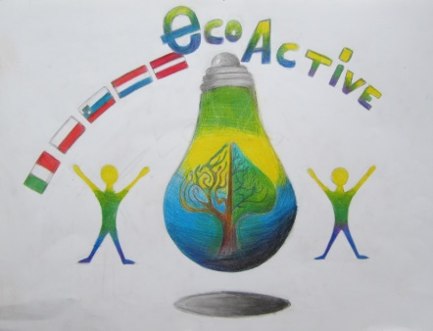
ECO-ACTIVE
Erasmus+ programme
newsletter 1.09.2018 – 30.11.2018

We have started the 3rd year of the European project“Eco-active”. This year the thematic area is HEALTH. All partners schools are collecting PET bottle caps.

LATVIA
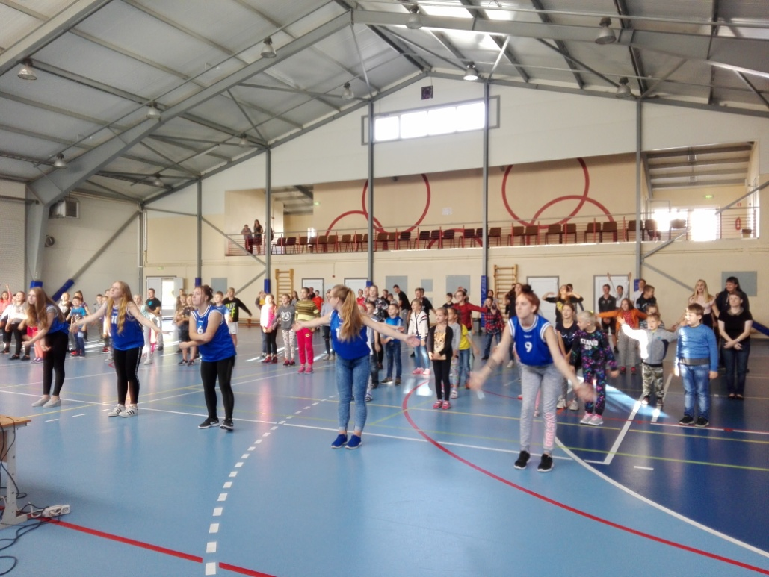
*) From 17.09.2018 until 21.09.2018 there was a sports week "Be Active!" at the school, which ended with the Olympic Day.

*)In 26.09.2018 students in grades 6 and 7 took part in a forest expedition in the nature park Tervete.

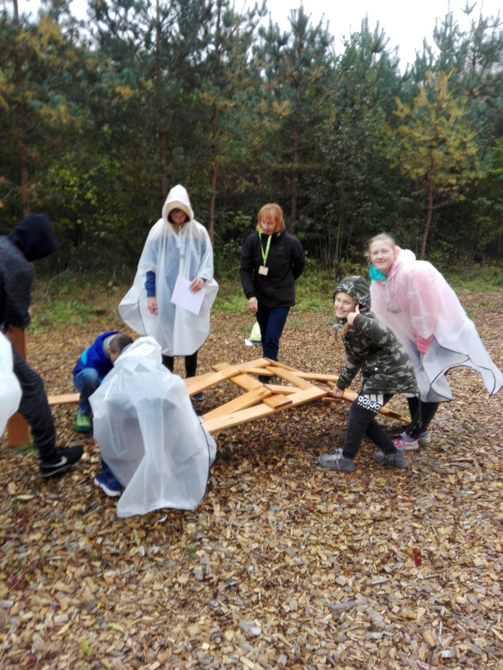

*)On 29.09.2018 there was a Miķeli market at the school where students sold their own things and cookies, which were made with the help of their parents.
*)10/05/2018 students in grades 6 and 7 participated in water tasting at Tērvetes beer brewery. The company plans to produce water with different flavours.
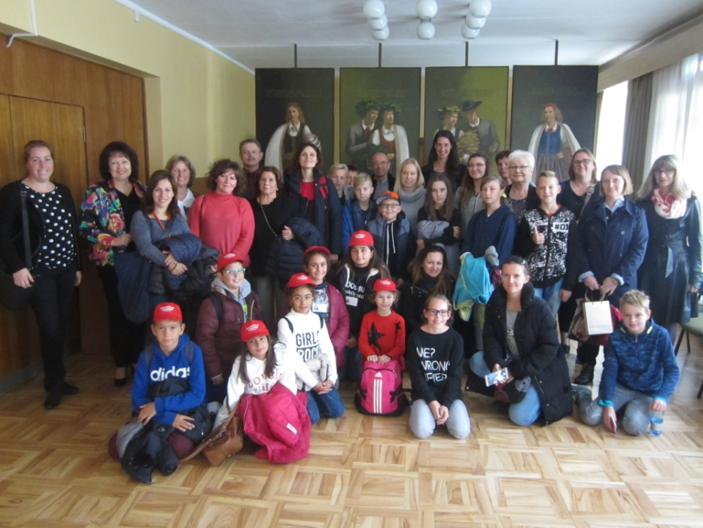
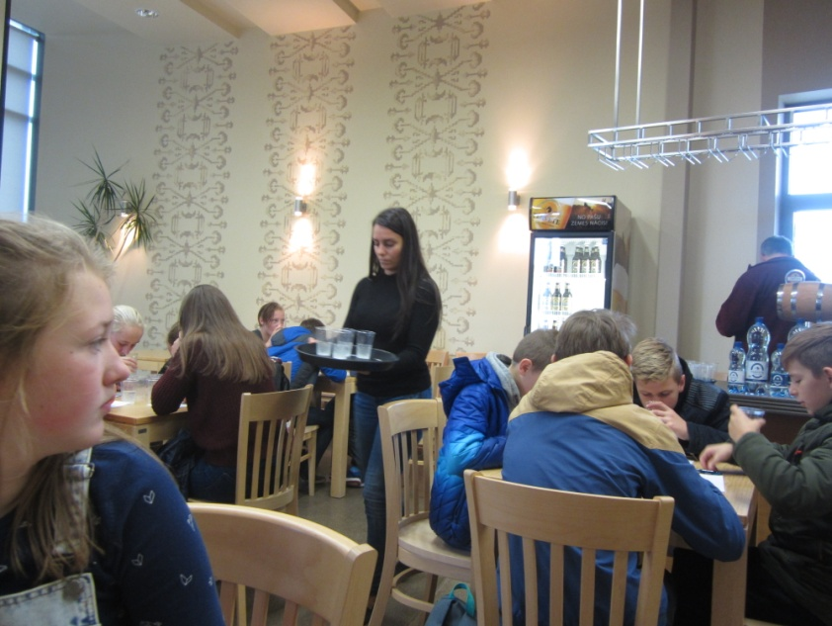

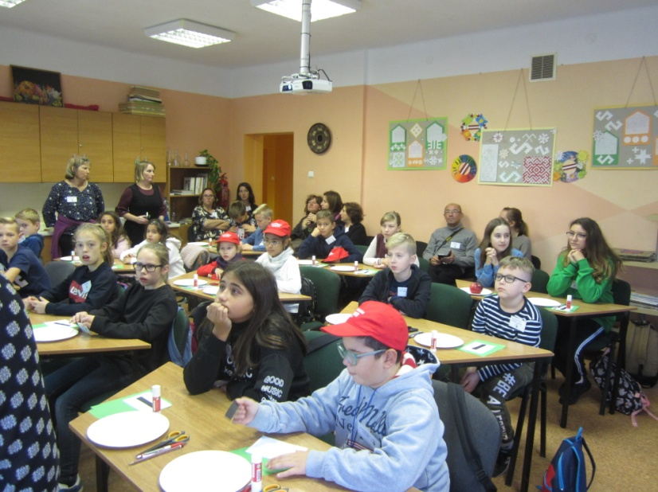
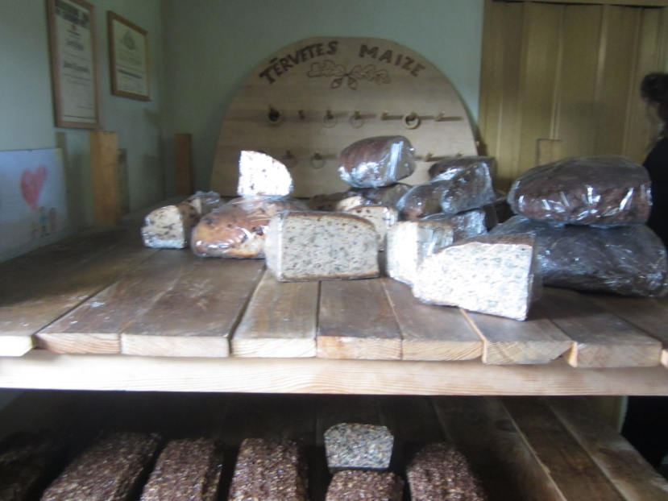

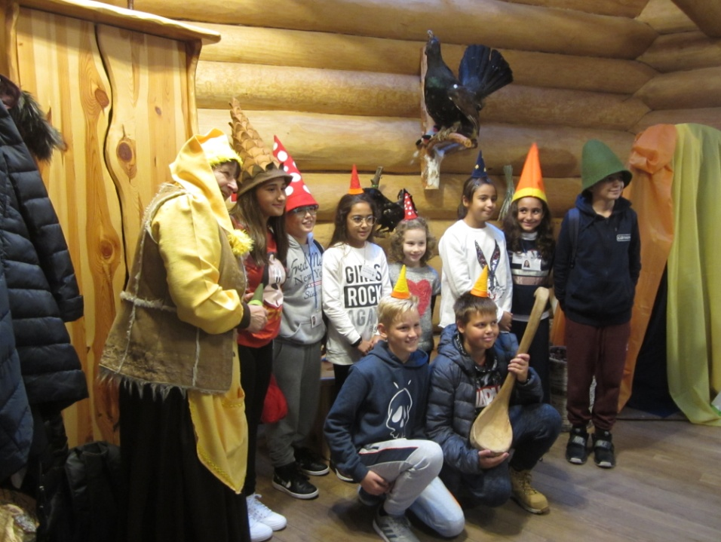
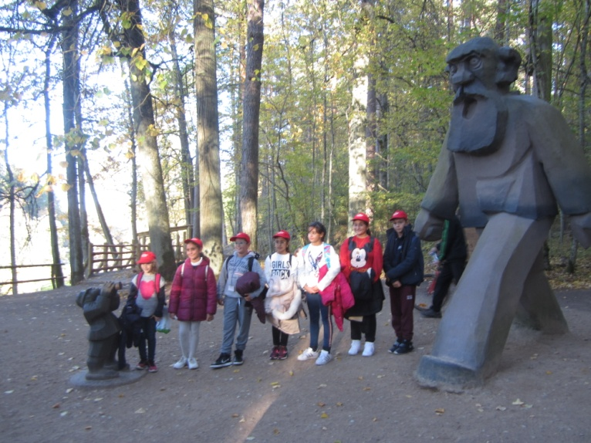

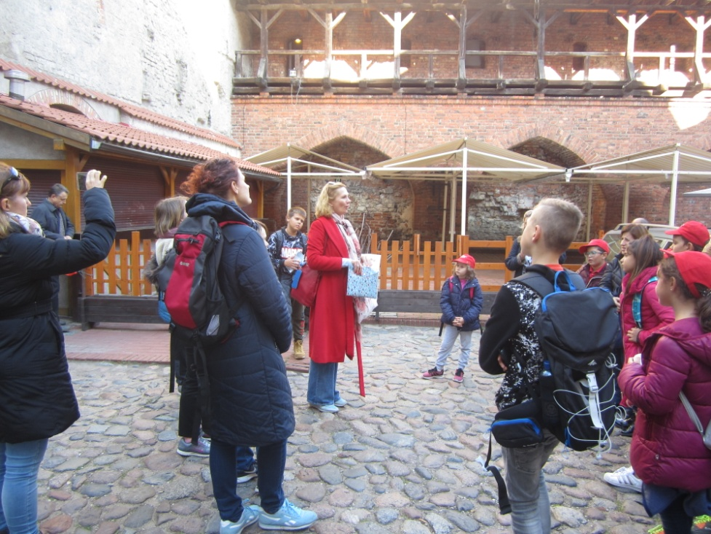
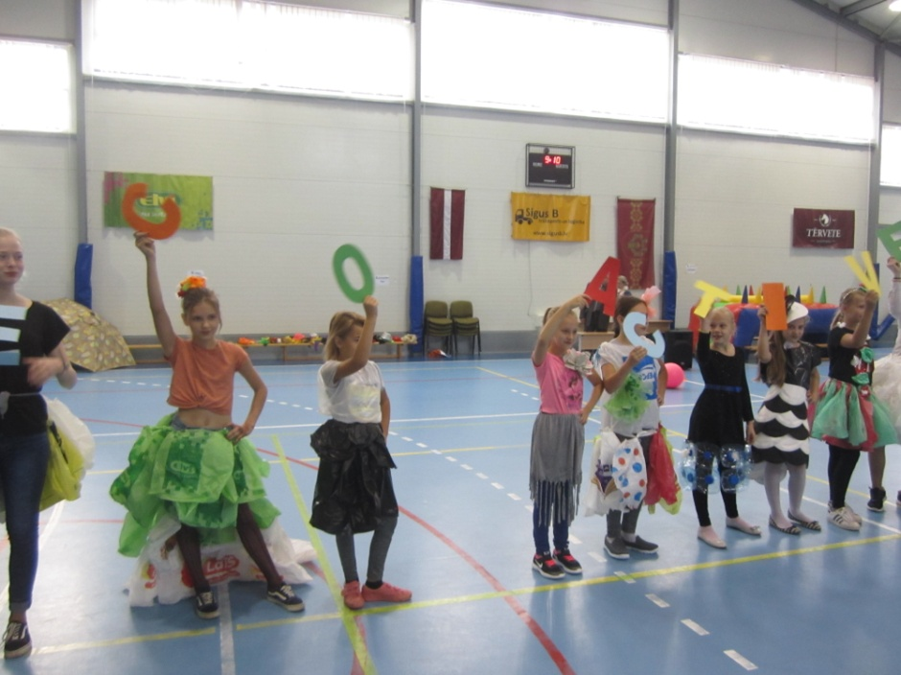

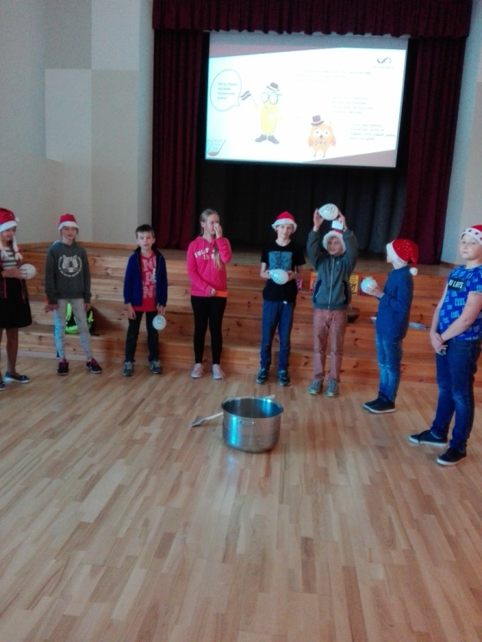
*)On 19.10.2018 Porridge day took place at school, where pupils from grades 1-5 were told about different kinds of porridge: oatmeal, semolina, corn, and others.

*)On 30.10.2018 we met Polish schoolchildren at the videoconference.

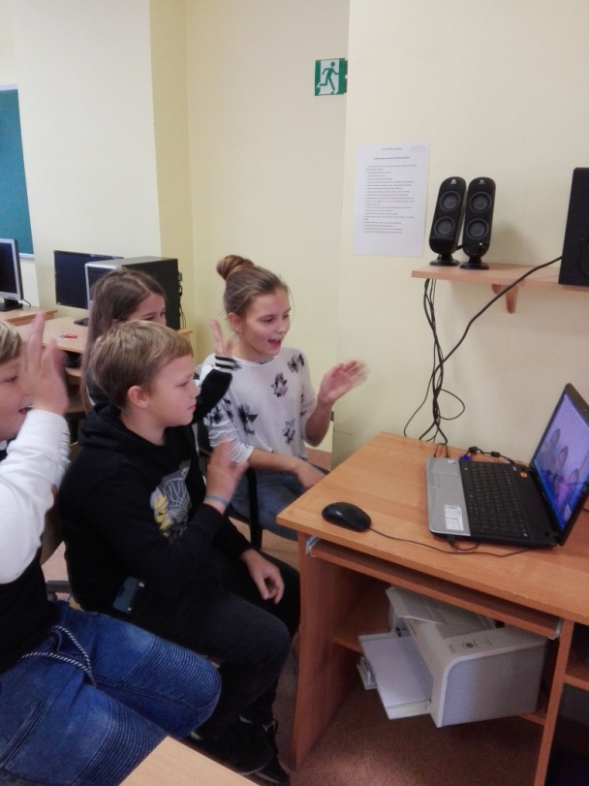

*) We have collected 76.14 kg PET bottle caps.

