SLOVENIA
13. October 2018 – The whole school
- Slovenian school organized an Eco Day. We invited parents, grandparents and the whole comunity to participate in workshops and on the Eco Bazar.
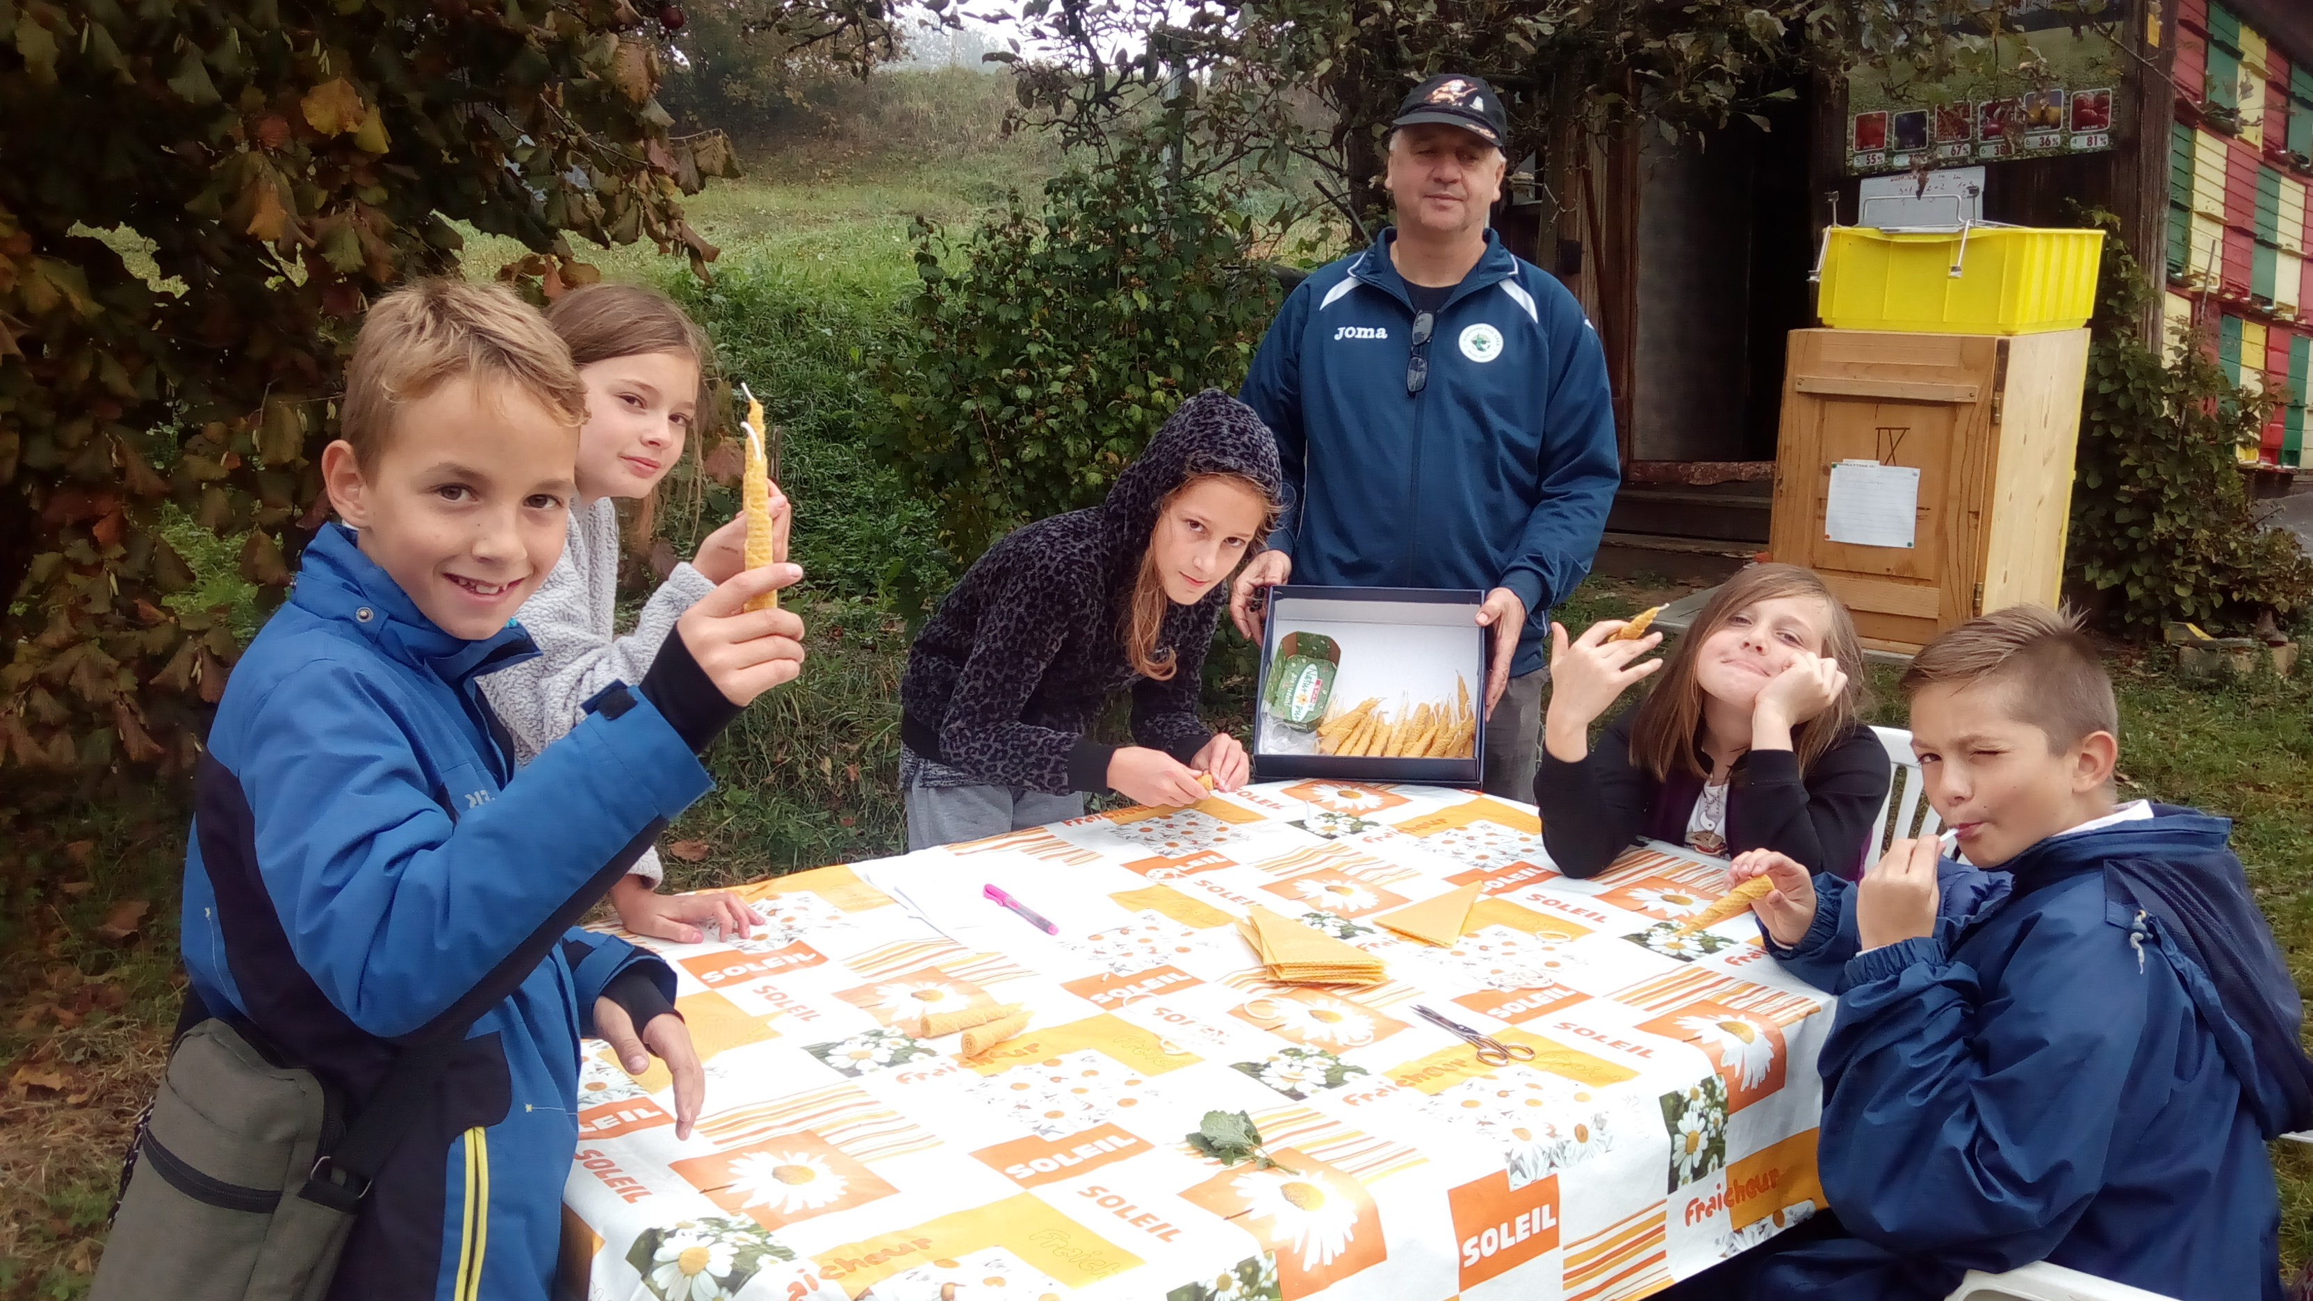
- The students from 1st to 5th grade join performance for children about »Healthy breakfast«.
- 1.grade- The teachers and the pupils from the 1. grade invited a lecture who talk to the teacher about healthy habits and proper washing of hands. Pupils also made cards - classical characters, which remind them every day for movements.
- 7. Grade During the lessons »Modern food preparation« pupils prepared smoothie from various fruits of all countries of the world. They baked »rolado« with marmalade, and they were baking pancakes. In September, they also arranged a school garden, picked apples and pears for the winter.
- Pupils from the 3rd grade studied a healthy food and drew a 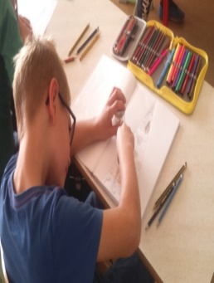healthy food plate.

- We organized a lecture for parents on the topic: The necessity for a balanced diet in children and eating disorders.
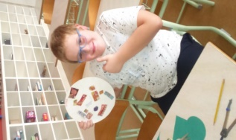
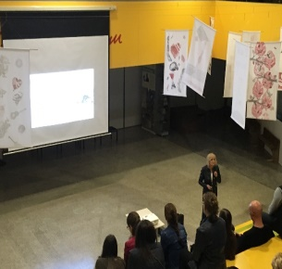
- The pupils from the second grade were researching the amount of the sugar in different kind of liquids.
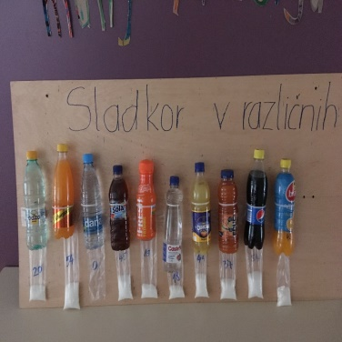
- The pupils from the 5. grade invited the nurse/ lecture from a health center Novo mesto to talk about healthy lifestyle.
