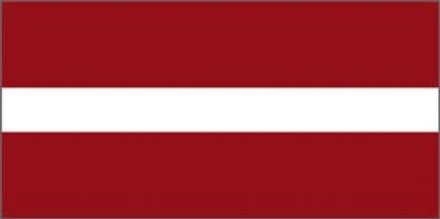
Niks Kaufmanis, Eduards Tutiņš
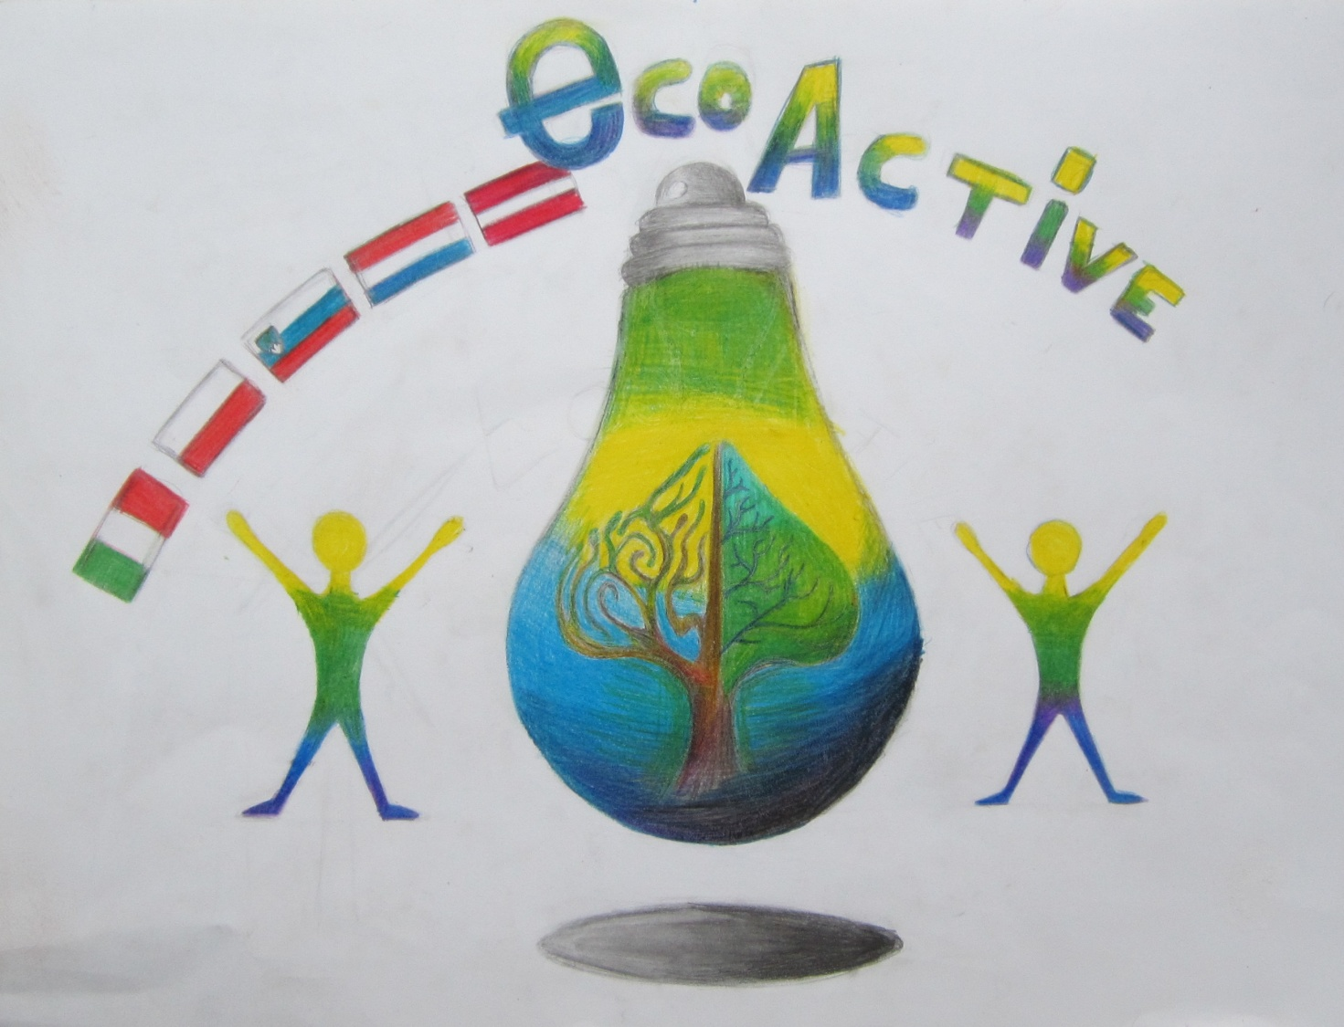
EUTOPIA
*)The typical national food is cooked and filled salmon with baked potatos, melted cheese and mushrooms.
*)There usualy are two people who will participate to be our country’s president. People who are older than 18 can vote about the person that they want to be our country’s president. Who will get the most votes is going to be the president.
*)We produce energy from water and wind generators.

Eutopias national anthem
We are forest and grass
We are the air and sea
Or life is colorful like a parrot
We are like hard working bees
We own freedom and the sun
We own green Eutopia

*)Our industry name is „Clean Nature”. Every year people join us to clean our country. We throw out plastic and glass bottles. They give us the bottles and we make new items from them.
*)The most cars in Eutopia are electrical, but we still have gas tanks for cars who use gas.
*)Every Eutopian eats vegetables every day but they also eat fruits.
Eutopian people are very friendly and always help each other. We rearely argue.
*)In 2050.scientists will make a medicine to cure deadly virusis. Eutopia will look greener. There will be a lot of trees.

