

WELCOM IN THE WORLD OF ENERGY.  
HAPPY INTO THE FUTURE!

*Introduction Movie in Dutch(!)*[*https://youtu.be/yl_RtgiCJbc*](https://youtu.be/yl_RtgiCJbc)

**ITEM 1: WHAT IS ENERGY?**

**INFO SHEET WHAT IS ENERGY? (FORM 7-8)**

What is energy?

In this section you will discover what energy is.

What types are there and when do you have something?

Energy is everywhere

Do you have a lot of energy? Where do you notice that?

It is difficult to imagine exactly what energy is.

You could see it like this: energy is the ability to provide heat, light or

movement.

There is energy in everything. You can use that energy as soon as you convert the energy or allow it to flow.

So you can make light, heat, movement or sound with it.

With clever techniques we can convert one form of energy into another.

This way we can convert light or movement into electricity and with electricity we can heat

Electricity.

Electricity is a way to use energy. That works like this: everything consists of moving

particles. A flowerpot, a computer, you yourself ...,

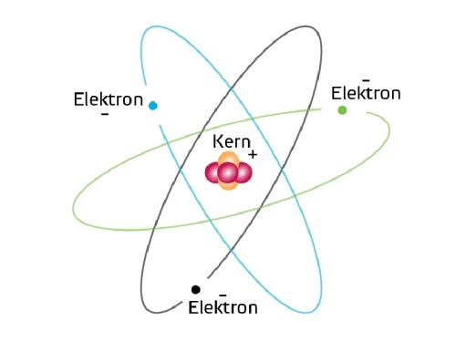really everything.

There are core particles and even smaller particles around them

to fly. All those particles are so small that we

they cannot see with our eyes.

Those loose flying particles are called electrons. They have

a negative charge. The core particles on them

turn are positively charged. Draw that difference

those core particles the electrons

Positive and negative always want to go to each other

toe. The electrons are not attached to the core particles,

but stay in the neighborhood. They can also

move from one core to another.

If there are a lot of electrons at once in the same move direction, you have an electric current.

You only get an electric current when the electrons can flow around.

Just look at a battery, you will see a + on one side and a - on the other side. The plus-side is positively charged. The minus side is negatively charged. Positive and negative want to go to each other. So if you ensure that there is a connection between minus and plus, for example with a wire, a current will flow. When you let the current flow through a device, the device will start working.

What can you do with energy?

With electric current you can for example light a lamp. Electricity is used in the lamp

converted into light and a little heat. Then you have some energy!

Gas is also full of energy. By burning it on a pit on the gas stove, you turn it over

heat. Then you can cook with it.

When you have cooked something tasty, you eat it naturally. Then it is in your body.

Your body converts the energy from the food into strength.

Thanks to that energy you can move!



**WORK SHEET ITEM 1 “WHAT IS ENERGY” ( FORM 7-8)**

Use the information sheet to look up things.

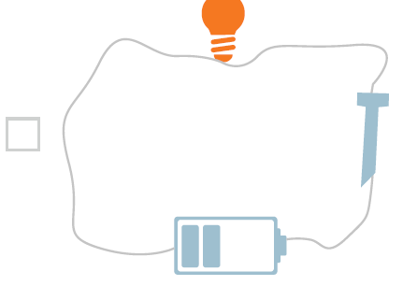

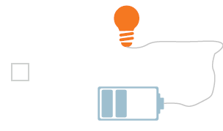Task 1

One of the lights next to it will light up.

Which one is that?

Task 2

Why is not the other light on?

……………………………………………………………………………………….

……………………………………………………………………………………….

There are usually numbers on lamps. Watt and Lumen.

Lumen shows how much light the lamp gives. More Lumen, more light.

Watt wants to say how much energy the lamp needs per second.

Compare these two lamps.

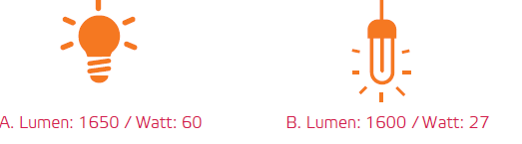

Task 3 3

Calculate how much energy lamp A needs to burn for 20 hours. 20 x 60 = ……………watt-hour

Task 4 4

Which lamp is the most economical?

B

A

Task 5

A

B

Which lamp gives the most light? (although you hardly see that difference).

You see that you have calculated how much watt-hour costs the burning of the lamp. Used in a year a family in the Netherlands averaged 3,500,000 watt hours. That is a big number and that is why we say typically 3,500 kWh (kilowatt hours). Kilo stands for 1000.

More and more people have solar panels on their roof, which they themselves use as part of the energy they need to arouse. A family with a large roof wants to buy solar panels that are 150 kWh. per year generate .They consume 3600 kWh per year.

Task 6

How many solar panels do they need to generate half of their electricity themselves?  
……………………………………………………………………………………………………………………………………

Task 7

What percentage of their electricity does this family generate? ………………………………..

Task 8 *

You only get electrical current when electrons can flow around. A battery has a plus-side and a min-side.

a. What charge do electrons have? …………………………………………….(+ or -)

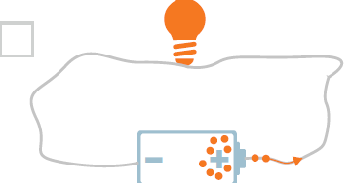b. On what picture do you see the correct direction of the electrons? 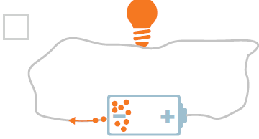

Task 9 *

Electrons find the shortest way. You may have heard of short circuit. The current then takes a short cut and no longer goes through the lamp. Below you see two pictures with a circuit.

On which picture do you see a short circuit?

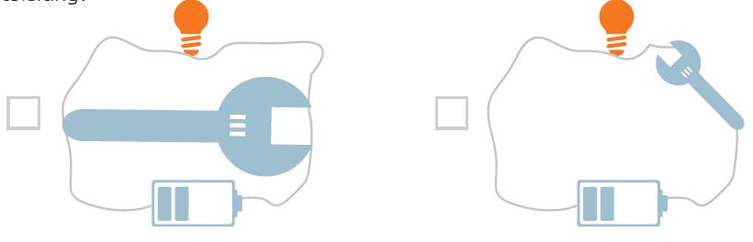

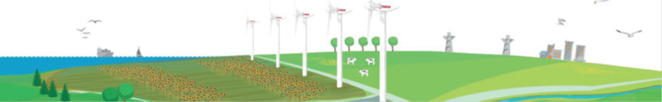

**WHAT DID YOU LEARN? ITEM 1 “WHAT IS ENERGY” (FORM 7-8)**

• Energy is the ability to provide heat, light, or movement.

• Energy is everywhere. If you pass it on or sell it, you have something to it.

• Electricity is a current of electrons.

• If the circuit is closed, the current will start to flow.

• Electric current always searches for the shortest route. (Group 7/8 only)

• When your power flows through a device, the device will start working.