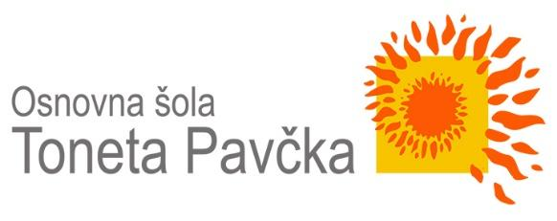
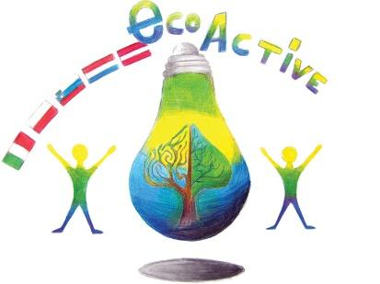
LESSON PLAN
SCHOOL | Tone Pavček Primary School, Slovenia
THEMATIC AREA | Water around us
TEACHER | Sanja Pavlinić Vidic
SUBJECT | Science
AGE GROUP (approximately) | 11–13 (older groups)
TIME REQUIRED | 90 minutes
PLACE | Classroom
LESSON OBJECTIVES | Students:  - Explain the difference between surface waters and groundwater.  - Justify the importance of protecting water.  - Explain the importance of groundwater as a source of drinking water.  - Identify and describe contaminants of surface waters and groundwater.
LESSONS YOU CAN USE | - Chemistry  - Science  - Foreign Language (as vocabulary extension)  - Ecology
CLASS ORGANISATION | - Pair work  - Group work  - Individual work
MATERIALS | Plastic bottles, water from rivers, lakes; rainwater; conical, filter paper, glass; EcoLabBox; paper, photos…
ICT TOOLS | Interactive board
PROCEDURE | The teacher welcomes the class and introduces the topic: Water around us.  The teacher invites the students to make groups and give them two glasses filled with different kind of water.  You need: two plastic bottles; fill the first bottle with rainwater and the second one with water from the river.  The teacher introduces the two bottles and invites the class to share their thoughts about what can they see.  The teacher asks some questions, such as:  - What can you notice?  - Why is the water dirty?  - What made it dirty?  - Is it drinkable?  - Is it contaminated?  The teacher asks the students to think about causes of water pollution. The students and the teacher talk about the causes. (The teacher can bring litterature, use websites.)  The causes are for example: separation of wastewater from industry and households; wrong and excessive use of fertilizers and sprays in agriculture; high precipitation; natural disasters; traffic; industry.  - Practical work. Students work in groups of 4.  You need: an Erlenmeyer, a filter, water from the river, distilled water, fungus.  - Take a bottle nr. 1 (water from river, lake) and pour it through the filter.  Ask: »What can you notice?«  - Take bottle nr. 2 (artificial fertilizers) and pour it through the filter.  Ask: »What can you notice?«  Discuss the questions:  - Is the water clear now?  - Is it good for drinking? What do you think?  - How can we check?  The teacher sums up: Distilled water is not drinkable, including water from the river, since it is not purified. There are numerous micro-organisms and many harmful substances in the water. Using the Ecolabbox set, we will investigate what is in the water and what percentage of this substance is.  - Practical work - Analysis of harmful substances in water  You need: “Ecolabbox”.  The teacher presents the phosphates, nitrates, ammonium in water and invites the student to analyse for example: the water from river, rainwater…  - Water analysis-phosphate (sample glass with blue code)  - Fill the sample glass with water sample to the mark.  - Add 10 drops of reagent 1, close sample glass with plastic stopper again, and shake sample glass.  - Open sample glass, add 1 drop of reagent 2, close the sample glass with plastic stopper, shake sample glass.  - Colour matching after 5 minutes.  Now look through the colour solution from above and compare the colour of the solution with the colour of field around the circle.  - Ammonium in water (sample glass with green code)  - Fill the sample glass with water sample to the mark.  - Add 10 drops of reagent 1, close sample glass with plastic stopper, shake sample glass.  - Open sample glass, add 1 measuring spoon of reagent 2, close sample glass with plastic stopper again, shake and leave for 5 minutes.  - Open sample glass, add 15 drops of reagent 3, close the sample glass with plastic stopper, shake sample glass.  - Colour matching after another 7 minutes.  Now look through the colour solution from above and compare the colour of the solution with the colour of field around the circle.  Conclusion: The teacher divides the students into the groups and offers them some pictures/photos. The students look at the photos and write down some tips on How to save the environment?  For example:  - Never throw rubbish away anyhow. Always look for the correct ways of disposing the waste.  - Use water wisely. Do not keep the tap running when not in use.  - Do not throw chemicals, oils, paints and medicines down the sink drain, or the toilet..  - Buy more environmentally safe cleaning liquids for use at home and other public places. They are less dangerous to the environment.
EVALUATION
ATTACHEMENTS

