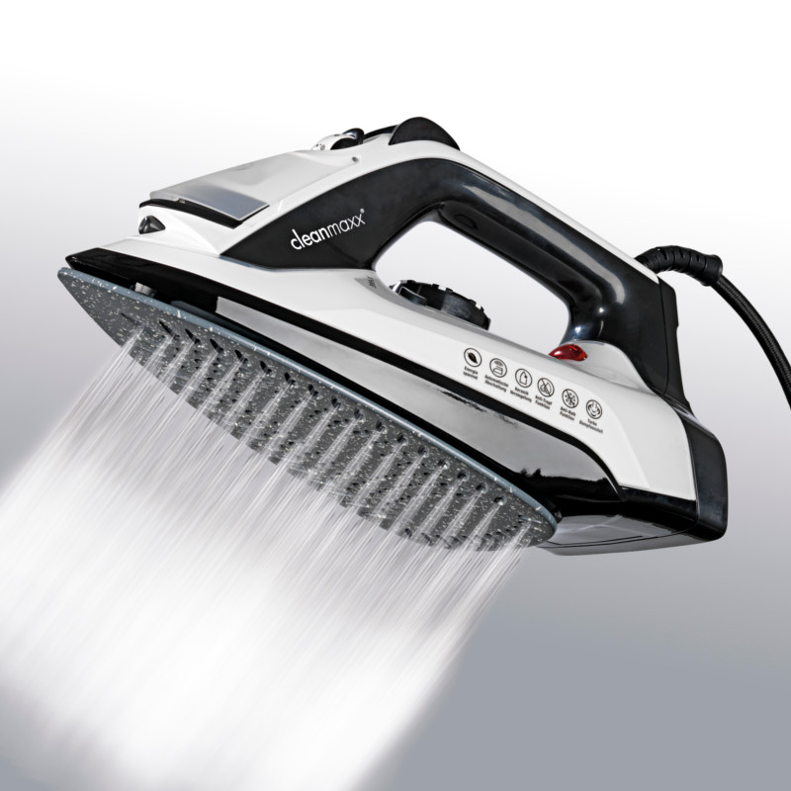
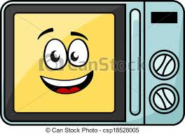
This appliance is as hot as the Sun. It helps your mum to iron all your clothes.
It is a transparent glass bulb. When the electricity comes into it, you will get the light.

It whistles and steams. It can help you to make hot tea or coffee

It absorbs all things it meets on a carpet: dust, wrappers and sometimes tiny candies
It stands on cupboard sometimes hangs on the wall. You can use a remote controller to watch what you want.
This appliance is so smart, it will heat your cold meal just in few minutes.

