Subject: Energy around us.
Learning objectives;
- To review the renewable energy sources
- To sensitize the students on the topic of ecology

- To extend the knowledge on the advantages of the renewable energy sources
- The examples of wind, water and solar power plants and their role in the world energy industry
- Reading and interpreting diagrams and charts

Work types: individual, group and class work
Methods : brainstorming, presentations and source documents

I Introduction
- Sharing the learning objectives of the lesson with the students. The revision of the information about power and energy. Finding cross links with the geography topic: renewable sources of energy
- Giving students a worksheet ( attachement 1) which is supposed to be filled in during the lesson time.

II The main teaching part – students’ presentations
Students have worked in groups at home time on the energy projects. They presented their work in the form of multimedia presentations, folders, essays and 3D models of wind power stations. Some examples of their work were presented during the lesson.
I presentation – wind power (attachement 2)
Pros and cons of wind power plants and the display of the 3D models of wind power stations.
Qustions to the students:
Read and interpret the chart below and answer the following questions:
How many wind power plants are going to be built on the land and on the sea by 2020? Compare the numbers with the present year. Talk through the increase of power in those stations.
The increase of power in wind power plants in Poland until 2020.
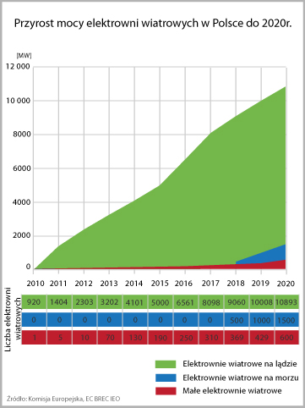

Green – wind power plants on the land
blue - wind power plants on the sea
red – small wind power plants

Which regions have the largest wind power?
Wind power according to the regions in Poland (Energy Regulatory Office 2010)
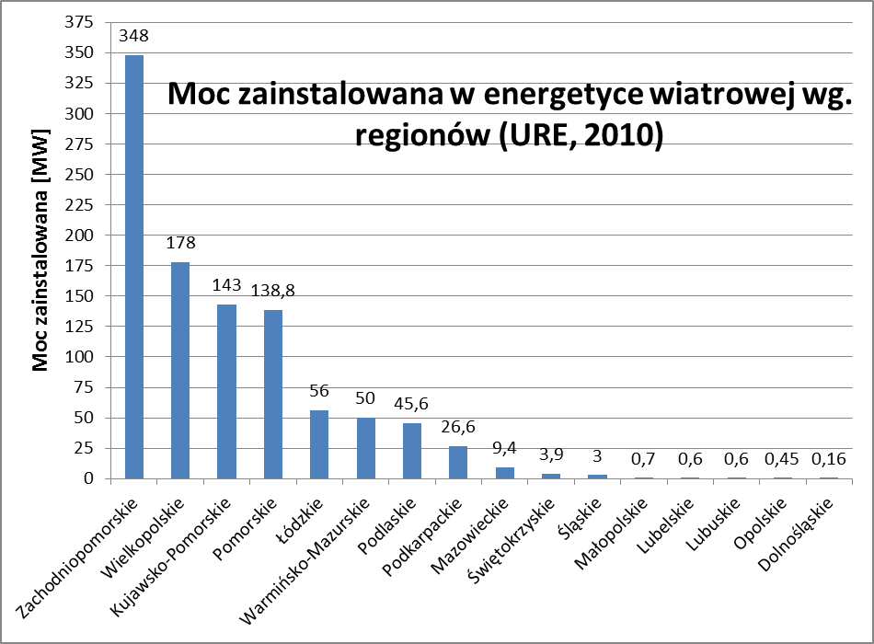

II multimedia presentation by a group of students – water energy (attachement 3)
Questions to the class:
Read and interpret the pie diagram below and answer the following questions:
Which continents have the highest number of small water power stations? What is the Europe’s percentage share in these power plants?
The world’s precentage share in the wind power installed in small water plants.
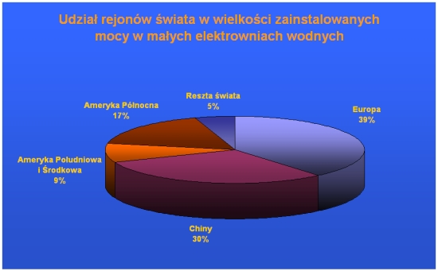
Europe- 39%
China – 30%
Middle and South America – 9%
North America – 17%
The rest of the world – 5%

Questions to the class:
Read and interpret the bar chart below and answer the following questions:
Which European countries have the highest solar power use? What is Poland’s contribution?
Solar power globally: the proportion of the power of solar panels installed:
2008 data: Germany 36%, Spain 21,9%, Japan 14,6%, USA 8%, North Korea 2,4%, Italy 2,4 %, China 1,0%, Indie 0,6%, France 0,6%, Be;gium 0,5%, Portugal 0,5%, Czech Republic 0,4%, Poland 0,1%, other countries 11,0%.

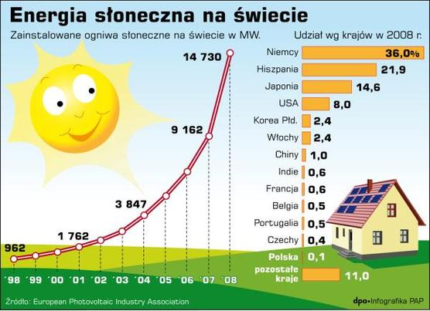
Pros and cons of solar power:
Advantages:
- Free energy source
- The decrease in the use of the natural energy sources
- Clean energy sources
- Can be used locally so the transportation is not an issue
Disadvantages:
- high costs of the energy panels production
- the long production process
- short period of time of the panels’ usage ( 25 years)
- no possibility of the energy accumulation
- dependence on the weather and climate conditions
IV Plenary
Read and interpret the bar chart below and answer the question:
Which energy sources are predominantly used for the production of electricity?
(the key in the table: red - geothermal energy, yellow – photovoltaics, orange –CSP, green – biomass, light blue –wind power, dark blue – hydropower)
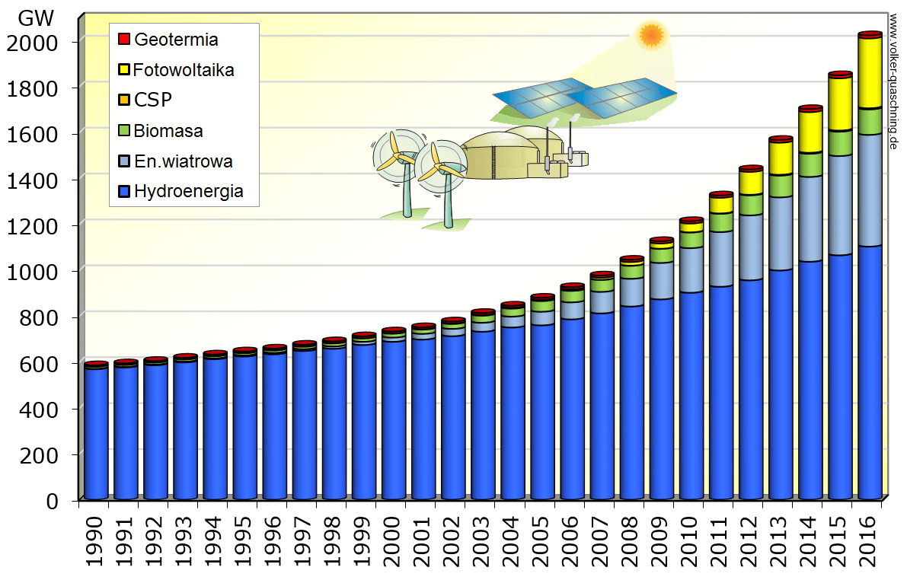

Students do the peer marking of the worksheets that they were given at the beginning of the lesson.
V Evaluation

