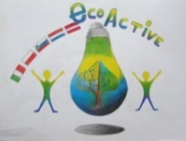 LESSON PLAN 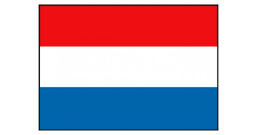
SCHOOL | Bs De Weijerwereld
THEMATIC AREA | WATER
TEACHER | Thea Willems
SUBJECT | Water-circuit
AGE GROUP  (approximately) | 7-8 years
TIME REQUIRED | 60-70 minutes
PLACE | Classroom,
LESSON OBJECTIVES | Experiences with different subjects and situations of/with water.  What does water do in different situations?  Characteristics of water
REGULAR LESSONS YOU CAN USE | - Language, for translation in English  - Biology  - Nature knowledge
CLASS ORGANISATION | - Pupils work in groups
MATERIALS | Exersises-games-experiments  - movie: origine of the water pipe (Video lesson: Thirst with Wouter and Wiesje)  - creating a water pipe: tubing, from high position to a low position  - filtering dirty water: bottle filled with mud, cloth used as filter  - water cycle: watching movie and drawing the cycle  - float and sink: various little materials  - water organ: bottles filled with water in different levels, little sticks  - water-resistant: various materials: which are water-resistant, which are not  - game blowing away a little boat: water basin, little boats, straws (influence of the wind on the boat)  - goose board game: theme “water”” ,  - freeze water: making ice
ICT TOOLS | Computer: various movies, experiment with water
PROCEDURE | The pupils group is broken apart into small groups of 5 pupils (max.)  All the groups can work/ experiment 10 minutes on each exercise/game/experiment.  After 10 minutes every group goes on tot he next item of the workshop.  Parents explain the pupils what they have to do and support them if necessary.
EVALUATION | You8ng pupils experience in a playful way, that water is very important and that people can’t live without water.
ATTACHEMENTS | See the report about the ECO-week, written by these young pupils.

