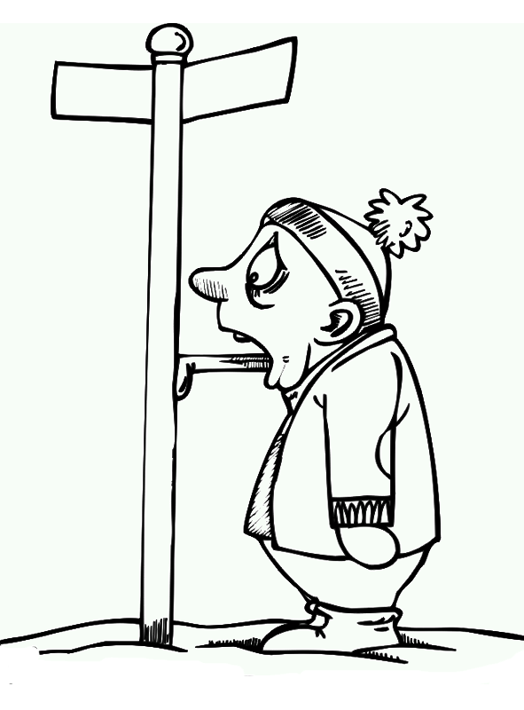
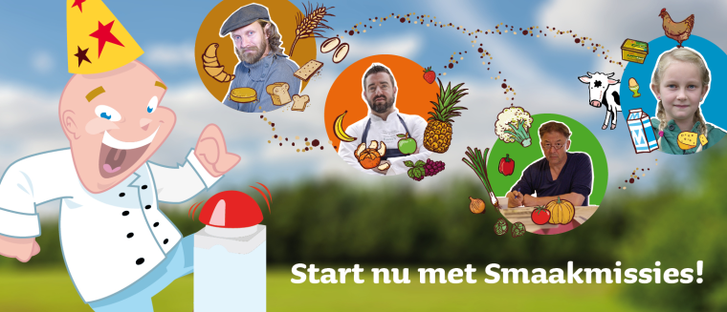Flavoring lesson

The Netherlands
 | Taste 1 |  |  | Taste 2 |  | Taste 3 |  | Taste 4
 | Use your nose |  | Pinch your nose closed | Use your nose | Pinch your nose closed | Use your nose | Pinch your nose closed | Use your nose | Pinch your nose closed
1.What do you taste?
2.What kind of taste is it?
3. How does it smell?
4. Do you like it? Yes of No and why!
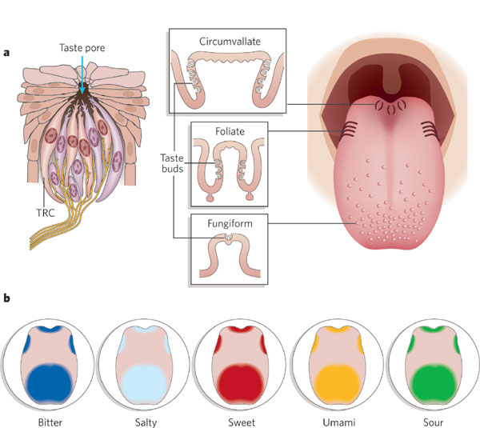
Draw your funniest cartoon picture with a special tongue

