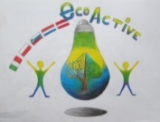 LESSON PLAN 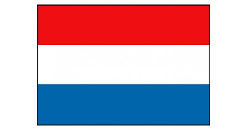
SCHOOL | De Weijerwereld
THEMATIC AREA | ENERGY
TEACHER | Maaike Simons, and guest teacher from Eneco
SUBJECT | Energie
AGE GROUP  (approximately) | 10-12 years
TIME REQUIRED | 2 hours
PLACE | classroom
LESSON OBJECTIVES
REGULAR LESSONS YOU CAN USE | - Windenergy  - Electricity  - Saving water  - Fuel
CLASS ORGANISATION | - Pupils work individually and in groups.  - The teacher gives instruction on the subject.  - The children then work in groups on the worksheet.  - This is followed by a follow-up discussion.
MATERIALS | Digiboard, internet, work sheets, site Eneco
ICT TOOLS | Digiboard, internet, site Eneco.
PROCEDURE | Printing work sheets  Website Eneco  Lesson has different steps:  .First you discuss the information with the children (by means of a video the children get an explanation about the different subjects). Then they start working in groups with the assignments of the worksheet.  After each worksheet there is a feedback and the answers are discussed. After the 4 different parts there is a quiz. This quiz consisted of yes / no questions every time where the children had to go to the correct answer. The winner of the quiz won a solar toy set for the class.
EVALUATION | All 4 steps that came into the lesson are done. This was a lot of work in 2 hours. The children were very enthusiastic about the subject of Energy. Many parts of this were already known for them, because of our lessons in nature education / technology. Nice lesson for the oldest pupils.
ATTACHEMENTS | See attachments 1-5 for lessen 1 Energy

