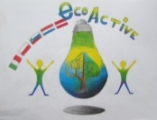 LESSON PLAN 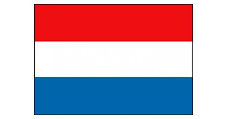
SCHOOL | De Weijerwereld
THEMATIC AREA | HEALTH – Healthy food
TEACHER | Oldest pupils 10-11-12 years
SUBJECT
AGE GROUP  (approximately) | 9 t/m 12 jarigen
TIME REQUIRED | 4 x 1 hour
PLACE | CLASSROOM
LESSON OBJECTIVES | o.a. Senses / origin / disc of five  Lesson 1: Tastemakers: Taste and the role of the senses  Lesson 2: The energy balance: Relationship between eating and exercising  Lesson 3: Fair Trade: Fair Trade products  Lesson 4: Tests with additives: Additions and the label
REGULAR LESSONS YOU CAN USE | - Language ,for translation in English of course the English lesson  - Biology  - Nature knowledge
CLASS ORGANISATION | - Pupils work in pairs  - Pupils work in groups  The teacher gives instruction and we exchange information in the group. Children will also taste / discover in pairs.
MATERIALS | Materials as described in the teacher manual:  This involves kitchen materials, foodstuffs, copy sheets. In addition, via the site a game / videos belonging to the lesson.
ICT TOOLS | http://www.smaaklessen-online.nl/ (form 8)
PROCEDURE | (what happens, what we do step by step)  - Print the manual and view the contents. Buying food.  - Prepare materials per lesson: food + kitchen equipment + copy sheets.  - Start the lesson on the IWB: prepare game / video.  - The course of the lesson is described in the manual.
EVALUATION | Lesson 1: children view / smell / taste products more consciously. For some students it is difficult to try something new, others discover flavors that they like.  Lesson 2: children aware of the amount of sugar in productive  Lesson 3: Fair Trade explained. Comparing the chocolate did not come into its own; one chocolate was in fact purer than the other. Because of this, it was partly a taste issue.  Lesson 4: awareness of additions; you do not always eat what you expect. For example, there is no gram of strawberry in strawberry custard pudding.  Within the informative lessons, various approaches to nutrition have been discussed.
ATTACHEMENTS | Manual as pdf ◊ 'Taste lessons group 8.pdf' (Dutch)

