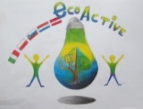 LESSON PLAN 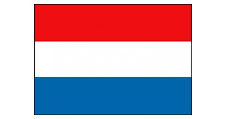
SCHOOL | De Weijerwereld Boxmeer
THEMATIC AREA | Crea
TEACHER | Lida, Mariëlle, Imke
SUBJECT | Healthy food
AGE GROUP  (approximately) | 4-5-6 years
TIME REQUIRED | 45 minutes
PLACE | Classroom
LESSON OBJECTIVES
REGULAR LESSONS YOU CAN USE | Lesson cut and past
CLASS ORGANISATION | Groups 6 pupils.
MATERIALS | Paste, paper, scissors
ICT TOOLS | -
PROCEDURE | Sandwich and healthy food. First search for pictures and healthy food in flyers. Put the pictures on the sandwich. Then put the paper sandwich on a plate, then the plate and sandwich on a placemat. Add a cup and cutlery. We talk about healthy breakfast and lunch
EVALUATION | It was difficult for the pupils to think about healthy food, what is healthy food. And after this cut and paste the pictures it depends on the level of their fine motor skills.
ATTACHEMENTS | 