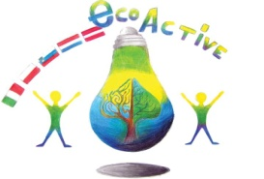 LESSON PLAN
Primary school | Primary school “2 Circolo Didattico “Cavour” Marsala Italy
thematic area | Water
Teacher | Stefania Vinci, Silvana Li Volsi, Maria Barraco; Graziella Pellegrino
-SUBJECT | Science
Age Group | 8-9 years
Time required | 60 minutes
Place | AREA
LESSON  OBJECTIVES | - Identify characteristics and properties of the water;  - Understand the water cycle; water phases: vapor, fluid, ice;  - Describe and recognize atmospheric phenomena.  - Reflection on daily water uses aimed at preventing the Waste
LESSONS YOU CAN USE | • practical activtivities: experimentation  • science  • english  • Information Technology  • Art: pictures of the water phase
CLASS ORGANISATION | - Pupils work individually  - Pupils work in pairs  Pupils work in groups
MATERIALS
ICT TOOLS | • ICT (informatic): power point production  • Researches about water and its importance
PROCEDURE | - Detection and recording of the presence of water in all its forms in  the surrounding environment;  - Experiences to discover some water features;  - Experiments on water-phase changes;  - Reconstruction of the complete hydro-geological cycle through schematization and animation  - Experimental Simulation of a Cycle Made of Two-Three State  Steps;  - Reflection on daily water uses aimed at preventing the Waste  - Create a power point presentation about water: use-protection-Preciosity
EVALUATION | -Represents and describes the cycle of water;  -Make difference between correct and incorrect use of water;
ATTACHEMENTS | Power point about wate

