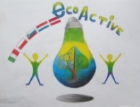 LESSON PLAN 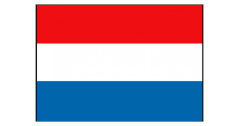
SCHOOL | De Weijerwereld
THEMATIC AREA | ENERGY
TEACHER | Lida, Emmy en Imke
SUBJECT | Orientation on the world
AGE GROUP  (approximately) | 4-6 years
TIME REQUIRED | 30 minutes
PLACE | Classroom, activity in a circle
LESSON OBJECTIVES | - Children get acquainted of various types of energy and what energy does  - Children learn how to use energy in a responsable way  - Children get acquainted with the circle of energy
REGULAR LESSONS YOU CAN USE | - Oral language  - citizinship
CLASS ORGANISATION | - Class activity, all pupils are involved activ
MATERIALS | - https://eneco-energieles.podium.nl/thema/34/thema-2/2 (in Dutch....)
ICT TOOLS | - Digital board  - https://eneco-energieles.podium.nl/thema/34/thema-2/2 (in Dutch…..)
PROCEDURE | - First start with the introduction movie  - Then discussion about various types of energy (wind sun human energy  - Information about batteries, ho wit works and collecting old batteries  - Energizer: transpor chain, two groups of pupils pass along a word to eachother by wispering
EVALUATION | -
ATTACHEMENTS | - Picture windmill  - Picture solar cell

