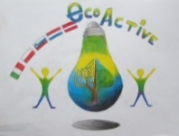 LESSON PLAN 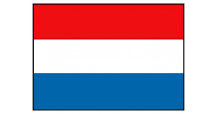
SCHOOL | De Weijerwereld, Boxmeer
THEMATIC AREA | Energy
TEACHER | Gertjan Vrenken
SUBJECT | Orientation on the world
AGE GROUP  (approximately) | 8-9 years
TIME REQUIRED | 2x 1 hour
PLACE | Classroom and play ground
LESSON OBJECTIVES | - Children are introduced to different forms of energy and how they work  - Children learn what wind energy is  - Children are introduced to the power of wind (air pressure)
REGULAR LESSONS YOU CAN USE | - Language  - Reading comprehension  - Citizen chip
CLASS ORGANISATION | - Pupils work individually
MATERIALS | - Lesson about wind energy  - Craft materials
ICT TOOLS | - digiboard  - movies windmills (movie from “nature news” Dutch TV)
PROCEDURE | - Introduction movie digiboard (wind mill)  - demonstration in the classroom (experiments) wind power  - explanation concerning construction plate, handicraft of wind power car  - tinkering with a wind power car  - try out the wind power car outside
EVALUATION | Outside trying out the wind power car, the car succeeds in moving on air pressure?
ATTACHEMENTS

